NEW TO ELFT
Practice Manager Transitional Training Programme

This is a training programme and induction pack designed to support the learning and development of leaders from outside of ELFT transitioning into Practice Management within the Primary Care Directorate

Name
Role
Start Date
Line Manager
Trainee supervisors and competency sign off lead

The difference between a practice manager in the ELFT model and the practice manager in a partnership model
Practice Manager in a partnership (high level) | Practice Manager in an ELFT practice | Things done by supporting functions in the ELFT model
- Drawings  - Book-keeping and paying invoices  - Year-end accounts  - Claiming and invoicing  - Buildings and maintenance  - PCN managerial lead  - CCG Managerial link  - Managing practice publications  - Performance & Governance of the practice  - CQC  - Contract management  - Human Resources - Recruitment and HR process such as sickness, etc  - Compliments & Complaints | - Management of non-clinical staff  - Performance lead  - Finance lead  - PCN managerial lead  - CCG Managerial link  - Compliments & Complaints  - Managing practice website  - CQC  - Line Management Support  - Oversight of local risks and maintenance of Practice risk register  - Review all incidents and ensure lessons learned | - Recruitment – supported by people and culture  - Practice finances supported by Finance business partner – there is no paying of wages, booking etc in the ELFT model  - Claims / invoices – done by income and data manager  - Health and safety  - Quality and compliance supported by quality manager  - Responding to NHS choices  - Human Resource - Guidance and advise

Practice Manager key skills framework
Key Skills / training | Training provided by | Date of course / programmes/ | Signed off by inductor | Signed off by line manager
Primary Care Directorate Leadership Programme | ELFT
The PC in Practice Leadership Programme | In development
Lunch and learn – Covid-19 risk assessments | P&C
Lunch and learn – How to carry out wellbeing assessments | P&C
How to carry out supervision and using structured supervision approaches | P&C
How to read budget statement training | Finance
Managing Sickness and Absence Training | P&C
Appraisal Training for Managers | P&C
Managing Capability and Performance Training | P&C
Managing Work life Balance Requests | P&C
Managing Disciplinary. Grievance and Dignity at Work Processes Training | P&C
Investigating Officers Training (Disciplinary/Grievance/Dignity at Work) | P&C
Access to medical records process for leads | Keisha
Understanding Serious Incident Investigations (co-reviewer duties) | Governance
Risk Officer Training (3 yearly) | Governance
Health roster training | P&C
Complaint’s training | Charlotte
IGDPR | Keisha
Trained in Envoy for reviewing patient feedback data | QA
Datix training | Joanne
Duty of Candour training | Governance
Has had oracle training | Finance
Has had training on the trust booking agency and bank systems | Finance
CQC readiness – has been trained to undertake peer review | QA
Care hill formula, weighted payments to practices, deprivation ranking and prevalence | P&C
GMS, PMS and APMS contract types and who can hold them | P&C
Boundaries, why a contractual boundary exists | P&C
What you need to do to extend or reduce your boundary | P&C
New patient registrations and contractual implications | P&C
Ghost patients and list cleansing | P&C
Violent and vexatious patients' deductions process | P&C
Special allocation scheme | P&C
Opening hours and contractual cover required | P&C
Payments for locums, maternity and sickness | P&C
The role of the CCG in contract managing | P&C
GP IT role of the CCG and NHS in the provision of GP IT systems | P&C
National extractions from clinical systems and coding | P&C
Rent and rates reimbursement, what is covered, what is not covered and how you claim | P&C
Exeter, PCSE and CQRS - what they are, what they tell you and how you use them | P&C
Annual eDec return | P&C
Annual NHSE complaints return | P&C
Directed enhanced services | P&C
Locally enhanced services | P&C
National enhanced services | P&C
Enhanced services commissioned by a GP Federation | P&C
Contractual requirement - PPG | P&C
Primary care network DES, ARRS, PCN participation payments, PCN admin payment, PCN clinical director payment | P&C

Key things you will need to know about any practice you are leading
- Practice address
- Phone number
- Bypass phone number
- E-mail address
- Website
- Who the practices safeguarding lead is?
- Practice Code
- Practice Opening and Closing Times
- Signing in and out process
- Fire, Health and Safety information
- Health and Safety Lead
- Fire Marshall
- Fire protocol can be found…
- Shift Patterns
- Annual leave and changes to shifts
- Practice closures
- Telephone system at the practice
- Booking system at the practice
- DNA policy
- IT or Digital issues please contact
- Smartcards
- To raise a significant event / Patient safety incidents
- Housekeeper/cleaners
- Hand soap and sanitiser replenished by
- Our PPG / People participation
- Where policies and procedures are
- Meetings and governance structures
- Visitors’ policy
- Signing in and signing out policy
- Chaperone policy
- Incoming post process
- Home visit process
- Vaccines and responsibility
- Prescription safety
- Patient Safety Incident process
- Smartcard process
- Pathology process
- Home visits process
- Death’s process
- All deaths
- Who is your Housekeeper / Cleaning service and how to contact them
- Any IT or Digital issues please contact
- DNA policy

Key external contacts and contact details you need to know about at any practice you are leading
- Coroner
- Social Services
- Language Line
- District Nurses
- Palliative Care Team
- Local Hospitals
- Nearest A&E
- Eye Casualty
- GP Out of Hours Service
- Local CCG Website

Key items you will need to know where to find in any practice and who is in charge of reviewing and overseeing
- Fire exits
- Fire extinguishers
- Toilets
- Kitchen
- Stationery
- Printer paper
- Emergency bag with defibrillator and oxygen
- Prescription paper
- Sample bottles
- Urine dipsticks
- Tongue depressors
- Couch roll
- Speculums
- Spare sharps boxes
- Spillage kit (for urine, blood, vomit)
- RCGP Sepsis Toolkit
- Doctor’s bag for home visits

Key figures you will need to know in any surgery
- Lead GP
- Lead Nurse
- Nurses
- Vaccine Lead
- Resus Lead
- Admin team
- Pharmacists/Pharmacy technicians
- Prescribing lead
- Palliative care lead
- Carers Lead
- Caldicott Guardian at ELFT is
- Caldicott Guardian in house is
- Adult Safeguarding Team
- Adult Safeguarding in house
- Child Safeguarding Team
- Child Safeguarding in house
- FGM
- Information Governance Lead is
- GP Team (with special interests)
- Who works at this practice?
- What PCN additional roles you have

Key induction areas, competencies and learning areas you were be emersed in
Key area | Lead | Date | What you will know at the end of the session / section
Introduction to the primary care directorate at ELFT.  this session will cover  - Directorate what it does  - Who is in the directorate?  - Governance structures  - Meetings  - Policies / procedures  - Handbook  - Extranet  - Meetings  - Support  - Supervision  - Access to K drive  - DMT  - PCNs  - How the ELFT model differs from the traditional general practice model | Head of Operations |  | All about the primary care directorate and its underpinning governance structures and key documents for reference.
Introduction to General Practice Contracts | Extranet webinar
The primary care directorates annual plan | Director of Primary Care
Introduction to the Medical Director  - what they do and who they manage  - the role of the Lead GP at an ELFT practice | Medical director
Introduction to the head of nursing  - what they do and who they manage  - the role of the Lead Nurse at an ELFT practice | Head of nursing
Introduction to people and culture which will cover  - Line management  - Forms and how to use them  - Recruitment and selection  - Sickness  - Supervision in the primary care directorate | P&C BP
Introduction to QI in the primary care directorate | Improvement advisor
Introduction to people participation in the primary care directorate | PP Lead
Introduction to Finance and income Getting set up on oracle and authorised signatory database  - Access and how to read budget statements  - Practice expenditure and income  - Services the practice is signed up to  - coding invoices and purchase orders | Finance partner
Temporary recruitment how to  - safer staffing calculator 52/72 per 1000  - Agency and bank  - How to book  - Guidelines  - IR35  - Framework  - Request forms to use and what to complete | Head of Operations |  | The process on how to book locum or bank staff
Introduction to performance  Will cover  - What gets captured and how  - Reporting cycles  - How the PM will be supported by the performance team  - Setting up searches and running searches in EMIS and S1 | Head of Operations |  | The process on data collection and how to collect
Differences between smaller and larger GP Practices  - Admin and clinical teams in smaller practices and ways of working  - Admin and clinical teams in larger practices and ways of working | Head of Operations |  | Shadowing teams to see how larger surgery comes to smaller
Introduction to the general practice support unit | Head of Operations
Introduction to the primary care skills academy @ELFT | Head of the skills academy
Introduction to the wellbeing champion in the primary care directorate | Wellbeing champion
Introduction to the care navigation procurement | Head of the skills academy |  | Connexus
Introduction to quality and governance  will cover  - PREM  - Datix  - Risk registers  - Business continuity plans  - Complaints / compliments  - You said we did  - PPG and engagement  - Policies and procedures | Quality Manager
Introduction to contracts  - How contracting works at the trust  - What you can and cannot sign for at a practice level  - IG / DSA  - Liaising with CCG and others re finances or contracts  - PCN DES  - Practice DES  - APMS and GMS  - PCN ARRS | Head of Operations
Performance in general practice  - National performance management of general practice  - CCG performance management  - Extractions  - National GP data hub  - National GP finance reporting  - What indicators are measured  - Action expected | Performance team
CQC in general practice  - How this works  - The handbook  - Peer review  - Nigel’s surgery | See handbook with head of operations

You will be required to go and visit teams across the back office and understand how it works and how leads the teams
ADMIN | What I have learnt and when I visited
What are the clinical systems and how do they work?
What is summarising? What is the process on the Clinical System?
Registration Process and who is PCSE?
Deduction Process?
Clinical Records off site?
Non-NHS Work and What is the process? Price List
What is a complaint and how to process?
What is the prescription process and how to process a prescription?
CLINICAL | What I have learnt and when I visited
Services available to our patients
Services we have visit on site
Chaperone policy
MHRA Spreadsheet what it is and where it can be found…
List of palliative patients, vulnerable adults, vulnerable children is sent out via notification every month by…
A list of Priority Patients is kept…
Our carers register is kept by…
Clinical Audits
How do I… | What I have learnt and when I visited
Call a patient from the waiting room
Organise blood tests and advise the patient to get the results
Send urine/blood to the lab
Text a patient
Send a task
Record a death
How do I organise repeat prescriptions
How does Docman work in the practice
How are test results managed in the practice
Book a nurse appointment
All emergency equipment is checked daily by…
With the back up being…
REFERRALS | What I have learnt and when I visited
What is the Referral Process?
Refer to MDT
Refer for palliative care
Refer a patient – 2ww
Refer a patient – Urgent
Refer a patient - Routine
Refer to Physio
Refer to mental health teams
Refer to drug and alcohol services
Refer for X-rays
Refer for USS
Organise an ECG urgent/routine
Refer a patient for antenatal care
Organise a smear test
Home visits
Help a patient to access family planning
Pathology
MEETINGS | What I have learnt and when I attended for induction
Clinical Governance
Data
Primary Care Network
Full Staff
Nursing
Non-Clinical Staff
Other

Your best friend
The primary care directorate over the last year has built its own extranet which is full of its own bespoke policies and procedures. Everything you could ever need is available at quick reference please create yourself an account and explore. Please use the feedback button to let us know if there is anything that you think is missing so we can look to create this. As this site is an extranet it can be entered home or at work and through any mobile device.
Please enter here: https://elft.nhs.uk/primarycare
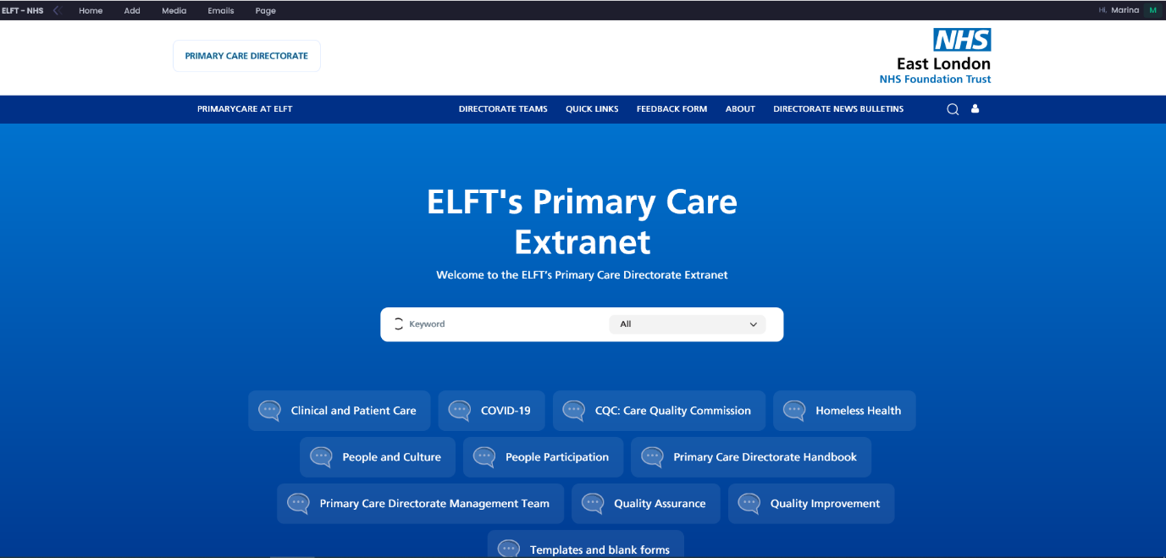

Your best friend - Primary Care Directorate handbook https://elft.nhs.uk/PrimaryCare/resources/677/Primary-Care-Staff-Handbook#P227
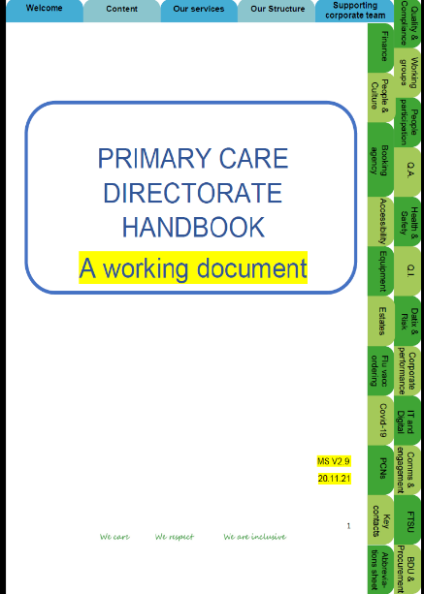

Your best friend - CQC compliance in primary care
https://elft.nhs.uk/PrimaryCare/resources/561/CQC-Handbook#P189

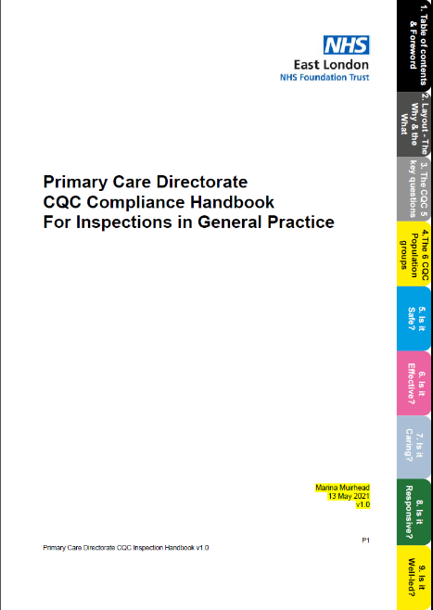

Induction meetings and key contacts to help you settle in
Person | Role / function | Date meet | Phone Number | Email address
Irfaan Ibne | Head of Operations
Emma Dirken | Practice Manager |  | 020 7247 0090 | emma.dirken@nhs.net
Louise Wilson | Practice Manager and Head of the Primary Care Skills Academy |  | 0207 909 4986 | louise.wilson70@nhs.net
Sultan Ahmed | Service Manager |  | 0208 536 2255 | sultan.ahmed1@nhs.net
Louise Cole | Practice Manager |  | 07494 206415 | louise.cole7@nhs.net
Lead GPs | N/A
Lead Nurses | N/A
Marina Muirhead | Director of Primary Care |  | 07717 418219 | marina.muirhead@nhs.net
Liz Dawon | Medical Director Primary Care |  | 07388 707359 | liz.dawson1@nhs.net
Mohit Venkataram | Executive Director of Commercial Development |  | 07852 766068 | mohit.venkataram@nhs.net
Shade Olutobi | Directorate People Business Partner |  | 07387 522 785 | shade.olutobi@nhs.net
Mairead Heslin | Directorate OD Business Partner |  | 07918 445678 | mairead.heslin1@nhs.net
Keely Smith | Directorate People Relations Advisor |  |  | keely.smith3@nhs.net
Alaa Alhamoud | Directorate Finance Manager |  | 074 3602 7536 | a.alhamoud@nhs.net
Joanne Alder Pavey | Directorate Quality and Governance Manager |  | 07785 695413 | j.alder-pavey@nhs.net
Nicola Hoad | Directorate Development Manager |  | 07918 446170 | nicola.hoad@nhs.net
Sri Putti | Directorate Data and Income Manager |  | 020 8510 4490 | sri.putti@nhs.net
N/A yet | CCG Commissioning Lead
N/A yet | PCN Clinical Director and Manager
N/A yet | CCG Claims / Finance Manager

Induction and learning log
Weeks | Venue | Key learning areas and competencies this week that you will be learning and from whom | Key things I have learnt this week | Key areas this week I feel I need more support / learning on | Signed off by Inductor

Induction sign off
Key induction area | Signed off by inductee | Signed off by Line Mgr | Date
Has access to an ELFT email address
Has been provided with an initial work plan with key areas of focus for the diary
Understands how to use the EMIS / S1 system
Signed up to the authorised signatory database (for line managers only)
Has access to datix
Has access to oracle
Covid-19 risk assessment has been undertaken
Has had training on CEG dashboards
Understands the practices registration policy and fee-paying systems
Understands and has log ins for Exeter, CQRS and any other system
Understands practices complaints and datix systems and timelines
Understands the PREM survey and how to obtain the data and the you said we did process
Understands the national GP patient survey, what it is for and how to use the information
Understands the practices governance on
- Practice based clinical governance meetings and
- Practice based performance and finance meetings
Understands the approach to supervision and takes a structured approach using the directorate forms
Knows how and where to find ESR self service
Knows how to code an appraisal in ESR
Signed up to the Directorates Leadership Programme
ESR hierarchy has been updated to reflect line management responsibilities for individuals under your care
Is receiving the directorate communications bulletin
Is receiving the directorate CQC bulletin
Understands all areas of health and safety including policies on mask wearing and IPU
Understands the visitor’s policy to practice and the track and trace system
Understands how to report infection control issues to ELFT
Knows where to find all practice policies and procedures
Knows where to find all Trust and directorate specific policies and procedures
Has access to the K drive
Understands the directorates process on performance and finances
Understands what enhanced services (Directed, national and local) are available to the practice and which ones are signed up to
Understands the practices systems and processes
Is signed up to
Signed up to Oracle with relevant form access
Has completed the trust induction
Understands the trust systems on the booking of agency / locum staff
Understands how to calculate annual leave and the process for booking of annual leave by their teams for safer staffing levels
Care hill formula, weighted payments to practices, deprivation ranking and prevalence | P&C
GMS, PMS and APMS contract types and who can hold them | P&C
Boundaries, why a contractual boundary exists | P&C
What you need to do to extend or reduce your boundary | P&C
New patient registrations and contractual implications | P&C
Ghost patients and list cleansing | P&C
Violent and vexatious patients' deductions process | P&C
Special allocation scheme | P&C
Opening hours and contractual cover required | P&C
Payments for locums, maternity and sickness | P&C
The role of the CCG in contract managing | P&C
GP IT role of the CCG and NHS in the provision of GP IT systems | P&C
National extractions from clinical systems and coding | P&C
Rent and rates reimbursement, what is covered, what is not covered and how you claim | P&C
Exeter, PCSE and CQRS - what they are, what they tell you and how you use them | P&C
Annual eDec return | P&C
Annual NHSE complaints return | P&C
Directed enhanced services | P&C
Locally enhanced services | P&C
National enhanced services | P&C
Enhanced services commissioned by a GP Federation | P&C
Contractual requirement - PPG | P&C
Primary care network DES, ARRS, PCN participation payments, PCN admin payment, PCN clinical director payment | P&C

Upward feedback to the directorate on the training scheme
- What has worked well?
- What could have worked better?
- Do you feel equip to lead a practice?
- If not why not? – what further training and support can be provided?

Services within the primary care directorate
- Leighton Road Surgery in Leighton Buzzard. The practice has a list size of 20,000 and is part of Leighton Buzzard PCN. The practice provides routine medical care to a mixed urban and rural population.

- Cauldwell Medical Centre in Bedford. The practice has a list size of 9,000 and is part of East Bedford PCN. The practice provides routine medical care to a slightly younger population than normal and has a slightly higher than average caseload of patients with mental health problems.

- Newham Transitional Practice is based over two sites with a list size of 4,500 and covers the whole of Newham. The practice is commissioned to provide care to a transitional population of patients, which includes patients who do not have access to an NHS number, those experiencing homelessness and some are from migrant populations as well as other vulnerable groups

- Health E1 in Tower Hamlets. The practice provides care to a list of 1,000 homeless patients. The practice team have close working links with mental health teams, voluntary organisations etc.

- The Greenhouse Practice in Hackney. The practice provides care in a very similar way to Health E1 and look after a list of 1,000 patients.

- The Homeless Outreach Service - This service was set up in April 2020 in response to the Covid-19 pandemic. It was initially commissioned to provide primary care services to people in hotel accommodation who had formerly been rough sleeping. The service has a team of GP’s and primary care nurses and operates across Newham, Tower Hamlets and City and hackney. The team works closely with the nurse led outreach service at Newham Transitional Practice. The service has developed during the Covid-19 pandemic and now aims to offer flexible care to any person who is homeless and needs care in any setting outside of one of our homeless practices.

- The Pathway Homeless Team @ RLH - The Pathway service is linked to Health E1 and based in Bart’s Hospital Trust. It is a small team that works with clinical staff in the Bart’s Trust to ensure that robust discharge plans are in place for homeless people admitted to hospital thus ensuring that these patients do not stay in the hospital longer than necessary and are not discharge to the street. To contact the Pathway Homeless Team at the Royal London Hospital please call 07730130221 (mon-fri 9-5) or email elft.pathwayhomelessteam@nhs.net

- City and Hackney Pathways – similar service to the one listed above.

Appendix – Trust Board
Trust Values (on your lanyards) - “We care, We respect, We are inclusive “
Trust Mission “improving the quality of life for the people we serve”
Freedom to speak up (whistle blowing) elft.freedomtospeakup@nhs.net
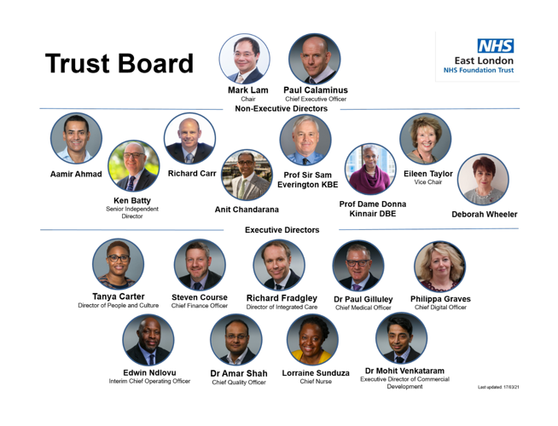
Appendix Management Structure
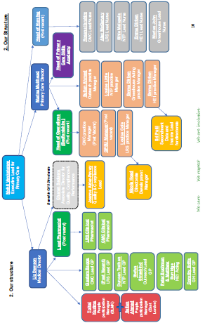
Appendix – supporting corporate team
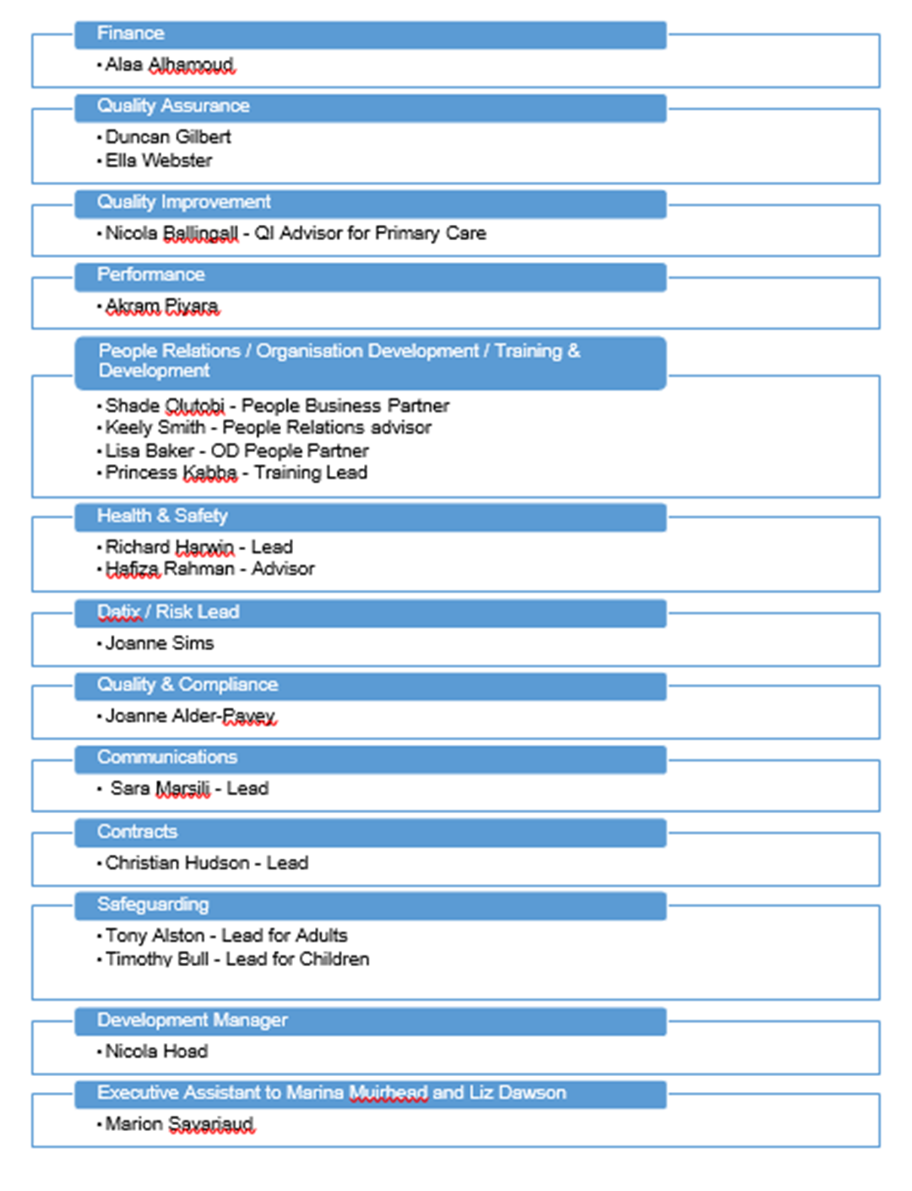
Appendix – Primary Care Directorate Governance Structure
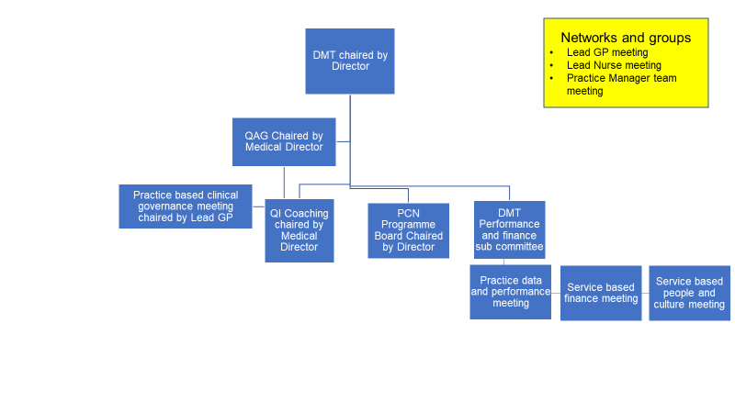
Appendix Practice Structures

Newham Transitional Practice
Greenhouse Practice

HealthE1 Practice

Cauldwell Medical Centre

Leighton Road Surgery

Appendix – quick guide documents
Document | Link
PC Directorate Handbook | Please find on the extranet
Easy guide to general practice | Please find on the extranet
PC Directorate People and culture ‘how to guide’ | Please find on the extranet
Sign up to the authorised signatory database (for line managers only) | http://finweb:81/asdb/
A range of translated materials (letters / texts in 15 languages can be found here) | K:\Primary Care Directorate Admin\People participation materials\translations.zip
Policies and procedures | Please find on the extranet
Appraisal forms | https://sway.office.com/jZPNjPoisxs6byDE?ref=Link
Appraisal training | https://www.elft.nhs.uk/Working-For-Us/Training-and-Development/Appraisals
Coding an appraisal in ESR | https://sway.office.com/223Zo3i95qIK2lBQ?ref=Link
ELFT - Declaration of Interests Form | ELFT - Declaration of Interests Form
ELFT Accessing on-line payslips | ELFT Accessing on-line payslips
ELFT Childcare-Vouchers-Parent-FAQs | ELFT Childcare-Vouchers-Parent-FAQs
ELFT NHS Employee Discount | ELFT NHS Employee Discount
Recruitment Form (Budget Authorisation Form): | http://finweb:81/esrforms/recruit.php
Staff Change Form: | http://finweb:81/esrforms/change.php
Staff Leaver Form: | http://finweb:81/esrforms/leaver.php
Staff Sickness Form | http://finweb:81/esrforms/sickness.php
To view forms submitted by you: | http://finweb:81/esrforms/search.php
ELFT Policies and procedures on HR | https://www.elft.nhs.uk/About-Us/Freedom-of-Information/Trust-Policies-and-Procedures/Human-Resources-Policies
NHSE primary care handbook | https://www.england.nhs.uk/wp-content/uploads/2017/11/B0134-primary-medical-care-policy-and-guidance-manual-v3.pdf

Appendix – Supervision form for Managers

1:1 Record Sheet
Staff Member: |  | Role | Practice Manager
Line Manager: |  | Date: | 2022

Core role responsibilities and progress against them | X month progress / update
Wellbeing conversation
What is on your list to discuss?
Care navigation
Skills academy and KSF
Service Performance and reporting including rotas
QOF
Ad hoc funding
Service Finance including bank and agency
PCN relationships, IIF, ARRS and developments
People and culture
People participation
QI projects
CQC preparation and peer review
Sickness;
Covid-19 risk assessment
Annual leave, planned, booked, remaining, handover plans
Training needs/CPD & mandatory training;
Appraisal Roles-objectives; review / discussion;
Embedding
- Trust processes and procedures
- Extranet
- handbook
What help do you need from me / others?
Do you need to escalate anything to me? Information or any action?

Signed:
Staff Member: | Date
Line Manager: | Date

DMT Performance and Finance Subgroup
- Every month there will be a DMT performance subgroup which is chaired by the Head of Operations.
- The terms of reference for the group can be found here: https://elft.nhs.uk/primarycare/resources/472/Terms-of-Reference-TOR---DMT-Subgroup-Performance-
- Practice Managers along with other lead figures at the surgery will be held account for the practices performance at this meeting.

