Reducing health inequalities in primary care at East London NHS Foundation Trust – early/pre-scoping discussion paper
Summary
This paper identifies three initial options for a ‘deep dive’ project to investigate and address an aspect of health inequalities in primary care, as part of wider work to strengthen ELFT’s population health approach.
They are:
- Option 1: investigating and addressing inequalities in patient access and experience in Bedfordshire practices
- Option 2: investigating and addressing inequalities for people with protected characteristics in specialist East London practices
- Option 3: investigating and addressing the impact of changes arising from the COVID-19 pandemic on equality of service uptake across the Primary Care Directorate
DMT is asked to:
- Discuss these high level options and identify a preferred option
- Consider how this work might help to embed an ongoing strategic approach to reducing health inequalities within the Directorate
Background
ELFT’s Primary Care Directorate is seeking to identify impactful action it can take to reduce health inequalities in the populations it serves.
Outputs of the project are to be defined by the primary care team with the support of the public health team.
The purpose of this paper is to:
- Stimulate initial discussion leading to shared understanding of the role of primary care in reducing health inequalities
- Help to reach consensus on areas of focus for a ‘deep dive’ into an aspect of health inequalities in the ELFT Primary Care Directorate
- Generate ideas from within the Directorate on which inequalities to focus on, and how they might be addressed
Policy and planning context
Reducing health inequalities is a key ambition in national, regional and organisational plans.
The NHS Long Term Plan includes specific commitments to strengthen contribution to prevention and the reduction of health inequalities and requirements on local areas to set out measurable goals and mechanisms for the reduction of health inequalities.[1] The NHS Mandate for 2021-22 also includes an expectation to reduce inequalities, with specific measures including the difference in COVID-19 vaccination uptake between different ethnic groups, and differences in primary care access by level of deprivation.[2] Tackling inequalities in outcomes and access is one of the four fundamental principles underlying the process for development of integrated care systems.[3]
Population health and reduction of health inequalities are also a core component of ELFT’s organisational strategy and delivery plans.
What are health inequalities?
“Health inequalities are avoidable, unfair and systematic differences in health between different groups of people”.[4] They include inequalities in
- health outcomes (such as mortality rates, life expectancy or disease prevalence)
- healthcare quality and access (such as availability of specific treatments)
- immediate health risk factors (such as smoking, diet or alcohol use)
- wider social and environmental factors (such as deprivation or air pollution).
They may arise from differences in individual circumstances - such as income level - within a single population; from differences between geographical populations in the social, physical and economic environment; from specific characteristics protected under the Equalities Act; or from other potential sources of vulnerability such as recent migration. Intersectionality of different characteristics can also lead to poorer health outcomes for some populations.
Primary care at ELFT
The Primary Care Directorate at ELFT includes both routine and specialised primary care services.
Two practices offer routine medical care in Bedfordshire:
- Leighton Road Surgery in Leighton Buzzard (list size ~20,000)
- Cauldwell Medical Centre in Bedford (list size ~9,000)
Three practices offer specialised services in East London:
- Newham Transitional Practice in Newham (list size ~4,500), serving a transitional population including some people without access to an NHS number, some recent migrants and some homeless people
- Health E1 in Tower Hamlets (list size ~1,000) serving a homeless population, with links to an additional service provided by Pathway to support discharge planning at the Royal London Hospital
- Greenhouse Practice in Hackney (list size ~1,000), serving a homeless population
In addition, the Directorate includes a Homeless Outreach service commissioned in April 2020 to provide primary care services to former rough sleepers in temporary accommodation during the COVID-19 pandemic.
Applying national learning at ELFT
Evidence and experience from the Health Inequalities National Support Team suggests that health inequalities in primary care can best be addressed through a systematic approach to improvement for practices working with deprived or high-need populations. This includes intervening for all age groups, with the intent to have an impact over different time periods, and acting at civic level, community level, and service level within place based systems.[5]
Primary care has a direct role in addressing inequalities of access, outcomes and experiences of healthcare within its service provision, but can also influence the wider determinants of health through strong links to other services and relationships with the local community (see figure 1).
Figure 1: the potential role of primary care in reducing health inequalities
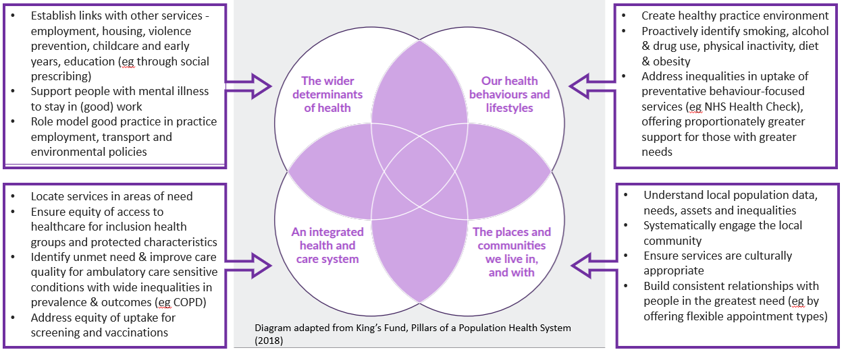
Early intervention and a focus on prevention are particularly important because inequalities accrue across the lifecourse, and because there is evidence of differences by income group in use of preventative services.[6]
Initial parameters for this project
This project will need to:
- Align with existing ICS, PCN and ELFT plans
- Be completed (to at least one phase) within 8 months
- Focus on the direct role of primary care services in reducing health inequalities
- Adopt quality improvement principles and tools
- Develop and test an approach to Directorate-level support from the ELFT Public Health team which can be applied to future population health and health inequalities projects
Initial project options
The project will follow ELFT Quality Improvement methodology, beginning with a problem identification phase before developing an understanding of the problem, development of a strategy and change ideas, testing, and implementation.
A first step is to examine practice data to understand local population need and aspects of services where there could be scope to improve. For example, ELFT practice data drawn from National General Practice Profiles (see Appendix) suggests that ELFT practice scores and rates are lower than the national average in:
- Overall patient experience in Cauldwell Medical Centre and Leighton Road Surgery
- Uptake of cervical, breast, and bowel cancer screening at Greenhouse, Health E1, Newham Transitional Practice and Cauldwell Medical Centre
- Flu vaccination uptake for some clinical risk groups at Greenhouse Surgery, Cauldwell Medical Centre and Leighton Road Surgery
- Recording of some physical health care indicators for people with mental health problems in Cauldwell Medical Centre and Leighton Road Surgery
Differences from national rates may arise from differences in the way data are recorded; in the underlying characteristics and needs of the populations served; or in the way services are offered and delivered. Further exploration of the reasons for these differences could help to reduce inequalities between and within practice populations.
Three high-level options for a potential area of focus in 2021-22 have been identified following a Primary Care Directorate Management Team (DMT) meeting on 24 February 2021; discussions with the Primary Care Director and Medical Director on 5 May; and review of the Directorate Handbook and annual plan.
Thematic areas arising from the DMT meeting were:
- Access inequalities
- Hidden inequalities
- Different types of inequality (digital, race, gender, LGBT, history of abuse)
- Data quality
- Service linkage and referral patterns
Thematic areas arising from the 5 May meeting were:
- Equity of access to routine primary care
- Impact of inequalities by protected characteristics within inclusion health groups in specialist practices
Aspects of services where improvement/development work is already planned in the Primary Care Directorate (2021-22 ELFT Implementation Plan) include:
- Uptake of preventative care (breast, bowel and cervical cancer screening, vaccinations)
- Integrated health and housing project (Greenhouse Practice)
- Establishing a GPSU
Option 1: investigating and addressing inequalities in patient access and experience in Bedfordshire practices
Overall patient satisfaction scores are lower than the national average at Cauldwell Medical Centre and Leighton Road Surgery (see appendix). Wider research has found evidence of differences in patient experience between different ethnic and income groups, so a project which strategically targets inequalities in patient experience could have benefits for lower income groups and some ethnic minority communities.[6] [7]
The two practices serve populations which differ in age profile, relative level of deprivation and life expectancy. A project based in these practices could compare practice list demography and access patterns with the local population to understand how well the practice is engaged with the local community.
These practices are large, and have scope to improve, so a project based here could have benefits for a big proportion of the overall population of patients registered with ELFT primary care services.
Option 2: investigating and addressing inequalities for people with protected characteristics in specialist East London practices
As specialised primary care services, Greenhouse, Health E1 and Newham Transitional Practice already directly address housing, migration status, and related needs as social determinants of access to healthcare. There may be opportunities to further strengthen this approach by examining variation in service access, patient experiences and outcomes by specific subgroups protected under the Equalities Act. A project based in these practices could seek to understand and address how well practice lists reflect diversity within the subpopulations they support.
These practices serve specific high need populations, so a project based here could have substantial benefits for these groups.
Option 3: investigating and addressing the impact of changes arising from the COVID-19 pandemic on equality of service uptake across the Primary Care Directorate
The COVID-19 pandemic has had a widespread impact on primary care service delivery in England, particularly an increase in remote working, as well as reports of increases in demand.[8,9] A project in ELFT’s primary care directorate could investigate and seek to mitigate inequalities arising from differences in service access patterns arising from increases in the proportion of telephone consultations and/or changes in uptake of services. Feedback from patients in recent Directorate PREMs reportd suggests that access to appointments is already a concern for some people.
Identifying inequities arising from recent changes could help to mitigate inequalities across the Primary Care Directorate before new practices become firmly embedded.
FOR DISCUSSION WITH PRACTICE LEADS
- Which demographic groups, people with protected characteristics, or inclusion health groups do you think might be under-served in your practices?
- Which aspects of clinical need, access patterns, patient experience and services quality do you think need attention in your practices?
- Which inequalities do you think will have widened because of changes to patterns of primary care service use during the COVID-19 pandemic?
- What do you think would be the challenges in measuring these inequalities in your practices?
- Which option would have your support, and why?
- Is there scope for a wider strategic approach to reducing health inequalities across the Directorate?

Project governance
The project will report to the Health Inequalities Working Group, with accountability to the Board level Population Health Task & Finish Group.
Project team
Team | Name | Project role
Public Health: | Emily Humphreys, Specialty Registrar in Public Health | Scoping  Specialist public health advice  Analysis and reporting
 | Angela Bartley, Deputy Director of Public Health | Public health oversight
Primary Care Directorate: | Liz Dawson, Medical Director | Clinical engagement and leadership
 | Marina Muirhead, Primary Care Director | Managerial leadership
 | Who else may need to be involved (TBC as project is scoped)  - Louise Little (Service Manager, Newham Transitional Practice)  - Nicola Hoad (Directorate Development Manager)  - Joanne Alder-Pavey (Quality & Compliance Lead)?  - PPI lead | Roles needed (to be confirmed as project develops)  - Project management support  - Data access  - Service user engagement  - Other roles to be defined

Next steps
- Discussion with primary care directorate to agree an area of focus (mid-late June)
- Initial data review and further project scoping (late June-mid-July)
- Establish project team, governance and approach (late July)
Appendix 1: potential measures of inequality
Potential outcome measures
- Access: registration; appointment waiting times; appointment type; list turnover
- Experiences/processes of care: patient satisfaction scores; offer and uptake of preventative services (smoking cessation support, screening, vaccination, NHS Health Checks); cancer late diagnosis; QOF prevalence and scores for specific priority conditions; IAPT referrals
- Short/medium term outcomes & proxies: health behaviours (eg smoking status); mental health; hypertension; diabetes; cancer; ACS emergency admissions
Potential dimensions of inequality:
- Protected characteristics: age, race, disability, sex, gender reassignment, sexuality, marriage and civil partnership, pregnancy and maternity, and religion or belief
- Inclusion health groups: any socially excluded group with complex needs including homeless people, sex workers, people from GRT communities, people with drug or alcohol dependence, vulnerable migrants, people in contact with the criminal justice system, victims or perpetrators of domestic violence.
- ELFT inequalities workstream priority groups: people experiencing multiple disadvantage (rough sleepers, carers, people with a learning disability, people living in care homes, families with young children, people living with addiction, people with no recourse to public funds), BAME communities, staff (race, disability, LGBTQ, intergenerational, WRES), social determinants (financial insecurity, food insecurity, poor housing, employment, digital exclusion, domestic violence), different stages in the lifecourse (children, “ments health”?, older people)
- Additional factors influencing health equity: postcode-level index of multiple deprivation, occupation, income, level of education, exposure to adverse childhood experiences.

Appendix 2: selected primary care indicators, by practice
Figure 1: trends in patient satisfaction at ELFT practices, in comparison to England
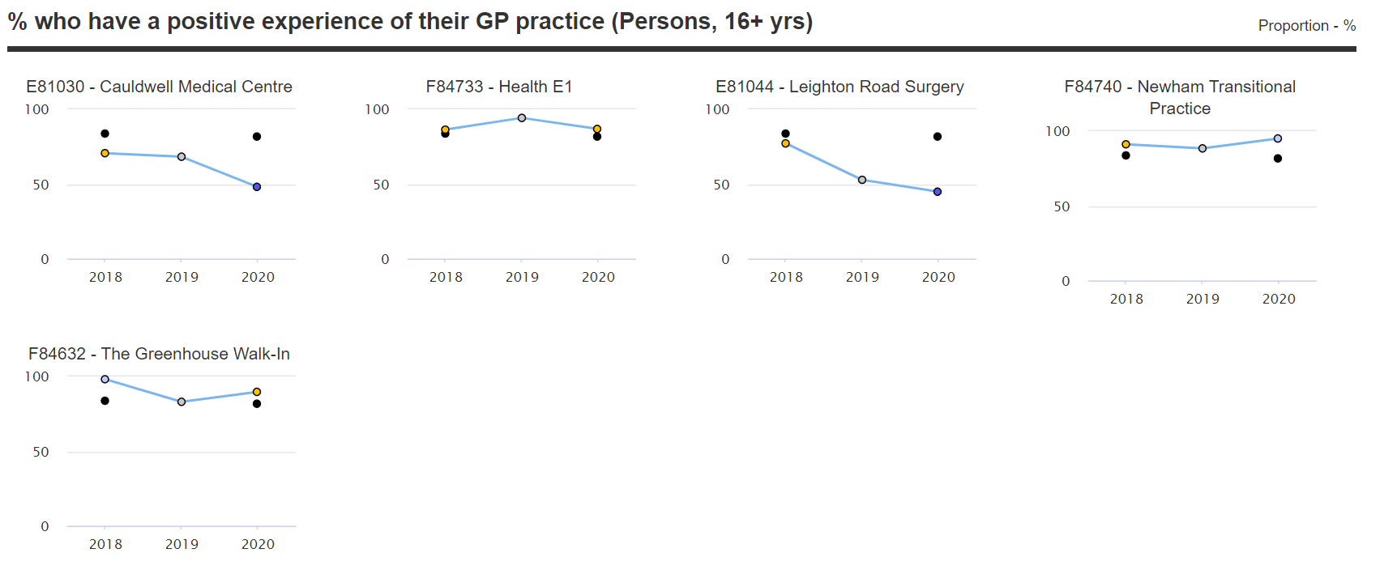
Disease prevalence
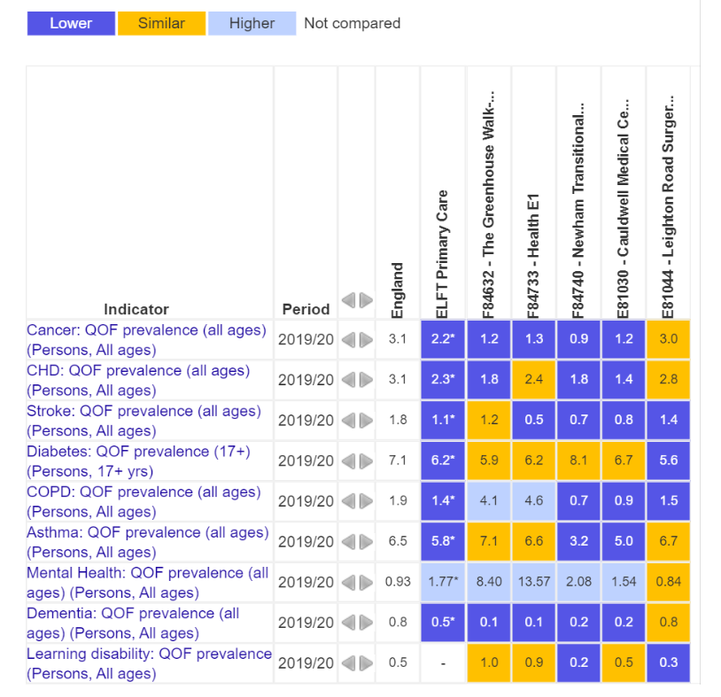

Cancer screening
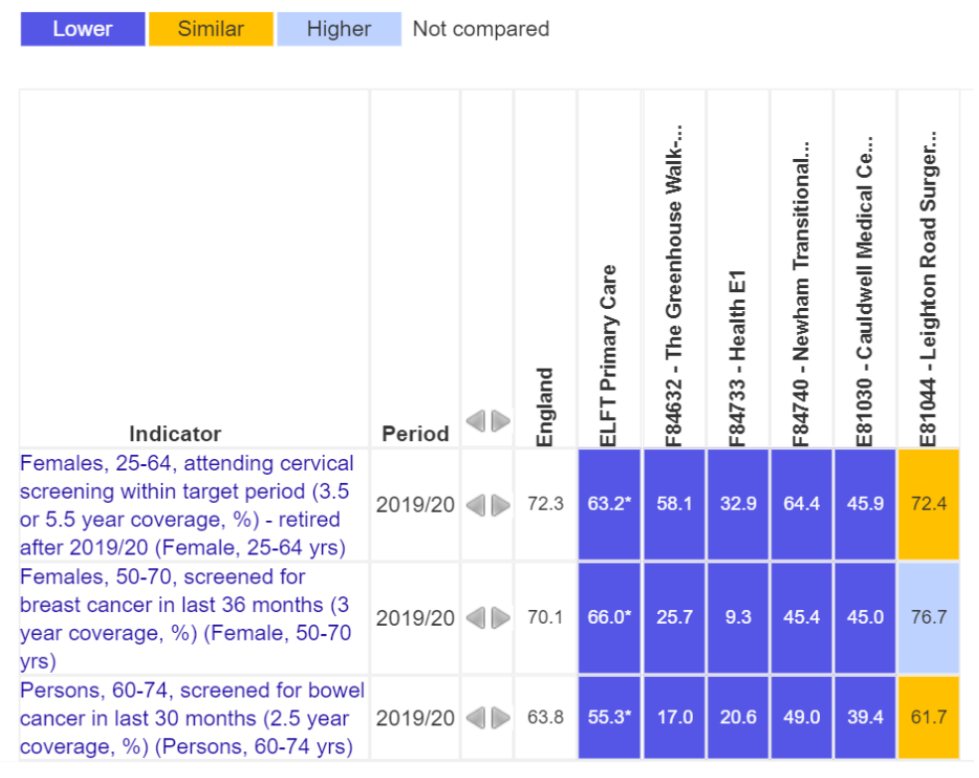
Physical health risk factors
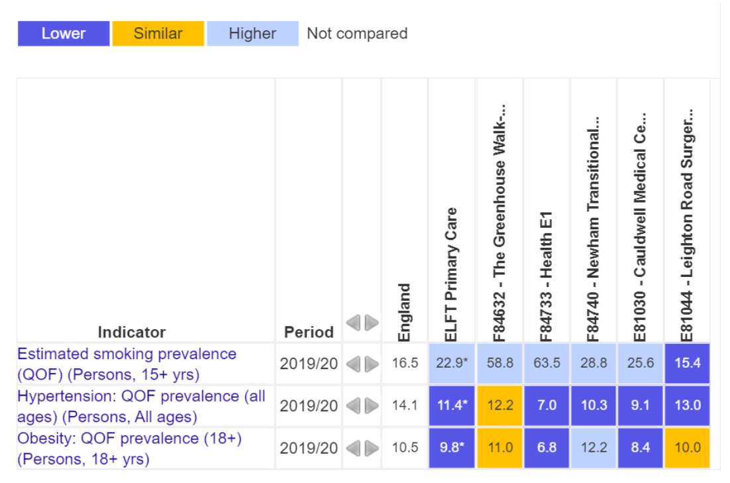

Flu vaccination
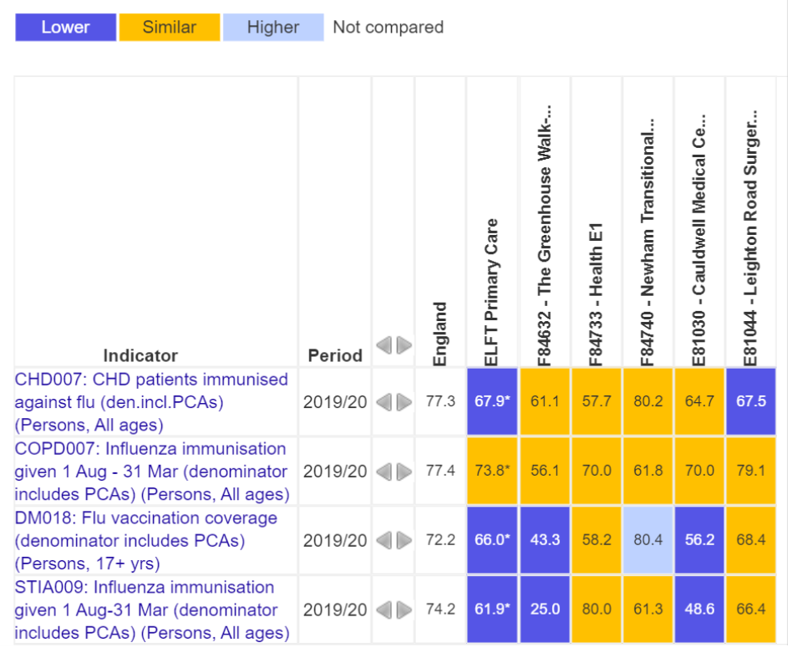
Care for people with mental health conditions
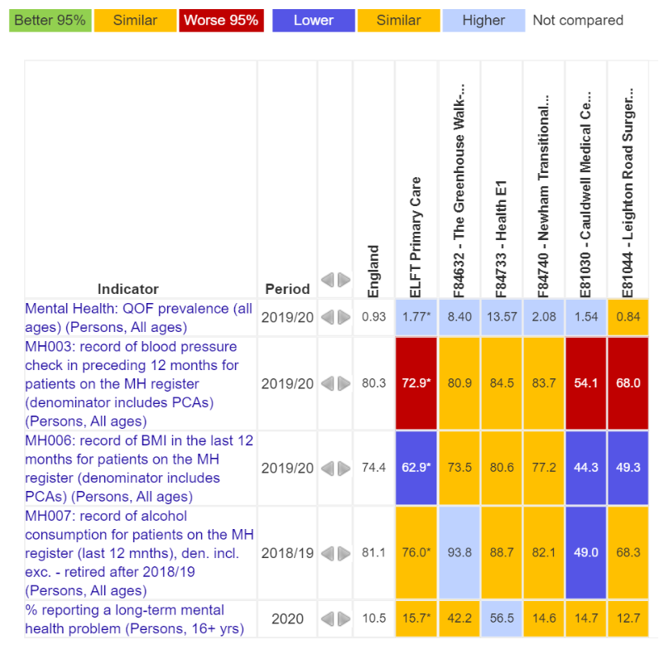

References
1 NHS England. NHS Long Term Plan. 2019. https://www.longtermplan.nhs.uk/online-version/overview-and-summary/ (accessed 28 May 2021).
2 Department of Health and Social Care. The Government’s 2021-22 mandate to NHS England and NHS Improvement. 2021. www.gov.uk/dhsc (accessed 28 May 2021).
3 NHS England & NHS Improvement. Integrating care: Next steps to building strong and effective integrated care systems across England. 2020.
4 Williams E, Buck D, Babalola G. What are health inequalities? | The King’s Fund. 2020.https://www.kingsfund.org.uk/publications/what-are-health-inequalities (accessed 7 May 2021).
5 Public Health England. Reducing health inequalities: system, scale and sustainability. 2017. www.facebook.com/PublicHealthEngland (accessed 26 May 2021).
6 Cookson R, Propper C, Asaria M, et al. Socio-Economic Inequalities in Health Care in England. Fisc Stud 2016;37:371–403. doi:10.1111/j.1475-5890.2016.12109
7 Nazroo JY, Falaschetti E, Pierce M, et al. Ethnic inequalities in access to and outcomes of healthcare: Analysis of the Health Survey for England. J Epidemiol Community Health 2009;63:1022–7. doi:10.1136/jech.2009.089409
8 Majeed A, Maile EJ, Bindman AB. The primary care response to COVID-19 in England’s National Health Service. J. R. Soc. Med. 2020;113:208–10. doi:10.1177/0141076820931452
9 RCGP. NHS pressures are not just about hospitals, says RCGP as GPs deliver record numbers of consultations. https://www.rcgp.org.uk/about-us/news/2021/may/nhs-pressures-are-not-just-about-hospitals.aspx (accessed 28 May 2021).

