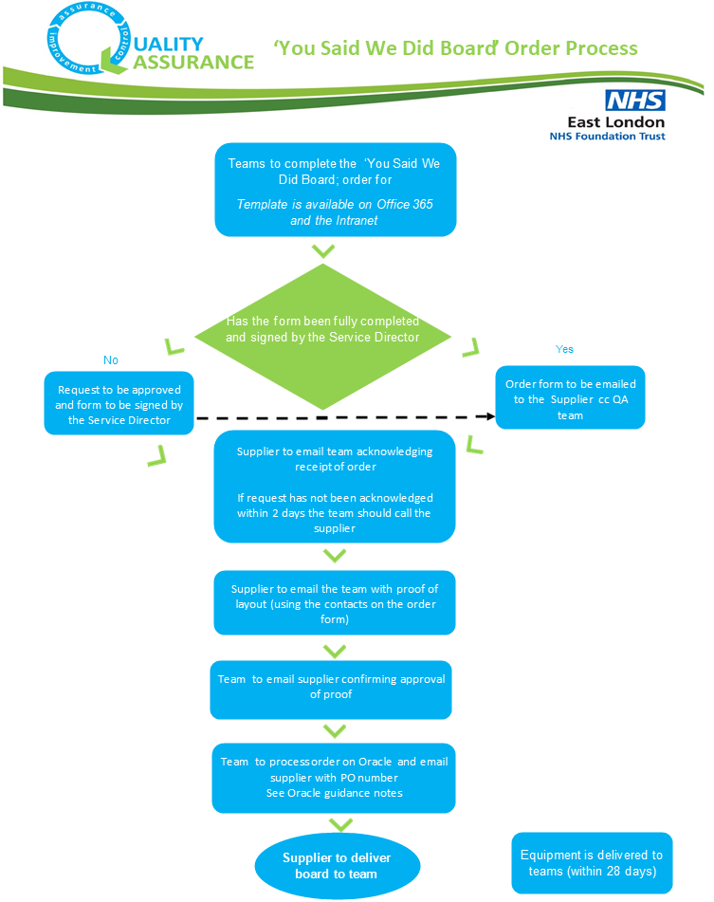

Further information:  Refer to additional guidance on processing request on Oracle  Order forms can be found on the Intranet or on Office 365  Any queries contact the supplier or the QA team elft.qa@nhs.net | Supplier  Dave Prudames  Streamline Your Print 07970833185  dave@streamlineyourprint.com

Ordering You Said We Did Boards via Invoice
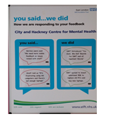

Step 1. Team to complete the ‘You Said We Did’ form.
https://nhs.sharepoint.com/:w:/r/sites/msteams_2ab901/_layouts/15/Doc.aspx?sourcedoc=%7BCE89FA62-0AA1-4CEA-B605-524DF3157399%7D&file=Template%20-%20Hardware%20Order%20Form%20YSWD%20-%20Nov%2019%20(1).docx&action=default&mobileredirect=true
Notes:
- Ensure that the Display name noted on the form is exactly how you want it to appear on the board
- Ensure that you state whether you want the board to be of portrait or landscape layout
- Please note the following sizes:
- 1200 x 900 mm (Portrait or landscape)
- 900 x 600 mm (Portrait or landscape)
- 450 x 320 mm (Landscape only)
- Copy of the request form is available on Office 365 and the Patient Experience Section of the intranet

Step 2. Once the form has been fully completed and signed off by the Service Director, the team should email the order direct to the Supplier (for processing) and cc the Quality Assurance team (for information only). See below for contact details
Supplier  Dave Prudames  Streamline Your Print  07970833185  dave@streamlineyourprint.com | Quality Assurance Team  Elft.qa@nhs.net
Step 3: Supplier to confirm receipt of request to the relevant contacts noted on the order from
Step 4: If no acknowledgement of receipt within 2 days, follow up with supplier by phone to confirm they have received the request
Step 5: Supplier to send through draft proof of the board via email to the team contacts
Step 6: Team to confirm approval of proof with Supplier via email
Step 7: Team to process order on Oracle (Refer to the guidance notes on processing the order on Oracle)
Step 8: Supplier to complete order and arrange delivery to the team
Step 9: Supplier to invoice Trust

Ordering You Said We Did Boards
Guidance for processing on Oracle

Step 1. Click on the shop tab on Oracle
Step 2. Click on non -catalogue request

Step 3. Complete the following:
- Select Goods or services billed by amount
- Complete the item description For example:1 x You Sai d We Did Board (Bedfordshire Wellbeing Service)
- Enter category (Use ZWI for Publicity Services)
Note: If ZWI Publicity Services is not set up under your budget code you will need to liaise with your relevant budget holder and accounts manager to open up the code or suggest an alternative
- Enter Quantity
- Enter unit price (refer to the order form for this)
- Enter the supplier name (Enter ‘Streamline your print’ (Welwyn Garden City)

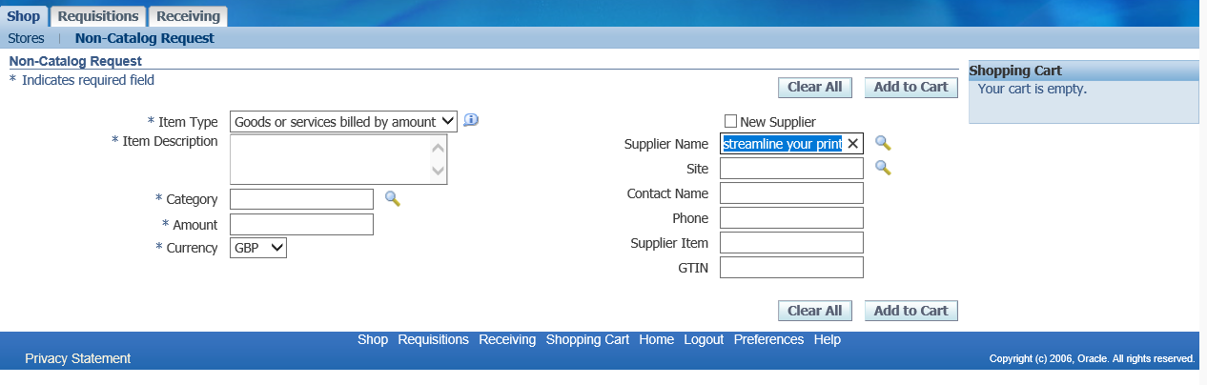
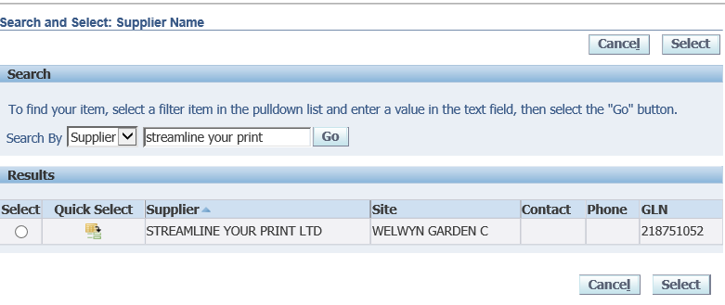
Step 4 .Enter Charge Account details
The charge account details includes the Budget code (cost centre) and subject category
Example: RWKN.0000.7251.0000.00000.000000

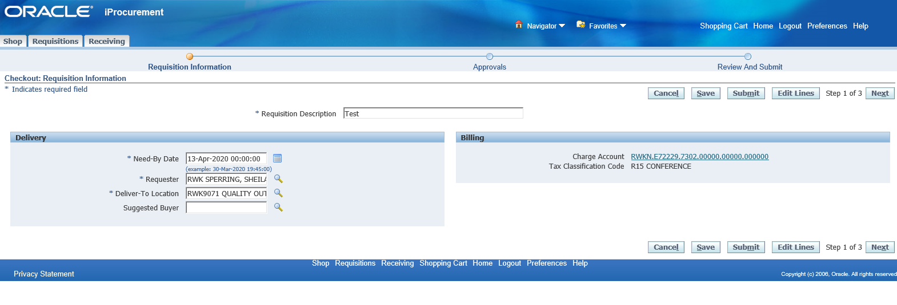

Note: If the subject category is not set up under your budget code you will need to liaise with your relevant budget holder and accounts manager to open up the code or suggest an alternative

Step 5. Upload relevant attachments
Ensure you upload the relevant attachments to Oracle to support the order. This must include a copy of the ‘You Said We Did’ Board order from.
Step 6. Submit the oracle request

