EMIS – Accessing Shared Data in Care Records / Templates
Purpose: This document provides guidance on how to access shared data in care records and clinical templates
If a patient has consented for health professionals involved in their care to access their (e.g. GP) record, this can be viewed by simply clicking on the ‘All Records’ icon highlighted below (which is visible in every tab of the Patient’s EMIS care record – there are a number of sharing agreements in place between WELC (Waltham Forest, East London and the City), Barts Health, ELFT and Newham / Tower Hamlets GPs – to view which organization’s record you can access, click on the plus sign in the ‘All Records’ field to expand:

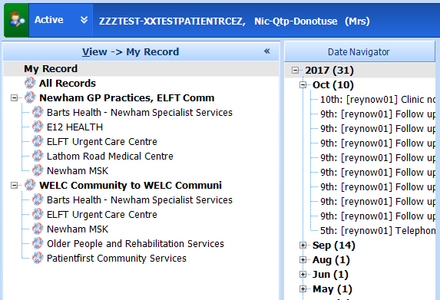

Shared record (external) entries can be identified by the blue / red arrow icon – local entries do not have an icon:

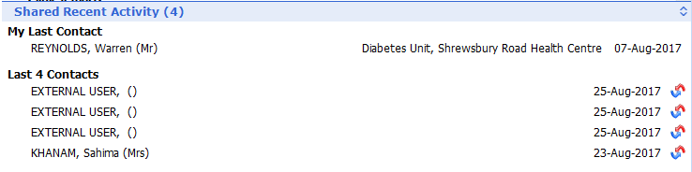

Shared record / external entry icon

When entering a consultation using a template in the Shared Record mode, previous entries by external providers are visible on the right-hand side of the template, again distinguished by the red / blue arrow icon:

