EMIS – Add/Delete a Warning (Risk)

Purpose

This document provides guidance on how to add or delete a warning on a patient’s EMIS record.

1. Adding a New warning to a patient’s EMIS record

Once you have accessed the patient’s EMIS record, click on the chevron to expand the patient’s Précis bar

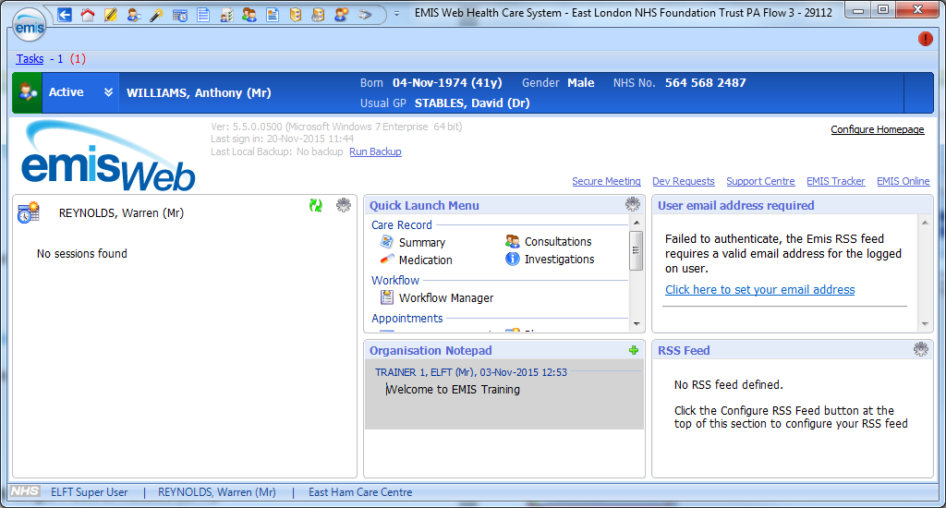

When expanded, click on the green ‘Manage’ button on the right-hand side of the Précis bar in the ‘Warnings’ section:
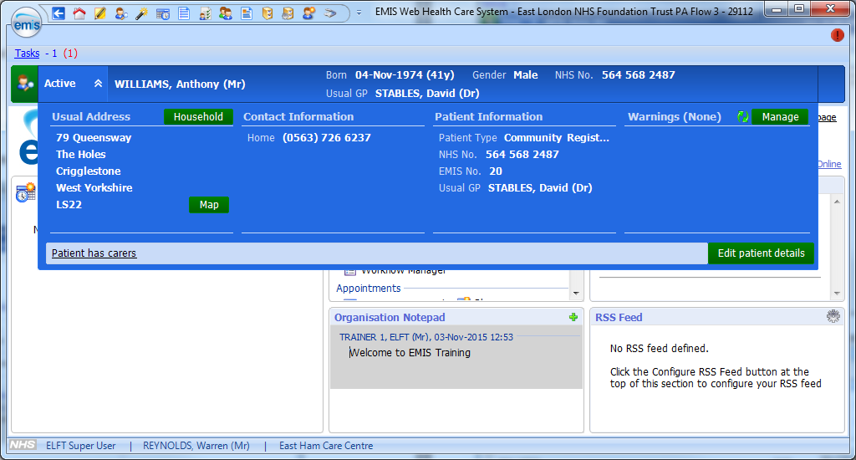

A ‘Manage Patient Warnings’ box will appear – click on the green & white ‘add’ icon:

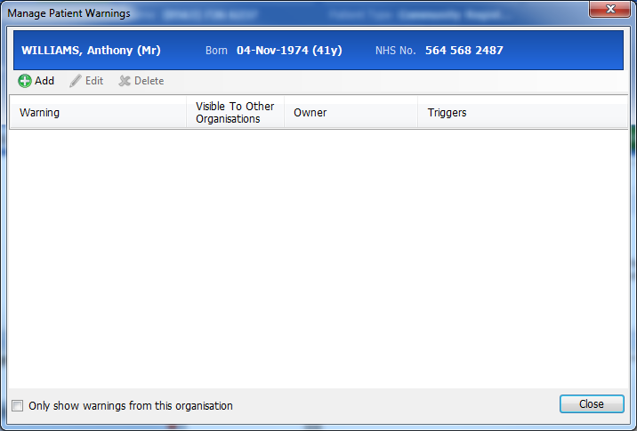

A ‘Add Patient Warning box will now appear – insert the type of warning required and when you want it to appear when navigating around the patient’s EMIS record e.g.:

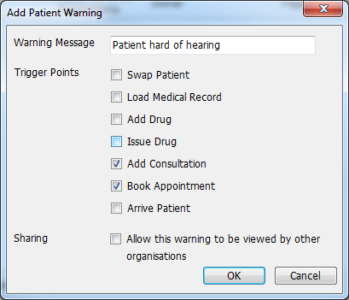

Click ‘ok’ – the following screen will appear outlining the warning details and the triggers chosen (when the warning will appear as you navigate the patient’s EMIS record):

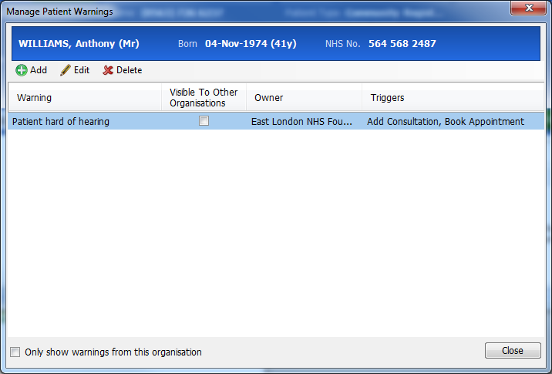

To add additional warnings, repeat the above steps as required.

You will now see the warning when you expand the patient’s Precis bar when you click on the chevron to expand:

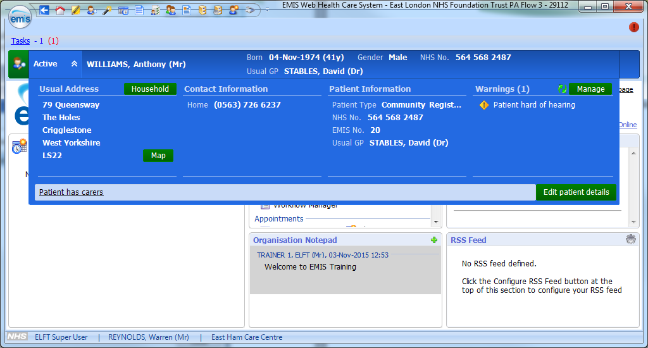

When you navigate to an area of the patient’s EMIS record you have chosen as a trigger to display the alert, the following warning box will appear:

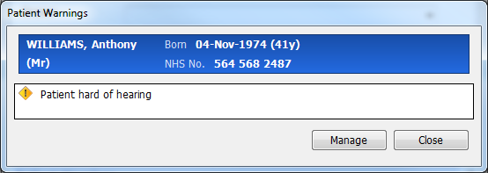

2. Deleting a warning in a patient’s EMIS record

If you wish to delete a warning from a patient’s EMIS record, Navigate to the patient’s Précis bar and click on the chevron to expand. When expanded, click on the green ‘Manage’ button on the right-hand side of the Précis bar in the ‘Warnings’ section:
:

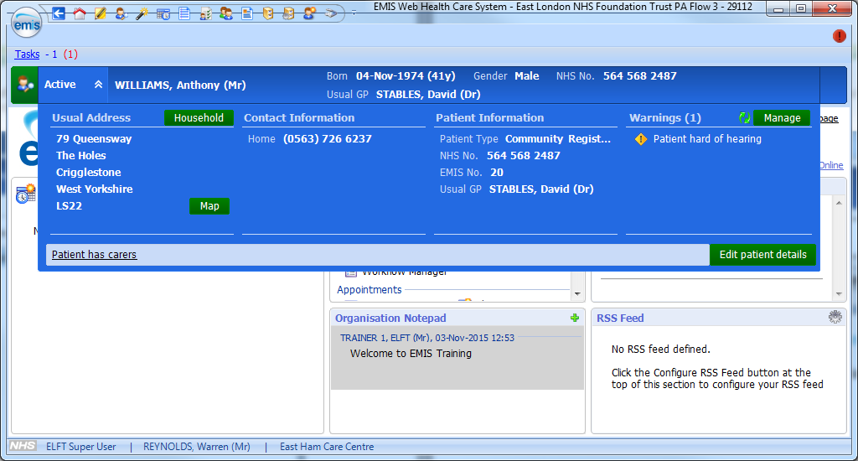

The ‘Manage Patient Warnings’ box will appear – select on the warning you wish to delete and click on the ‘Delete’ button:
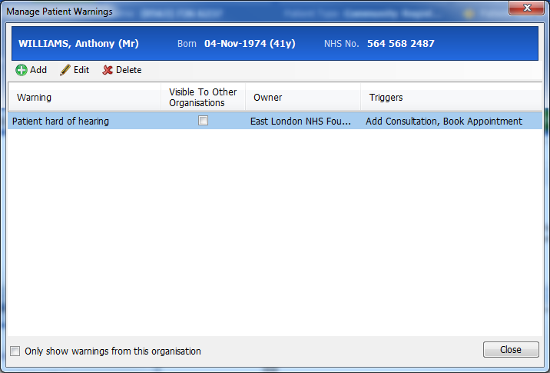

The following warning will appear – if you wish to proceed click ‘Yes’:

The ‘Manage Patient Warnings’ box will appear blank:

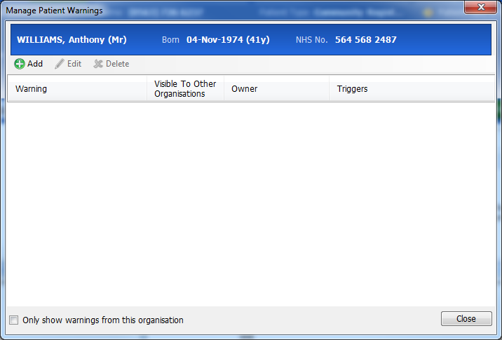

Viewing the patient’s Precis bar, the deleted warning will have been removed:
