EMIS – Adding Codes
Purpose: This document provides guidance on how to add a code on EMIS

When adding a code (for a value e.g. HbA1c IFFC Standardised) navigate to the ‘Add’ button on any tab of the Patient’s Care Record (except ‘Medication) – click on the lower half of the ‘Add’ button and select ‘Code’:

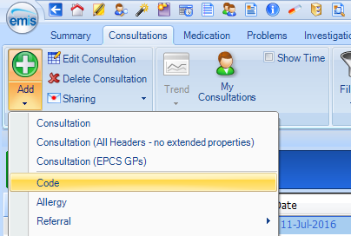

In the ‘Add a Code’ box search field, start typing the code you wish to choose – the codes will then automatically begin populating the results field beneath – select the code you require:

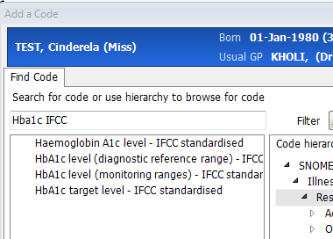

Select required code results
Text entered in search field

Enter the value in the appropriate field and ALWAYS ensure the date corresponds to the date of the test result:

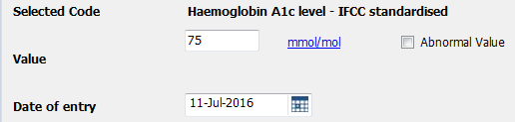

Date MUST correspond to date of test result
Enter value

When adding a code with a value e.g. a test result, these will appear in the ‘Investigations tab of the Patient’s care record

