EMIS – Assigning a Key Worker

Purpose: This document provides guidance on how to assign a key worker

Find your referral and highlight:
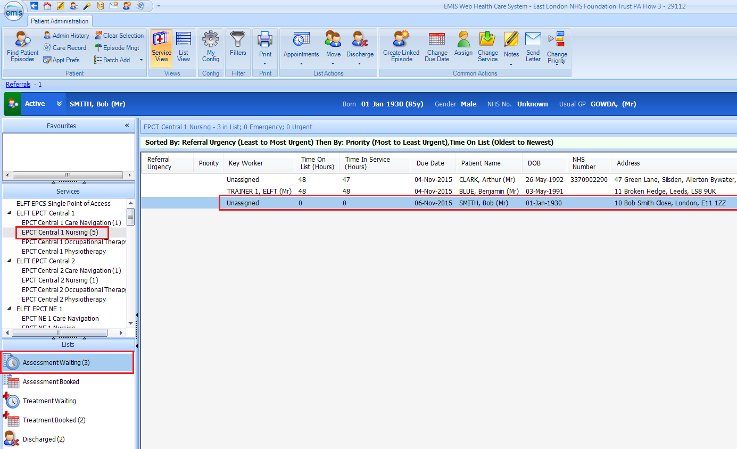

Click on Assign:
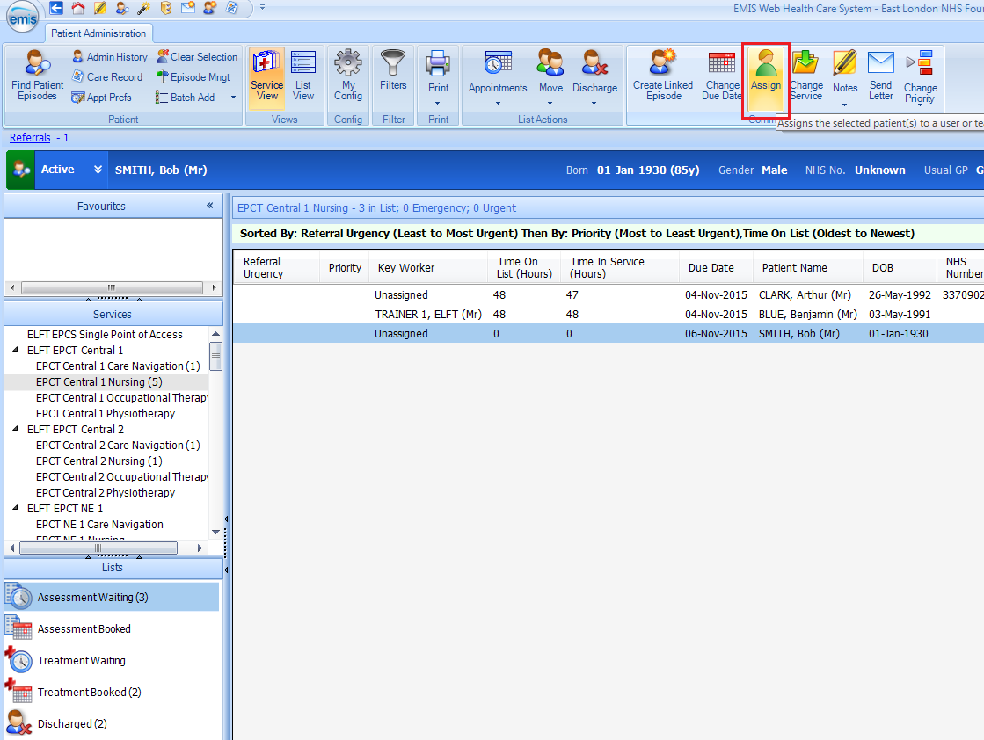

Select the Key Worker’s name who has been assigned and click on OK:
