EMIS – Booking Treatment Schedule

Purpose: This document provides guidance on how book a Treatment Schedule in EMIS.

Click on the Appointments icon on the ribbon (when in Patient Administration) and select ‘Book Treatment Schedule’ - the Add Patient Schedule box appears:

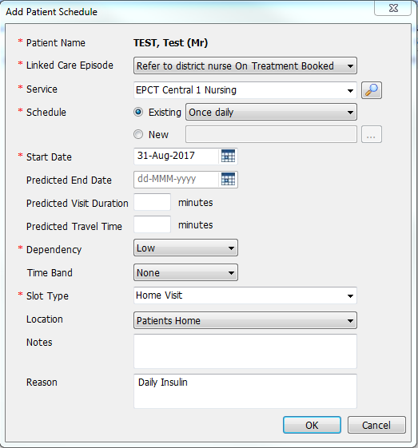
- Linked Care Episode - will default to appropriate episode in Patient Administration
- Service - Relevant service should be selected
- Schedule – If schedule does not require an end date, appropriate should be selected (change start date where applicable)

*If schedule requires an end date please follow guidance below*

- Dependency – The correct dependency should be selected
- Slot Type should be selected as appropriate (Home Visit, Gym, Class etc.)
- Location should be selected as appropriate (Patients Home, Clinic, etc.)
- Reason – enter reason for visits, class etc.)

If Patient Schedule requires an end date:

In the ‘Schedule’ section of the ‘Add Patient Schedule’ screen select ‘New’ and click on the button:

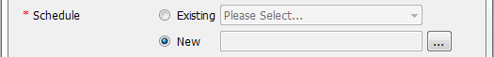

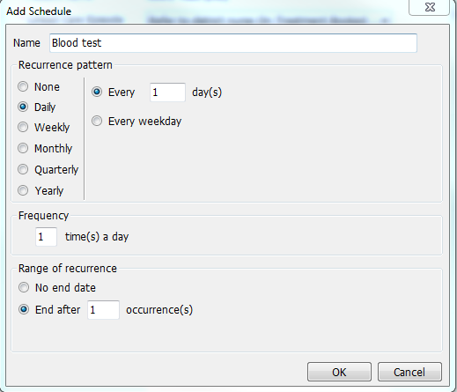
- Name – Add reason / schedule name
- Recurrence pattern – select ‘Daily’ enter ‘1’ in the days field
- Range of recurrence –

Click on OK

The patient will now appear on the Assignment List

