EMIS – Booking an Appointment

Purpose: This document provides guidance on how to book a patient appointment in EMIS.

Find your patient and highlight - click on Appointments and select Book Assessment or Book Treatment Appointment (WHEN IN Assessment booked or Treatment Waiting):
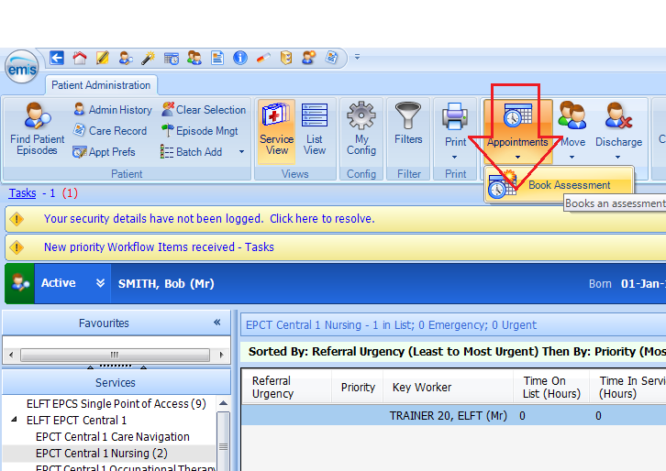

Finding the appointment slot:
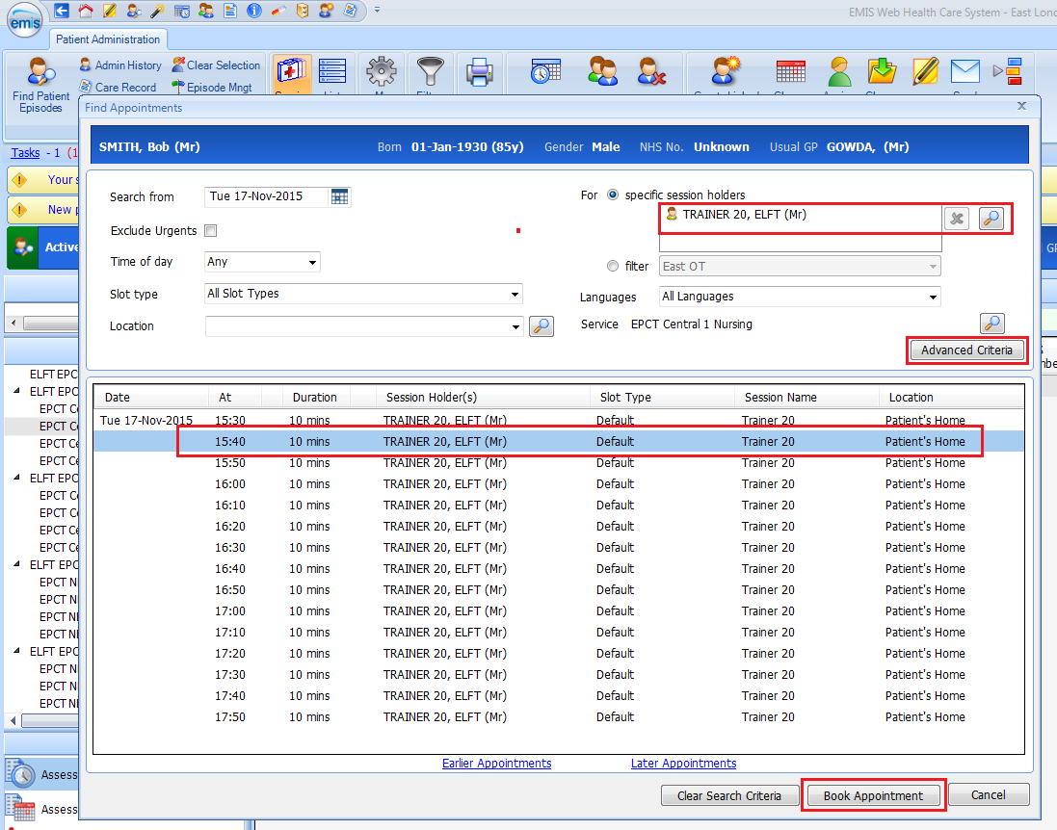
*Note:

- Select the relevant session holder’s name or select relevant filter if required
- Find and select appointment slot
- Click on Book Appointment

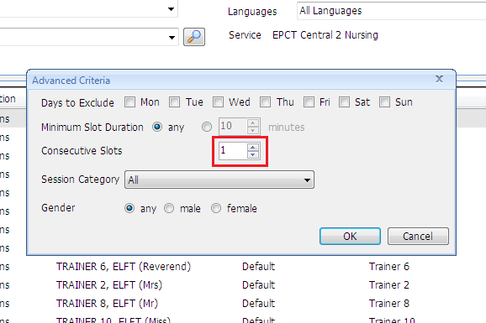
*Note:

To extend the appointment slot time, click on Advanced Criteria (see above) and increase the number of Consecutive Slots (see adjacent screen shot) ie 2 slots. This will show you a double appointment slots.

Once appointment slot has been selected (as above), change slot to type and click on Book:
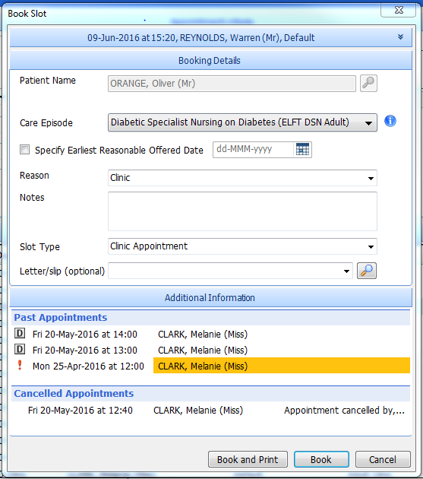

Enter a reason or notes where applicable
Print letter if applicable – click on magnifying glass to find letter

