EMIS – Changing Services

Purpose: This document provides guidance on how to move a referral between service lists in Patient Administration

When a referral has been received and added to one service list (e.g. ELFT Physio) and upon triage it is established a different intervention is required (e.g. Pain Management) you can do the following to move the referral to the appropriate service:

With the referral sitting in the Under Discussion list, navigate to the ribbon and click on the ‘Change Service’ icon:

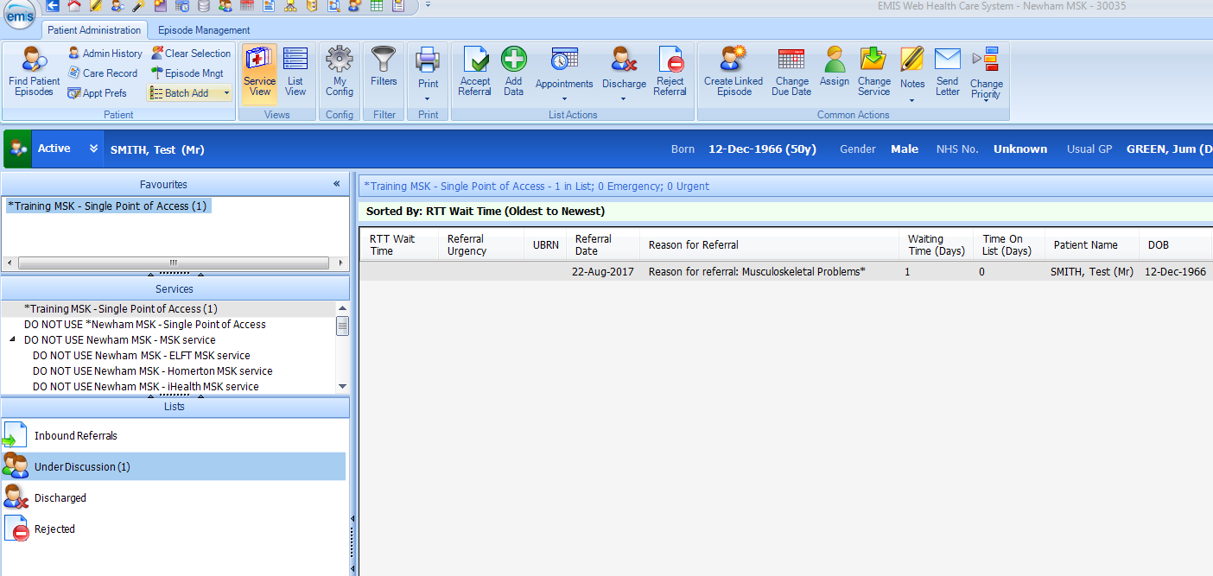
Change Service icon

Select the appropriate service and list (e.g. Under Discussion) and press ‘OK’:

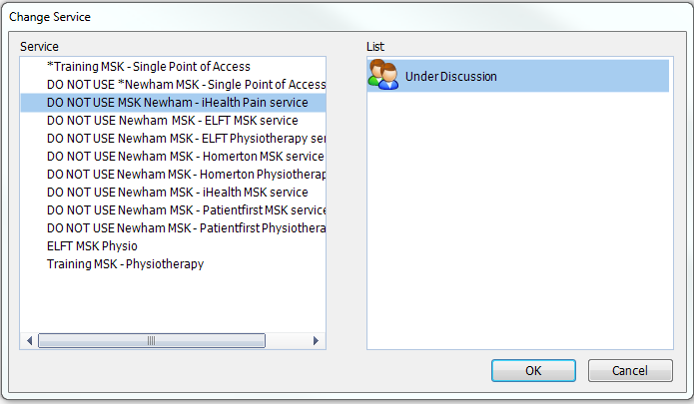

If a patient is already on a service’s caseload but requires their care to be switched to another discipline (not as a new referral) users can simply change the patient’s referral to another service and list in the same way:

