EMIS – Creating Letters
Purpose

This document provides guidance on how to create letters.

1. Creating a Letter

Once you have accessed the patient’s EMIS record and navigated to the Document tab, click on the lower part of the ‘Add’ button on the far left of the ribbon and click on ‘Create Letter’ option (you can navigate to this via any tab in the Care Record, except ‘Medication’):

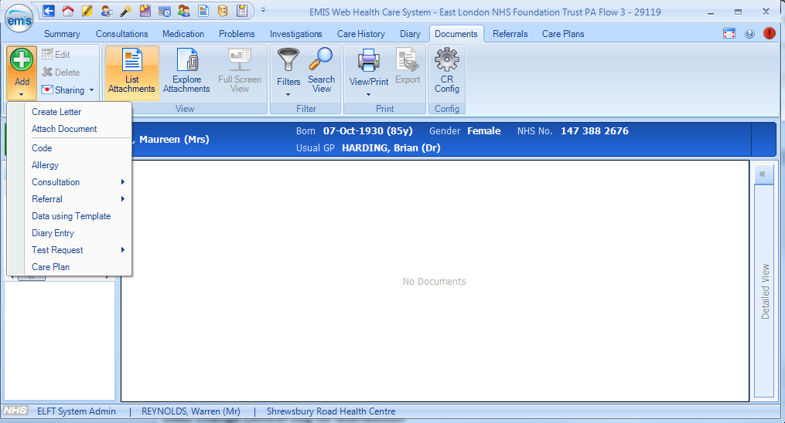

After selecting ‘Create Letter’ a New Patient Letter box will appear (please note this may not be populated with any template options if you have not created a letter before) to search for the template you require, click on the magnifying glass in the bottom-right hand corner:

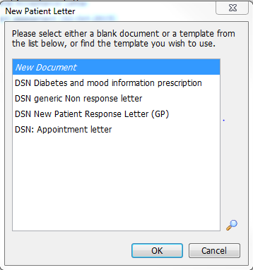

A ‘Find Document Templates’ box will appear – click on your Services folder below the ELFT Community Hierarchy list to view template options – select the template you wish to use:

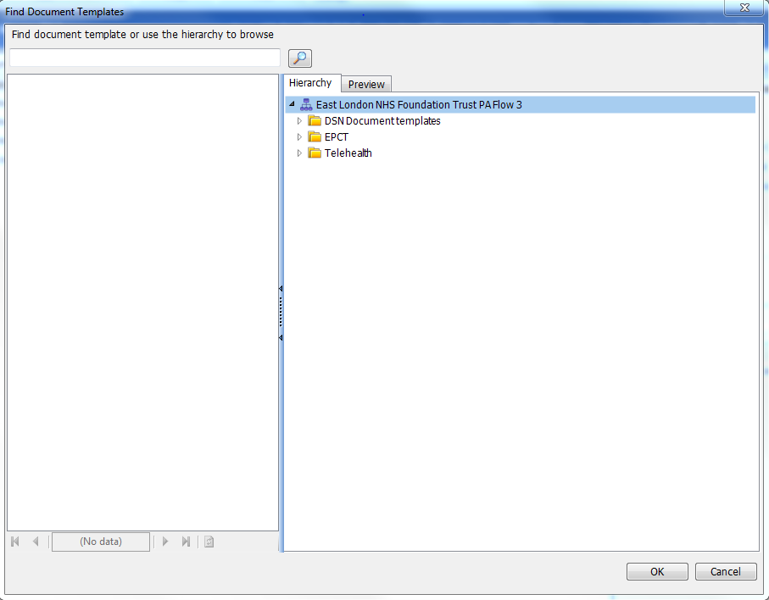
Click to expand service folder and choose template

The chosen template will now appear – enter details accordingly:

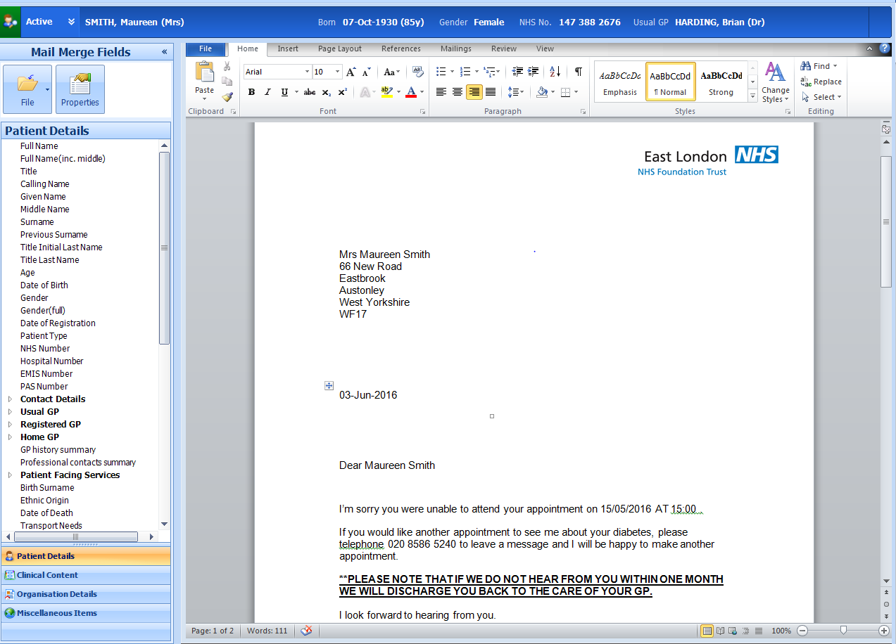

When completed, select the ‘File’ icon on the top left-hand side and select ‘Save and Close’

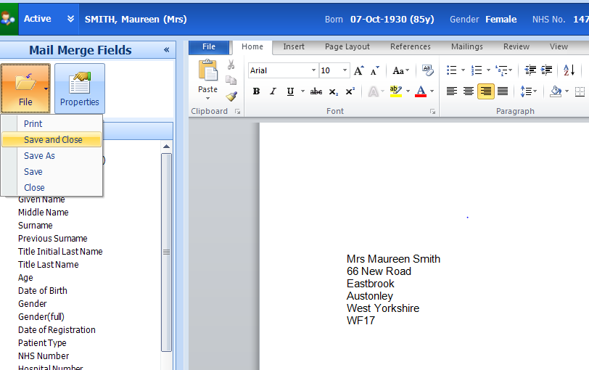

You will be returned to the ‘Documents’ tab of the Care Record where the new document will be listed:

