EMIS – Creating Linked Episodes

Purpose: This document provides guidance on how to create linked episodes on EMIS

If a patient has an active Episode of Care on a team’s caseload (e.g. DSN Adults) but requires intervention from another team (e.g. Education) a linked episode can be created AS LONG AS THE SOURCE OF REFERRAL IS THE SAME.

Find the Patient’s Episode of Care via the Patient Administration module and select:
Find Patient Episode

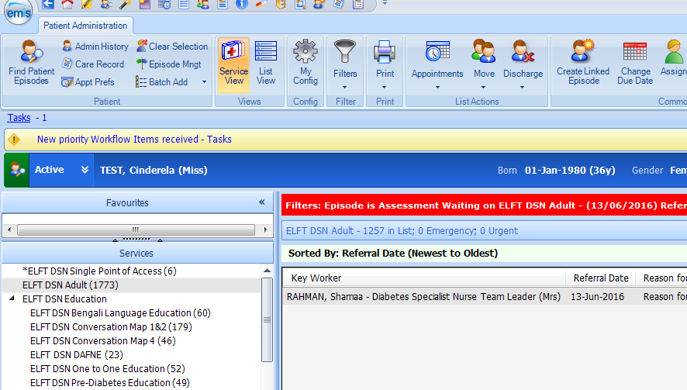
‘Create Linked Episode’ icon

Current team
Existing Episode of Care / Referral

On the ribbon click on the ‘Create Linked Episode’ icon (see above). When the ‘New Linked Episode’ screen appears, select the team you want to link the Episode to from the ‘Service’ drop-down menu and select the ‘List’ (e.g. Assessment Waiting, Assessment Booked) you want the Episode of Care to be placed in:
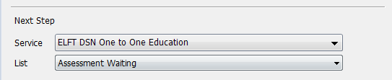

The linked episode has now been created and the patient has two active episodes of care on the team’s respective caseloads:

