EMIS – Discharging a Patient

Purpose: This document provides guidance on how to discharge a patient in EMIS.

Access Patient Administration:
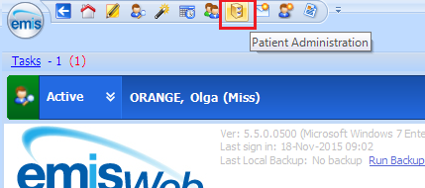

Find patient and highlight referral, click on Discharge and select Discharge to Discharged:
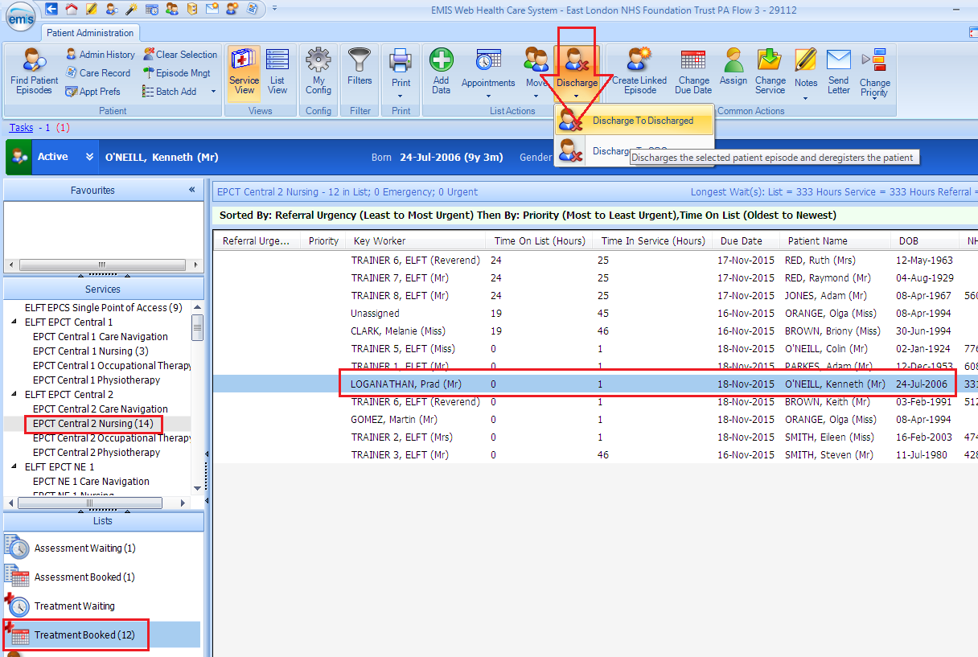

The Discharge Referral box appears:
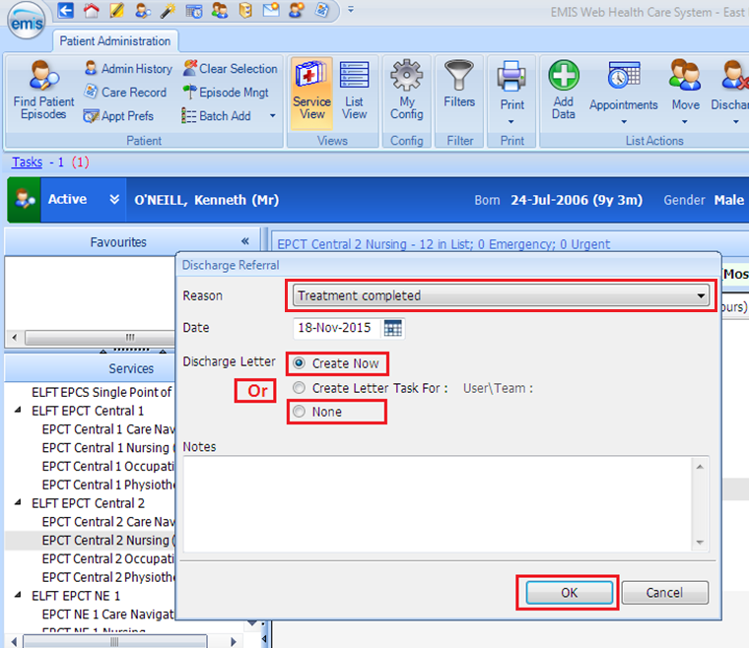
*Note:

- Select Reason for discharge
- Discharge Letter – select either Create Now or NONE
Click on OK

Read the message and select Yes for Discharge Confirmation, if you are happy to discharge:
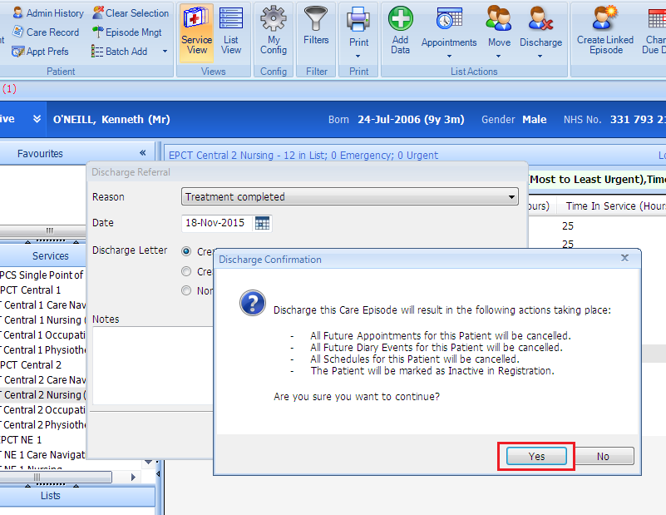

Click on the magnifying glass and select appropriate discharge letter template and click on OK:
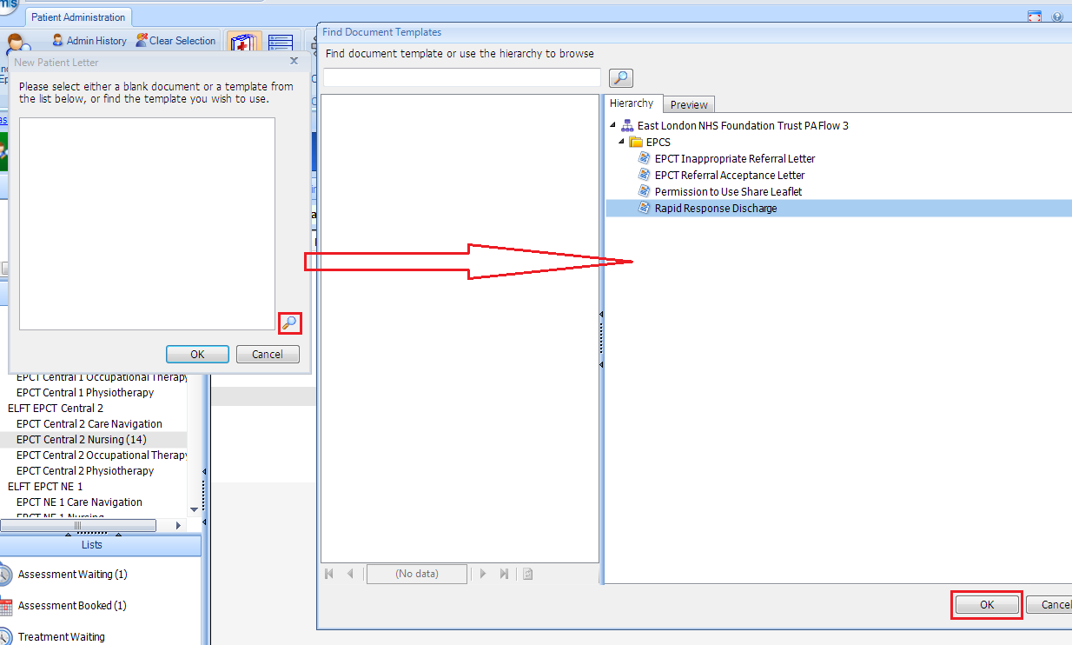

Once discharge letter is complete you can edit the discharge letter if required, click on File and select Close and Complete:
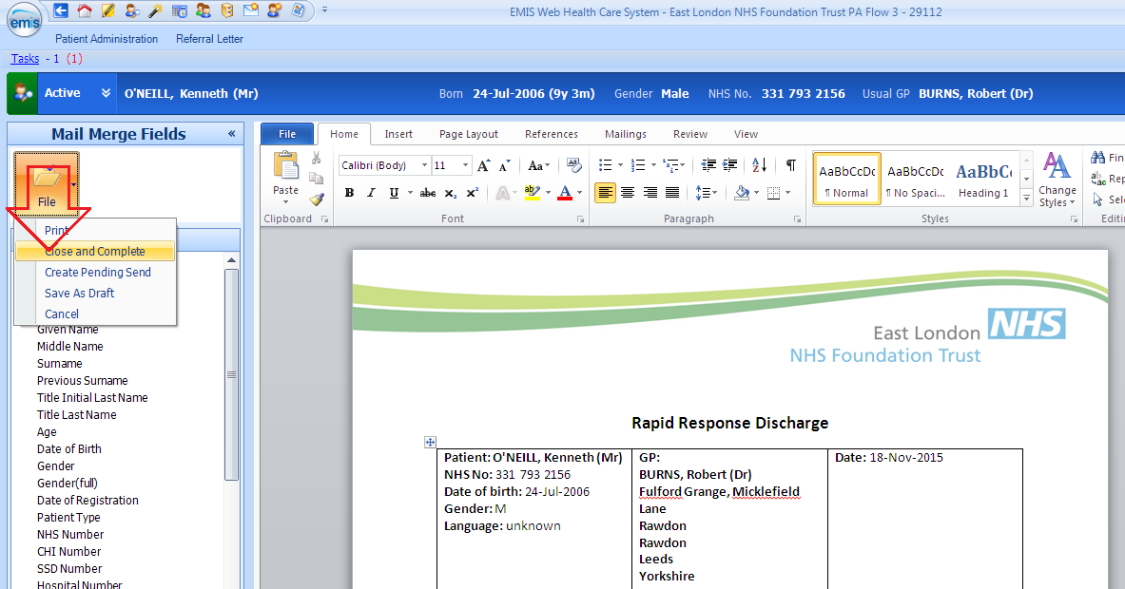

Confirmation of the discharge can be seen by clicking on Discharged under Lists: