EMIS EPCT Risk Algorithm
Purpose

This document provides guidance on how to use the Risk Algorithm during the triage process.

1. Configuration

Click on the F12 key – a Protocol Launcher field will appear on the right-hand side of the screen. Right-click in row A and select ‘add:

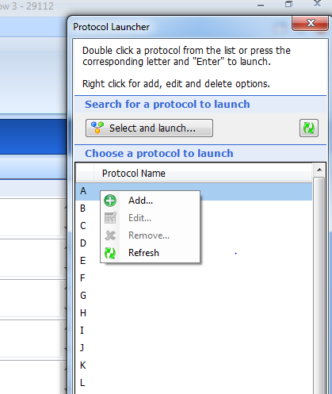

A ‘Protocol Picker’ box appears – in the search field type ‘Lone’ and press the magnifying glass – the ‘EPCT Lone Working Risk Assessment will populate the search results box. Double-click to select:

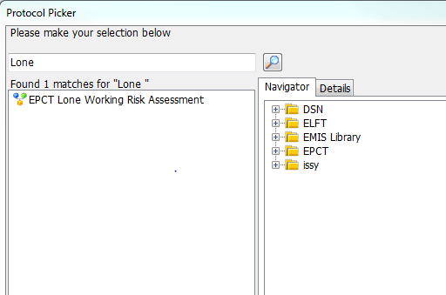

The ‘EPCT Lone Working Risk Assessment’ protocol now populates row A of the protocol launcher. You will only have to Configure the protocol once:

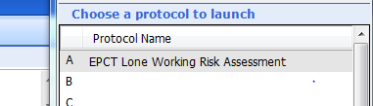

2. Using the F12 Risk Algorithm

When you have triaged an incoming referral and accepted for the service, press F12 to launch the Protocol Launcher and double-click on Row A ‘EPCT Lone Working Risk Assessment’:

A series of prompts will appear on the screen – depending on the information provided on the referral regarding any patient-related or environmental risks, select yes or No accordingly e.g.

No identifiable risk from information on referral

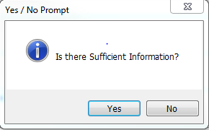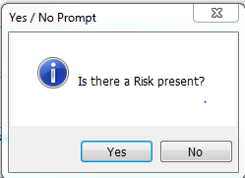

Risk identified from information on referral

The Risk Assessment Template will automatically launch to enable staff to record details of the risk identified. Once completed save template :

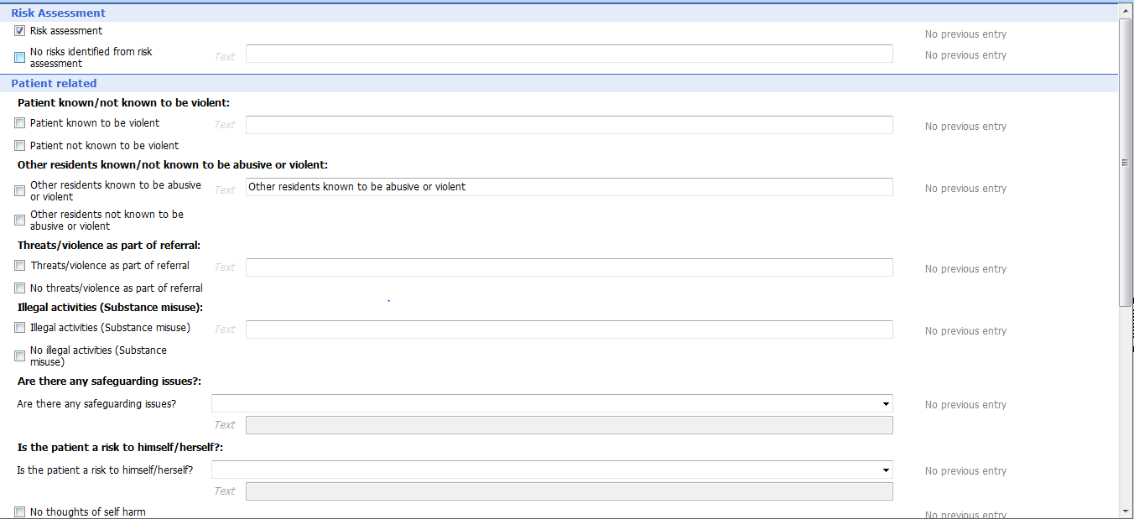

The following prompt will appear:

Following consultation with clinical lead, select the appropriate answer:

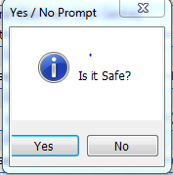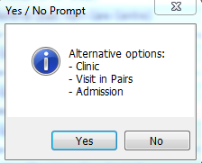

Insufficient Information on Referral:

