EMIS – Find Patient Episodes
Purpose: This document provides guidance on how to find patient episodes of care in EMIS

- To see if a patient has an active referral (episode of care) on EMIS, Navigate to the Patient Administration module and click on the ‘Find Patient Episode’ icon on the ribbon:
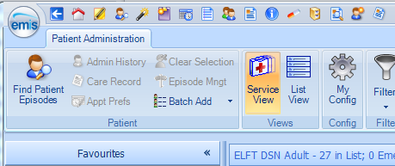
Patient Administration icon
Find Patient Episodes icon

- Enter patient search details and Press ‘OK’

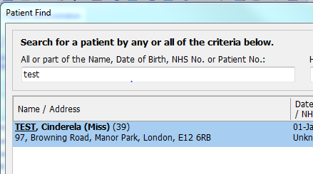
- All active and discharged patient Episodes of Care will populate the ‘Select Patient Episode’ box. To view a particular episode of care, click on it and press the ‘Go to List’ button – a filter will be applied and you will be taken to the selected teams caseload to view the referral:
