EMIS – Linking Consultations to the Episode of Care
Purpose: This document provides guidance on how to link consultations to Episodes of Care on EMIS when adding a consultation directly into patient record and not outcoming from the diary

- From Consultations click on Save to save your consultation to the patient record
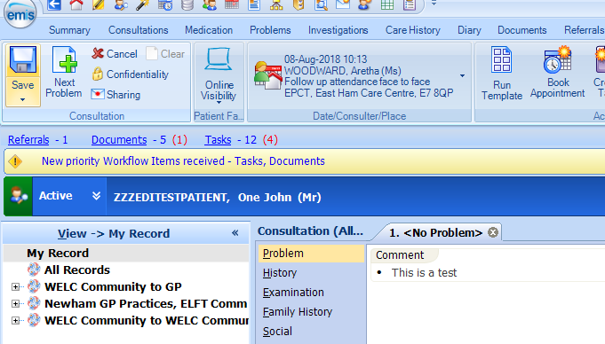

B. Click on the correct ‘Episode of Care’ under Active episodes that your consultation is to be linked to. (This will be the service that you work for), then click OK

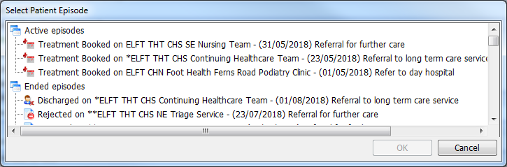

C. Complete the ‘Care Contact’ and click OK.
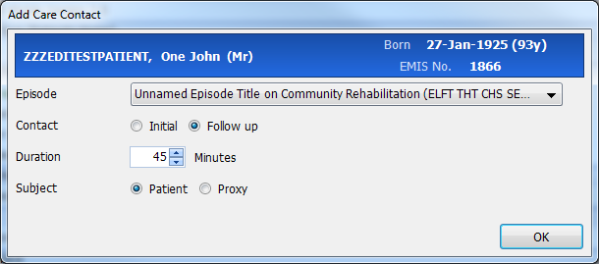

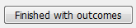
D. Click on Finished with outcomes to finish.

