EMIS MOBILE USER GUIDE

Table of Contents

Log on to EMIS Mobile
- Launch EMIS Mobile App
- The EMIS Mobile Login screen is displayed
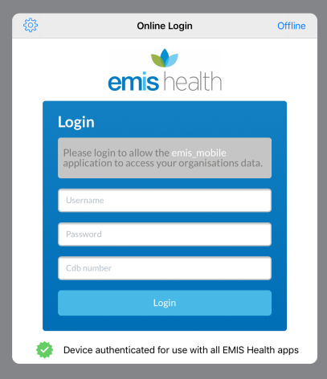
- In the Username field, type your EMIS Web Username.
- In the Password field, type your EMIS Web Password.
- In the CDB number field, type your CDB number = 25362
- Tap Login.

Synchronise Data in EMIS Mobile

- When you login, the list of patients in your diary will be displayed in the Appointment screen.
- If the list is not there, tap in the top right hand corner.
- The ‘Synchronise Data’ screen is displayed.

Viewing Patient Demographics
- In the Appointment List page you can access your patient’s information and records. Select the next to the patient’s name will show you the patient’s information.
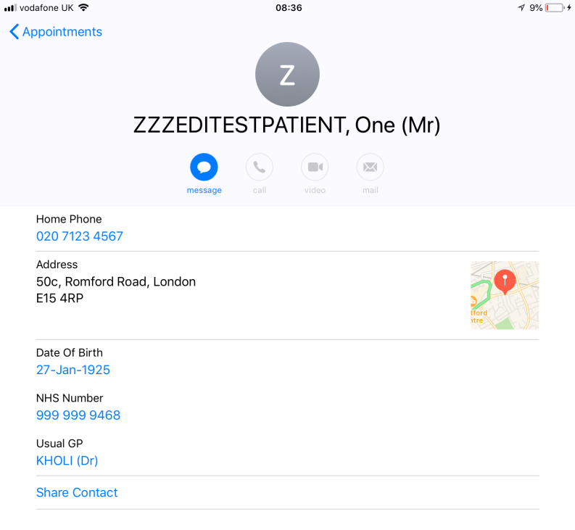

Accessing Shared Records
- In the Appointment List, select the patients name which will take you to the Summary Page. Select the and follow the instructions on the screen to view the patient’s shared records.
- Any Shared records will have this icon by the entry

Add a Consultation

- In the Appointment Screen, tap on a patient name to go to the patient Summary Screen.

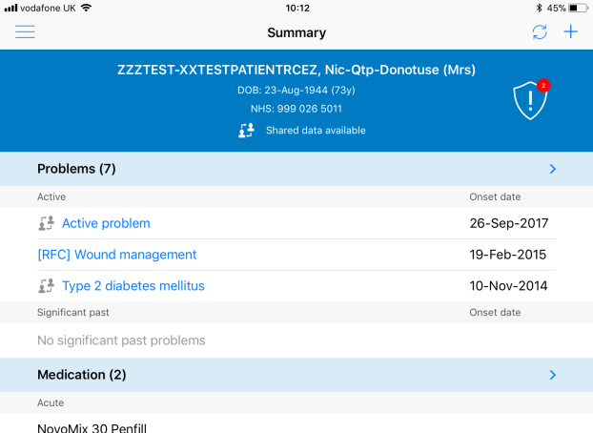

- In the Summary Screen tap on the top right hand corner.
- The Select Option Screen opens.
- Tap on ‘Add Consultation’. The Add Consultation Screen is displayed.
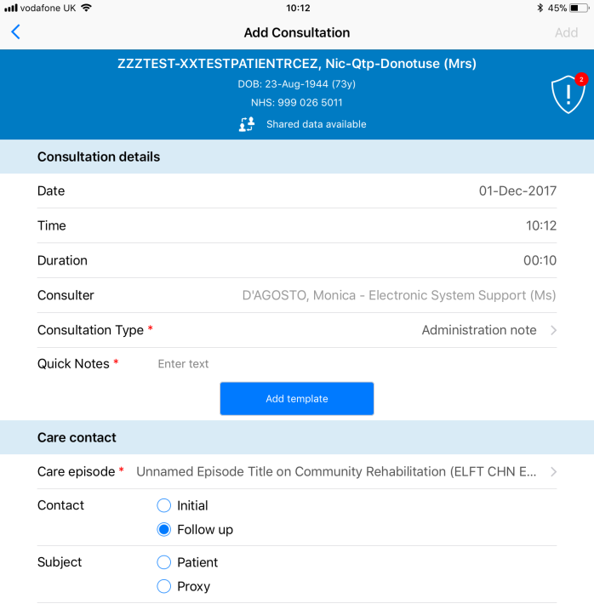
- Select a ‘Consultation Type’ and tap on ‘Add Template’ and select one template from the list.
- The template screen is displayed.
- Scroll down and enter the relevant information, once done, tap on ‘Done’ on the top right hand corner.
- Tap ‘Add’ on the top right hand corner.
- Synchronise the consultation on the top right hand corner

Voice Recognition
- Tap on the 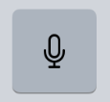 voice recognition key when the keyboard is displayed and dictated the text.
- To end the dictation, tap on at the bottom of the screen.

Delete a Pending Consultation
- To delete a consultation tap on the top left corner
- Tap on ‘Summary’
- The consultation can be found in the ‘Pending’ sections.
- With your finger, swipe the consultation on the left hand side and tap on the delete button.
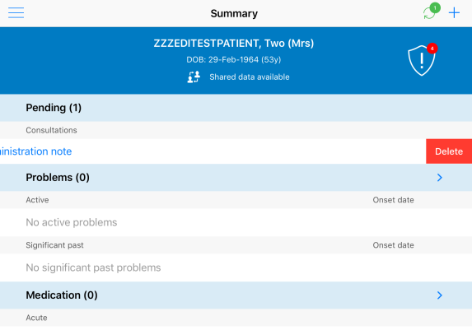

Return to Appointment List
- To return to the ‘Appointment List’ tap and select ‘Appointment List’.

Booking a one-off Appointment from the Ipad

- To book an appointment for your patient, select the patient you want to book an appointment for (from your appointment list or pulled through as an Unplanned patitent) then select the and press Book Appointment.

- Fill in the range of the dates you would like to see available appointments for.
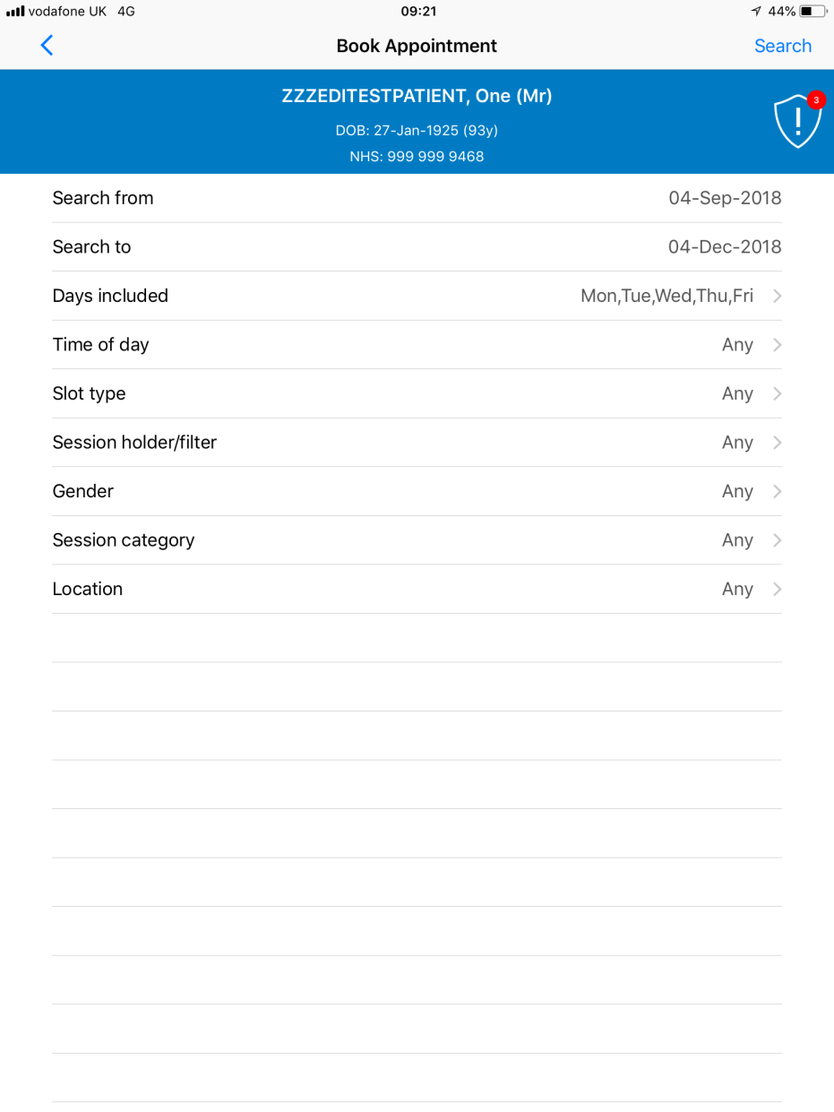

- Then seach for your name in the Session holder/filter, select your name and press Search.

- Pick a time solt from the available slots.

- Fill in the Care Episode, making sure you pick the correct one for your service, then press Book.

- When the appointment is booked, a confermation box will appear. Sync the ipad to update EMIS web.

