EMIS – Move to Under Discussion
Purpose

This document provides guidance on moving inbound referrals to Under Discussion on EMIS.

Select the required Service’s Single Point of Access and Inbound Referrals

Select patient’s referral from list and click on Move to Under Discussion:
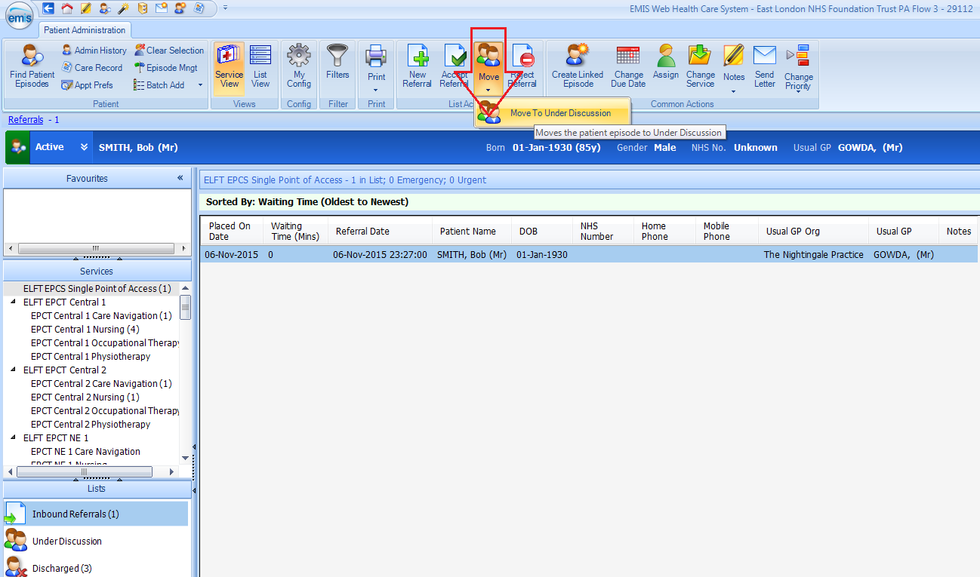

Click on Under Discussion, select patient’s referral and click on Add Data:
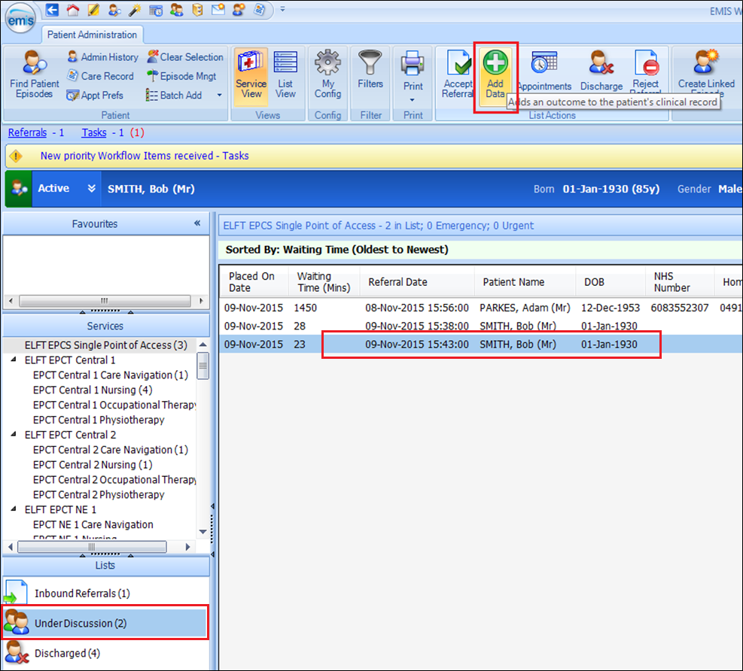

Enter Consultation Date and Time, select appropriate Location and Consultation Type (you MUST select a Consultation type):
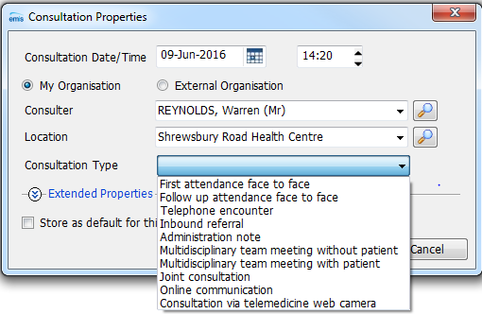
Click on OK

Select Service:
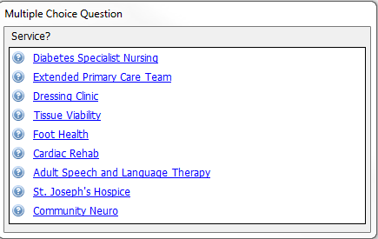

Select template:
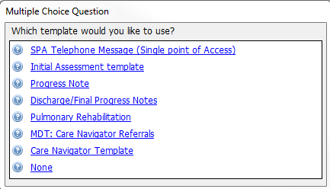

Complete Template where appropriate and Save Template:

Remember to save your Consultation
Click on Save:
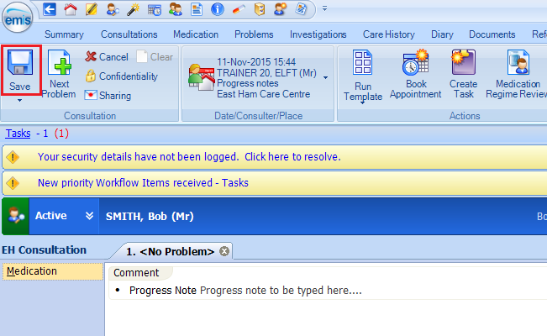

The ‘Add Care Contact’ box appears:
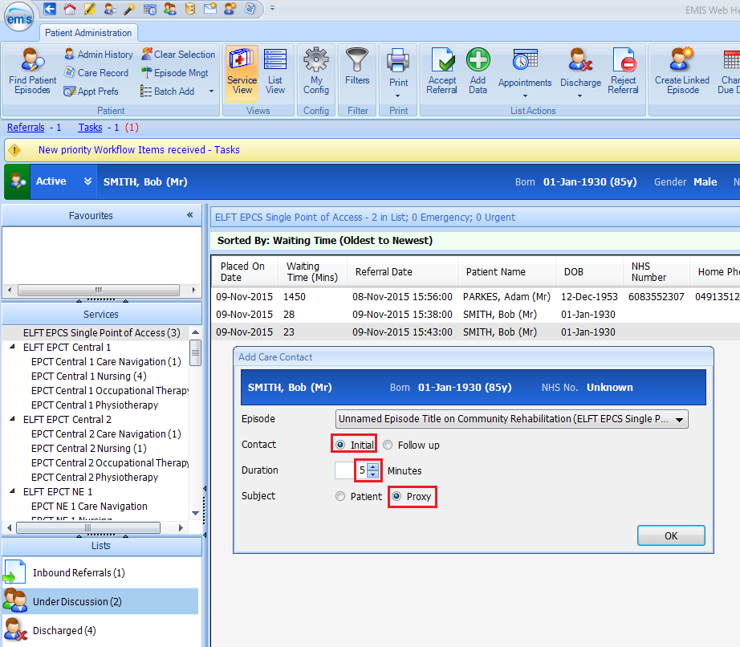
*Note:

- Contact should be Initial or Follow up
- Enter Duration
- Subject Select Patient or Proxy (patient is not present at this stage)

Click on OK

Click on your next action or Finished with outcomes:
