**EMIS – Outcome an Appointment**

**Purpose: This document provides guidance on how to outcome an appointment in EMIS**.

Access the **Appointment book**:

The appointment you created should now be visible on your appointment book:

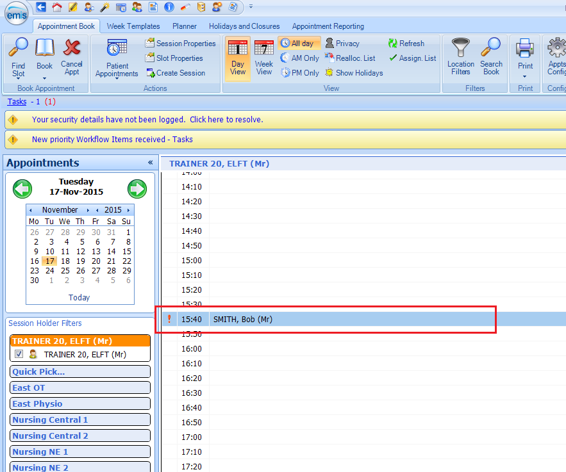

For Clinic appointments, press **A** for patient arrived, **S** for send in and **L** for left.







For home visits, click on the appointment and press **V** if patient was visited and seen or press **N** if patient was not in.



Consultation box appears:

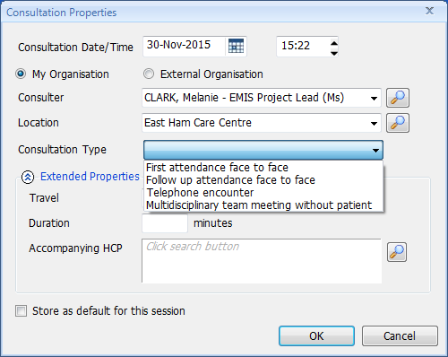

Enter duration

*Note

**Extended Properties may or may not be visible depending on your set-up**

*Note:

**Consultation Date/Time** **MUST** be **ACTUAL** visit Date/Time

Complete all relevant fields. You **MUST** enter a consultation type. Click on **OK**

Select the Service and the select template you require - click on **OK**:

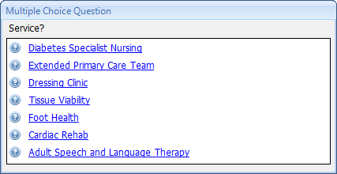

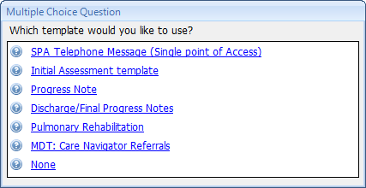

Complete template and save. If required add Medication. Remember to save Consultation.

Click on **Save**:

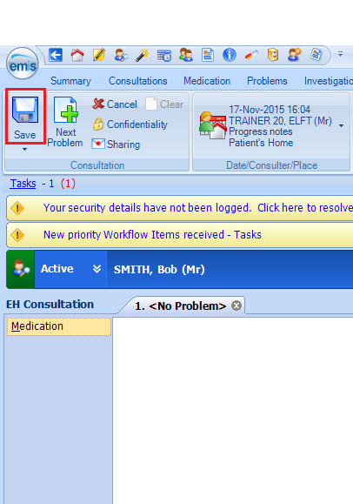

If this box appears, it is important to select the correct patient episode and click on **OK**:

Please **NEVER** click cancel or select the wrong referral. *This could lead to inaccurate reporting.*

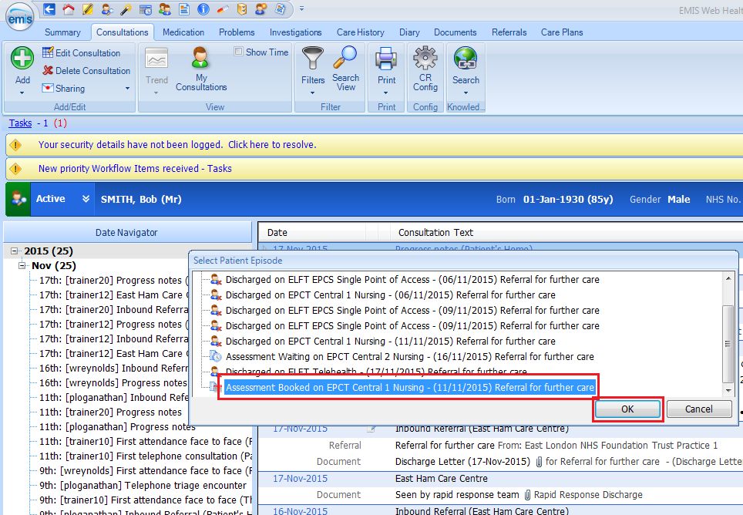

The **Add Care Contact** box appears:

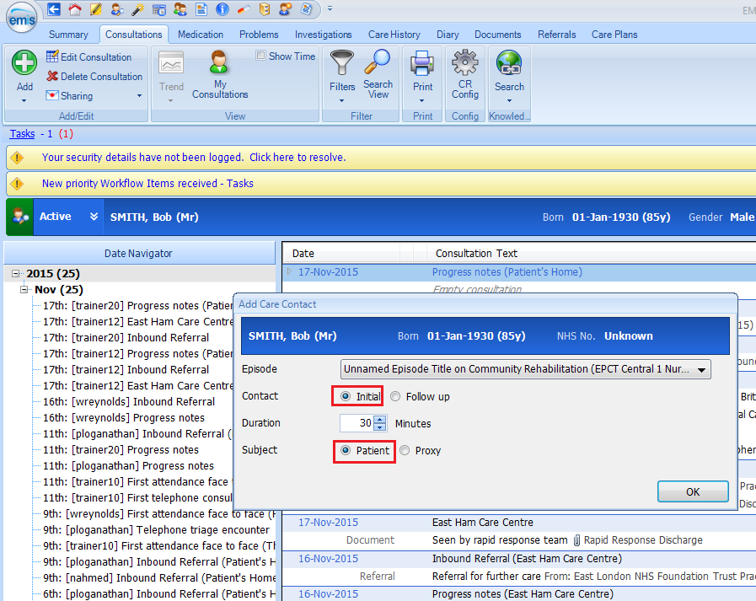

*Note:

* **Contac**t should be **Initial or Follow up**
* **Subject** should be **Patient**

Click on **OK**

**If required select an action from the list or Finish with Outcomes:**

