EMIS Receiving Managed Referrals

Purpose: This document provides guidance on how to receive a referral EMIS to EMIS

Managed referrals enables sites to send referrals electronically between primary care and community care organisations, as well as community care to community care organisations. Managed referrals enables sites to send referrals electronically between EMIS Web organisations that have services configured to accept referrals.

- It is important to remember that you won’t receive a notification when a managed referral is received. Therefore, please ensure you have a policy in place to check Patient Administration – Inbound Referrals routinely.

- In Patient Administration, the Referral Type column will allow you to identify if the referral is Written, Verbal or Managed. If the referral is Managed, the GP will have completed most of the fields, and the patient will have been automatically added onto your system.

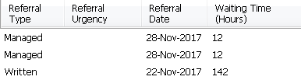
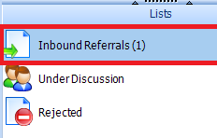

- Please follow your services triaging protocol .

- Please note however, before accepting the referral, you may want to check they have the correct referral letter(s) in their records. To do this, highlight the referral and go to Documents:

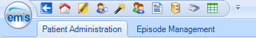

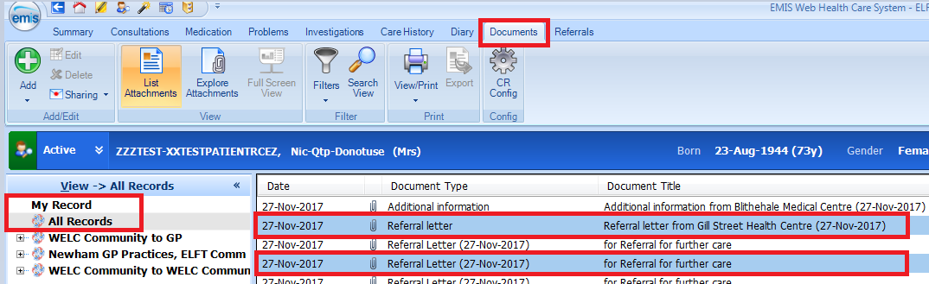

- Click on All Records to view the GP’s referral letter and any other documents. You can double click to open and view the contents of the letter.

- To accept that referral, highlight it and click Accept on your ribbon.
(Please note you will be unable to Edit a Managed referral)

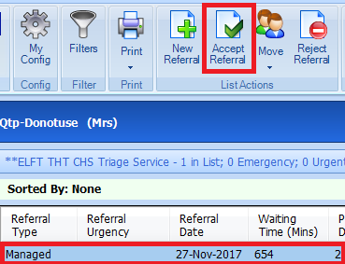

- The Inbound Referral window will then pop up and ask you to complete any fields that the sending location were unable to complete. This is also your chance to make sure they have completed the rest of the form correctly.

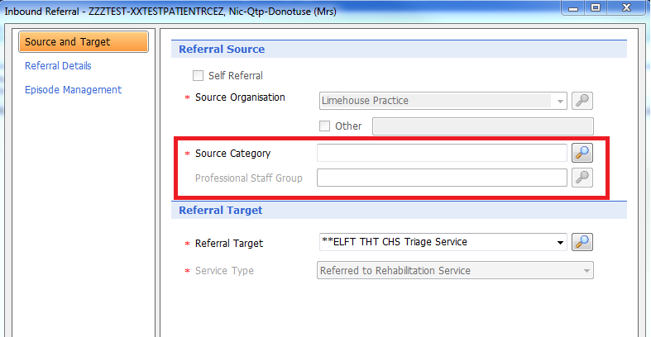

- Please review and check any relevant fields. You will also be required to enter a Reason for Referral.
Please note that the GP’s Reason for Referral will appear under Comments.

- Once you have finished your checks, press OK, select the target service and press OK.

