EMIS – Removing Duplicate Referrals

Purpose: This document provides guidance on how to find and remove duplicate referrals on EMIS.

- To generate a list of identified duplicate referrals please access the ‘Reporting Services’ icon on the desktop, select the appropriate team and run the report

- Once the report has been generated, navigate to ‘Patient Administration’ on EMIS, click on ‘Find Patient episode’ and enter the patient’s EMIS number:

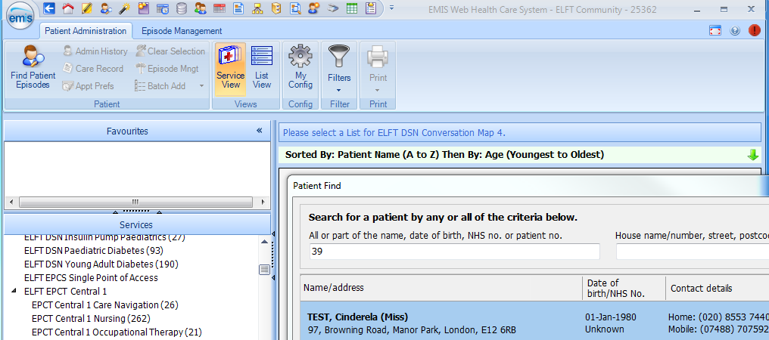
Enter patient’s EMIS number
Click on find Patient Episode

- The ‘Select Patient Episode’ screen will appear – scroll through until you’re able to identify the duplicate referrals:

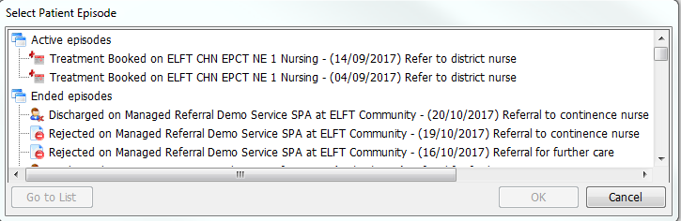

- Select any of the referrals and click on ‘’Go to List’:

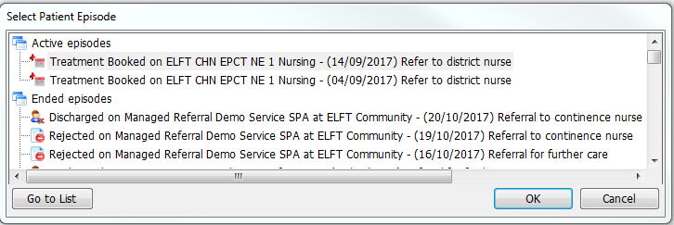

- A filter will be applied, only showing the referral you selected – As both episodes of care are currently on the ‘Treatment Booked’ service list, the easiest way identify which episode of care has a schedule attached to it is move one referral to ‘Treatment Waiting’ or another service list, depending on where the referral is sitting – this will allow you to distinguish between which episode of care to keep, and which to discharge

- Select the patient referral and, navigating to the ribbon, click on the ‘Move’ icon and select ‘Move to treatment Waiting:

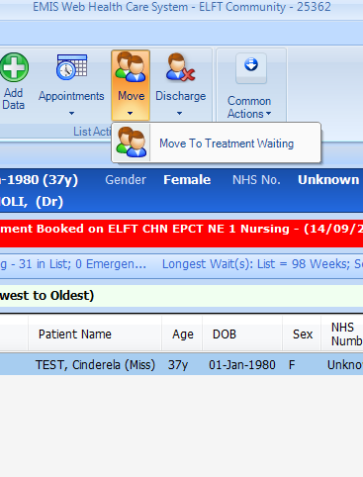

- Click on the Service’s Treatment Waiting list (as the filter is still applied, the only patient visible will be the one you’re looking for:

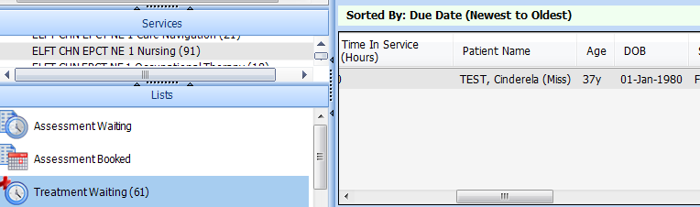

- right click on the referral and select ‘Appointment Details’:

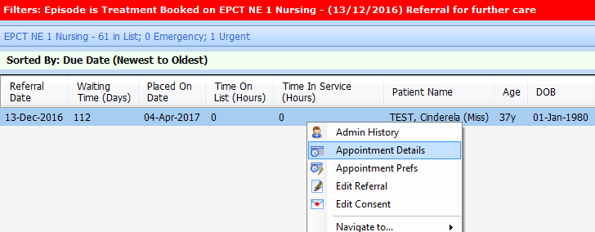

- In the ‘Patient Appointments’ screen select the Patient Schedules tab then click on the schedule and select ‘Edit Schedule’:

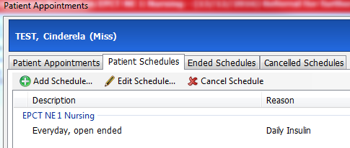
2. Select Patient Schedule
3. Select Edit Schedule
1. Click on Patient Schedule tab

- In the ‘Edit Patient Schedule’ click on the ‘Linked Care Episode’ drop-down menu – you will notice one of the care episodes in highlighted blue – this indicates the schedule is linked to the episode of care currently sitting in the service’s ‘Treatment Booked list:

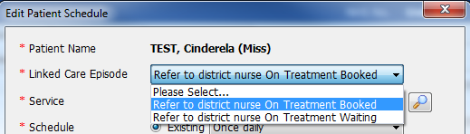

This confirms the duplicate referral that should be discharged is the episode of care currently sitting in ‘Treatment Waiting’ as the schedule is linked to the referral in ‘Treatment Booked’ (Please remember the episode of care could be sitting in other service lists, what is important is to establish which episode of care the Patient Schedule is linked to)

- Now we have established which episode of care is not linked to the Patient Schedule, we can navigate back to it in order to discharge it as a duplicate referral. Select ‘Go to List’ as before and complete the discharge process with the reason ‘Patient already on Caseload’ (remembering to select ‘None’ to avoid creating a discharge letter):

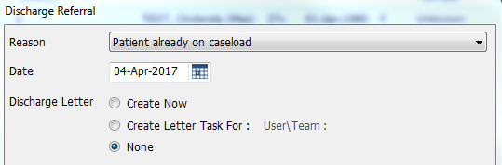

- To double-check the Patient Schedule is still in place, go through the ‘Find Patient Episode’ process and review the Patient Schedule tab:

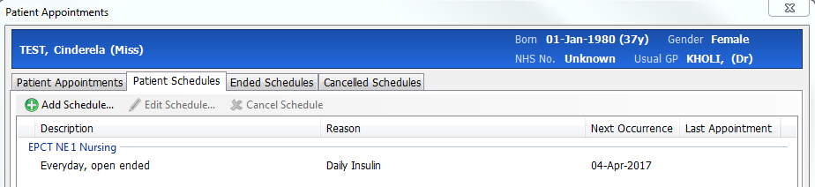

Patient Schedule still in place – duplicate referral removed

