EMIS – User Configuration

Purpose

This document enables users to personalise the EMIS Home Page and other configurable features

Configuring the Homepage link

Click on the Configure Homepage link (top right) will open the Configure Homepage window

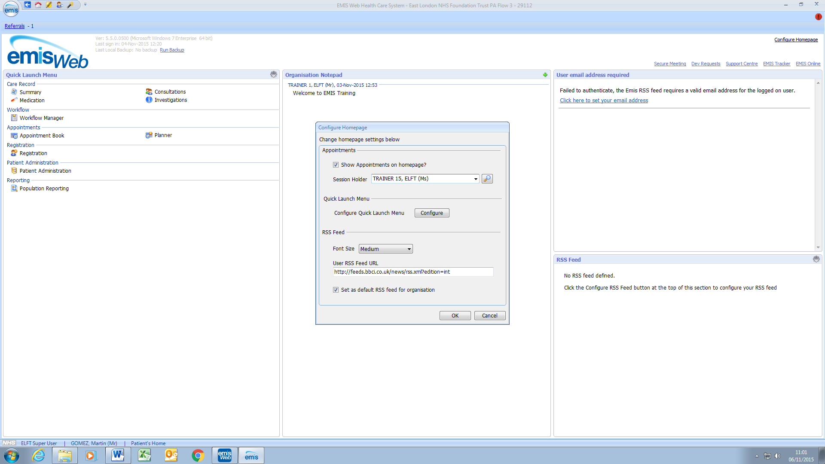

Show Appointments on Home Page
Tick the ‘Show Appointments on Homepage?’ – click the magnifier and search for the user’s name from the list and click OK.

Configure Quick Launch Menu
Click the ‘Configure’ button

The ‘Customise Quick Launch Menu’ window is open.

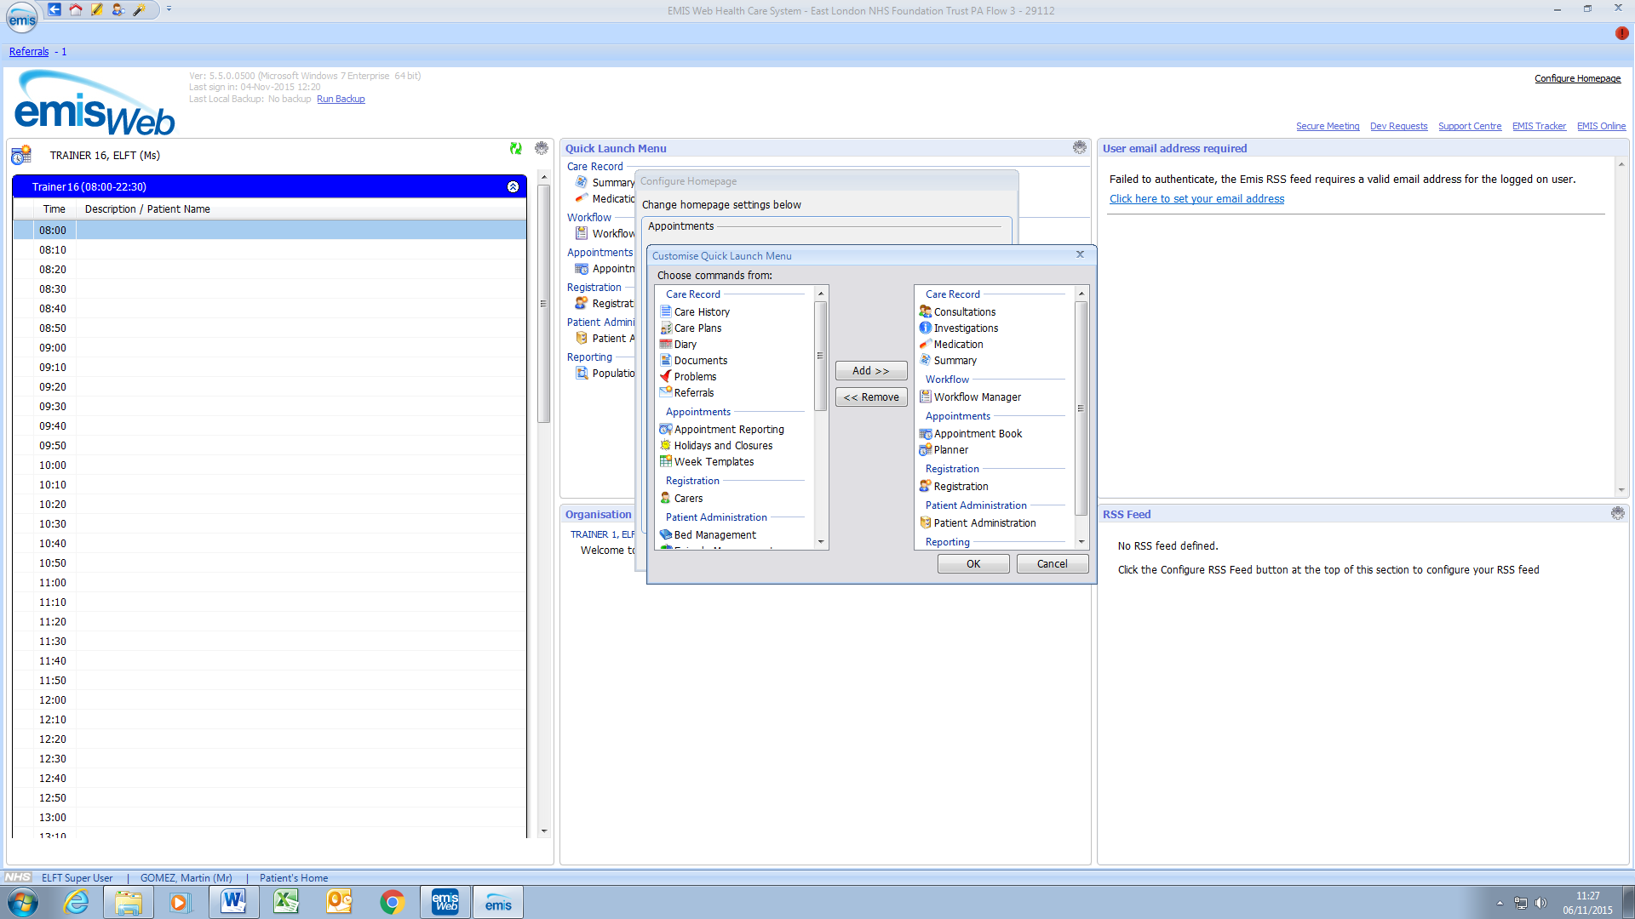

The existing config will be similar to the below:

Care Record
Consultations
Documents
Investigations
Medication
Summary
Workflow Manager

Appointments
Appointment Book

Registration
Registration

Patient Administration
Patient Administration

Customize the Quick Access Toolbar

Click the ‘Customize Quick Access Toolbar’ dropdown button and select ‘Customize Quick Access Toolbar.’

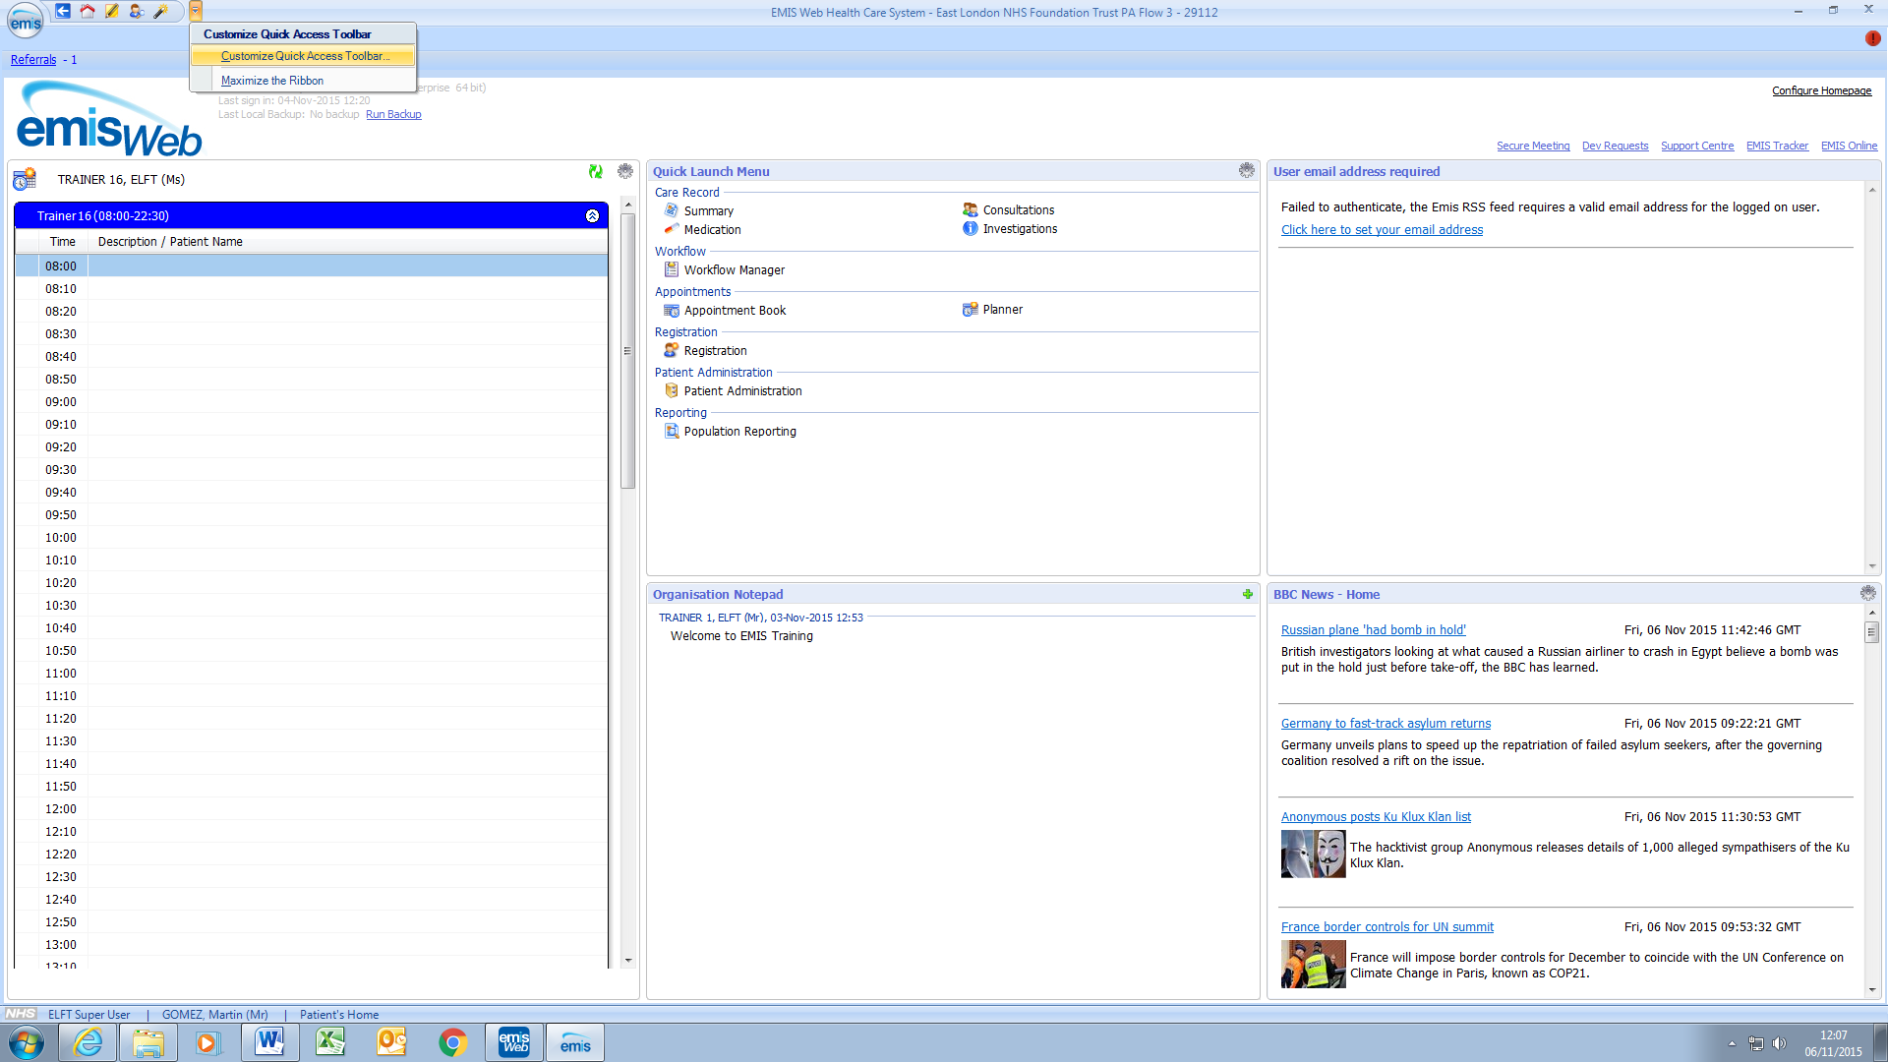

On the ‘Customize Quick Access Toolbar’ window select required icons from the left pane such as:
- Appointment Book
- Consultations
- Documents
- Investigations
- Medication
- Patient Administration (NOT Patient Administration Manager!)
- Registration
- Summary
- Workflow Manager
- Scanning & Documents

Click ‘Add>>’ to move to the right pane, and click ok.

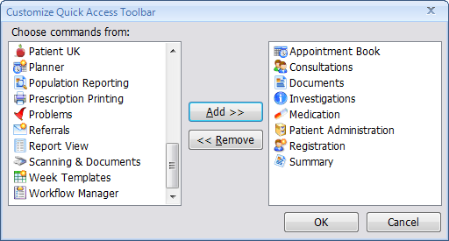

The selected icons will appear on the Quick Access toolbar.

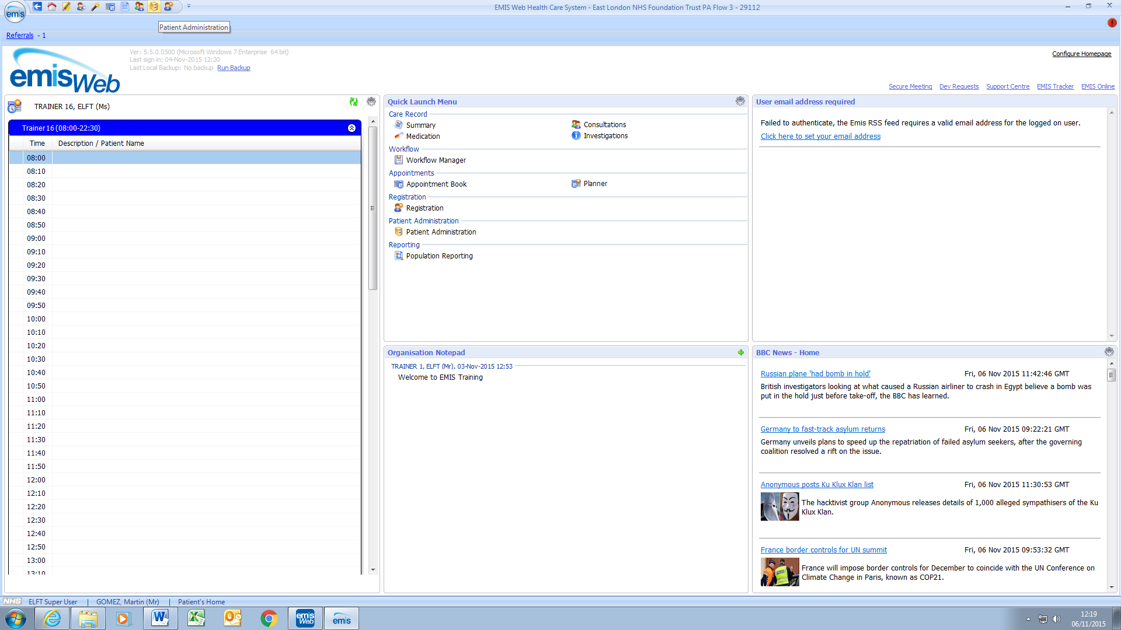

Configuring Users Consultation:

Click on Consultations:

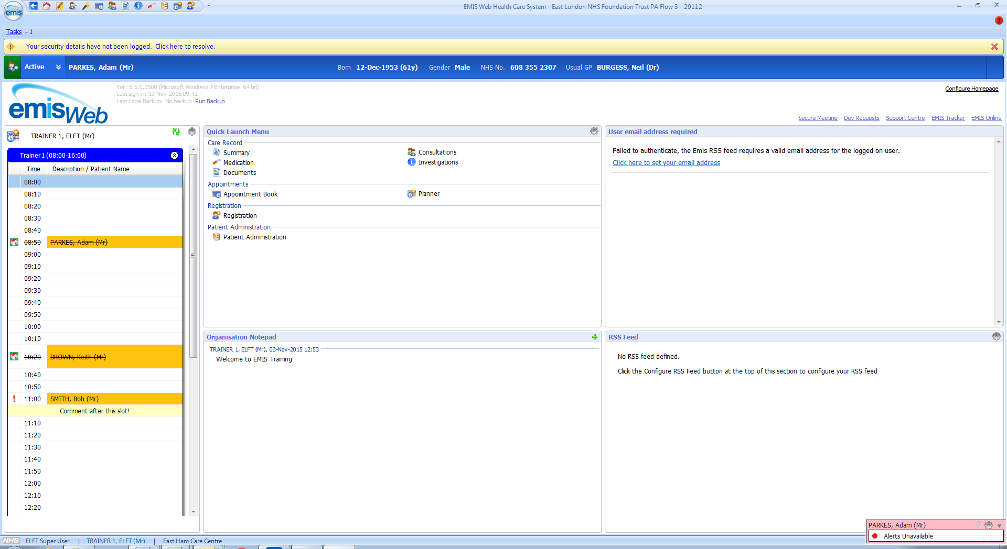
Click on CR Config:

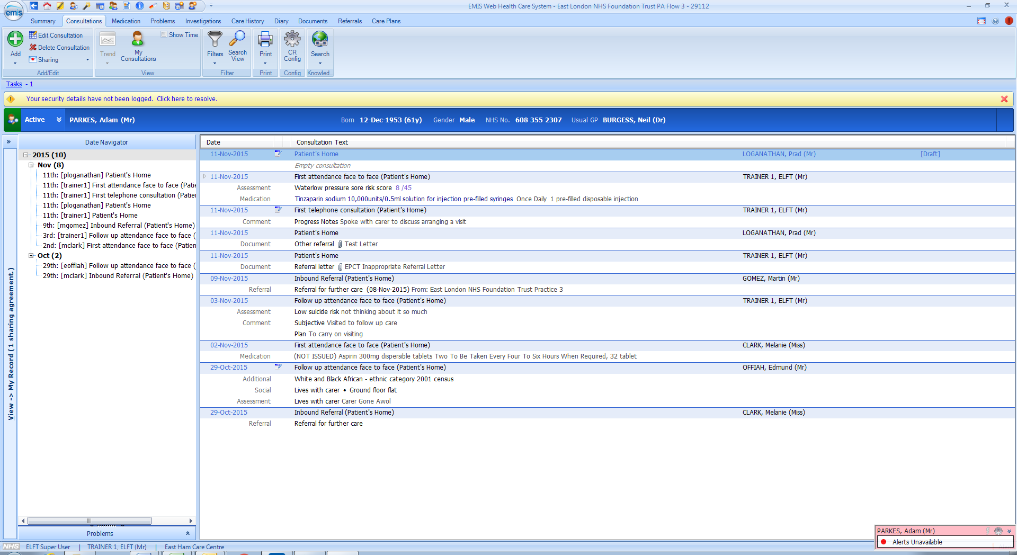

Under User Options – Consultation Styles – Select your appropriate Consultation style and tick ‘Make Default’:
And remove Quick Note and any other options under Active Styles:

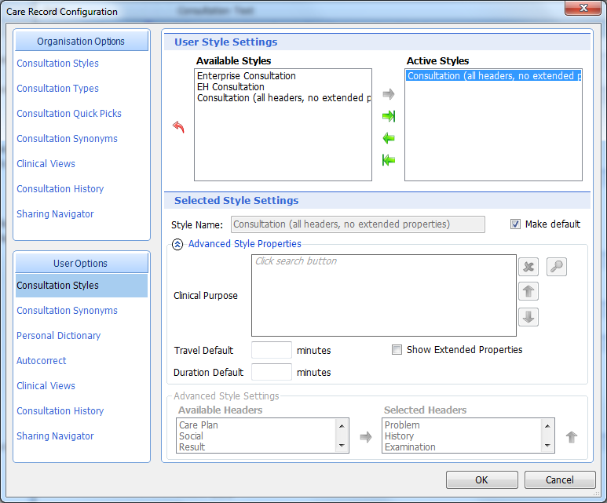

Under User Options – Clinical Views – Select your required View and click on ‘Make Default’.

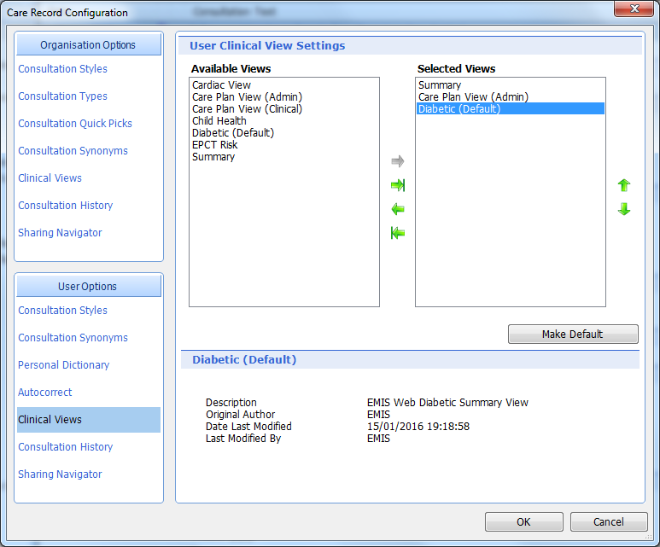

Configuring Users Appointments:

Click on Appointment Book:

Click on Appts config:

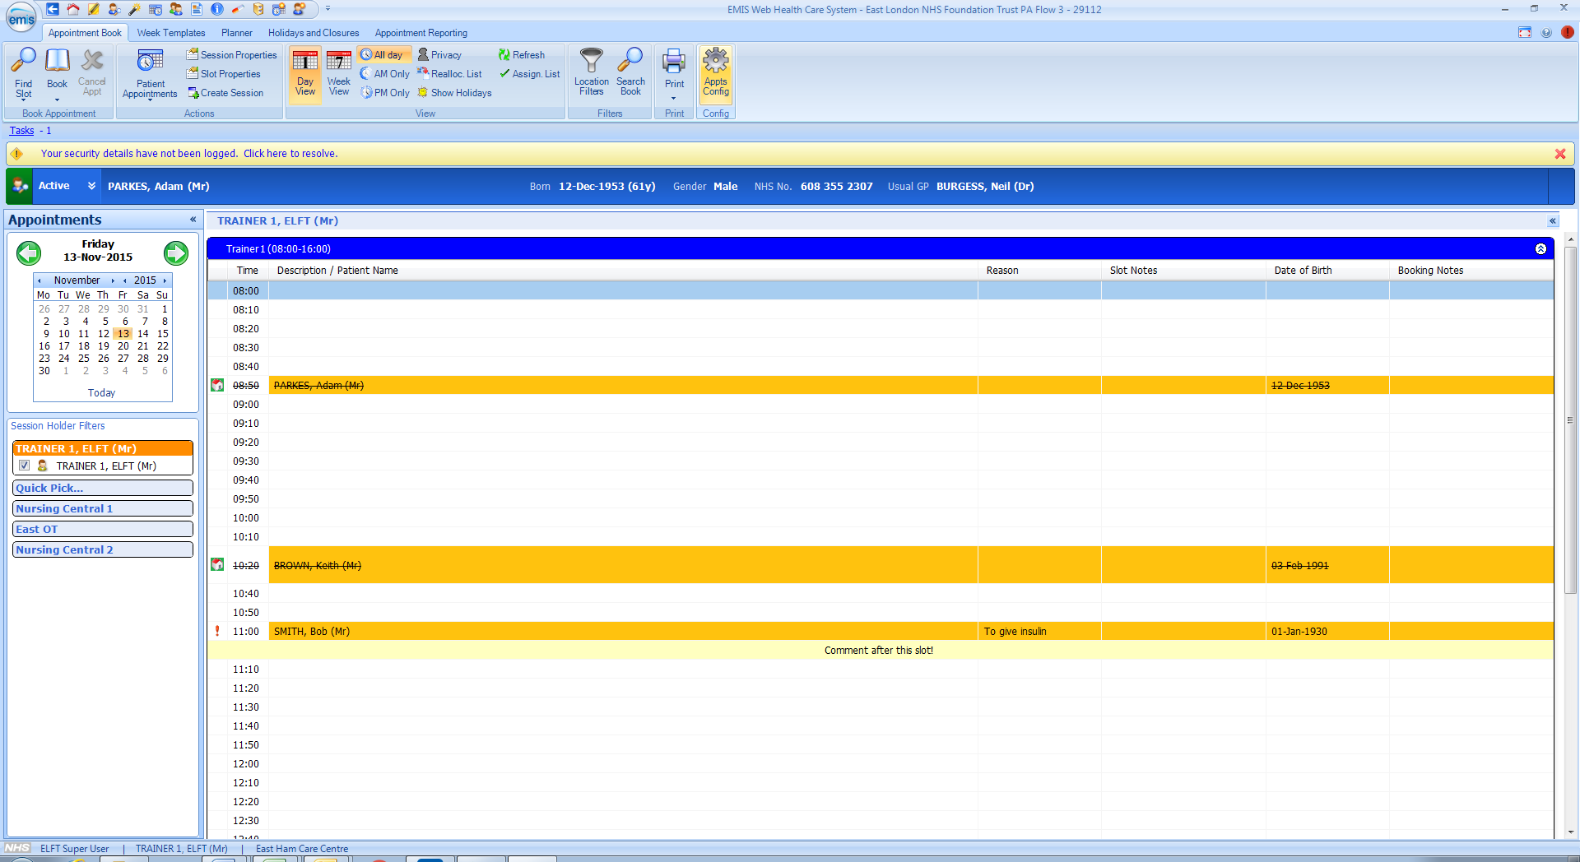

Click on General.

Ensure the Included columns are selected and are showing in the EXACT order as below:

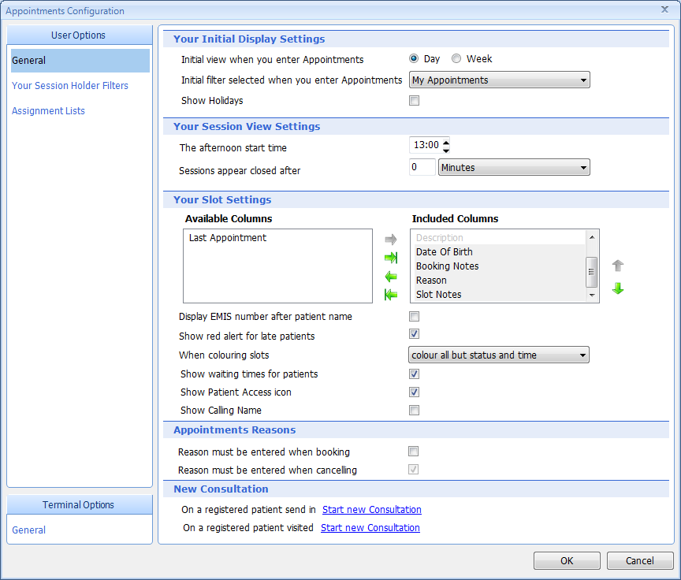
And finally, under ‘New Consultation’ click on ‘Do Nothing’ for both options so it displays ‘Start New Consultation’ for both options if you want to automatically link to a Consultation from SEND IN in the Appointment Book.

Click on Your Session Holder Filters and select ONLY the diary filters that are relevant to you. This may only be 1 or 2.
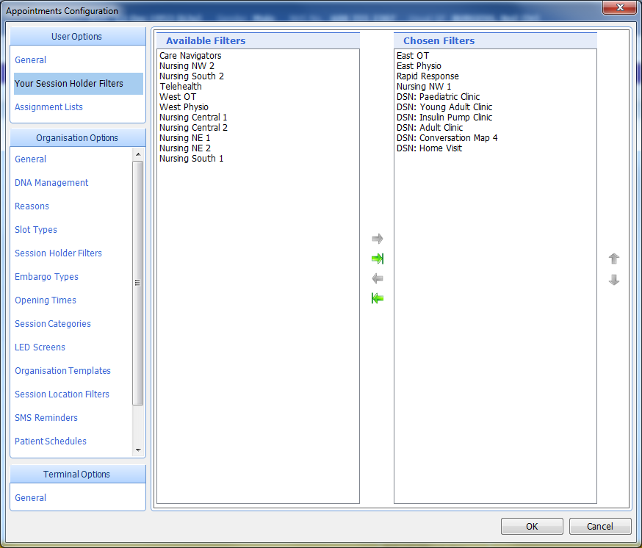
If applicable and your service uses schedules, Click on ‘Assignment Lists’. Ensure all options are correctly selected as per below.
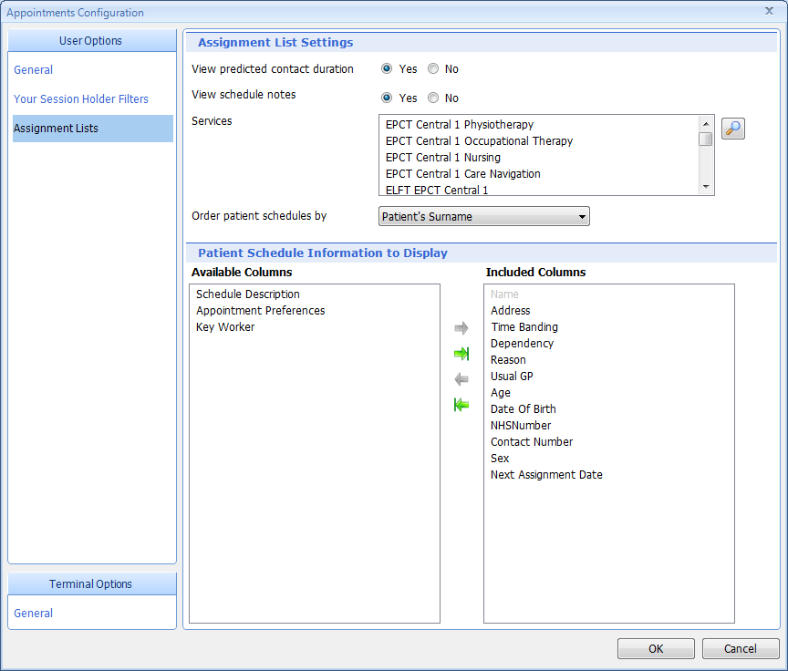
Under Services select ONLY the teams you will be assigning to if appropriate. Click on ‘OK’

To ensure the relevant Patient details are visible when printing appointment books, configure the ‘Patient details print settings’ accordingly:

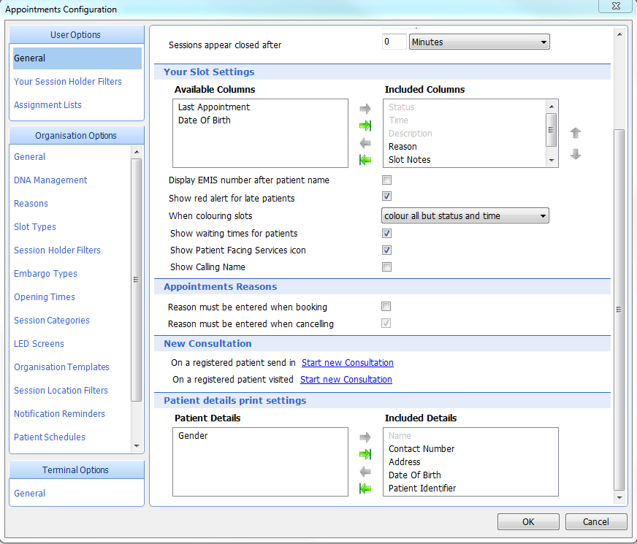

Configuring Task Deputies:

Click on Workflow Manager:

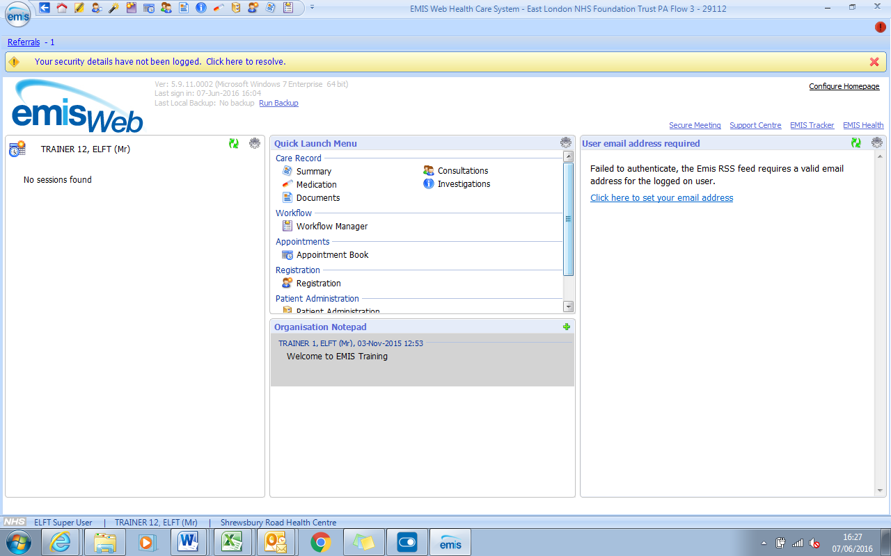

Click on Config. Tick Enable my deputies when I am in the office. Click on Add and select your deputy:

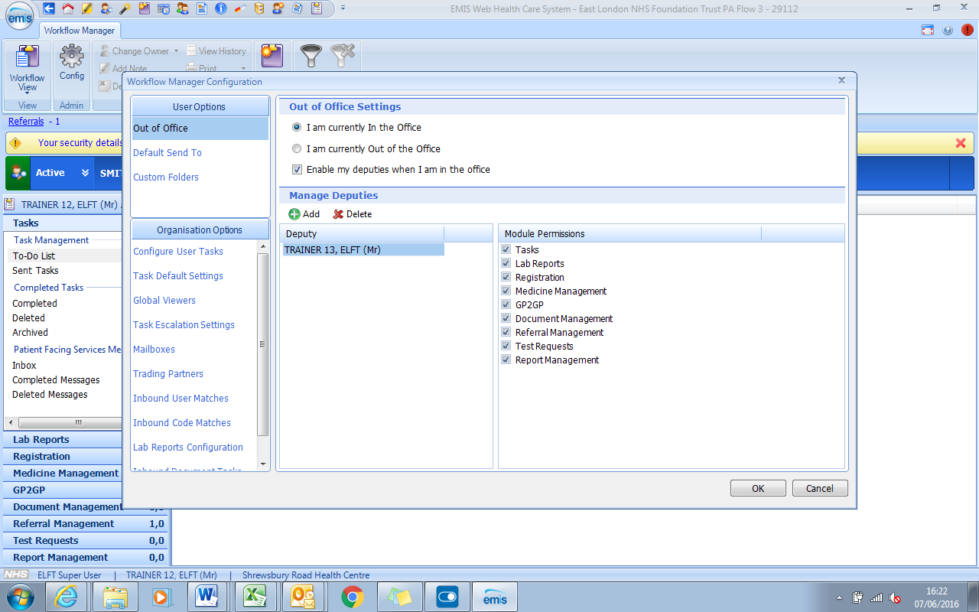

Configuring Task Deputies:

Click on Workflow Manager:

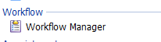
Workflow Manager Icon on Quick Launch Menu

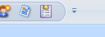
Workflow Manager Icon on Quick Access Toolbar

Click on the Config button:

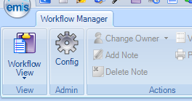

In the Workflow Manager Configuration screen, click on the ‘Add’ button and select the deputies / buddies you want. Should you wish to change your deputies, you can delete and add different colleagues using the delete and add functions when required

