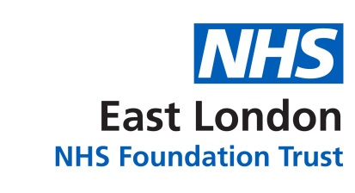

Membership Office
East London NHS Foundation Trust
9 Alie Street
London E1 8DE
Telephone: 0207 655 4140/4167
Freephone: 0800 032 7297
Email: elft.membership@nhs.net

Welcome to ELFT’s Staff Membership

Dear Staff Member
Welcome to the Trust. As a staff member of East London NHS Foundation Trust (ELFT), you are automatically included as being a Foundation Trust staff member. However staff can choose to opt out of the membership by contacting the Membership Office to inform them.
The Trust has been a Foundation Trust since November 2007. Being a Foundation Trust means it is run locally. The Trust involves both staff and public members to have a say in shaping and developing Trust services to provide better services that meet the needs of the local communities it serves.
As a Staff Member you can:
- Attend and take part in the Trust’s Annual Plan consultations to help shape, improve services and staff satisfaction. These are held annually.

- Nominate yourself to become a Staff Governor
- Vote for your Staff Governor representatives in the Governor Elections.

- View Staff Governor profiles by going to the Trust’s website:
https://www.elft.nhs.uk/Get-Involved/Council-of-Governors/Meet-the-Council-of-Governors
or obtain a copy from the Membership Office.

- Can contact a Staff Governor via the Membership Office. Staff Governors can communicate your views to the Trust.
Would you like to become a staff governor?
To find out more, please contact the Membership Office on the details above.
Help the Trust to recruit new members
If you work with service users, carers or the local community, the Trust would like to ask you to encourage them to join the Trust as public members. Please take some membership forms at Trust Induction or contact the Membership Office to request forms or alternatively they can complete sign up online by going to: https://www.elft.nhs.uk/Members/Membership-Application-Form.aspx
Thank you
Membership Team

