New NODF / DLF Procedure – Brief Guidance

We have developed a more efficient process for creating a patient’s DLF (Discharge Liaison Form) using RiO. The Rio ‘Hospital Discharge Form’ has been reduced significantly in size and should be significantly quicker to complete, and the aim is therefore to complete this during a patient’s discharge ward round.

The information in the Hospital Discharge Form is then combined with information pulled from a number of other places in RiO to create an ‘editable letter’ which is the document sent to the GP and uploaded to RiO as the NODF (Notification of Discharge Form – the four letter code used to upload in RiO).

The intention is to gradually change the way we enter information into Rio during day-to-day clinical work, so that most of the information pulled from other places in RiO to create the editable letter is entered during the course of a patient’s admission, rather than being left until the time of the patient’s discharge.

In order to successfully generate the complete editable letter, clinical information needs to be entered into the following places in RiO:
- Clinical Assessment Form in the Medical Documentation Folder (specifically the Presenting situation, which will be pulled into Circumstances of admission on the letter, and Mental state examination, which will be pulled into Mental state examination on admission on the letter). It is expected that the admitting doctor will complete this form on admission. During early deployment, this loop may not have been closed, and these two fields may need to be completed before the editable letter can be generated.
- Blood and ECG results in the Investigations form in the Physical Health folder.
- Blood pressure and BMI data in the Observations and Measurements form in the Physical Health folder.
- Smoking, diet, exercise and alcohol intervention information in the Lifestyle form in the Physical Health folder.
- The new Hospital Discharge form found in the Medical Documentation folder which gathers information on treatment during admission, discharge medication and discharge plan. It is anticipated that this be completed during the discharge ward round.

The Hospital Discharge Form is found in the Medical Documentation folder:
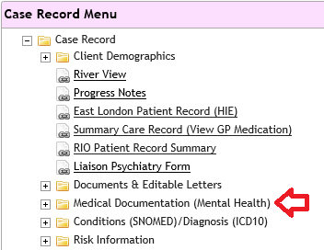

This form should be completed briefly, as in the following example:

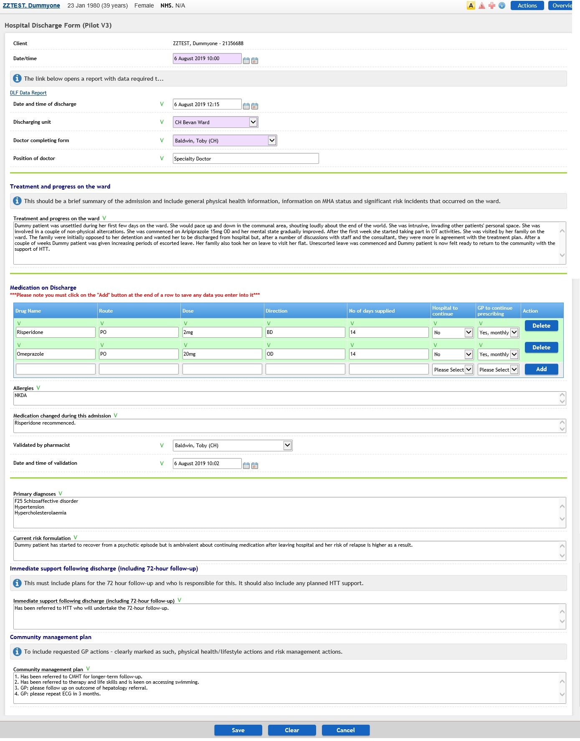

There is a link on this form (near the top, called “DLF Data Report”) which brings up a report on the information which should be entered elsewhere in RiO. It either displays this information or reports it as missing. You can click on the headings of this report to access the relevant forms to enter missing information if necessary.

Once the form, including discharge medication, has been completed, the medication section should be validated by a pharmacist, which they can indicate by entering their name and date/time of validation at the end of the medication section. Note: occasionally a pharmacist may find their name is not in the picklist. If this happens please contact the RiO Helpdesk via the Service Now portal and we can get this swiftly corrected.

The editable letter can then be generated and sent to the GP. The editable letter is titled “**Discharge Liaison Form” and should be found close to the top of the list as shown below. Note: access to the editable letter is assigned on an individual basis. We hope we have assigned this letter to everyone who needs it but if you don’t see it then please contact the RiO Helpdesk via the Service Now portal and we can get this swiftly corrected.

