NODf
Notification of Discharge (NODF) also known as Discharge Liaison Form (DLF) -
A Notification of Discharge form (NODF) is a summary of patient care which is produced when a patient is discharged after in-patient admission. NODFs are a vital communication tool between our services and a patient’s GP. NODFs should be completed and sent to patient’s GP within 48 hrs. NODFs are one of our main KPI.

the current process
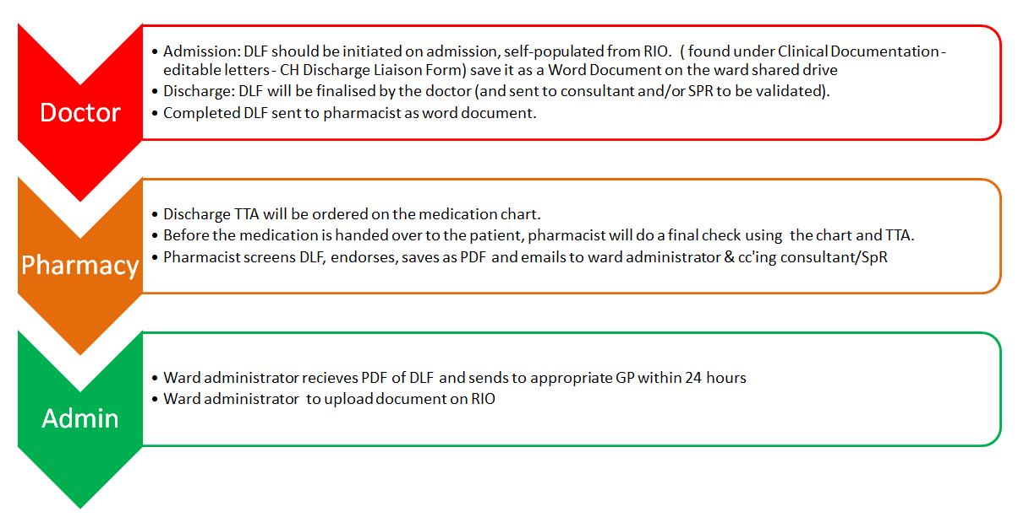

the New process currently being implemented
The form itself is a RiO embedded form which Doctors and pharmacist complete.

the screenshot process done by Doctors and Pharmacy
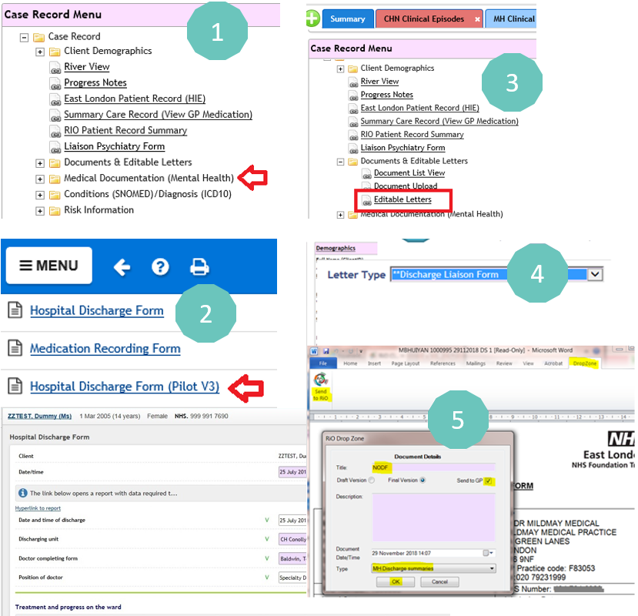

How to run the ‘Failed to sent’ report in screen shots
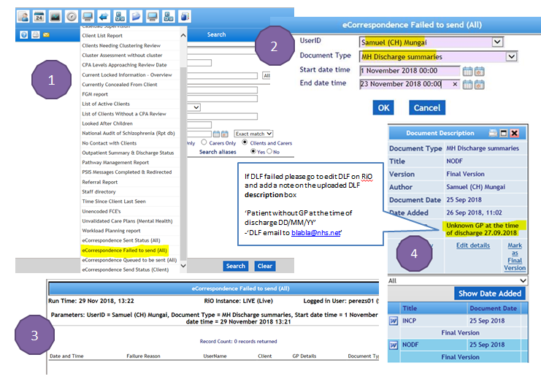

How to run the daily missing DLF report in screen shots
