Oxygen Therapy

Support for Community and Mental Health Staff
During the Coronavirus Pandemic

Version number: | 1
Consultation Groups | Senior Pharmacy Managers  The CHS Policy Alignment Group  Lead Nurses  Governance and Risk team  Quality Assurance & Safety Team  Infection Prevention and Control Team  Resuscitation Team  IT – EPMA Team
Approved by (Sponsor Group) | Medicines Committee
Ratified by: | Medicines Committee
Date ratified: | 13 May 2020
Name of Author: | Dupe Fagbenro, Lead Pharmacist, Bedfordshire CHS
Executive Director Lead: | Dr Paul Gilluley, Medical Director, ELFT
Implementation Date: | May 2020
Last Review Date | May 2020
Next Review date: | May 2023

Services | Applicable
Trust wide | √
Mental Health and LD
Community Health Services
Primary Care Directorate

Version Control Summary
Version | Date | Author | Status | Comment

12 May 2020, version 1
Contents
Summary 3
Scope 4
Safety considerations 4
Infection Prevention and Control (IPC) considerations 5
Assessing patients 5
Target Oxygen Prescription 5
Oxygen delivery devices 6
How to prescribe Oxygen 8
Oxygen Concentrators 9
Oxygen administration 9
Monitoring and maintenance of target saturation 9
Mouth care and Humidification 10
Weaning and discontinuation of oxygen therapy 10
Oxygen in End of Life (EoL) 10
Use of Oxygen whilst waiting for an ambulance by patients already on Oxygen 10
Oxygen supply and training programmes 11
References 11
Consultation list 12
Other useful resources 12
Appendix 1 13

In an emergency or if a patient is deteriorating follow emergency guideline in Appendix 1

Summary
The essence of this guideline can be summarised simply as a requirement for oxygen to be prescribed according to a target saturation range and for those who administer oxygen therapy to monitor the patient and keep within the target saturation range.
The guideline recommends aiming to achieve normal or near-normal oxygen saturation for all acutely ill patients apart from those at risk of hypercapnic respiratory failure or those receiving terminal palliative care
Oxygen therapy is the administration of oxygen at a greater % than ambient air (21%). Oxygen is an odourless, colourless and tasteless gas. It is essential for cell respiration and to prevent tissue death.
Oxygen has routinely been a treatment for hypoxaemia (insufficient oxygen in the blood), not breathlessness. However, NICE recommend to consider a trial of oxygen (when available) in COVID-19 patients as part of supportive care to manage breathless patients and assess whether breathlessness improves (NG163, April 2020).

Scope
This guidance applies to all ELFT staff (Community and Mental Health) engaged with prescribing, administration and monitoring of acute oxygen therapy. It does not cover prescribing, administration or use of BiPAP.

Safety considerations
- Oxygen supports combustion, therefore to reduce the danger of fire it is necessary to inform the patient and relatives of the dangers
- There must be no smoking in the vicinity of oxygen.
- Never use oxygen equipment near open fires or naked flames.
- Materials which become enriched with oxygen will burn very vigorously if they are ignited.
- Never leave the oxygen supply running when it is not being used.
- Fire extinguishers must be readily available although not necessarily in the patient’s rooms
- Oxygen cylinders should be kept secure in an upright position and away from heat.
- A flow meter will be used to regulate the control of oxygen in litres per minute
- All disposable oxygen delivery equipment is single patient use.
- If the patient complains of sore/dry nostrils secondary to the oxygen therapy – KY jelly is the only product on the market that is safe to use. All other creams are petroleum based.
- Alcohol, ether and other inflammatory liquids should be used with caution in the vicinity of oxygen. Do not use aerosol sprays such as hairsprays or deodorants whilst using oxygen equipment. You can use alcohol to clean your hands- but need to make sure that the alcohol gel is massaged in well. Your hands should be completely dry when handling equipment.
- Vapping. The National Fire Chiefs Council advice: Never use a vaping device close to medical oxygen, flammable emollient creams or airflow mattresses.
- Don’t use oil-based emollients, such as Vaseline, when using oxygen
- Drug Safety Update April 2016: Paraffin-based skin emollients on dressings or clothing: fire risk
- Drug Safety Update Dec 2018: Emollients: new information about risk of severe and fatal burns with paraffin-containing and paraffin-free emollients

Infection Prevention and Control (IPC) considerations

  - IPC consideration for Cylinders
- The medical gas cylinder should be cleaned thoroughly in between patients/ when visibly dirty with disinfectant wipes.
- All parts of the device should be wiped down and left to air dry.
- Cleaning of the Oxygen cylinders should be included in the re-usable medical devices cleaning schedule.

IPC consideration for Concentrators
- Concentrators must be wiped down after use/ in between patients with disinfectant wipe (clinell)
- Administration /tubing should be single patient use and changed per patient.

Aerosol generating procedure (AGP)
High flow oxygen therapy, non-invasive ventilation (CIPAP and BIPAP) are aerosol generating, staff will need to use FFP3 mask and gown/ coveralls and face visor.

Assessing patients
- For critically ill patients, high-concentration oxygen should be administered immediately and this should be recorded afterwards in the patient's health record.
- In patients with COVID-19 infection, once hospitalised and treated with oxygen, their oxygen requirement might increase rapidly if their respiratory function deteriorates but this may not result in any additional significant increase in the NEWS2 score. Therefore, in patients with COVID 19, all staff should be aware that ANY increase in oxygen requirements should trigger an escalation call to a competent clinical decision maker.
- Clinicians must bear in mind that supplemental oxygen is given to improve oxygenation but it does not treat the underlying causes of hypoxaemia which must be diagnosed and treated as a matter of urgency.
- The oxygen saturation should be checked by pulse oximetry in all breathless and acutely ill patients, ‘the fifth vital sign’ (supplemented by blood gases when necessary) and the inspired oxygen concentration should be recorded on the observation chart with the oximetry result. (The other vital signs are pulse rate, blood pressure, temperature and respiratory rate).
- Pulse oximetry must be available in all locations where emergency oxygen is used. Clinical assessment is recommended if the saturation falls by ≥3% or below the target range for the patient.

Target Oxygen Prescription
Oxygen must always be prescribed legibly on the medication chart or e-prescribed. Best practice is to prescribe a target range for oxygen for patients at the time of admission so that appropriate oxygen therapy can be started in the event of unexpected clinical deterioration with hypoxaemia and also to ensure that the oximetry section of the early warning score (EWS) can be scored appropriately.
Target saturation range should be circled / prescribed on the medicine chart / e-prescribed at the time of prescribing. e.g. Oxygen should be prescribed to achieve a revised target saturation of 92–96% during the COVID-19 pandemic (to conserve oxygen) for most acutely ill patients or 88–92% or patient-specific target range for those at risk of hypercapnic respiratory failure. Saturation is indicated in almost all cases except for palliative terminal care.
Flow rate must be specified in L/min for nasal cannulas (e.g. 2-4 L/min) and reservoir non-rebreather masks (e.g. 15 L/min). The rate of flow range should be prescribed clearly and include a period of time it is to be delivered. This must be titrated to achieve the target saturation level.
Oxygen concentration should be prescribed as a percentage (e.g. 24%) when using the venturi valves and masks. The flow rate could also be specified.
Occasionally patients may require PRN oxygen – this should be prescribed by circling PRN on the prescription chart and / or prescribing in the PRN section.
Delivery device should be specified. (e.g. nasal cannula, venturi or mask)
Please see the BNF for full detail regarding the prescribing of Oxygen https://bnf.nice.org.uk/treatment-summary/oxygen.html
Useful Oxygen prescribing information http://www.oxfordmedicaleducation.com/prescribing/how-to-prescribe-oxygen/

Oxygen delivery devices
Appropriate oxygen delivery devices must be utilised. 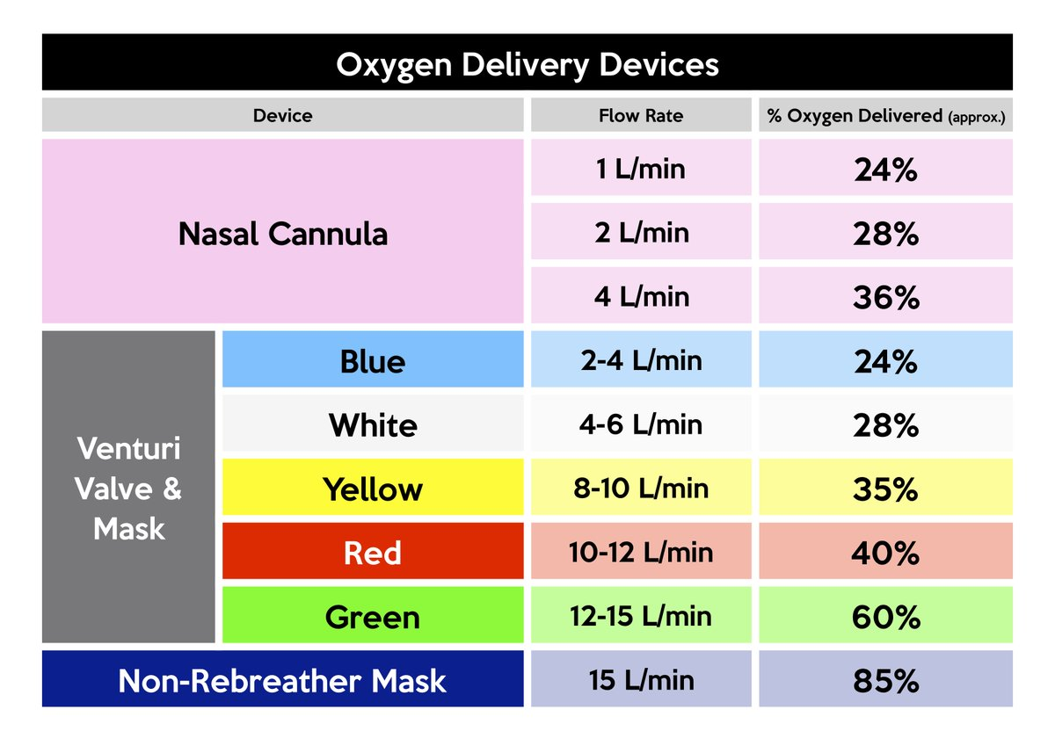
Nasal cannulas – also called nasal prongs. Specify flow rate range (e.g. 1-2 L/min). Nasal cannulas deliver low/ variable oxygen concentrations and should not be used at above 5l/min as mucosal drying will cause irritation / bleeding. They provide greater comfort of use and are best suited for chronic usage. If patient has nasal congestion or breathes through their mouth, then change over to a simple mask.

Simple face mask - also called Hudson mask. Specify flow rate range (e.g. 2-3 L/min). Delivers a variable flow rate of oxygen which needs to be at a flow rate of at least 5 l/min to ensure that waste CO2 is flushed out of the mask.
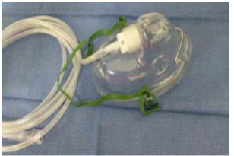

Venturi valves & mask - A Venturi mask gives an accurate concentration of oxygen i.e. 24%, 28%, 35%, 40% or 60% via the colour-coded valves. Fixed concentration masks are suited to patients where concentration is critical. This should be used where it is important to know the oxygen concentration being given.
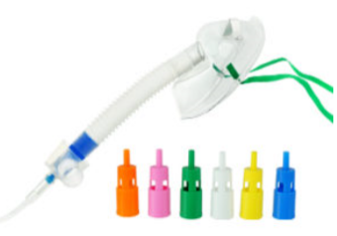

Reservoir bag mask - will deliver a high concentration of oxygen up to 98% and should only be used when a high concentration of oxygen is required (12-15 L/min flow).
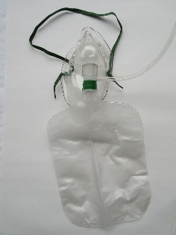

A video on Oxygen therapy and delivery can be watched here: https://www.youtube.com/watch?v=Nc2zl2SeQNo

How to prescribe Oxygen

Electronic Prescribing guideline for oxygen can be found here:

Sample of an electronic prescription of continuous oxygen on EPMA
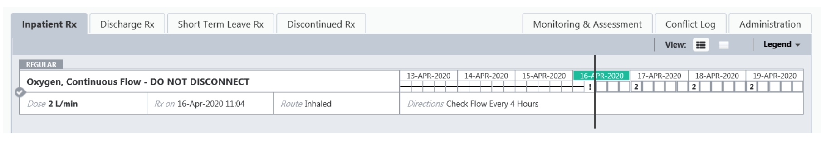

Sample of a paper drug chart of oxygen: specify target saturation, device, flow rate or percentage oxygen concentration desired and sign.
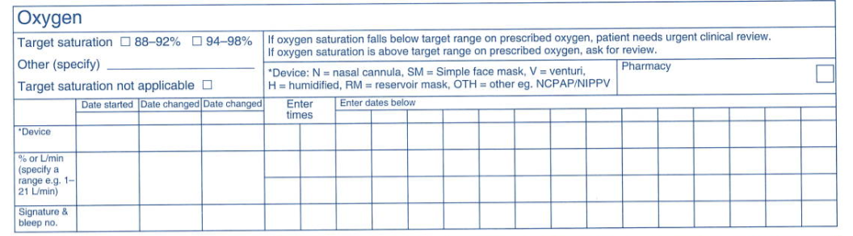

Oxygen Concentrators
- An oxygen concentrator is a device that concentrates the oxygen from a gas supply (typically ambient air) by selectively removing nitrogen to supply an oxygen-enriched product gas stream.
- It is normally used for patients requiring home oxygen, for conditions such as COPD or severe long term asthma (https://www.nhs.uk/conditions/home-oxygen-treatment/ ).
- ELFT have acquired 15 concentrators for use across the trust, these will be located at East Ham Care Centre (5), Columbia ward (5), Fountains Court and Archer Unit (5).
- A description of the unit is available http://files.caireinc.com/CutSheets-Lit/ML-CONC0082.pdf
- These Oxygen concentrators can only deliver up to a maximum of 5L/min of Oxygen.
- Information on how to use the oxygen concentrator can be found here - https://www.youtube.com/watch?v=Fy9MjlhgfAA (AirSep® VisionAire™ 5 Basic Operation)

Oxygen administration
- Oxygen should be administered by staff who are trained in oxygen administration.
- These staff should use appropriate devices and flow rates in order to achieve the target saturation range.
- Staff should be trained in the use of a range of different oxygen delivery devices to ensure oxygen is delivered safely.
- Healthcare professionals should only supply / administer oxygen in accordance with the prescription chart.
- The only circumstance under which it is appropriate to administer oxygen without prescription is in an emergency situation. Oxygen is a life-saving treatment that may be administered in an emergency as a life-saving measure without a prescription.
- The most suitable delivery system and flow rate should be used to administer oxygen to maintain or achieve target oxygen saturation and adjusted to keep the oxygen saturation in the target range.

Monitoring and maintenance of target saturation
- The patient’s oxygen requirements must be assessed on a regular basis and the effectiveness will vary, dependent upon clinical need / situation / individual patient.
- The adult patient should be checked at a minimum of 4 hourly, this may need to be undertaken more frequently depending on the condition of the patient.
- This will depend on their NEWS 2 score - Recommended clinical observations: Respiratory Rate, Pulse Rate, Pulse oximetry for oxygen saturations, Temperature, Blood Pressure, Level of consciousness
- Oxygen saturation together with the concentration of oxygen being given and delivery system (including flow rate) should be recorded on the patient's monitoring chart.
- A signature should be entered on the drug chart on each drug round.

Mouth care and Humidification
- Oxygen therapy can dry oral secretions and inhibit sputum expectoration.
- Mouth care and/or humidification must be considered in patients with tenacious (thick/sticky) sputum who are receiving oxygen therapy especially when prescribed at a higher percentage (> 28%) or flow rate (>4L / min) for longer than 12 hours or with known lung pathology MUST receive humidification.
- This should be documented in multi-disciplinary notes.

Weaning and discontinuation of oxygen therapy
- Oxygen should be reduced in stable patients with satisfactory oxygen saturation.
- Oxygen should be discontinued once the patient can maintain saturation within or above the target range breathing air but the prescription for a target range should be left in place in case of future deterioration and to guide EWS/NEWS.

Oxygen in End of Life (EoL)
- There is no strong evidence that oxygen is beneficial for the management of breathlessness in palliative care. Oxygen should be considered for End of Life patients if hypoxic on room air.
- It may be appropriate to use other strategies, pharmacological and non-pharmacological, to manage breathlessness before trialling oxygen.
- If oxygen is used, it should be reviewed after 72 hours. If it has not been beneficial, consider discontinuing.
- Please refer to the trust End of Life prescribing guidance and local end of life team guidance for more detail on prescribing Oxygen at end of life https://www.elft.nhs.uk/Professionals/Information-for-ELFT-Staff/Clinical-Guidance/ELFT-Guidance

Use of Oxygen whilst waiting for an ambulance by patients already on Oxygen

Refer to Appendix 1 in emergency.
COPD patients and other patients who have had an episode of hypercapnic respiratory failure should have an Oxygen Alert warning card with a 24% or 28% Venturi mask and instructed to show the Alert Card to the ambulance crew and Emergency Department staff in the event of an exacerbation. Follow the instructions on the card. These patients addresses and ideal oxygen dose or target saturation ranges can also be flagged in the ambulance control systems and disseminated to ambulance crews before arrival at the patient’s address when required.

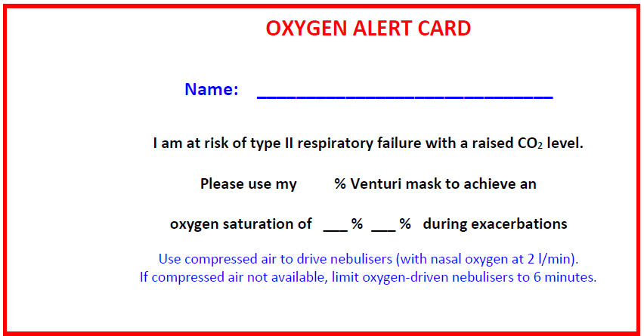

Oxygen supply and training programmes
- BOC Healthcare is the UK's largest supplier of medical gases. Oxygen is supplied to the patients in three ways. It can be piped to a community hospital ward where the gas is expelled via a flow meter attached to a wall portal, via a cylinder or oxygen concentrators.
- Mandatory Trust training and assessment will be provided
- In addition, register for a free account and enrol on the appropriate free BOC online course here - https://www.boctraining.co.uk/local/coursecatalogue/index.php?parent=2
  - Integral Valve Oxygen Cylinder Operation (sizes CD, ZD, HX, ZX, ZH)
  - Pin index cylinder operation (size J) – Mainly for EHCC

References
- NICE guideline 163. COVID-19 rapid guideline: managing symptoms (including at the end of life) in the community. Published: 3 April 2020; www.nice.org.uk/guidance/ng163 [Accessed 16/04/2020]
- NHSE. Clinical guide for the optimal use of Oxygen therapy during the coronavirus pandemic. Version 1 09/04/2020 Accessed via https://www.england.nhs.uk/coronavirus/wp-content/uploads/sites/52/2020/04/C0256-specialty-guide-oxygen-therapy-and-coronavirus-9-april-2020.pdf [Accessed 20/04/2020]
- O'Driscoll BR, Howard LS, Earis J on behalf of the British Thoracic Society Emergency Oxygen Guideline Group, et al. BTS guideline for oxygen use in adults in healthcare and emergency settings. Thorax 2017;72:ii1-ii90 [Accessed 06/04/2020]
- Patient Safety Alert. NHS/PSA/W/2018/001. Risk of death and severe harm from failure to obtain and continue flow from oxygen cylinders. Accessed via: https://www.england.nhs.uk/wp-content/uploads/2019/12/Patient_Safety_Alert_-_Failure_to_open_oxygen_cylinders.pdf [Accessed 20/04/2020]
- British Thoracic Society Emergency Oxygen Guidelines. https://www.brit-thoracic.org.uk/quality-improvement/guidelines/emergency-oxygen/
- British Thoracic Guideline for oxygen use in healthcare and emergency settings: https://www.youtube.com/watch?v=Ld05IZQegBY
- National Institute of clinical effectiveness Chronic Obstructive Pulmonary Disease Guidelines. https://www.nice.org.uk/guidance/ng115
- Rapid response report. NPSA/2009/RRR006. Oxygen safety in hospital.

Consultation list

- Jennifer Melville, Chief Pharmacist, ELFT

- Charity Okoli, Lead Pharmacist ELFT, Newham CHS

- Dr Nivenka Jayasekera, Respiratory Consultant, Clinical Lead for TB at Newham, Barts Health Trust, Newham University Hospital

- Charlotte Francis, Home Oxygen Service Lead, Adult Care Respiratory and Rehabilation Team (ARCaRe), Barts Health NHS Trust

- Christabelle Chen, Lead Respiratory Pharmacist, Barts Health NHS Trust

Other useful resources

Primary care and Respiratory Resource Pack

Emergency Oxygen Guidance Primary care setting (also Appendix 1)

Bedford Hospital Oxygen Training Booklet

Oxygen therapy outside acute settings during the COVID 19 pandemic
Appendix 1
