USING VDI
1. Login to VDI as usual using either an internet browser or Horizon client
2. a. If using the internet browser press CTRL + ALT + INSERT
b. If using the Horizon client press CTRL + ALT + END
3. Click change a password
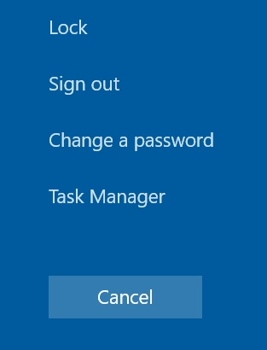
4. Enter your current password, then enter a new passphrase and re-enter the new passphrase
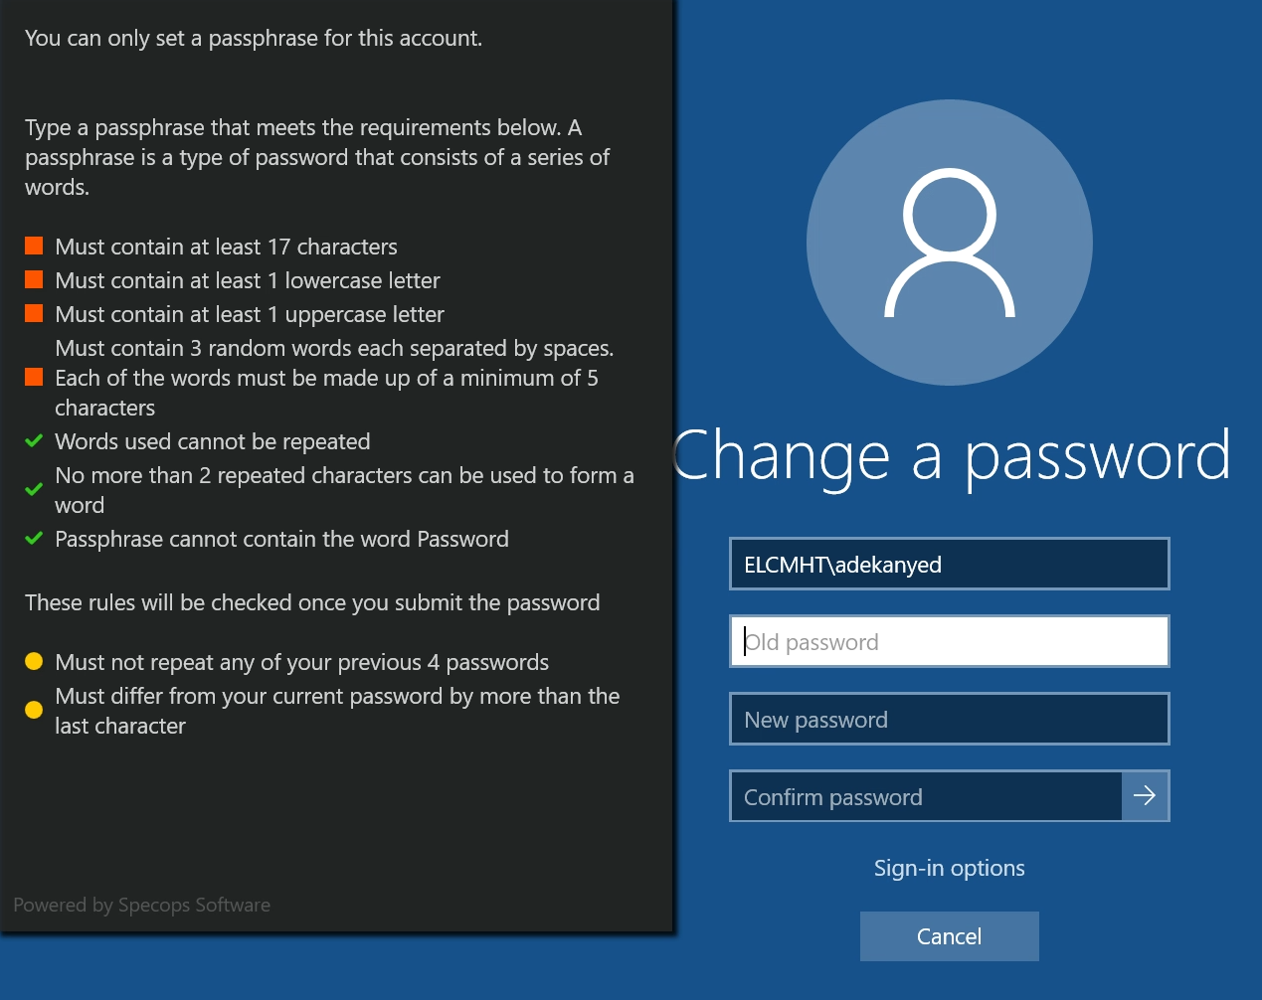
5. Once the passphrase chosen matches the pre-set conditions, all conditions will be marked green
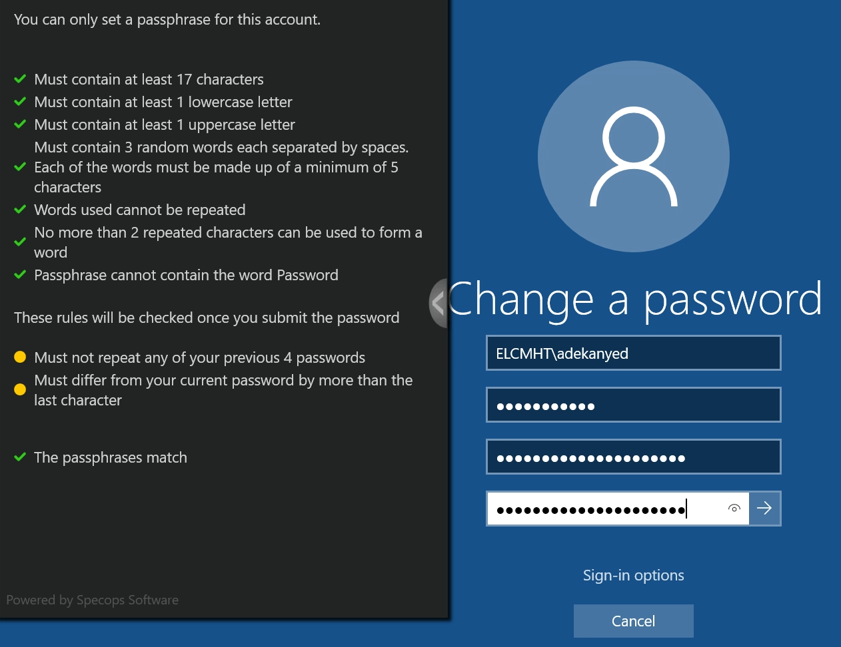
6. Press the white arrow when completed.
7. Log off the VDI system completely and log back in with your new passphrase
USING A TRUST PC
1. Login to your PC or your laptop, then log on to AnyConnect VPN
2. After successful log on to VPN, press CTRL + ALT + DEL
3. Click change a password
NB: PC must be connected to any trust site or connected via AnyConnect for this to work
4. Enter your current password, then enter a new passphrase and re-enter the new passphrase
5. Once the passphrase chosen matches the pre-set conditions, all conditions will be marked green
6. Press the white arrow when completed.
7. a. If working in a Trust site, log off your PC or laptop and log back in with new passphrase
b. If using AnyConnect, allow about 15 mins before disconnecting your VPN session

