How to add Groups and Relationships

- Retrieve patient record.
- Right click on Groups & Relationships in the clinical tree.
- Click record relationship.

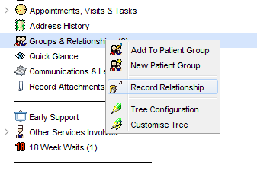
- Select the type of relationship you want to record. Press ok.

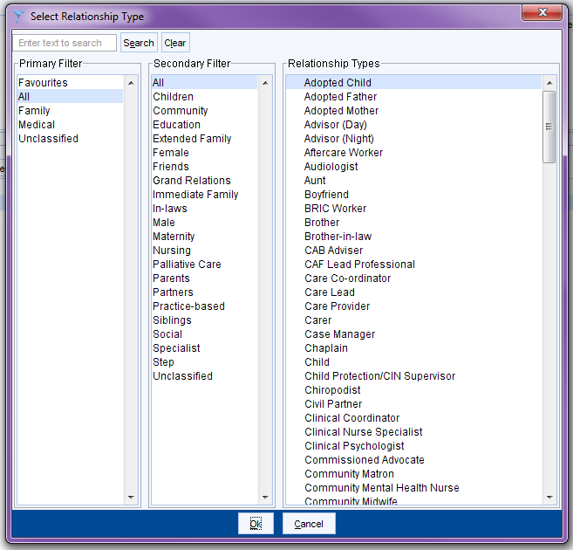

- Choose the type of relationship – is it with a SystmOne user or someone else.

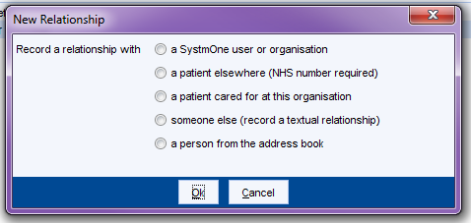

- Complete the relevant details and press ok.
