**ADDING TO WAITING LISTS**

* Retrieve Patient Record (**see process for “Introduction to SystmOne”**)
* Navigate to toolbar at the top of S1 and select “Waiting Lists”.

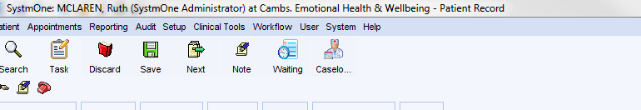

NB : You can also get to waiting lists via your clinical tree:

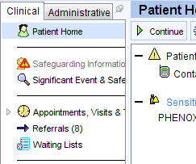

* You will now see a list of available waiting lists – select the one you wish to add a patient to and press “add patient”.

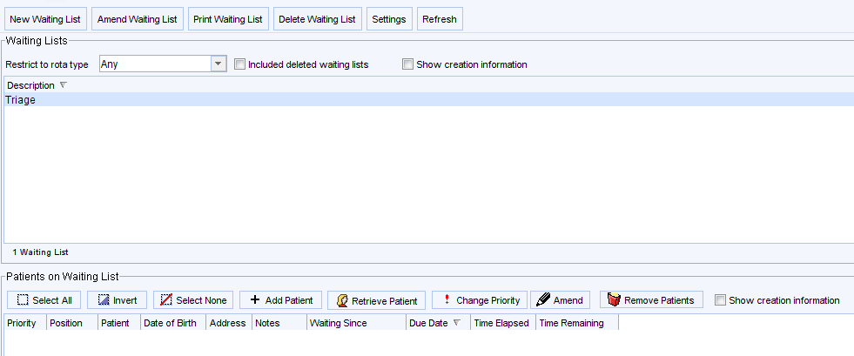

* Add “waiting since” date, due date (if required), priority (defaulted to normal) and any notes.



* Once a patient has been added, you will be able to view what date they have been waiting since, and if a due date has been added, time elapsed since they were placed on the waiting list and time remaining. Once the due date has been reached, the entry will turn **red.**

