ENDING REFERRAL AND DISCHARGING PATIENT

- Search for patient’s record on SystmOne.
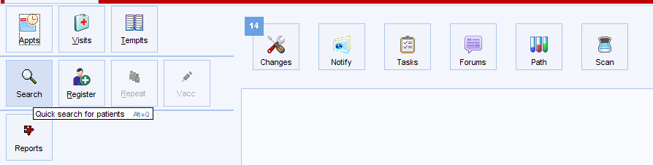
- Search for patient by either name, DOB or NHS Number
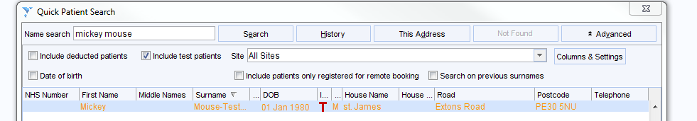
- Once correct patient is retrieved, select “Referrals” from the Clinical Tree.
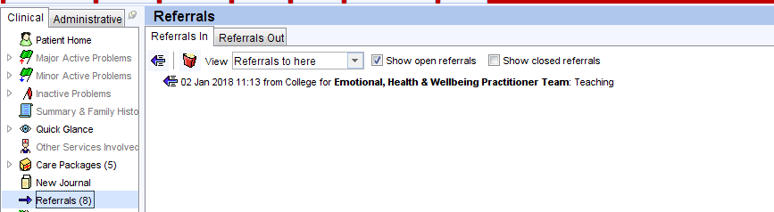

- You will see a list of open referrals on the right hand side of the screen – there may be more than one.

- Select the referral you wish to end and right click on it. You will then see the following list of options.

- Click “End Referral”
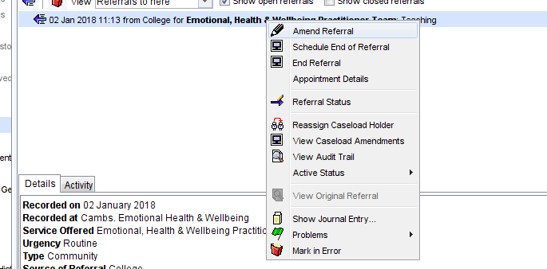

- Specify date of discharge, location after discharge and intervention.
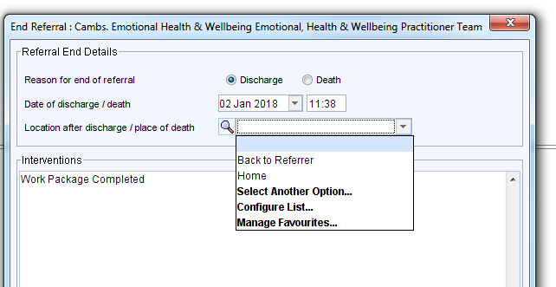
- If this is the only open referral on the unit, you will see the following prompt:
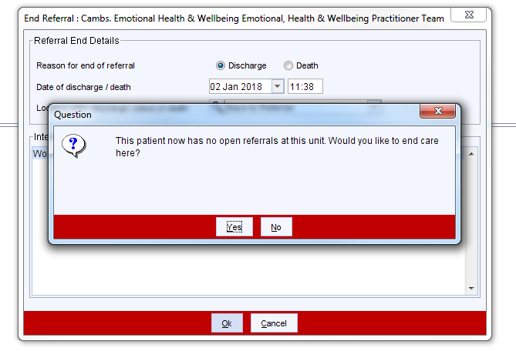
- If you are satisfied that care should be ended, please select “Yes”. This will then close the referral and end the patient’s care on the unit.

