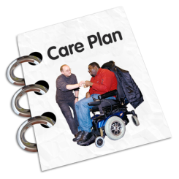
My Recovery Care Plan

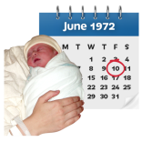
About me
Name: Insert name

Date of birth: Insert DOB

Who can see my plan?
Other people can only see my plan if I say it is ok.
The people who I want to see my plan are:
Insert names of people who can see the plan

Contact details of key people
My Care Coordinator: insert name and number
My Psychiatrist: insert name and number
Other people: insert name and number
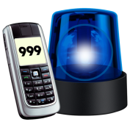
In an emergency,
please contact: insert name and number

What does recovery mean to me?
These are the things that are important and matter to me:
Insert details of what matters to service user

These are my goals for the next year:
Insert details of goals for next 12 months

These are the things that will help me to reach my goals:
Insert text – skills, strengths and experiences

To help me reach my goals, these are the things that I am going to do:
My goal for good mental health:
Insert text – details about mental health goal.
Include action plan to achieve these goals

My goal for good physical health:
Insert text – details about physical health goal.
Include action plan to achieve these goals

My goal for where I live:
Insert text – details about goals for accommodation.
Include action plan to achieve these goals

My goal for my activities:
Insert text – details about goals for leisure time.
Include action plan to achieve these goals

My Triggers

These are the things that might make me unwell:
Insert text – details of triggers for when service user becomes unwell

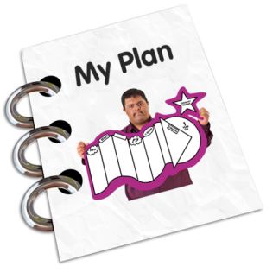
This is the plan to manage these:
Insert text – action plan for manage above triggers

My Early Warning Signs
These are the early signs that I might be unwell:
Insert text – details of early warning signs that service user is becoming unwell

This is what to do if you see these signs
Insert text – action plan for what to do when the above signs are present

Getting worse
This is how you will know if I am getting worse:
Insert text – details of signs that service user is becoming more unwell

This is what to do if you see these signs
Insert text – action plan for what to do when the above signs are present

Getting Better
This is how you will know if I am getting better:
Insert text – details of signs that service user is getting better

How to Contact me:
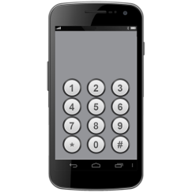
This is how to contact me:
Insert text – service user contact details

If you cannot contact me, this is who you can speak to instead:
Insert text – alternative contact details and details of anyone who should NOT be contacted

