RECORD SHARING CONSENT - SYSTMONE
(ADULT & CHILDREN)

SystmOne electronic healthcare records enables the full electronic record to be shared with other SystmOne healthcare professionals involved in the patient’s direct care, across different healthcare services.

At Registration (Prior to consent being asked)

At point of registration we should adhere to GDPR Article 9h guidance:

“Processing is necessary for the purposes of preventive or occupational medicine, for the assessment of the working capacity of the employee, medical diagnosis, the provision of health or social care or treatment or the management of health or social care systems and services on the basis of Union or Member State law or pursuant to contract with a health professional and subject to the conditions and safeguards referred to in paragraph 3”

SystmOne Record Sharing should initially be set to ‘Consent not asked’ to enable information to be shared both into and out of SystmOne.

Explicit consent MUST be obtained at the FIRST point of contact and updated on SystmOne.

As part of best practice it is important that a discussion regarding record sharing takes place at each intervention. Patients should be informed of the benefits of sharing information with other health professionals involved in their care and reminded that they can withdraw consent at any time.

Record sharing preferences can be determined by a patient, parent/carer/guardian or Fraser competent child aged13 years and over.

Please note patients can set different sharing preferences for sharing in and out of SystmOne. For example they can agree for health care professionals involved in their care to view information from other organisations but could refuse consent for information to be shared out from this organisation.

- Recording Sharing preferences can either be recorded via the pop up box when registering a patient or by using the Record Sharing quick link
Recording ‘Consent Not Asked’
Sharing Out
- Consent not asked
- Yes – share record
- Policy
- Comments should read: Sharing under GDPR article 9H
Sharing In
- Consent not asked
- View Shared Record
- Policy
- Comments should read: Sharing under GDPR article 9H
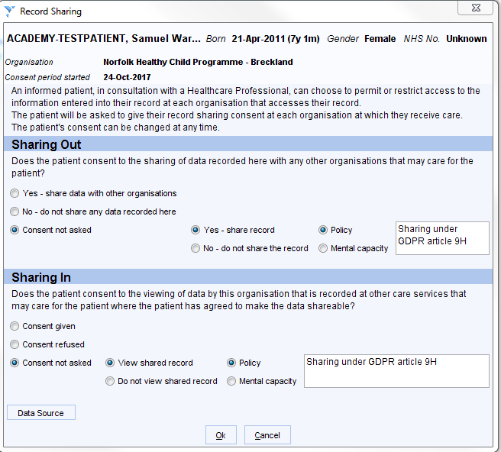

Recording Explicit Consent - (Consent has been gained from Patient)
Sharing Out
- Yes – Share Data with other organisations
Sharing In
- Consent Given

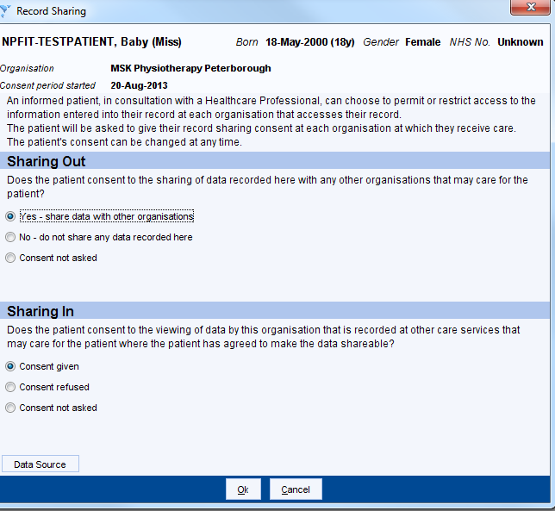

Recording Dissent - (Patient has explicitly stated that they do not wish to share their record)
If a patient requests that their records should not be shared with other SystmOne health professionals involved in their care, then this must be considered on a case-by-case basis. Please seek supervision from your line manager or seek guidance from the Information Governance Team.
Sharing Out
- No – do not share any data recorded here
Sharing In
- Consent refused.
