REGISTERING PATIENT AND ADDING NEW REFERRAL
- Open S1 Unit
- Click on “Register”.
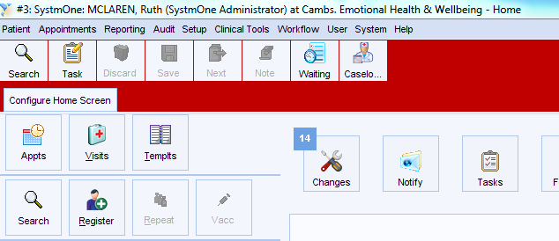
- Enter details of patient to be registered.
- Please note - you will need to either enter an NHS number or surname/DOB. You will also need to specify gender.
- Click Search.
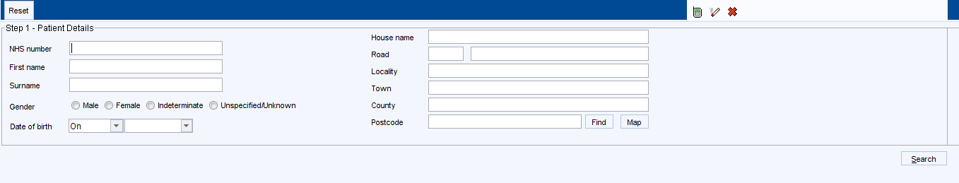
When registering a new patient, it is important to check that the patient’s record does not already exist on SystmOne to avoid creating a duplicate record. If the record does already exist, you will be able to retrieve it straightaway.

If matches are found, they are displayed in a table. Do one of the following;
- Click the green tick at the end of the row that corresponds to the relevant patient to register an existing SystmOne patient:
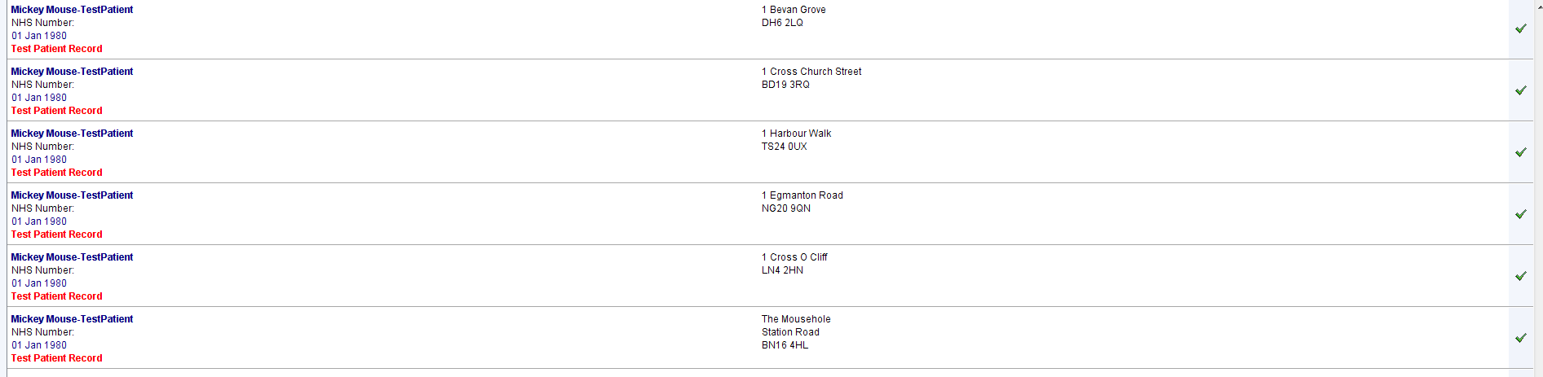
OR

- Click “Patient is not in this list” at the bottom of the table.
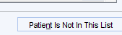
If SystmOne has not found a match, consider searching for the patient using their NHS number only before clicking Patient is not on this List.
If the patient is not found on SystmOne, and you click Patient is not in this list, the New Patient screen is displayed with a number of buttons stacked down the left hand side of the screen.
Starting at the top, click each button in turn and complete the screens that display with the patient’s details. The right hand side of the New Patient screen displays the details you have entered so far.

Adding a new referral
- Once you have registered a patient, you will see the screen below, which will be used to record a referral in:
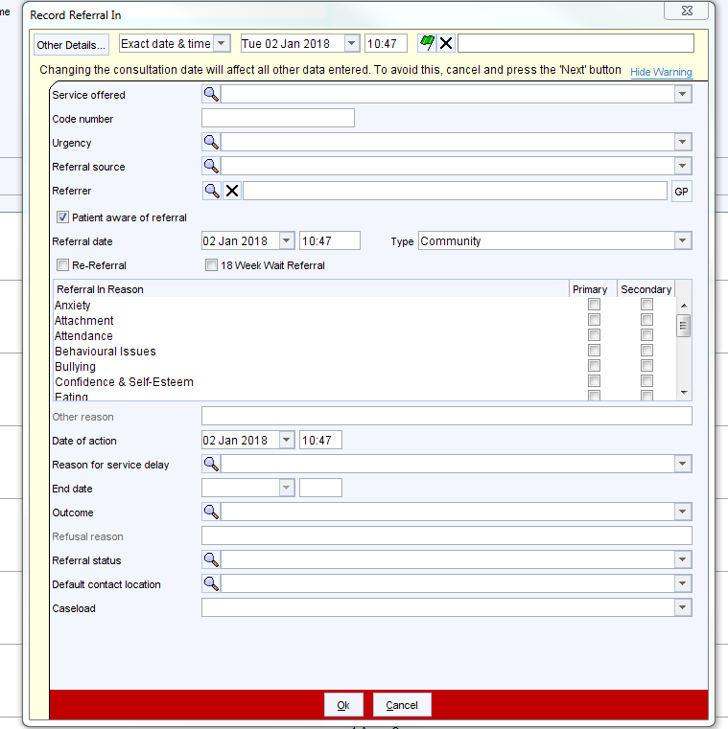

- Select Service Offered
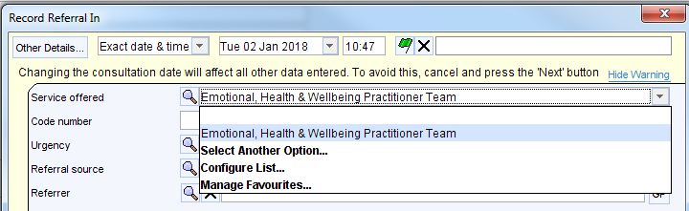
- Select Urgency of Referral
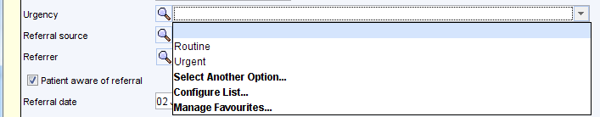
- Select Referral Source (where referral has originated from)
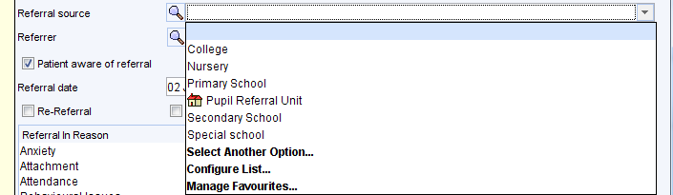
- Select date of referral

- Select referral in reason – you may have one primary reason and as many secondary reasons as applicable.
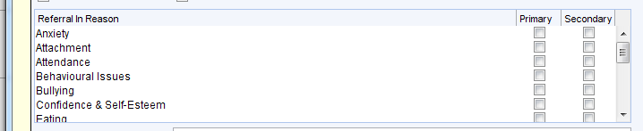
- Record outcome of referral
- Record status of referral
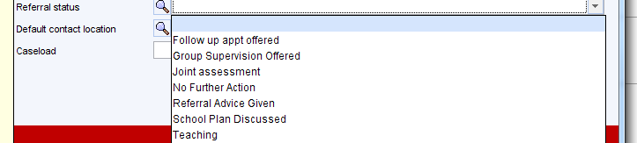
- Record default contact location
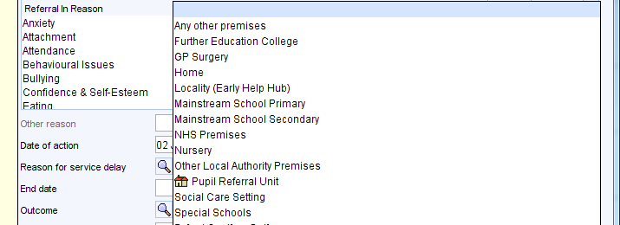

- Record caseload if required
- Once you have completed referral in, for new registrations only, you will see the following pop up box. You should only choose “Yes” if you are registering another patient from the same family.
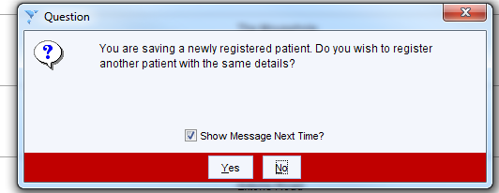
- You will now see the following pop up box to indicate that the patient is now registered on the unit.
