ADDING STAFF LEAVE

- Setup
- Users & Policy
- Staff Leave
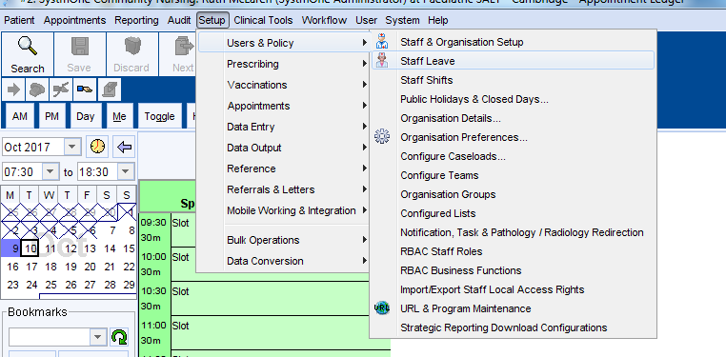
- Add leave
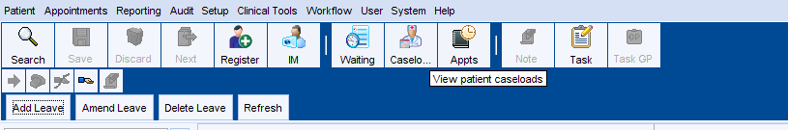
- Add description of leave, i.e. annual leave
- Specify dates leave starts and ends
- Select staff member
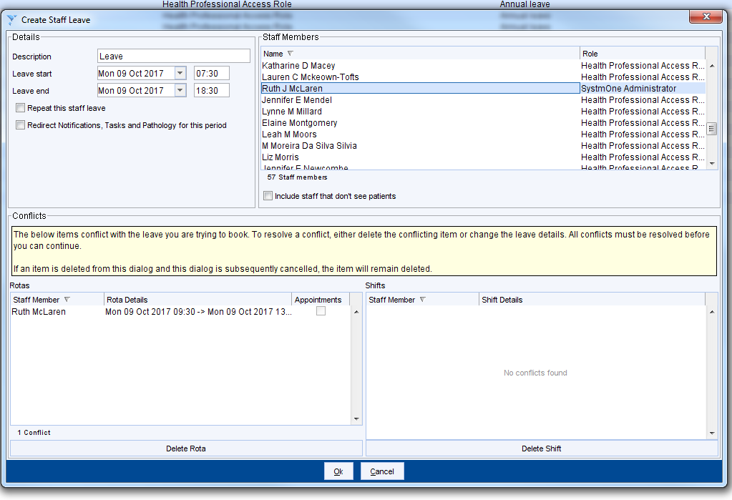
Please note that you will not be able to add staff leave if rotas are already applied on the dates you have specified – any conflicts will show in this box
To resolve the conflict, right click on the rota in the box and press Delete Rota

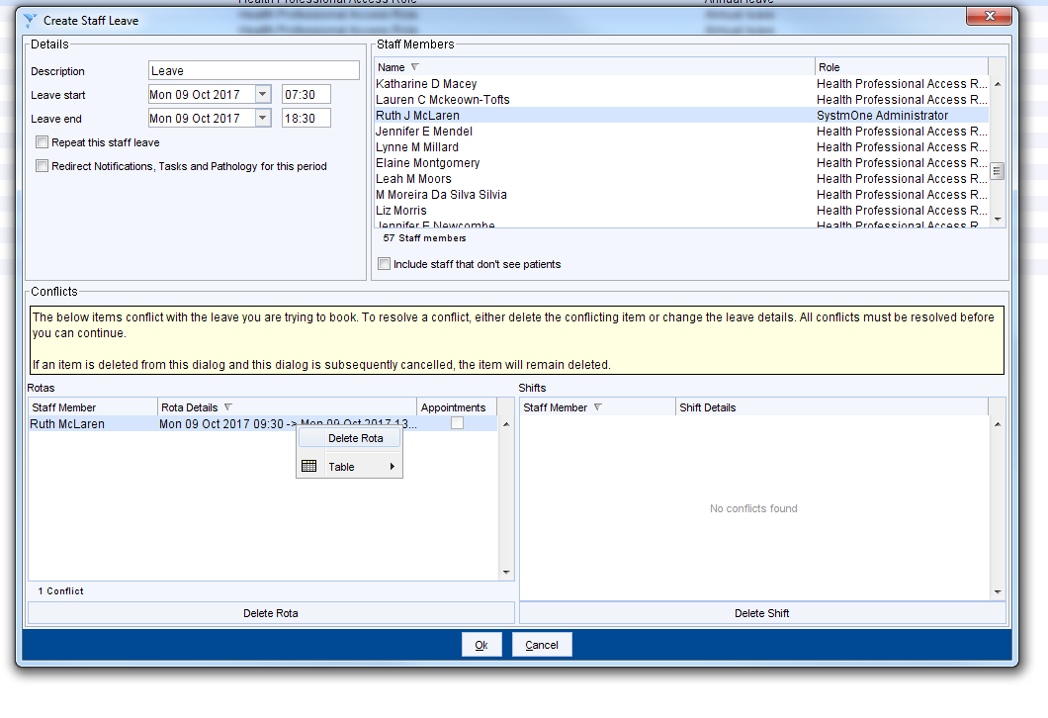

Please be aware that if you have any appts booked in this rota it will still allow you to cancel the rota – please ensure that any appts have therefore already been rearranged prior to deleting the rota

