Amending Slots on Appointments Ledger

- Right click on slot you wish to change
- Amend slot
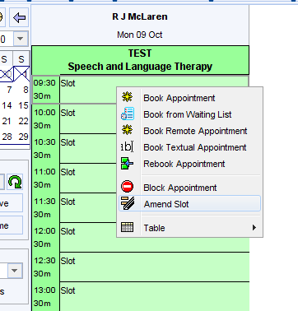

This will allow you to alter the type of slot you wish to use
