CANCELLING AN APPOINTMENT

- Right click on the appointment in the ledger
- Administration
- Choose reason for cancellation, i.e. Cancellation by unit, Cancellation by patient
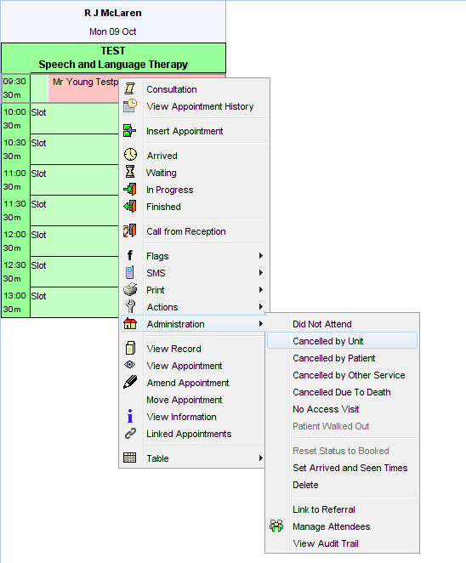

You will then get a pop up box that will ask you if you would like to:
- rebook the appointment now
- rebook later
- not rebook at all
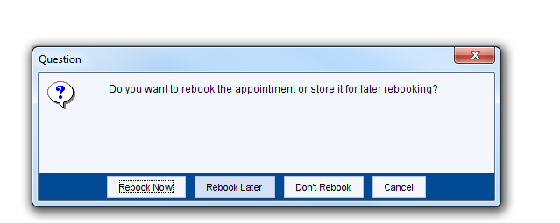
Rebook now will enable you to rebook the appointment immediately.

Rebook later will move the appointment to “Appointments for Rebooking” under the Appointments tab

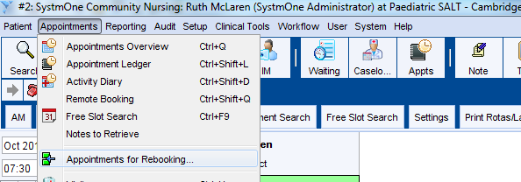

Clicking on Appointments for Rebooking will allow you to see all appointments currently waiting to be rebooked

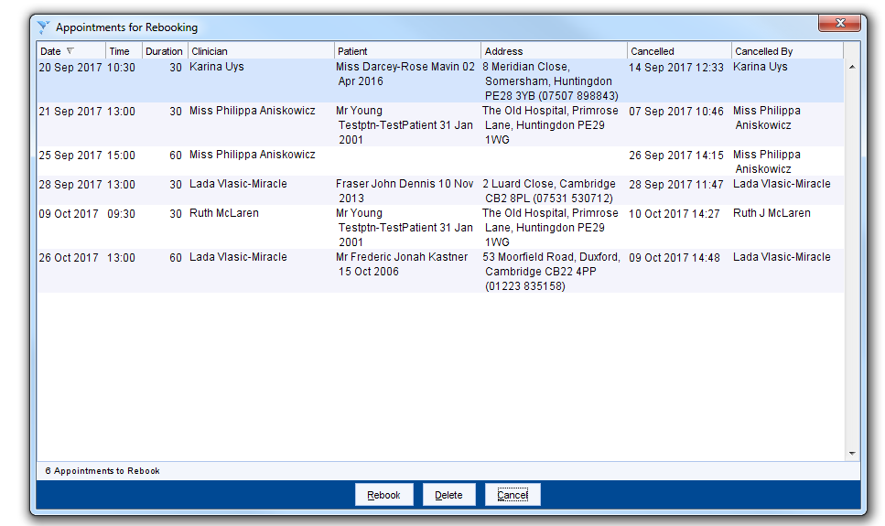

Please be aware that Appointments for Rebooking can only hold a maximum of 200 appointments, after which you will not be able to add any more to the list.
To rebook an appointment left click on the patient details so it is highlighted and then click on Rebook the details will then show up on SystmOne and then you can book them into a slot.

