PRINTING INTEGRATED WORD APPOINTMENT LETTERS FROM LEDGER
(These are letters that are set up with a data source of “appointment”)

- Select patient from your appt ledger – do NOT retrieve patient record.
- Right click on name – select “print” and “integrated word appointment letter”.

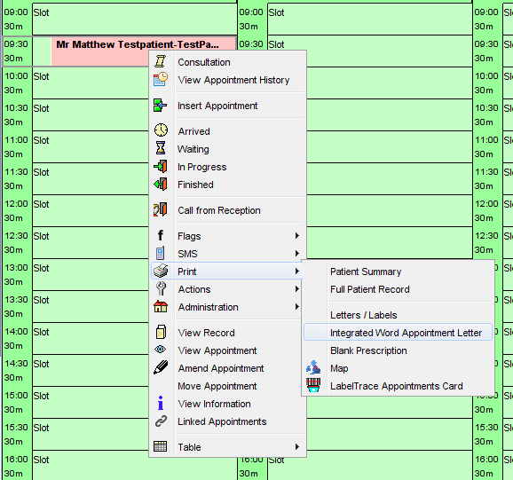

- Select appropriate template from the dropdown lists.
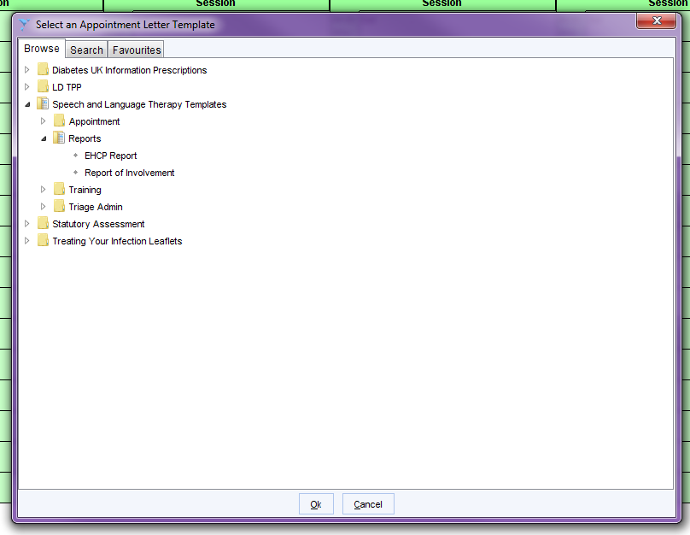

- This will open the letter template in a word document which you can edit and type into.
- Once you are happy with the contents of the letter, select “Merge and Print”.
