**Setting Task list to show Caseload**

* From the top toolbar, select: User then User Preferences



* Select from the list: Tasks then Task List.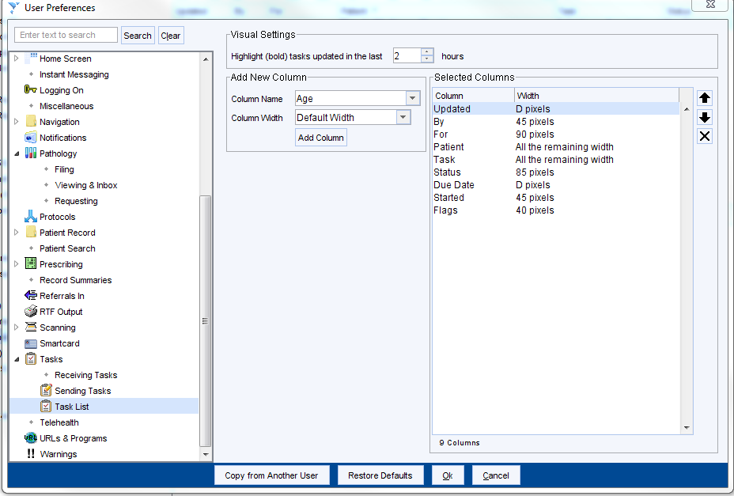
* Select Caseloads from drop down box.



* Select Add Column

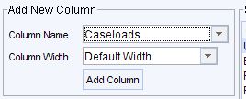

* Use the arrow to move ‘caseloads’ to the top of the list

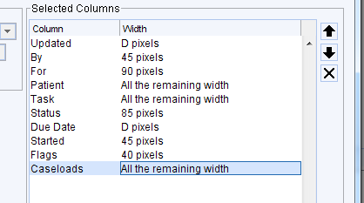

* Press ok.

Task list will now display the Caseload holder.