Creating an Auto-Text

Auto-Text are custom commands used to insert specific user-defined content in a report. Use Auto-Text commands to create phrases, paragraphs, or complete note templates that you dictate frequently.

Exercise 1: Basic Auto Text

- Open the Dictation Box.
- Say “The patient was evaluated by the psychiatric liaison, who feels that at this time, the patient does not meet criteria for psychiatric admission. The patient denies suicidal or homicidal ideation and will contract for safety. Additional resources will be provided upon discharge.”
- Say “Select All”
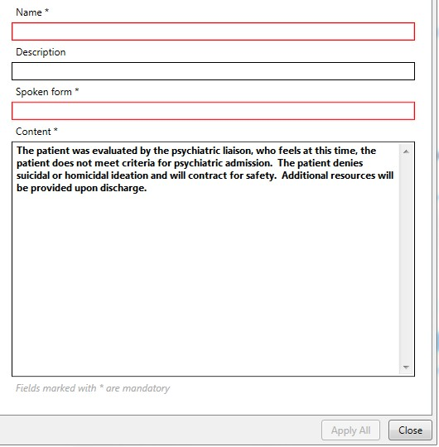
- Say “Make that an Auto-Text.”
Observe that the Manage Auto-Text window has opened with your dictation appearing in the Content box.
Notice there are three required fields (Name, Spoken Form, and Content), highlighted in red and marked with an asterisk.
- Click into the Name field and type My Psychiatric Discussion
Observe that Dragon entered your text into the Spoken Form field automatically. Note: Special characters, numbers, and punctuation are not allowed in the Spoken Form field.
- Click Apply All
- Click Close

Now we can execute the Auto-Text by simply saying the name.
- Open your Dictation Box and clear any text that appears.
- Say “My Psychiatric Discussion”
Observe that the entire block of text populated into the Dictation Box in one action.
Observe that our Basic Auto text example does not include specific references to a patient’s gender, diagnosis, or any specific treatment plan. Basic Auto-Texts are best suited to blocks of text that do not need to be edited with each use; however, after inserting the Auto-Text, you could edit the text using your keyboard and mouse or the commands covered in Basic Dictation and Correction section of the DM One Foundational Training. If you have a text template that needs to be edited with each patient interaction, you can use a Variable Auto-Text.

Exercise 2: Variable Auto-Texts (and editing variables)
Variable Auto-Texts work essentially the same way as Basic Auto-Texts, but also allow for quick editing of specific words or phrases. To identify which content needs to be changed, place square brackets at the beginning and end of any text.
- [ dictated as “left bracket” or “open bracket”
- ] dictated as “right bracket” or “close bracket”

Once the Variable Auto-Text is executed, we can use additional DM One features to quickly navigate between the variable fields to update the Auto-Text content.
- Click the Blue Flame icon in the DragonBar and choose
Manage Auto-Texts o Or just say “Manage Auto-Texts”
- Click the + button to create a new Auto-Text

- Click into the Name field and dictate (or type) My Radiation Discussion
- Click into the Content field.
- Say “A discussion with the [patient’s mother] was held regarding the risks and benefits of repeat radiation. Considering that the patient has had [several] CT scans in the past [month] and that there is no clinical evidence of [acute appendicitis] today, [the mother] has decided to decline a CT of the [abdomen/pelvis].”
Note: You can say “open bracket” and “close bracket” for the delimeter characters while dictating the passage, just like any other punctuation. Or you can dictate the passage without the brackets and then type them into the appropriate places afterwards. Just be sure that when you are done, the text in your Content field matches the screenshot here.
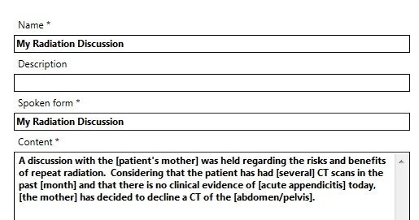

- Click Apply All
- Click Close

Now we can execute the Auto-Text by simply saying the name.
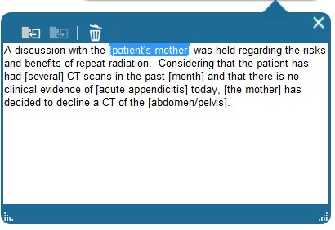
- Open your Dictation Box
- Say “My Radiation Discussion”

Observe that, just like the previous example, the entire block of text populated into the Dictation Box in one action. The difference is that now, the first of the variable fields is already highlighted.

Now we can navigate between our variable fields (bracketed items) to update the Auto-Text. Use the following scenarios to change your Auto-Text.
Perhaps, for this patient encounter, we held our discussion with the patient’s legal guardian (rather than the default value of mother). With the variable already highlighted:
- Say “Patient’s legal guardian”
Observe that our new dictation has overwritten the variable field.
We can navigate between the remaining variable fields using the “Next Field” and
“Previous Field” commands. Recall that the custom PowerMic buttons can be configured to execute these commands, too. You could also assign hotkeys to these commands.
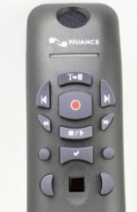
- Say “Next field” (or use the button on your PowerMic) Observe the next variable field (several) is now highlighted.
- Say “seven”
- Say “Next field”
- Say “2 years”
- Say “Next field”
Perhaps, for this patient encounter, the default values of [acute appendicitis] and [abdomen/pelvis] are appropriate. There is no need to dictate a new value over the default within the brackets.
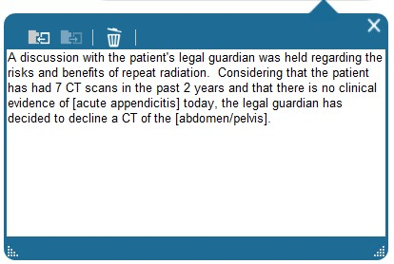
- Leaving the default value (acute appendicitis) unchanged, say “Next field”
- With the next variable field highlighted (the mother), say “the legal guardian” to overwrite it.

Now that we have updated our text to reflect the appropriate values for this patient interaction, the only step left is to get rid of the remaining delimiters. We can use the “Accept Defaults” command to finalize our editing.
- Leaving the last default value (abdomen/pelvis) unchanged, say “Accept Defaults”
Observe that the Accept Defaults command removed all of the remaining brackets within the passage.
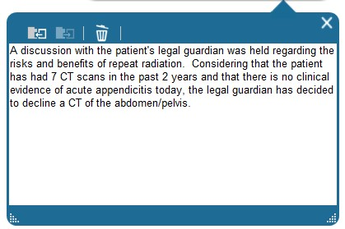

Exercise 3: Copy Auto-Text
For those on DM One version 3.5 or higher, you can copy Auto-Texts in order to create a duplicate entry that you can easily edit rather than recreate.
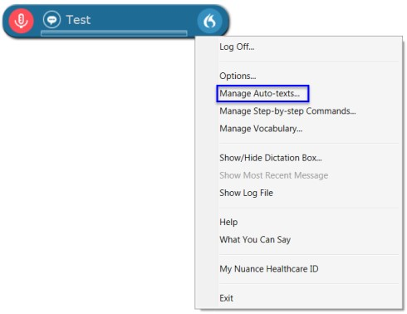
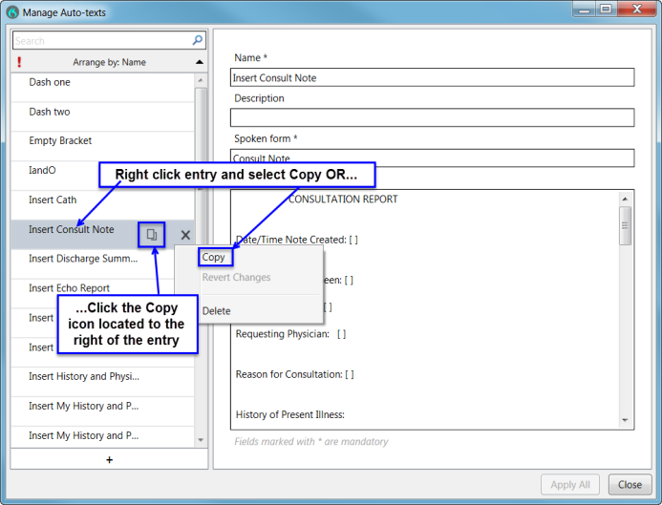
To Copy an Auto-Text
Select the Manage Auto-Texts option from the DragonBar drop-down menu.

From the Manage Auto-Texts window, identify the Auto-Text you would like to copy, right click on the entry and select Copy. You can also click the Copy icon located to the right of the entry to copy the entry.

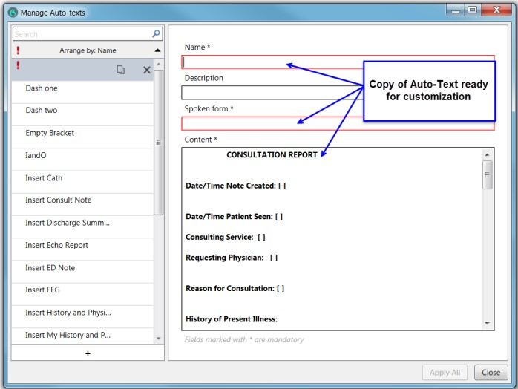
The “Revert Changes” feature reverts ALL recent modifications and changes back to its original state.

This will create a copy of the Auto-Text that is ready for customization.

Editing/Deleting Auto-Texts

Once an Auto-Text has been created, you can always go back and edit the Name, Spoken Form, or Content fields. You can also delete Auto-Texts that you no longer need.

Exercise 4: Editing an Auto-Text

- Say “Manage Auto-Text”
- Click on My Radiation Discussion in the list on the left
- You can click into any of the available fields and make changes as you see fit.
- Once you are done making changes to an Auto-Text, click Apply All

Exercise 5: Deleting an Auto-Text
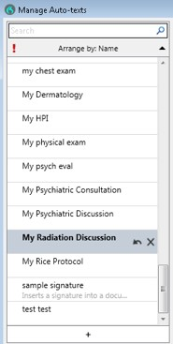

- Say “Manage Auto-Text”
- Click on My Radiation Discussion in the list on the left
- Click on the X symbol to the right of the Auto-Text name
Note: The Auto-Text will not actually be removed from your list until you click the Apply All button. This feature is helpful to avoid accidentally deleting Auto-Texts. If you accidentally delete an Auto-Text, you can use the arrow icon to restore it (only if you have not yet clicked Apply All).
- Click Apply All

