Nuance®
Dragon Medical One – Dealing with Mis-Recognised words

Manual Revision: Version 4.0
Dated 16th March 2020:
Author: A J Mitchell

Index
DMO Client
Page
- Index
- Correcting words using correction menu
- Manage words in the Manage Vocabulary
- Training Words by voice
- Adding a Pronunciation
- Deleting words from the Vocabulary
- Deleting double-barrelled words
- Viewing words in the Vocabulary
- Using the filter: Site / Group / User
- Adding Sentences, or group words in the Vocabulary.
- Adding Multiple pronounciations to the vocabulary

Nuance Management Center

- Adding words in the Nuance Management Center.
- Using .txt to import words.
- Deleting / Disabling words in the Nuance Management Center

There are 3 main areas where we can correct words:
- Correction menu (on the fly)
- Manage Vocabulary
- Using the Nuance Management Center

Dealing with Mis-Recognised words within Dragon Medical One.
A common issue is clipping of the first word when using a USB Microphone.
TIP: Remember, there is a slight delay when pressing the record button on your microphone to record your dictation. Get into the habit of waiting for the Dragon bar icon to turn green before starting your dictation.
Correction Menu. (Say “Select XXXX”)
You can work ‘on the fly’ and correct words as you come across mis-recognised words.
- You can select the text and record new text to overwrite the selected text
- You can select the text and use the correction menu to correct.

In this example, say “Select Karen”, then use the correction menu to select the word you wish to change. Example “Choose four” will change Karen to Carin.
**The system will ‘over a short time’ remember from this and start learning your preferences**
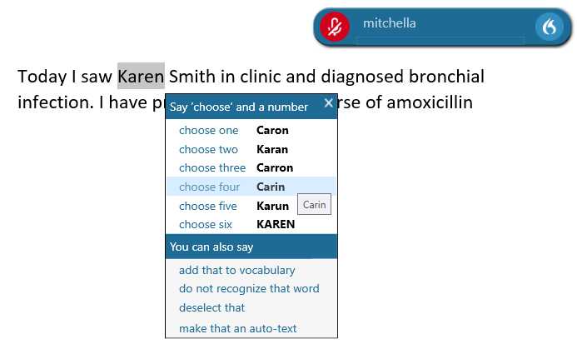
TIP: Remember to refrain from using the keyboard to ‘Hand type’ corrections. If possible, always use voice to make corrections.
You can add words in the Manage Vocabulary
Sometimes, words may need to be added to the vocabulary. Such words may be Doctor Names, Towns or places, Manufacturer names, new drug names and so on……
You may work in a Dietetic department where for example food names, such as Coco Pops, Aymes Shake Compact, Enshake, Fresubin Energy drink etc may need to be added.
- To do this Use the Dragon flame icon, and select Manage Vocabulary.
- You can even say “Manage Vocabulary” or “Add word”into your Microphone.

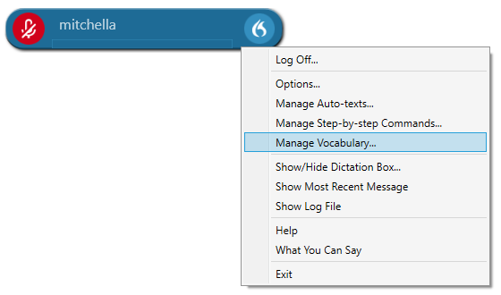
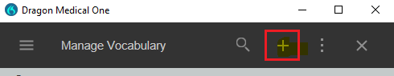

- Click the + sign or click ‘Add’.
- Type in the word you wish to add to the Vocabulary.

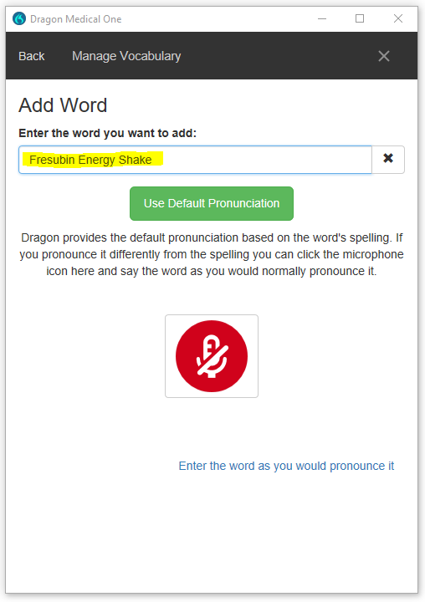
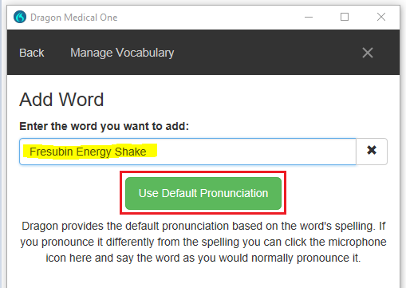

- In this case, as the word is spelt the way it is
Pronounced, use ‘Default Pronunciation’

In some cases, the word is not spelt the way it is pronounced. To correct these words, we can use either the
- Train word (Red Microphone button) or
- ‘Enter the word as you would pronounce it’

Train word
TIP: it is important you get the timings correct when using this function. Ensure there is no background noise. Making a mistake here can cause the word not to work at all. If you have doubts, train the word again.
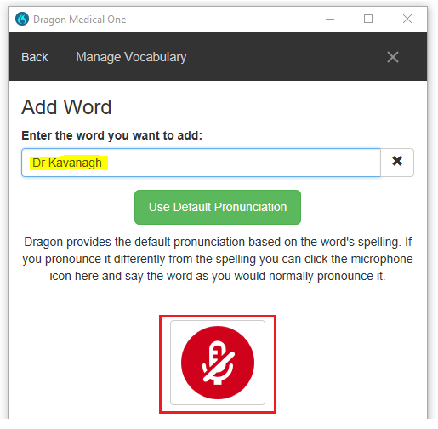

- Position your Microphone about 2/3 inches from your mouth. DO NOT use the record button on your Hand Microphone. The Microphone’s internal mic will automatically be enabled by the click of the RED button.
- WAIT! For the Red Icon to change Green. The green icon will ‘circle’ to indicate the Mic is listening.
- In your most ‘natural’ voice, say the word you wish to train. Do not enunciate or shout the word. Think about how you would naturally pronounce the word in a sentence.
- When your word is ‘heard’, the utility will analyse and process! It will run a comparison to what was heard to the word text. Once this is done click ‘Confirm’

** Sometimes, if the word ‘text’ differs too much from what is said, a warning will be displayed that the word differs too much from the text. In this case, you will get an option to try again
(Example 1) Try again
(Example 2) Accept or add a pronunciation.

Example 1
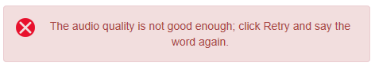
Example 2
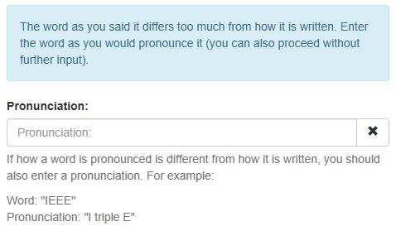
Adding a Pronunciation:
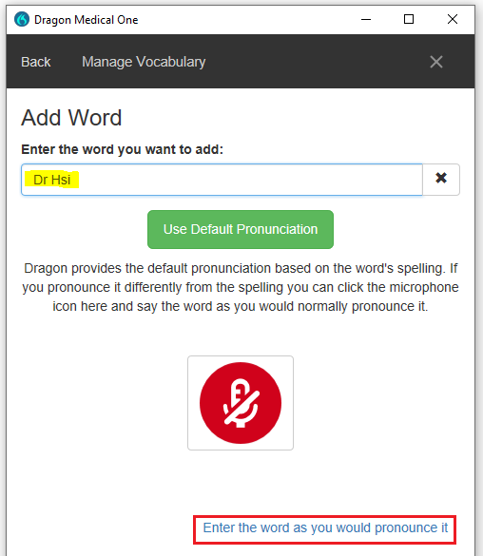
In this example we are using the word ‘Dr Hsi’, which is pronounced “Doctor hessey”
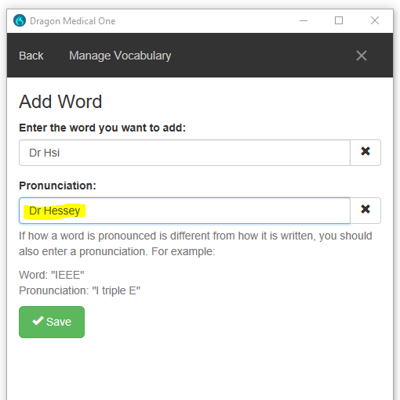
- Click ‘Save’ to save the entry

Deleting words from the Vocabulary
Sometimes it is necessary to delete words from the Vocabulary.
A word such as varicocele and hydrocele will undoubtedly be resulted as US spelling, varicocoele and Hydrocoele respectively. It may be necessary to delete the US spelling in this circumstance and add the UK spelling.
- Click on the ‘3-DOTS’ Icon
- Click ‘Disable’

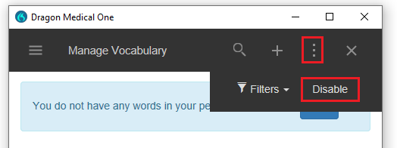

- Click ‘Confirm’ to confirm that you wish to input a word to delete.
- Type in the word you wish to delete and click ‘Disable’

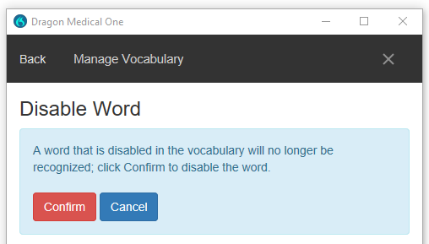
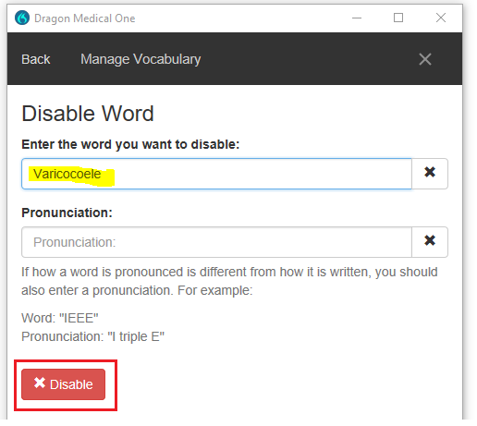

- Once successful, you will get the following prompt.

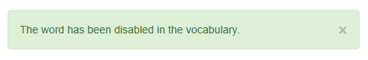

Deleting Double-Barrelled Words

Followup vs Follow up (Delete Follow-up)

There may be some double-barrelled words you will wish to disable from the Vocabulary. These work slightly different to single words.

Such an example is ‘Follow up’

When dictating ‘Follow up’ in Dragon Medical One, depending on the way it is pronounced, you may get the result with the 2 words joined. Such as followup.

To rectify this, you will need to disable the word ‘Follow-up’ (**Remember to include the dash in the middle of the double-barrelled word**)

This will ensure that you get the result: Follow up

Do I use ‘Enter the word as I would pronounce it’ as a translation tool, or delete the word?

Mum vs Mom

Rather than deleting/disabling a word in the vocabulary, the same result can be achieved by using the ‘Enter the word as I would pronounce it’ as a translation aid (as per the following example)

You could create a rule that simply translates mom to mum:

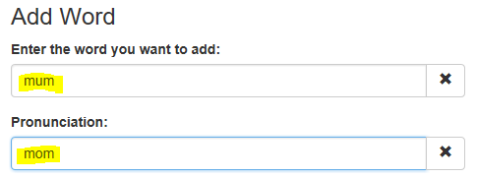

This may work depending on the way ‘mum/mom’ is pronounced.

**It is advised to delete the word if the ‘mom’ is never to be used**

Viewing words in the Vocabulary and the technique used to correct.

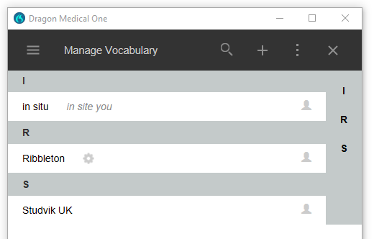

In the above example, you will get an indication of what technique you have used to add the word.
Word | Technique
in situ | Enter word as you would pronounce it (in site you)
Ribbleton | Trained word (Cog wheel)
Studvik UK | Use Default pronunciation (Blank)

Editing or Deleting words in the Vocabulary
If you wish to Edit / Re-train or delete a word, select the word and select the desired function.

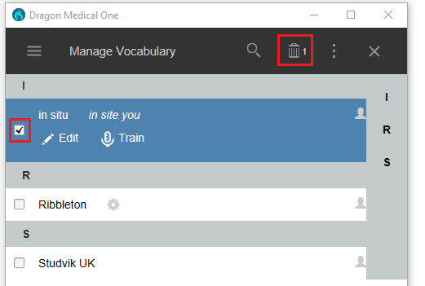

Site / Group / User words - Using Filters in the Vocabulary

So far, we have discussed adding words only in the Dragon Medical One client.

***Words added within the client can only be applied to the logged-on user***

Words can be added to Site/Group and individual users in the Nuance Management Center (NMC).

Ideally, words should be added at a Departmental (Group) level.
In certain circumstances, words may also be added at site level.
Site level includes all groups, and users within those groups.
Such examples may be the name of the Site Hospital or common words that apply for everyone at that site.

Your site Administrator may have added these words for you. Such words added at a Group or site level can be viewed in the Dragon Medical One client.

  - Select the ‘3-DOTS’ Icon
  - Select the Filters icon

Default is set to Users. This will always reset to ‘users’ when exiting the Vocabulary.

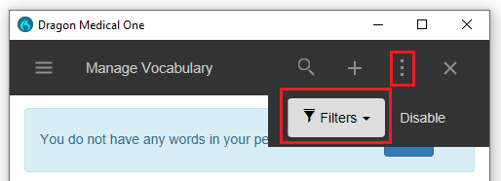

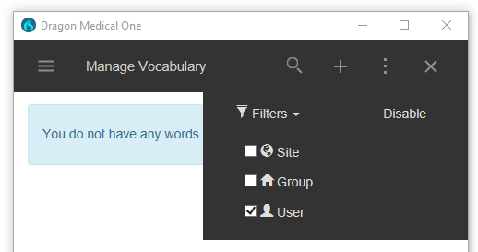

Adding sentences/groups of words in the Dragon Medical One Client

If for some reason a particular word is not being recognised, or the context is changing the word. Not only single words, but sentences can be added to the Vocabulary.

For example, if the clinician is saying: “There are 2 small cysts located in the fallopian tubes”

And for instance, the clinician requires the word ‘two’ rather than the numerical ‘2’, this would be hard to correct. You cannot delete 2, as it will be required in other reports.

Therefore, we can add to the vocabulary ‘two small cysts’. If this sentence is said at a reasonable speed, the DMO speech engine will provide a match for this added word, and hence produce:

“There are two small cysts located in the fallopian tubes”

-----------------------------------------------------------------------------------------------------------------------------

Maybe a word is being mis-recognised? Look at popular words that surround that word. There may be multiple sentences that word is used in.

For e.g. There is multiple metastasis in the xxxxxxx

If Metastasis is incorrect, as in this case. (as it is the singular version) You may wish for the plural version ‘Metastases’ instead.

Again, this may be difficult to correct, as the both words Metastasis and Metastases sound alike.

The solution here is to add: ‘multiple metastases’ in the Vocabulary.

Adding multiple pronunciations to a word.

It is possible to add more than one pronunciation to a word.
For example ‘Dr Kavanagh’ could be pronounced:
“doctor cavana” or “doctor cavanar”
To do this, add the word twice in the vocabulary.
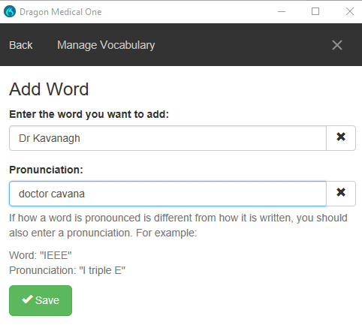
Save the first entry, then add another instance:
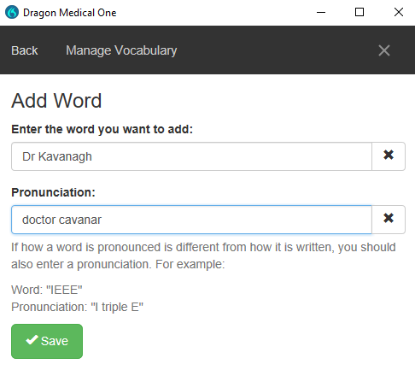
Save the second entry, and your result should be displayed as this:
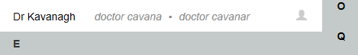

Nuance Management system (NMC): Adding words.

To improve Speech Recognition further, batches of words should be imported directly into the Site, group or individual user. For e.g. a ‘Dietetics’ Group would benefit further by adding Food/drink names. Any users added to this group would benefit from these added words.
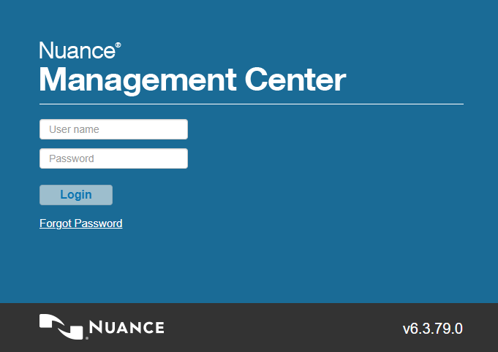
- Login to the NMC Portal
- Go to the Speech Recognition TAB
- Select ‘Manage’
          - Select ‘words’ from your list.
(You do not have to be on Group/site or user here)
- Select Import
- Select the file you wish to import.

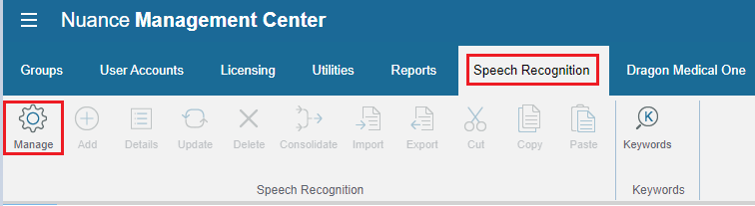

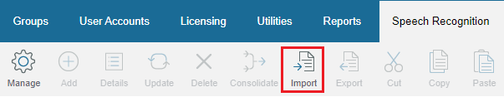

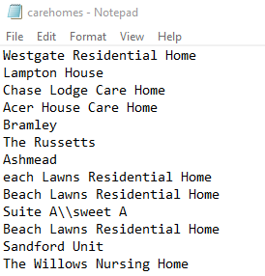
NOTES:
    - Words MUST be as a .txt file format as displayed in
The example on the left.

- Use a new line for each entry.

- Any pronunciation, should be separated by \\

For example:

Suite A\\sweet A
Dr Hsi\\doctor hessy

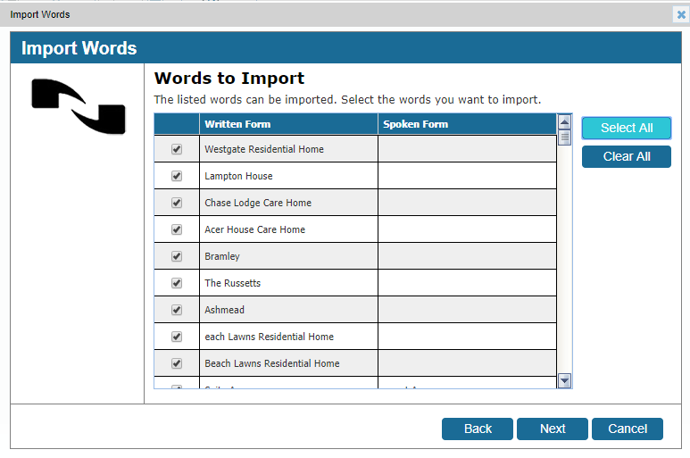

- Click ‘Select all’, or select the desired words you wish to import
- Click ‘Next’

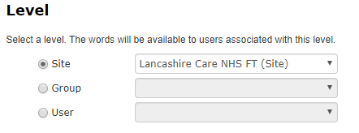
- The Level you wish the words to be imported to can now be selected. (Site / Group / User).
- Click next

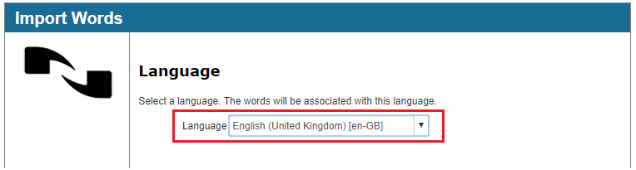

- IMPORTANT: Select the correct Language. English (UK)(en-GB)
This will normally be default to US format.
- Click ‘Next’
- Import will start

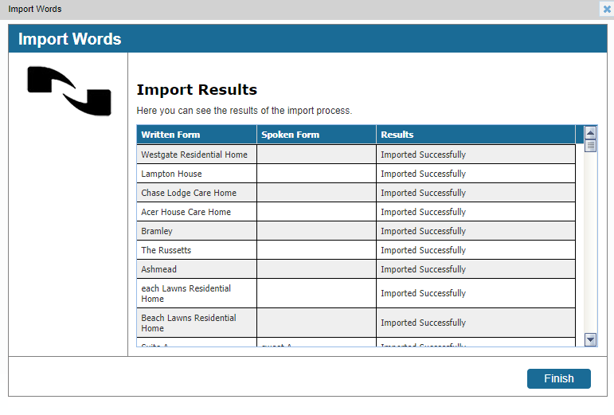

- Results of your import will be displayed.
- Click finish to exit
Deleting words in the Nuance Management Center (NMC) for
user / Group /site.
It may be necessary to delete or disable words at a Group or site level. This can be performed in the Nuance Management Center.
Maybe a group of Radiologists in the Radiology group wish for the word ‘Hydrocoele’ to be disabled. Disabled as meaning, they do not wish that word to be produced in the DMO Client.
**Deleting a word – meaning to disable a word***

- Log in to your NMC and Select the Speech Recognition TAB
- Click Manage.
- On the Left-hand side, select words and navigate to the location where you wish to delete / disable words from. This could be Site, Group or user level.
- if the word is not already present, add the word first. (as below)
- IMPORTANT: Ensure English (United Kingdom) (en-GB) is selected. (Default is US)

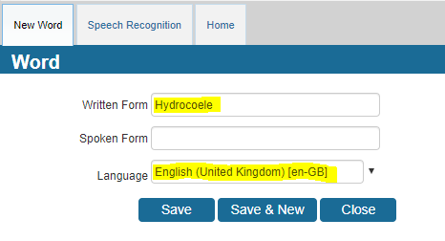
- Click ‘save’ or ‘Save & new’ if you wish to add another word.
Now the word has been added, you need to delete (disable) the word. This will ‘earmark’ the word to tell the system not to ever produce this word.
- Select the word you have just added

- Right Click, and select ‘Delete Word’
- You will get the following warning. Click OK.

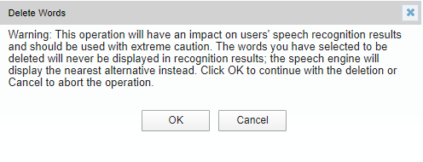
- You can view deleted words by selecting the following:

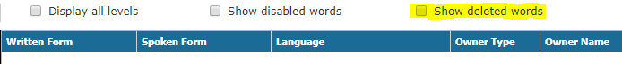
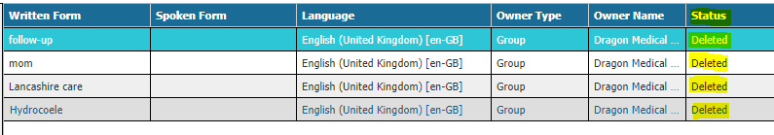
** Remember, this can be done at User, Group or site level**

