Step-by-Step Commands

Overview:
Step-by-step commands are an extremely useful way to accomplish a variety of tasks with your computer and with your EMR. The potentials range from a simple command to open a folder or website your visit regularly, to adding structured data from your EMR into a note in progress, to navigating within your EMR, to complex multi-step commands which lead to complex sequential actions. The beauty of the process is that you don’t need to know anything about computer programming, but simply learn the six categories of steps which can be created. Each of these six categories involve actions which can be customized to your needs. Like other aspects of using Dragon Medical One, your 10-year-old daughter could figure these out. They are not hard!
Commands can be created to do the following by means of voice:
- Insert text (see information on Auto Text above)
- Open any program, document or web page
- Control the microphone
- Press any key or key combination
- Combine any of the above into more complex sequential processes

Creating a Command
Creating a new command requires the following steps:
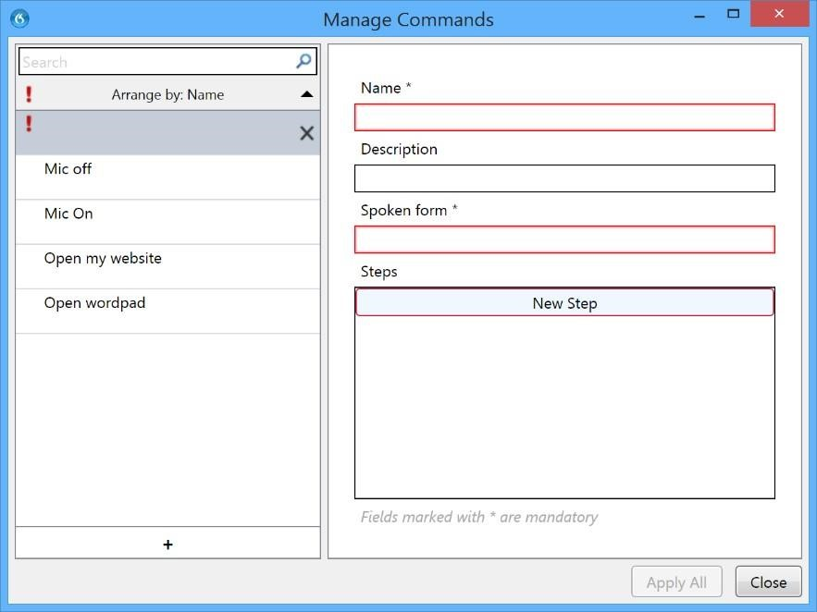
- Click on the Nuance icon on the Dragon Medical One console
- Select “Manage Step-byStep Commands …”
- Click on the “+” symbol on the bottom left
- Provide a name for the command (this is the verbiage which will launch the command) and type this in the appropriate box on the right side of the screen.

Click on the area entitled “New Step”
- From the drop-down menu select a line appropriate for the type of action or command you are planning
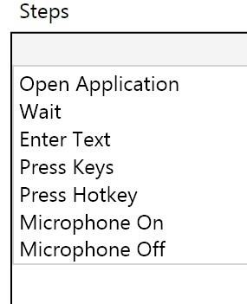
  - Open application: this is used to create a step which opens a document, application or web page
  - Wait: this creates a time delay in waiting for one step to complete before moving on to another step. The time is measures in milliseconds, i.e. 1000 ms = 1 second. The allowable range is 50-2500 ms.
  - Enter Text: this is used to enter some discrete text and is intended for only short lines of text (use Auto-Text, described above, for inserting large amounts of text)
  - Press Keys: although superficially similar to “Enter Text” this function is designed for situations in which a key depression is actually controlling a process rather than simply adding text. The Press Keys function can allow entry of keys not necessarily viewable on your keyboard. See the appendix for a list of keys and modifiers.
  - Press Hotkey: designed for situations in which a key combination is required such as “ctr + p” to send a print command or any combination in which a key is combined with a control, alt or shift key.
  - Microphone on or off: sometimes these steps can be the intent of the command. In other situations, particularly in commands with long sequences of steps during which you don’t want the microphone active as the command is going through its sequences, you might want to turn off the microphone at the beginning and then back on again at the end. In so doing, it prevents inadvertent sounds from influencing things during the course of a long sequential command.
- Sequentially click on the add step button to add further steps
- If necessary, add a “wait” step to provide any needed pauses in the command sequence
- If necessary change the order of the steps, using up and down arrows
- Click on “Apply All” to save the command

Sample Command: Printing a Document
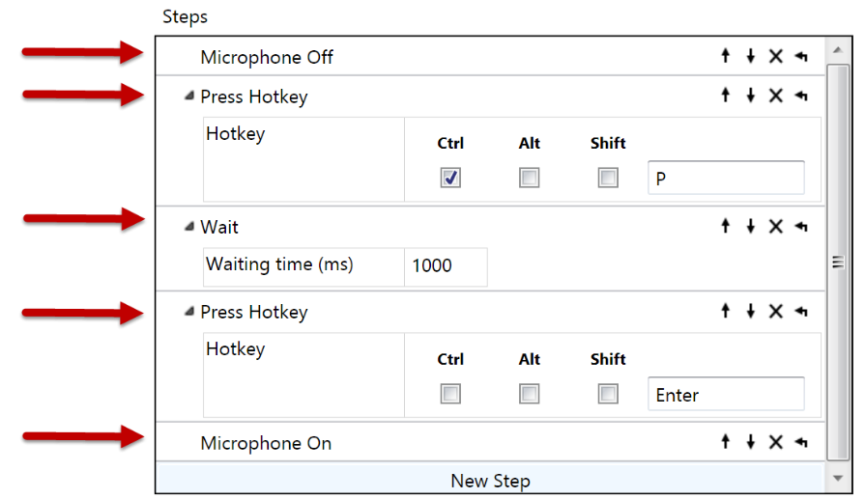
The command shown to the right is designed to print the current document and has five steps, including:
Step 1: turn off the microphone
Step 2: send the key combination control + p to open the print window
Step 3: wait 1 second
Step 4: Press the Enter key to confirm the print instruction
Step 5: Turn the microphone back on

Sample Command: Open a web page or Folder
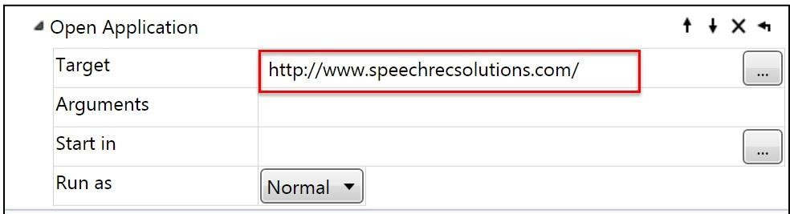
Creating a command to open a web page uses the “open application” functionality in a step-by-step command and this is done by adding a step and then simply pasting the URL for the web page in the box. See example to the right. The same principle can be used in creating a command to open a specific folder on your hard drive. In this case you need to paste the formal path to the folder, such as: C:\Users\jon w. wahrenberger\Documents\Speech Recognition Solutions

Sample Command: Emulating a “dot phrase” in the Epic EMR
For the Epic users out there, you know that a “dot phrase” or SmartPhrase is the mechanism by which you can initiate the insertion of text, a note template, or structured data by typing a “.” (dot) followed by specific letters and then hitting the enter or return key. The example shown here is fairly universal and can be applied to any of your dot phrases simply be changing the text to be typed during one stop. For this example, let’s say you want to create a command that will insert the patient’s most recent labs, which involves tying .LAB followed by an enter or return key. Here’s how you would create the step-bystep command from scratch:
- Navigate from the DragonBar menu to Manage Step-by-Step Commands
- Click on the small “+” on the bottom left of the Manage Step-by-Step commands page
- Name the command “Insert Labs” (type this into the name section) 4. Click on the “new step” button
From the drop-down menu, select “Press Keys”
- Type “.Labs” (commands are not case sensitive, so type it any way you want)
- To accept and move to the next step, click on the “new step” button again. The first step will be saved
- For the next step, select “Hotkey” from the drop-down menu. By default, the cursor will be in the text entry box
- Press the Enter key on your keyboard. The word Enter will now populate the text box
- (It is not necessary to click in any of the hotkeys modifier boxes)
- Since the prior step represented the final step, click on the “Apply All” button.
When done, the command should appear at pictured below. Hereafter, when in the Epic EMR you can initiate the SmartPhrase by saying “Insert Labs”.
