Annual Health Check Awareness Drop in sessions for carers and people with learning disabilities
Come and join us and learn more about what happens during an Annual Health Checks with the Nurse or Doctor.
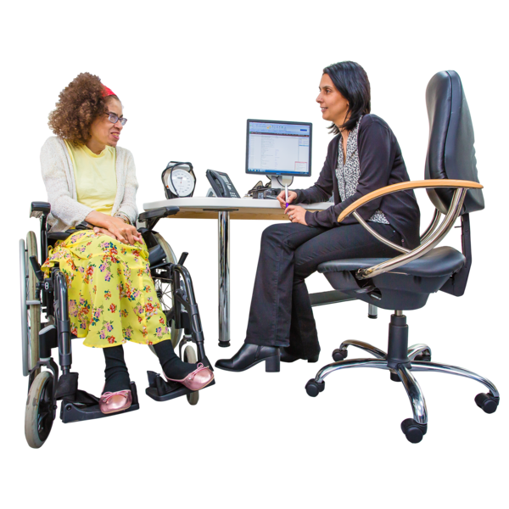
Understand why annual health checks are important and how we can help you to have one.
Venues and dates

Monday 20th June 2022- Weatherley Centre, Eagle Farm Road, Biggleswade, Beds, SG18 8JH (10-12pm)
Wednesday 22nd June 2022 Bedford Heights, Room 3, Brickhill Drive, Bedford, MK41 (10-12pm)
Monday 28th June 2022, The Hat Factory, 65 - 67 Bute Street, Luton,
LU1 2EY (10-12pm)

Feel free to drop in on the day and if you want more information, please email elft.-hfs@nhs.net or ring Simone Mingay on 07833 294335.

