Making a Beautiful

Musical Tree

Celebrate summer by
making Art and Music
at Twinwoods

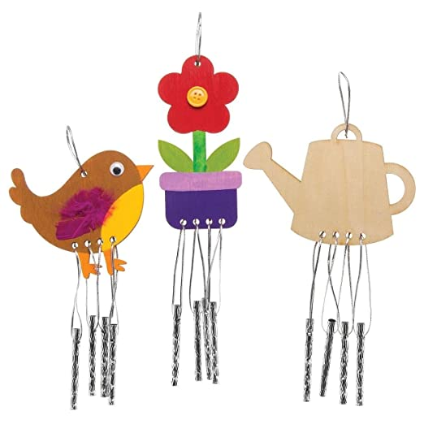

Enjoying the Sun
and
Having Fun

Tuesday 21st June 1 – 2.30pm

