Come and join us and learn more about the menopause
Menopause Awareness Session for carers and people with learning disabilities
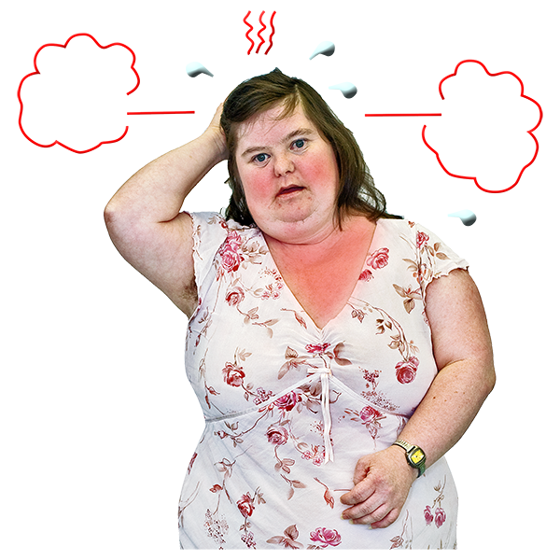
Learn about how the menopause can affect women.
Understand how you can recognise some of the signs and symptoms.
This is your chance to ask any questions you might have.
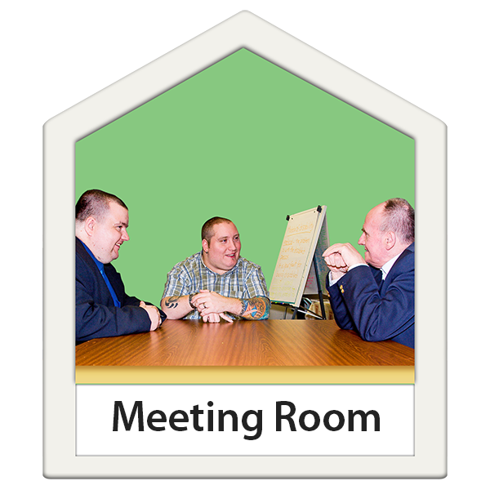
Date and Venue
28th June 2022
St Andrews Church Hall, Kimbolton Road, Bedford, MK40 2PF (Holt Room) from 6.30pm- 8.30pm
Enjoy some refreshments
Please confirm your attendance via email to elft.-hfs@nhs.net by 17 June 2022 or ring Simone Mingay on 07833 294335.

