ELFT WASTE REDUCTION 2022

Sign up for one of our waste reduction tool workshops!

Monday 18 July, 9:00 – 9:45 am AND Friday 22 July, 9:00 – 10:00 am
Monday 12 Sept, 9:00 – 9:45 am AND Friday 16 Sept, 9:00 – 10:00 am

These sessions are open to staff at every level and in every directorate of the Trust. We have already trained around 60 staff to use this tool and we welcome service users and carers to join these sessions too.

You can book here: https://forms.office.com/r/3rhJgP11gx

This week, as part of our campaign to reduce waste at ELFT, we wanted to share the stories of a group of corporate services staff who attended our waste reduction tool workshops.

Our corporate services play a key role in supporting clinical staff to deliver high quality care to those we serve. Staff in these areas oversee a large number of systems and processes which are utilised by staff across the entire Trust on a daily basis.

Tackling any waste in those systems and processes – freeing up money and time – can allow more effective allocation of resources to areas where we can have a real impact on the health and wellbeing of our service users and staff.

The corporate staff joined three mini-workshops and in the first, they were introduced to the ‘8 Wastes Tool’. This originates from Japanese car production in the 1950s but has been widely adopted across the world and in healthcare. It categorises different types of process waste; the bits of a process that do not add value for staff, service users or those we serve. Lucy Duggan, one of our Corporate Executive Assistants who attended the workshop found it eye opening “to start to think of waste as more than wasting paper. The workshop helped me identify that the biggest commodity my team waste is time”.

Taking the first letters of each of the 8 wastes forms the DOWNTIME acronym; to help you remember this, think of downtime as that bit of the week or the month when you might have a little time to consider whether your processes are efficient. The wastes are described below:

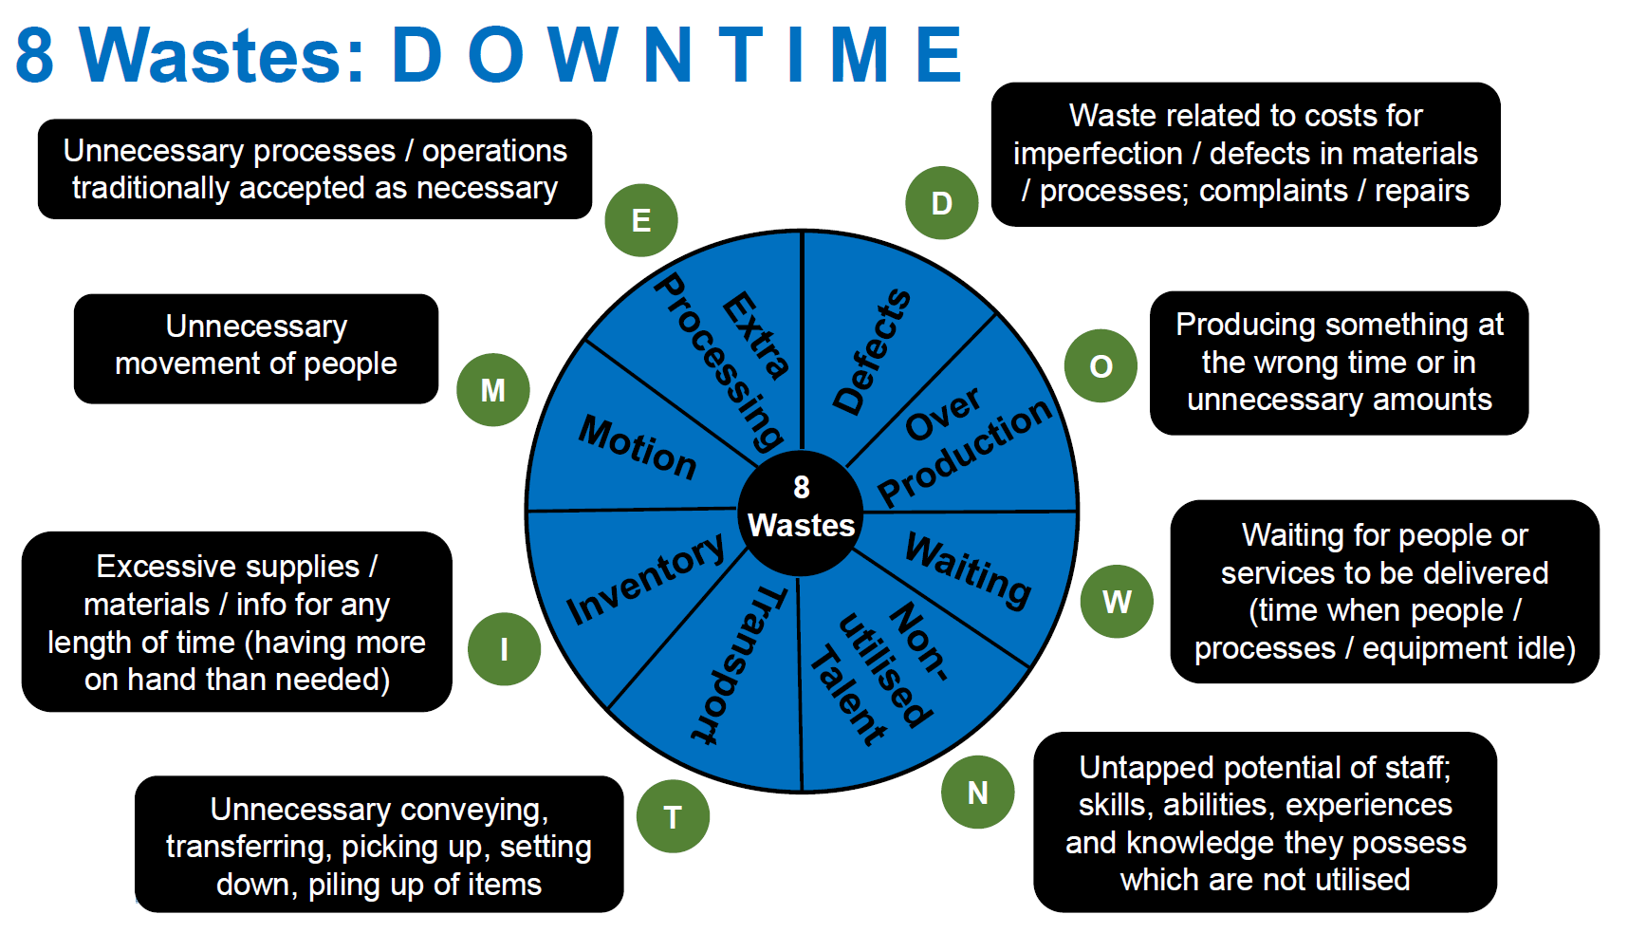
The tool is easy to use and can be applied to any system or environment. A local food outlet or supermarket can be great places to identify some of the 8 wastes in action. The next time you’re in one, see what you can spot!

Waste Tool sessions are a collaboration between our Value and Quality Improvement Teams. Norbert Lieckfeldt, Corporate Governance Manager, found it helpful to link waste reduction with the QI methodology he is already familiar with: “one big breakthrough for me during the workshops was finding I could test my hypothesis first, before embarking on wholesale change simply based on my assumptions”. Norbert had identified that the Trust spends almost £30,000 per year posting paper copies of TrustTalk to our members, although many are tech savvy and conscious of the environmental impact and would be happy to access an electronic version.
Another key piece of work emerging from these sessions was the digitisation of staff travel and subsistence claims, reducing paper and speeding up process time; this should have a really positive impact on a huge number of staff across the Trust.

If these stories stimulate some ideas about the waste in your area of work but you need some support to reduce or remove it, sign up to our waste reduction tool workshops in July and September! ttps://forms.office.com/r/3rhJgP11gx

Please continue to get in touch with sarah.barnett6@nhs.net if you have a waste reduction story to share or if you need any support to address some waste you have identified.

Together, we can all reduce waste at ELFT

Programme MANAGEMENT Team
Lorraine Sunduza Chief Nurse & Financial Viability Exec Lead
Samanthi Gibbens Interim Chief Finance Officer & Financial Viability Exec Lead
Sarah Barnett Financial Viability Programme Manager
Dr Waleed Fawzi Financial Viability Clinical Lead

