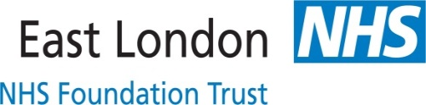
HELLO MY NAME IS....BADGE ORDER
East London Foundation Trust has embarked on the “#Hello my name is”….campaign to ensure that we continue to improve our relationships with those with serve and promote dignity in care. To this effect all departments are expected to order and wear the yellow badges.
To order your YELLOW badge, please use the contact details below:
K & R Badges Ltd (contact name – Kelvin)
Unit 11 Atlantic Business Centre
Atlantic Street
Altrincham
WA14 5NQ
Telephone: 0161 929 2440
Email: kelvin@kr-badges.co.uk
Web : www.kr-badges.com

PLEASE ADVISE KELVIN / WHOEVER PICKS THE CALL AT KR BADGES THAT YOU ARE FROM EAST LONDON FOUNDATION TRUST (ELFT)

The cost for each badge is £2.60 plus carriage & VAT

Postage Cost:
1 to 5 badges £1.25
6 to 30 badges £3.60
31 to 40 badge £4.00
41 to 55 badges £5.50
56 to 70 badges £5.90

All plus VAT.

You can order using your budget code.

For more information, please contact Caroline Ogunsola on c.ogunsola@nhs.net or call 07901 009 092

