Respiratory Infections Policy

|  |  |
| --- | --- |
| Version number : | 1.0 |
| Consultation Groups | Infection Prevention & Control Committee  Quality Committee |
| Approved by (Sponsor Group) | Infection Prevention & Control Committee  Quality Committee |
| Ratified by: | Infection Prevention & Control Committee |
| Date ratified: | October 2022 |
| Name of originator/author: | Infection Prevention & Control Team |
| Executive Director lead : |  |
| Implementation Date : | October 2022 |
| Last Review Date | October 2022 |
| Next Review date: | October 2023 |

|  |  |
| --- | --- |
| Services | Applicable |
| Trustwide | X |
| Mental Health and LD |  |
| Community Health Services |  |

Version Control Summary

|  |  |  |  |  |
| --- | --- | --- | --- | --- |
| **Version** | **Date** | **Author** | **Status** | **Comment** |
| 01 | 03-08-2022  07/10/22 | Rana  Begum | Final | Policy development in line with national guidance to management all respiratory infections:   * Influenza * Avian influenza * Parainfluenza * Respiratory Syncytial Virus * Adenovirus * Human Metapneumovirus * Rhinovirus * MERS coronavirus * COVID-19   Updates in line with national guidance updated- paused on asymptomatic patient & Staff testing |

# **Table of Contents**

|  |  |  |
| --- | --- | --- |
|  |  | **Page Number** |
|  | Policy | 7 |
|  | Executive Summary | 7 |
|  | Scope/Purpose | 7 |
|  | Roles & Responsibilities | 7 |
|  | Introduction | 8 |
|  | Respiratory Virus Transmission | 8 |
|  | Influenza | 9 |
|  | Pandemic Influenza | 9 |
|  | Avian Influenza | 9 |
|  | Parainfluenza (HPIV) | 10 |
|  | Respiratory Syncytial Virus (RSV) | 10 |
|  | Adenovirus | 11 |
|  | Human Metapneumovirus | 11 |
|  | Rhinovirus | 11 |
|  | Coronaviruses | 11 |
|  | Middle East Respiratory Syndrome Coronavirus (MERS-CO) | 12 |
|  | SARS Coronavirus | 12 |
|  | Management of CORONAVIRUS 2019 (COVID-19) Infections | 13 |
|  | Transmission of COVID-19 | 13 |
|  | Infectious Period of COVID-19 | 14 |
|  | Symptoms of COVID-19 | 14 |
|  | Management Pathway for Patients with COVID-19 Infection in Inpatient Ward Settings. | 15 |
|  | Management Pathway for Patients with COVID-19 Infection in Community/ Domestic Settings | 15 |
|  | Management Pathway for Healthcare Staff Members with COVID-19 Infection | 15 |
|  | Management Pathway for Service-User Who Is a Contact of Positive COVID-19 Case | 15 |
|  | Management of Individuals Who Are at Higher-Risk (Clinically Vulnerable) of Severe Illness from COVID-19 | 15 |
|  | Stepping Down Care in Isolation for Extremely Clinical Vulnerable Patients | 15 |
|  | Documentation of Lateral Flow Test / PCR Results | 15 |
|  | Management of COVID-19 Outbreaks | 15 |
|  | Admitting to Wards with Active COVID-19 Outbreaks | 15 |
|  | Root Cause Analysis Investigations of Hospital onset of COVID-19 Infections | 15 |
|  | Patient/ Service User Information for COVID-19 | 15 |
|  | Vaccination | 16 |
|  | Management of Respiratory Infections | 17 |
|  | Standard Infection Prevention Control Precautions (SICPs) | 18 |
|  | Patient Placement in Inpatient Setting | 18 |
|  | Hand Hygiene | 18 |
|  | Respiratory Hygiene/Cough Etiquette | 19 |
|  | Personal Protective Equipment (PPE) | 19 |
|  | Donning and Doffing of PPE | 20 |
|  | Aerosol Generating Procedures | 20 |
|  | Safe Management of the Care Environment | 21 |
|  | Safe Management of Care Equipment | 22 |
|  | Safe Management of Healthcare Linen | 22 |
|  | Safe Management of Blood and Body Fluids | 22 |
|  | Safe Disposal of Waste (Including Sharps) | 22 |
|  | Occupational Safety: Prevention and Exposure Management | 22 |
|  | Environmental Cleaning | 22 |
|  | Use of Portable Fans/ Recirculating Air Conditioning Units | 22 |
|  | Crockery & Cutlery | 22 |
|  | Outbreak Management of Respiratory infections | 22 |
|  | Management of Tuberculosis Infections | 23 |
|  | References | 27 |
|  | Appendices  See page 4 for full list | 29 |
| **55** | Document Control  55.1 Procedure Control  55.2 Equality Analysis  55.3 References | 99  100  101  108 |

# **List of Appendices**

|  |  |  |
| --- | --- | --- |
|  |  | Page Number |
|  | COVID-19 Patient Testing Pathway | 30 |
|  | Management Pathway for Service User with Covid-19 | 32 |
|  | Management Pathway for Patient with COVID-19 Infection in Community/Domestic Settings | 33 |
|  | Management Pathway for Healthcare Staff Member with COVID-19 Infection | 34 |
|  | Staff Testing Flowcharts | 35 |
|  | Stay at Home Flowchart for Staff Tested Positive for COVID-19 Infection | 36 |
|  | Staff Identified as Contact of a Person with Covid-19 | 37 |
|  | Staff Identified as Contact of a Person with Covid-19 Outside of Work | 39 |
|  | Management Pathway for Service User/ Patients Contacts of COVID-19 | 40 |
|  | Management of Individuals Who Are at Higher-risk (Clinically Vulnerable) of Severe Illness from COVID-19 | 41 |
|  | Stepping-down of Care in Isolation Precautions for Severely Immunosuppressed Patients | 45 |
|  | Documentation of Lateral Flow Test / PCR results/ RIO Crib-Sheet. | 46 |
|  | Management of COVID-19 Outbreaks | 53 |
|  | A-Z Management of an Outbreak | 54 |
|  | Contact Tracing Form for Occupational Health-Team | 55 |
|  | Outbreak Checklist | 56 |
|  | Reporting to the UK Health Security Agency | 57 |
|  | Covid-19 Outbreak Meeting – Chairing Guide | 58 |
|  | Admitting to Wards with Active COVID-19 Outbreaks | 61 |
|  | Root Cause Analysis Investigations of Hospital-onset COVID-19 Infections Flowchart | 63 |
|  | Root Cause Analysis (RCA) Form for Reviewing Hospital-onset COVID-19 Cases | 64 |
|  | Risk Assessment Template for COVID-19 Exposures in Healthcare | 73 |
|  | Virology Diagnostic Testing | 76 |
|  | PPE Requirements When Caring for Suspected/Confirmed Respiratory Infection | 78 |
|  | PPE Guidance for General Areas, Including Non-Patient Facing Environments | 79 |
|  | Donning and Doffing of PPE (Poster & Video Links) | 82 |
|  | Factsheet and Guidance on the Use of Filtering Face Piece Mask (FFP3 Mask) | 89 |
|  | Risk Assessment Guide for Wearing FFP3 Masks | 92 |
|  | Environmental Cleaning | 93 |
|  | Patient Information Leaflet on COVID-19 | 97 |

**Abbreviations**

|  |  |
| --- | --- |
| Human Metapneumovirus | HMpV |
| Respiratory Syncytial Virus | RSV |
| Human Parainfluenza Virus | HPIV |
| Coronavirus 2019 | COVID-19 |
| Middle East Respiratory Syndrome coronavirus | MERS-CO |
| Severe Acute Respiratory Virus | SARS |
| Aerosol Generating Procedures | AGPs |
| Upper Respiratory tract infection | URTI |
| Respiratory tract infection | RTI |
| Personal Protective Equipment | PPE |
| Filtering Face Piece respirator masks | FFP3 |
| Lower Respiratory tract infection | LRTI |
| Upper Respiratory tract infection | URTI |
| Infection Prevention & Control Team | IPCT |

# **Policy**

1. **Executive Summary**

This policy sets out standards for the assessment and management of patients with proven or suspected respiratory virus infections on Influenza, Avian influenza, Parainfluenza Respiratory Syncytial Virus, Adenovirus, Human Metapneumovirus, Rhinovirus, Middle East respiratory syndrome coronavirus (MERS-CoV) & Coronavirus 2019 (COVID-19).

1. **Scope/Purpose**

The purpose of this document is to provide information on how to manage patients with respiratory infections, in order to minimise the risk of transmission within the healthcare setting. This policy applies in all Trust settings for the care of patients (all ages) presenting with acute febrile respiratory tract illness which is suspected or proven to be due to a respiratory virus.

It should be used in conjunction with up-to date guidance from UK Health Security Agency (UKSHA) and the Department of Health; national guidance is regularly updated in accordance with circulating strains of Influenza/ Variants of COVID-19 prevalent in UK and the global status of respiratory virus outbreaks.

The policy covers infection prevention and control measures for common respiratory viral infections. Various infections e.g. varicella, measles etc. may be transmitted via the airborne route; however these will not be covered by this policy. Please refer to the Infection Prevention & Control Policy Manual for further information.

1. **Roles & Responsibilities**

|  |  |
| --- | --- |
| **Person/Department** | **Key Responsibilities** |
| Chief Executive Officer (CEO) | * Has overall accountability for the Trust policies |
| The Director of Infection Prevention and Control (IPC) | * To provide assurance to the board that IPC systems are in place that IPC risks are managed effectively for staff, patients and visitors across the Trust. * To ensure that any shortfalls in policy implementation are addressed. |
| IPC Doctor/ Microbiologist | * To provide advice on management & diagnosis of respiratory virus infections. |
| Infection Prevention & Control Team (IPCT) | * Act as role model for best IPC practice * Update this policy as required and immediately following any update on national guidance * Provide IPC training for all relevant staff where required * Act as an expert resource and support for all staff. |
| Borough Lead Nurses/Service Leads/ Modern Matrons/Team/Ward Managers | * Act as a role model * To ensure the implementation of this policy * Act upon IPC advice and disseminate information accordingly to teams * Ensure that staff are fit tested and aware of fit testing compliance figures within their departments |
| Infection Prevention & Control Champions | * Act as role model for best IPC practice * Support the IPCT to deliver the IPC agenda * Assist in creating an environment that is IPC safe for the patient, staff & visitors |
| Fit testing Team | * Provide training on fit tested for use of FFP3 respirator masks * Maintain accurate staff records on fit testing compliance |
| Occupational Health department | * Providing advice for staff affected by respiratory viral infection including when to return to work * Providing advice to staff who have had contact with patients with respiratory viral infection regarding their own health, including staff with underlying risk factors. * Follow up for staff contacts of patients with emerging severe respiratory virus infections. |
| All staff (including bank,/agency or contracted staff) | * All Healthcare staff has a responsibility to comply with Trust policies for prevention and control of infection; those who provide direct patient care must ensure they are up to date with PPE usage procedures. * Healthcare staff who may perform aerosol-generating procedures or care for patients with severe emerging respiratory viruses (e.g. avian influenza, MERS, COVID-19) must ensure they are trained in and fit tested for use of FFP3 respirator masks. |

1. **Introduction**

A respiratory tract infection (RTI) is an infectious process affecting any part of the upper and/or lower airways. Common viral causes of RTIs include: rhinoviruses, coronavirus, influenza, parainfluenza and Respiratory Syncytial Virus (RSV).

1. **Respiratory Virus Transmission**

The pathogens that cause respiratory tract infections are spread through one or more of four main routes:

1. **Large Droplet Transmission:** Virus containing droplets greater than 5 microns in size may be generated from the respiratory tract during coughing, sneezing or talking. If droplets from an infected person come into contact with the mucous membranes (mouth or nose) or surface of the eye of a recipient, they can cause infection. These droplets remain in the air for a short period and travel about one metre, so closeness is required for transmission.
2. **Direct Contact Transmission:** Infectious agents are passed directly from an infected person to a recipient who then transfers the organism into their mouth, nose or eyes.
3. **Indirect Contact Transmission**: A recipient has contact with a contaminated object (fomite) e.g. furniture or equipment. The recipient then transfers the organism from the object to their mouth, eyes or nose.
4. **Airborne transmission** during and after Aerosol Generating Procedures (AGPs) can produce droplets <5 microns in size. These small droplets can remain in the air, travel more than one metre from the source and still be infectious, either by mucous membrane contact or inhalation.
5. **Influenza**

Influenza or 'flu' is a respiratory illness caused by infection by influenza virus. It affects mainly the nose, throat, bronchi and, occasionally, lungs. Infection usually lasts for about a week, and is characterized by sudden onset of high fever, aching muscles, headache and severe malaise, non-productive cough, sore throat and rhinitis.

Influenza occurs most often in winter and usually peaks between December and March in the northern hemisphere. Illnesses resembling influenza that occur in the summer are usually due to other viruses.

There are two main types that cause infection: influenza A and influenza B. Influenza A and influenza B must not be nursed together in the same immediate environment.

Influenza A usually causes a more severe illness than influenza B. The influenza virus is unstable and new strains and variants are constantly emerging, which is one of the reasons why the flu vaccine should be given each year.

The typical incubation period for influenza can be up to 7 days, with an average of 2-5 days. Individuals infected with Influenza are regarded as being infectious for one day before the onset of symptoms and up to 7 days after the onset of the symptoms. Severely immunocompromised persons can shed virus for weeks or months.

Most infected people recover within one to two weeks without requiring medical treatment. However, in the very young, the elderly, and those with other serious medical conditions, infection can lead to severe complications of the underlying condition, pneumonia and death.

1. **Pandemic Influenza**

Pandemics arise when a new influenza virus emerges which is capable of spreading in the worldwide population. Pandemic influenza may occur when a new influenza A virus subtype emerges which is markedly different from recently circulating strains and is able to infect humans and spread efficiently from person to person and cause significant clinical illness in a high proportion of those infected. This was the situation during the influenza pandemic of 1918-19, when a completely new influenza virus subtype emerged and quickly spread around the globe.

The H1N1 (2009) 'swine flu' pandemic virus emerged in Mexico in 2009 and spread around the world causing mild/asymptomatic disease in the majority of cases but severe illness and death in a small proportion of cases, particularly in more vulnerable groups. In August 2010 the WHO officially declared the H1N1(2009) pandemic over, although the strain still causes a minority of Influenza A infections (as of 2017).

1. **Avian Influenza**

Avian influenza (bird flu) is a disease of birds caused by Influenza A viruses closely related to human influenza viruses. It naturally circulates in wild waterfowl such as ducks and geese; other bird species are susceptible and it may cause severe disease in birds with high mortality.

Avian influenza A(H7N9) emerged in 2013 in China where, as of May 2017 it has resulted in 1,486 laboratory-confirmed human infections, including at least 571 deaths.

Avian influenza A(H5N1) has been reported to have caused 859 confirmed human cases and 453 deaths between 2003 and May 2017. Outbreaks with avian influenza A(H5N1) have occurred amongst poultry in a number of countries during 2016/17 including in West Africa

(Nigeria, Niger, Libya, Cameroon, Cote d’Ivoire) the Middle East (Iran) and Asia (Vietnam, Nepal, India, Bangladesh, Cambodia, Nepal), however since 2015 the only human cases reported were in Egypt.

Avian influenza A(H5N6) has been responsible for widespread outbreaks in birds across China, Japan and South East Asia, and in 2017 significant outbreaks have been reported from Mainland China, Japan, Taiwan, Hong Kong, Myanmar and Vietnam. 17 human cases of avian influenza A(H5N6) have been reported in China since 2014 with at least 10 deaths

Avian influenza A(H5N8) is an emergent, highly pathogenic avian influenza virus that affects birds and was first reported in January 2014 and has since been detected in many countries including the UK, although human infections have not been identified as of June 2017.

Avian influenza viruses do not currently infect humans easily and most cases occur after close contact with poultry or birds. There have been no reports to date of sustained human-to-human transmission, although the associated mortality has been high. However, the potential for transformation of avian influenza into a form that both causes severe disease in humans and spreads easily from person to person leading to an avian influenza pandemic is a great concern for world health.

Additional precautions are indicated if epidemiology suggests possible exposure to avian influenza (including returning travellers).

1. **Parainfluenza (HPIV)**

There are four types of Human parainfluenza Virus (Types 1 to 4) and two subtypes (4A and 4B). They are generally considered community acquired respiratory pathogens. HPIV1-4 infection is one of the common causes of upper and lower respiratory tract disease, especially in young children. The incubation period is from 1-7 days, initiation of infection occurs when contact is made between the virus and nasal mucosa.

HPIV types 1-4 can cause a full spectrum of respiratory illness, including the common cold, croup, and severe lower respiratory tract illness (particularly in the elderly and immunocompromised), such as bronchitis, bronchiolitis and pneumonia. Treatment is generally supportive, requiring maintenance of airway and hydration. Steroids can be beneficial in treatment of croup. No vaccinations have yet proved successful.

1. **Respiratory Syncytial Virus (RSV)**

The incubation period ranges from 2 - 8 days. The communicability ranges from 2 days prior to onset of symptoms to 10 days after their resolution. However in young infants viral shedding may continue for as long as 3-4 weeks.

For most people, RSV infection causes a respiratory illness that is generally mild. For a small number of people who are at risk of more severe respiratory disease, RSV infection might cause pneumonia or even death. Those most at risk of developing severe illness due to RSV are the very young, aged 1 year and under and the elderly. RSV is best known for causing bronchiolitis in infants.

The virus is transmitted by large droplets and secretions from the respiratory tract of infected individuals. Studies have demonstrated that most cross infection is due to direct contact or indirect contact or through fomites rather than airborne spread.

There are no vaccines against RSV although children at high risk from infection may be offered passive immunity with monoclonal antibody preparation (Palivizumab) in line with Department of Health and Joint Committee on Vaccination and Immunisation (JCVI) Guidelines:

<http://webarchive.nationalarchives.gov.uk/20130107105354/http://www.dh.gov.uk/prod_consum_dh/groups/dh_digitalassets/@dh/@ab/documents/digitalasset/dh_120395.pdf>

1. **Adenovirus**

The incubation period is generally 4 to 10 days and uncomplicated infection usually resolves within 1 week. Adenoviruses can cause a wide range of presentations. Symptoms of adenovirus infection can be similar to the common cold, influenza or even pneumonia, croup, and bronchitis. Conjunctivitis, pharyngoconjunctival fever and gastroenteritis can also be caused by adenoviruses

Respiratory adenovirus infection is spread via droplet, direct contact or indirect via a contaminated surface or object. The virus is relatively resistant to physical and chemical agents, facilitating transmission by direct contact, water, contaminated objects, respiratory droplets and fomites. Their stability at low pH, such as gastric secretions allows faecal-oral spread. Virus enters via the mucosal surfaces of the eye, nose or mouth. Standard respiratory infection control procedures must be implemented for suspected or actual infection.

1. **Human Metapneumovirus**

Human metapneumovirus is a respiratory pathogen closely related to RSV. It is associated with a range of illnesses from mild infection to severe bronchiolitis and pneumonia.

HMpV is a common but under diagnosed cause of community-acquired respiratory illness in infants, children and adults. After an estimated incubation period of 5-6 days it causes upper and lower respiratory tract infections (URTI, LRTI), with symptoms ranging from subclinical to severe pneumonitis.

In infants/ children under 2 years, HMpV is an important cause of bronchiolitis and pneumonia. An individual patient with HMpV is clinically indistinguishable from one with RSV and so clinical diagnosis is unreliable.

Spread of HMpV is presumed to be airborne and by fomites. There is no vaccine and respiratory precautions and hand washing should be used to prevent spread.

1. **Rhinovirus**

Transmission of rhinoviruses is via direct contact, although infections have been documented by both large and small particle aerosols. Initiation of infection occurs when contact is made between the virus and nasal mucosa. Viral shedding persists after the resolution of symptoms and has been cultured from 10-20% of patients 2-3 weeks after the infection.

The symptoms of a rhinovirus infection are: discharging or blocked nasal passages often accompanied by sneezes, and perhaps a sore throat. A "runny nose" (rhinorrhoea) may be accompanied by a general malaise, cough, sore throat etc. The characteristic symptoms occur from one to four days after infection at which time extremely high titres of the rhinovirus are found in the nasal secretions (there can be as many as 1000 infectious virus particles per ml).

Rhinoviruses do not usually cause lower respiratory tract infection. They are sometimes detected in patients with severe respiratory tract infection but this may be an incidental finding.

Their contribution to disease in the immunosuppressed however has not been fully elucidated. Unless there are very immunosuppressed patients present, care in isolation is not routinely advised.

1. **Coronaviruses**

Human coronaviruses were first identified in the mid-1960s and are named after the crown-like projections that can be seen on the surface of the virus. These viruses cause respiratory infections of varying severity in humans and animals. Although many strains of coronavirus produce mild upper respiratory tract infection, the SARS (Severe Acute Respiratory Syndrome) coronavirus and MERS (Middle East Respiratory Syndrome) viruses are both coronaviruses which can cause severe respiratory disease. Additional precautions are indicated if epidemiology suggests possible exposure to these severe diseases (usually returning travellers).

1. **Middle East Respiratory Syndrome Coronavirus (MERS-CO)**

This coronavirus emerged in Saudi Arabia in 2012. Since then 2,029 laboratory-confirmed cases have been reported (as of June 2017), including at least 704 related deaths. Most of these cases have occurred in the Middle East, although there was also a large outbreak in South Korea in 2015. Four cases were detected in the UK in 2013 (none since February 2013) and although the global risk of widespread transmission of MERS-CoV remains low, ongoing vigilance is necessary.

The clinical presentation of MERS ranges from asymptomatic to very severe pneumonia with acute respiratory distress syndrome, septic shock and multi-organ failure resulting in death. The clinical course is more severe in immunocompromised patients and persons with underlying chronic comorbidities.

There is growing evidence that the dromedary camel is a host species for the virus and that camels play an important role as a source of human infection. Although it is likely that zoonotic transmission is the starting point of most clusters, human-to-human transmission is the most common mode of transmission for MERS-CoV. Many of the cases have occurred in the context of healthcare associated outbreaks where infection control precautions have not been appropriately implemented, highlighting the importance of the implementation of standard precautions and ongoing vigilance.

1. **SARS Coronavirus**

SARS is a severe respiratory disease caused by SARS coronavirus (SARS CoV). It was first recognised in Guangdong Province in China in November 2002, and spread worldwide before being contained by 5 July 2003. Between July 2003 and May 2004, four small and rapidly contained outbreaks of SARS were reported; three of which appear to have been linked to laboratory releases of SARS-CoV. No cases have been reported since 2004 (as of June 2017). The possibility of SARS re-emergence remains and there is a need for continuing vigilance.

1. **Management of CORONAVIRUS 2019 (COVID-19) Infections**

On 31 December 2019, the World Health Organization (WHO) was informed of a cluster of cases of pneumonia of unknown cause detected in Wuhan City, Hubei Province, China. On 9 January 2020, it was announced that a novel coronavirus had been identified in samples obtained from these cases and initial analysis of virus genetic sequences suggested that this was the cause of the outbreak.

In February 2020 this new virus was formally named as SARS-CoV-2, and the disease caused by it was named Coronavirus 2019 (COVID-19), in line with best practice guidance. On 11 March 2020 WHO declared the COVID-19 outbreak a global pandemic due to the rapid spread and severity of cases around the world.

Scientific consensus is that SARS-CoV-2 is zoonotic in origin, however the source of the original outbreak is yet to be determined. An intermediate host between the source and introduction into humans has been considered to be ‘likely to very likely’, and investigations are ongoing.

1. **Transmission of COVID-19**

Current evidence suggests that the virus spreads mainly between people who are in close contact with each other, for example at a conversational distance. The virus can spread from an infected person’s mouth or nose in small particles when they cough, sneeze, speak, sing or breathe. Another person can then contract the virus when infectious particles that pass through the air are inhaled at short range (this is often called short-range aerosol or short range airborne transmission). SARS-CoV-2 is primarily transmitted between people through these infectious respiratory particles (droplet and aerosol) when they are inhaled, or come into contact with the eyes, nose or mouth.

Transmission risk is highest in close proximity to an infectious person (particularly within 2 meters). The number of infectious respiratory particles is greatest close to the nose and mouth. Being in poorly ventilated indoor spaces, particularly for an extended period of time, also increases the risk of becoming infected.

Indirect transmission can occur through contact with surfaces contaminated with the virus (fomite transmission); the relative risk is likely to be lower than other routes of exposure, however this route may still be important in higher risk settings.

The risk of transmission in a specific setting depends on factors including:

* contact patterns, such as the proximity, number of contacts, and duration of contact with other people
* individual infectiousness and susceptibility, including viral load and immune status
* activities taking place in the setting, for example singing or exercising, which increase the volume and propulsion of respiratory particles

The virus can also spread in poorly ventilated and/or crowded indoor settings, where people tend to spend longer periods of time. This is because aerosols can remain suspended in the air or travel farther than conversational distance (this is often called long-range aerosol or long-range airborne transmission).

Once an individual has been infected, SARS-CoV-2 viral load has been shown to peak in the upper respiratory tract within the first week after symptom onset, and later in the lower respiratory tract. Contact tracing studies show that the highest risk of transmission occurs a few days before and within the first 5 days after symptom onset. Infected individuals who are pre-symptomatic and asymptomatic can still transmit virus to others, and viral loads at the start of infection appear similar between those who are asymptomatic and those who are symptomatic.

After 10 days from symptom onset or a positive test result, the likelihood of infectiousness is low in individuals who are not immunocompromised. Fragments of inactive virus may however be detected by PCR in respiratory tract samples following infection for prolonged periods (frequently up to 90 days, sometimes beyond) when the individual is no longer infectious.

SARS-CoV-2 has been detected in blood, faeces, conjunctival secretions and urine of confirmed cases. As always, body fluids should be regarded as potentially infectious when handling.

It is possible for humans to transmit SARS-CoV-2 to other mammals including dogs, cats, and farmed mink. The risk of transmission from mammals to humans is likely to be low, however this varies by species.

Aerosol generating procedures (AGPs) can result in the release of aerosols from the respiratory tract when these are performed in health and care settings. During Aerosol Generating Procedure (AGPs), there is an increased risk of aerosol spread of SARS-CoV-2 irrespective of the mode of transmission (contact, droplet), therefore, airborne precautions must be implemented when performing AGP on a suspected or confirmed case of COVID-19 /respiratory infections

1. **Infectious Period** **of COVID-19**

Transmission of SARS-CoV-2 occurs from 9 days before symptom onset to 15 days after symptom onset, with most transmission occurring 3 days before symptom onset to 5 days after symptom onset.

Immunocompromised patients can remain infectious for a much longer period.

There is some evidence that children may be less infectious, and are infectious for a shorter period of time, compared with adults.

Positive lateral flow device (LFD) tests have been shown to be associated with high viral load in infectious cases. People who have high viral loads are more infectious to other people.

1. **Symptoms of COVID-19**

The incubation period for SARS-CoV-2 varies according to the circulating variant.

COVID-19 presents with a range of symptoms with varying severity. It is estimated that 1 in 3 people have COVID-19 without displaying any symptoms.

The main symptoms include:

* fever,
* a new and continuous cough,
* anosmia (loss of smell)
* ageusia (loss of taste).
* shortness of breath,
* fatigue,
* loss of appetite,
* myalgia (muscle ache),
* sore throat,
* headache,
* nasal congestion (stuffy nose),
* runny nose,
* diarrhoea,
* Nausea and vomiting.
* Older people may present with less common symptoms.

In some individuals cough or a loss of, or change in, normal sense of smell or taste may persist several weeks, and are not considered an indication of ongoing infection when other symptoms have resolved.

Individuals who are infected with SARS-CoV-2 and who are asymptomatic can still transmit virus to others, however there is emerging evidence suggesting that asymptomatic cases are less infectious than symptomatic cases.

1. **Management Pathway for Patients with COVID-19 Infection in Inpatient Ward Settings.**

Please refer to Appendix 2.

1. **Management Pathway for Patients with COVID-19 Infection in Community/ Domestic Settings**

Please refer to Appendix 3.

1. **Management Pathway for Healthcare Staff Members with COVID-19 Infection**

Please refer to Appendix 4.

1. **Management Pathway for Service-User Who Is a Contact of Positive COVID-19 Case**

Please refer to Appendix 9.

1. **Management of Individuals Who Are at Higher-Risk (Clinically Vulnerable) of Severe Illness from COVID-19**

Please refer to Appendix 10 for further information on the management of vulnerable patients.

1. **Stepping Down Care in Isolation for Extremely Clinical Vulnerable Patients**

Please refer to Appendix 11 for documenting swab results.

1. **Documentation of Lateral Flow Test / PCR Results**

Please refer to Appendix 12.

1. **Management of COVID-19 Outbreaks**

Please refer to Appendix

1. **Admitting to Wards with Active COVID-19 Outbreaks**

Please refer to Appendix

1. **Root Cause Analysis Investigations of Hospital onset of COVID-19 Infections**

Please refer to Appendix

1. **Patient/ Service User Information for COVID-19**

Please refer to Appendix 30.

1. **Vaccination**

The first vaccine for COVID-19 [was approved for use by the Medicines and Healthcare products Regulatory Agency (MHRA)](https://www.gov.uk/government/publications/regulatory-approval-of-pfizer-biontech-vaccine-for-covid-19) in the UK on 2 December 2020. A further 3 have now been added to the list of approved vaccines. COVID-19 vaccination has been shown to reduce the risk of infection, severe illness, hospitalisation and death. However, fully vaccinated individuals can still become infected with SARS-CoV-2 and transmit the infection to other people.

For individuals who have recently tested positive for COVID19 infection vaccine administration should be given after 28 days of testing positive.

Current data have shown that 2 doses of vaccine provide a level of protection against symptomatic disease, hospitalisation and death, however the observed waning effect after 2 doses over time has necessitated the introduction of the booster programme for optimal protection.

1. **Management of Respiratory Infections**

This section of the policy will cover management of respiratory infections such as Influenza, RSV, etc.

**Table 1: Infection control precautions to prevent transmission of respiratory viruses:**

|  |  |
| --- | --- |
| **Routes of transmission** | **Measures to prevent transmission** |
| **Direct: Person to person by large droplet transmission**  From direct close contact with an infected person during the period of infectivity. | **Droplet Precautions**  Standard and contact precautions (as below) and:  Wear fluid resistant surgical mask when in side room or within 1m of infected person  Segregation of the coughing and sneezing patient; ask patient to wear FRSM |
| **Indirect: contact with items contaminated by large droplets**  Large droplets (from respiratory tract of an infected person) may contaminate the environment for short periods; virus can be transmitted by indirect contact from contaminated surfaces onto hands. | **Standard Infection Control precautions**  Hand hygiene after each and every contact (alcohol gel or soap/water)  Environmental cleaning – as standard policy  Equipment decontamination - as standard policy  **Contact precautions**  Gloves and aprons for contact with patient or their immediate environment. |
| **Airborne: fine droplet transmission in some activities where risk of aerosol is high** | **Additional PPE for staff performing aerosol generating procedures**  Standard precautions and  FFP3 respirator mask, eye protection and disposable long sleeved gown when performing aerosol-generating procedures |

**34.1 Diagnostic of Respiratory Virus Infections**

For patients admitted to hospital with suspected influenza or respiratory virus infection, viral swabs should be taken. These are sent to a reference laboratory where they will undergo molecular PCR (polymerase chain reaction) testing for a panel of respiratory viruses including influenza a & influenza B and RSV.

Please refer to Appendix 22 for further information.

**34.2 Care in Isolation Respiratory illness**

The patient must be nursed in a single room or cohort bay with the doors closed. Continue care in isolation after the onset of clinical symptoms or until the patient is asymptomatic. Advice will be provided by the IPCT on length of care in isolation depending on transmission spread of microorganism.

Staff contact should be kept to a reasonable minimum without compromising patient care.

**34.3 Ending Care in Isolation**

Care in isolation of the patient may be discontinued after 7-10 days depending on illness and onset of clinical illness providing symptoms are no longer present. Please discuss with IPCT before discontinuing care in isolation measures. Email [elft.infectioncontrol@nhs.net](mailto:elft.infectioncontrol@nhs.net)

N.B. Immunocompromised patients (and children) may excrete viruses for a longer period.

1. **Standard Infection Prevention Control Precautions (SICPs)**

SICPs are the basic IPC measures necessary to reduce the risk of transmitting infectious agents from both recognised and unrecognised sources of infection and are required across with ALL suspected /confirmed respiratory infections.

The elements of SICPs are:

* Patient placement and assessment for infection risk (screening/triaging) before and during admission;
* Hand hygiene;
* Respiratory etiquette;
* Personal protective equipment;
* Maintaining social/physical distancing
* Safe management of the care environment;
* Safe management of care equipment;
* Safe management of healthcare linen;
* Safe management of blood and body fluids;
* Safe disposal of waste (including sharps);
* Occupational safety: prevention and exposure management;

1. **Patient Placement in Inpatient Setting**

Following screening, triaging and testing, patients should be regularly reviewed for respiratory symptoms throughout their stay.

The Nurse in charge on shift should inform IPCT team (email [elft.infectioncontrol@nhs.net](mailto:elft.infectioncontrol@nhs.net) ). that patient has suspected respiratory viral infection.

Within ward setting where possible should be placed in a single room, ideally with en-suite facilities.

The transfer of patients outside their room should be limited to medically necessary activities where possible.

If a single room is not available, cohort patients with confirmed respiratory infection with other confirmed patients.

1. **Hand Hygiene**

Staff must undertake hand hygiene as per the World Health Organisation (WHO) ‘5 moments of hand hygiene’, using either soap and water or an alcohol-based hand rub.

Refer to IPC policy manual Hand hygiene section for further information.

**37.1 Hand Hygiene** **Etiquette for Service-Users**

Service users should be instructed and encouraged to wash their hands or use alcohol gel hand rubs at entry points to the facility where hand-washing signage should be in place.

Service users who are unable to wash their hands should be provided with wipes so they are able to decontaminate their hands prior to eating and drinking, after toileting and attending to hygiene needs as required. Clinell hand wipes can be ordered for this purpose.

1. **Respiratory Hygiene/Cough Etiquette**

Actively encourage patients to cover their nose and mouth with disposable tissues when coughing, sneezing, wiping or blowing their nose and dispose of the tissue in a disposal bag on the bedside prior to be disposed of as clinical waste.

For patients with COVID-19 encourage the wearing of a fluid resistant surgical mask (FRSM) where possible to prevent spreading and contamination of the environment.

Encourage/assist the patient to clean their hands after coughing, sneezing, wiping or blowing their nose.

Restrict patient movement unless clinically indicated, if they need to travel to other areas within the hospital they should wear a surgical mask (if tolerated) at all times.

1. **Personal Protective Equipment (PPE)**

Health care workers delivering direct patient care must wear personal protective equipment (PPE):

* Universal masking with surgical face masks (Type II or IIR) to prevent the transmission of respiratory infectious agents in health care settings, as a source of control measure.
* PPE must be available at point of use and stored in a clean dry area.
* An integral combined visor and mask, FRSM plus visor or goggles must be worn to protect from the risk of contamination by splashes, aerosols and droplets.
* A disposable apron must be worn whenever there is a risk of contamination by a patient’s blood or bodily fluids and during activities that involve close patient contact.
* Long sleeved fluid repellent gowns must be worn if there is risk of excessive soiling or contamination from aerosol generating procedures (AGP’s).
* Disposable gloves must be worn when in direct contact with blood and body fluids including mucus.
* Wear a Fluid resistant surgical mask for all patient care activities when in the side room/cohort bay or when in close proximity with an infectious patient (within 2 metre).
* Use additional eye protection (based on risk assessment) if risk of splashing.
* Wear appropriate PPE e.g. gloves and plastic apron for activities that involve direct contact with the patient and their immediate environment
* FFP3 respirator masks to be worn when undertaking aerosol-generating procedures

Regardless of whether staff have had, and recovered from a specific respiratory pathogen or have received vaccine for that organism, they should continue to follow the infection control precautions including PPE.

All PPE is single patient use apart from the surgical mask which can be worn for up to 4 hours. However FRSM should be replaced if damp.

Please refer to Appendix 23 for PPE requirements when caring for suspected/confirmed respiratory infection.

**Note:** The distinction between droplet and aerosol transmission is not always clearly defined. A clinical risk assessment should be performed using the hierarchy of controls to inform the assessment and should include evaluation of the ventilation in the area, operational capacity, and prevalence of infection in the local area. Staff should be provided with training on the correct use of RPE. Current guidance is that an FFP3 respirator must be worn by staff when caring for patients with a suspected or confirmed infection spread by the airborne route, when performing AGPs on a patient with a suspected or confirmed infection spread by the droplet or airborne route, and when deemed necessary after risk assessment.

* 1. **PPE Guidance for General Areas, Including Non-Patient Facing Environments**

Please refer to Appendix 24 for further information.

**40. Donning and Doffing of PPE**

All staff using personal protective equipment must be trained on how to safely don and doff their PPE including the correct order to avoid cross contamination.

See Appendix 25 further details on donning and doffing of PPE.

**40.1 Respiratory Protective Equipment (RPE)** - filtering face piece (FFP) mask must be considered when a patient is admitted with a suspected/ confirmed infection that spreads by the airborne route and when carrying out aerosol generating procedures (AGPs).

The decision to wear an FFP3 respirator/hood should be based on clinical risk assessment e.g. task being undertaken, the presenting symptoms, the infectious state of the patient, risk of acquisition and the availability of treatment.

**40.2 FFP3 Respirator or Powered Respirator Hood:**

* powered respirator hoods are an alternative to tight-fitting FFP3 respirators for example when fit testing cannot be achieved
* powered hoods can be single use (disposable) or reusable (with a decontamination schedule, see note) and must be fluid resistant; the filter must be enclosed with the exterior and the belt able to withstand disinfection with 10,000ppm av.cl.
* All tight fitting RPE i.e., FFP3 respirators must be:
* single-use (disposable) or reusable, and preferably and fluid-resistant (if not a full face visor should be worn)
* fit tested on all healthcare staff who may be required to wear a respirator to ensure an adequate seal/fit according to the manufacturers’ guidance
* fit checked (according to the manufacturers’ guidance) every time a respirator is donned to ensure an adequate seal has been achieved
* Compatible with other facial protection used i.e. protective eyewear so that this does not interfere with the seal of the respiratory protection.

For Further information on FFP3 mask please refer to Appendix 26.

**41. Aerosol Generating Procedures**

Aerosol generating procedures (AGPs) are medical procedures that can result in the release of aerosols from the respiratory tract. The criteria for an AGP are a high risk of aerosol generation and increased risk of transmission (from patients with a known or suspected respiratory infection).

The list of medical procedures that are considered to be aerosol generating and associated with an increased risk of respiratory transmission is:

* cardiopulmonary resuscitation (CPR)- ELFT Local policy
* awake* bronchoscopy (including awake tracheal intubation)
* awake* ear, nose, and throat (ENT) airway procedures that involve respiratory suctioning
* awake* upper gastro-intestinal endoscopy
* dental procedures (using high speed or high frequency devices, for
* example ultrasonic scalers/high speed drills)
* induction of sputum
* respiratory tract suctioning**
* surgery or post-mortem procedures (like high speed cutting / drilling)
* likely to produce aerosol from the respiratory tract (upper or lower) or
* sinuses.
* tracheostomy procedures (insertion or removal).
* Awake including ‘conscious’ sedation (excluding anaesthetised patients with
* secured airway)
* ** The available evidence relating to respiratory tract suctioning is associated with
* ventilation. In line with a precautionary approach, open suctioning of the respiratory
* tract regardless of association with ventilation has been incorporated into the current AGP list. It is the consensus view of the UK IPC cell that only open suctioning beyond the oro-pharynx is currently considered an AGP, that is oral/pharyngeal suctioning is not an AGP.

**41.1 Guidance for High-risk Aerosol Generating Procedures on Patients with Suspected/Confirmed Respiratory Virus:**

* The performance of aerosol-generating procedures should be minimised as far as is feasible without compromising patient care.
* Activity to be performed in a side room/single room (wherever practicable) and with the door closed.
* Limit personnel in the room to the minimum number necessary to perform the procedure.
* Staff involved in the aerosol generating procedure to wear: FFP3 respirator mask, eye protection, disposable long sleeved gown and gloves.
* Staff to have been correctly fit tested and trained in correct use of FFP3 masks and PPE.
* Healthcare staff who may perform aerosol-generating procedures should be medically cleared, trained and fit-tested for FFP3 respirator use. Responsibility lies with the staff member to make sure they are fit tested. Appendix D further information regarding the fit testing for FFP3 respirators, with training of organisational trainers being supported by the infection control and occupational health teams.
* Ensure adequate ventilation of room either by natural/ mechanical ventilation (window opening / non re-circulating air conditioning unit).

**42.Safe Management of the Care Environment**

Physical distancing is recommended to remain at 2 metres when caring for patients with suspected/ confirmed respiratory infection.

Inpatient bedded services can utilised the COVID-19 safety bundle on daily basis to support safe management of the environment.

Work place risk assessment should be undertaken 3-6 monthly to review the immediate work environment or earlier if they are significant changes to working environment.

**43.Safe Management of Care Equipment**

Re-usable medical equipment must be cleaned and disinfectant with two -step disinfection wipe. Please refer to IPC policy manual decontamination section.

**44.Safe Management of Healthcare Linen**

Linen should be managed as infectious linen in red canvas bag. Please refer to linen policy for further information.

**45. Safe Management of Blood and Body Fluids**

Management of blood and body fluids should be managed as per IPC policy manual- handling of blood & body fluids. Please refer to IPC policy manual.

**46. Safe Disposal of Waste (Including Sharps)**

Management of clinical waste should be managed as per IPC policy manual- management of clinical waste. Please refer to IPC policy manual.

**47. Occupational Safety: Prevention and Exposure Management**

For staff management of respiratory infections at work please liaise with Occupational Health and Please refer to IPC policy manual.

**48. Environmental Cleaning**

All floors and flat surfaces must be cleaned twice daily with the recommended disinfectant. Communal clinical equipment must be cleaned after each use with 2- step clean and disinfect wipe.

An care in isolation door notice must be displayed at all times. The door to the isolation room must remain closed at all times.

Please see Appendix 28 for cleaning definitions and terminology.

**49. Use of Portable Fans/ Recirculating Air Conditioning Units**

Avoid the use of fans that re-circulate the air. Please refer to IPC policy manual for further information.

**50. Crockery & Cutlery**

There is no need to use disposable plates or cutlery. Crockery and cutlery can be washed in a dishwasher. If there is no access to dishwashing processing, disposable cutlery should be used.

**51. Outbreak Management of Respiratory Infections**

Management of outbreaks of 2 or more cases in the same time and place will be risk assessment and outbreak management protocol will be implemented as per IPC policy manual. Please refer to IPC policy management outbreak subsection.

# **52. Management of Tuberculosis Infections**

**52.1 Introduction**

Tuberculosis (TB) is an infectious disease caused by the Mycobacterium Tubercle Bacilli. It usually presents as a respiratory disease affecting lungs, larynx, pleura or Mediastinal lymph nodes. It can also affect bones and joints, organs, the gastrointestinal and renal tracts, central nervous system or disseminated through the blood stream. Cases of pulmonary TB with sputum smear positive for acid-fast bacilli are considered infectious to others. TB is a major public health problem in London, accounting for 45% of all cases reported in England.

All patients on admission to East London NHS Foundation Trust should have a physical health check which includes assessment of risk factors for infection. If TB is suspected the patient should be referred urgently to the local TB team and appropriate infection prevention and control precautions should be put in place.

Patients for whom TB is being suspected should be isolated in a single room with en-suite toilet to minimise contact with others, door should remained closed for the duration of infectivity in mental health units, provided that there are no immunocompromised patients (e.g. HIV positive) in the area..

Resistance to TB drug treatment can develop, and in some cases multi-drug resistance (MDR TB) develops if patients are not compliant with medication. All patients with TB should have risk assessments for drug resistance and for HIV There is some evidence that patients with mental health problems are at greater risk of developing MDR TB (Story et al 2007). Refer to points 12.4 and 12.4.1 for a list of risk factors for MDR TB.

Suspected or confirmed MDR TB cases will need to be transferred to a specialist centre with negative pressure facilities for management

TB is a notifiable disease and the clinician in charge of the patient is responsible for notification to the local Health Protection Unit (HPU) under The Health Protection (Notifications) Regulations 2010. Suspected or confirmed TB cases, as mentioned above need to be referred urgently to the TB team and the infection prevention and control team needs to be informed.

If patients are later found to be negative the TB team will de-notified them. Risk assessment regarding significant exposures and possible contact tracing will be done by Public Health England local Health Protection Team in conjunction with the TB team and the Infection Prevention and control team. Contact tracing will be carried out by the TB Nurse Specialist following outcome of the risk assessment. Staff cases should be referred to Occupational Health.

People who have active infectious (open) pulmonary or laryngeal TB expel small respiratory droplets when coughing and sneezing. These small droplet nuclei are carried by air currents and can be inhaled by susceptible people.

**52.2 Infectious TB**

TB symptoms include:

* Malaise, weight loss, fevers and night sweats.
* A persistent cough (>3 weeks) which could be initially dry and non-productive, but later can become productive.
* Haemoptysis (blood-stained sputum)
* Breathlessness occurs when a substantial part of the lung is affected.
* Pain and haemorrhage are less common.

**52.3 Risk Factors for Developing MDR- TB**

* HIV positive people.
* Previous TB treatment especially if prolonged, incomplete or non- compliant. Treatment failure (patient remains smear positive and symptomatic after 4 months of compliant treatment).
* Contact with a known case of drug-resistant TB.
* Birth in a foreign country where there is a high incidence of TB.
* Age profile, with highest rates between 25-44 years and male gender.

**52.3.1 Additional Risk Factors for Mental Health Patients**

* Homeless people or living in hostels
* Substance misuse
* Contact with prison

A link between mental health patients with additional risk factors above have been identified in an outbreak of drug resistant TB in London in a large study which highlighted there is a high prevalence of drug resistant infectious disease, non-compliance with treatment and follow up in this sub-group

Although drug resistance can prolong the period of infectiousness to others as well as compromising the effectiveness of treatment, MDR TB is not more infectious than drug sensitive TB.

**52.4 Care in Isolation for Suspected/confirmed TB cases**

On identification of any TB case a decision will be made about appropriate placement based on a risk assessment. If a patient is **suspected or confirmed** to be AFB sputum smear- positive (not MDR TB) from 1 or more of 3 samples, the patient must be isolated in a single room with en-suite facilities (e.g. toilet) and with the door closed on the ward provided that there are no patients who are immunosuppressed in the area. If these groups cannot be relocated then the infectious patient should be referred to a specialist centre with negative pressure isolation facilities. If the patient is suspected to have MDR-TB they will need to be transferred to an acute hospital with negative pressure isolation facilities.

**52.5 Risk Management Flowchart**

TB culture positive but sputum smear negative for AFB, asymptomatic patient, fully compliant with TB treatment (if unsure seek advice from the HPU)

Notify all suspected or confirmed cases to:

The HPU, and refer them to: Local Chest Clinic (TB team) &

Inform the Infection Prevention & Control

TB culture positive but sputum smear negative for AFB, asymptomatic patient, fully compliant with TB treatment (if unsure seek advice from the HPU)

TB culture positive but sputum smear negative for AFB, asymptomatic patient, fully compliant with TB treatment (if unsure seek advice from the PHE)

TB culture positive but sputum smear negative for AFB, asymptomatic patient, fully compliant with TB treatment (if unsure seek advice from the HPU)

Sputum TB smear positive with risk factors for MDR TB, or confirmed MDR TB

Suspected or confirmed smear positive respiratory TB from one or more of 3 samples, no risk for MDR TB.

**52.6 Community Cases**

Infectious cases should be advised to stay at home until they have received 2 weeks of continuous compliant anti TB drugs. They should be educated about the risks of spreading infection and advised about disposal of tissues and to cover the mouth when coughing and turn away from contacts. Patients should not make any new contacts until they are non-infectious to others. Advice and follow up will be provided by the local TB team caring for the patients.

**52.7 Contact Tracing**

The TB team and the local Public Health England Health Protection team will assist the local team in performing the risk assessment to identify individuals who might have had significant exposure.

Details of all patient contacts will be sent to the TB nurse at the local chest clinic as soon as notification is made.

For community cases a list of friends and work colleagues may need to be checked as well as family and staff contacts.

A separate list of staff contacts will be sent to Occupational Health teams who will follow up all staff contacts.

Patients who have been in contact with an infectious TB case will need to be informed and an entry made in their notes by the doctor and the patients‟ GP informed. Patients who have been identified as at risk will be informed and screened by the TB Nurse Specialist.

Management of non-compliant Patients advice needed from Public Health England.

**52.8 Patients Who Are Non-Compliant with Treatment for Infectious TB**

Patients who are non-compliant with treatment for infectious TB are likely to fall into one of the following 3 categories are likely to fall into one of the following 3 categories.

Patients who have capacity to consent to treatment (as defined by the Mental health Capacity Act section 3) but who refuse to comply with treatment for whatever reason may need to have compulsory admission and detention to hospital to ensure that they are closely monitored under sections 37 and 38 of the Public Health Act. Compulsory medical examination can also be required under section 35 of that Act. Compulsory treatment is not allowed under the Public Health Act.

Patients who do not have capacity to consent to treatment as defined by the Mental Capacity Act, Section 3, can usually be treated, if necessary by admission to hospital under the common law doctrine of necessity e.g. that they lack capacity to consent and that it is in their best interests that treatment should be given. Any such treatment must be in conformity with the principles of the Mental Health Capacity Act and take account of the safeguards provided by that Act, such as the need to refer to an independent Mental Capacity Advocate in certain circumstances, or to consult with a Lasting Power of Attorney with health and welfare powers if one has been appointed.

Patients who refuse treatment for infectious TB due to mental disorder may in some cases be detained under the Mental Health Act 1983 though any such detention must be because the patient meets the criteria for detention under that Act and is being detained either for assessment under Section 3. The Mental Health Act does not provide a power for compulsory treatment of a physical condition. If the patient is incapable of consent to treatment for TB due to their mental disorder treatment can be provided according to above.

1. **References**

<https://www.gov.uk/guidance/covid-19-information-and-advice-for-health-and-care-professionals>

<https://www.gov.uk/government/publications/covid-19-guidance-for-people-whose-immune-system-means-they-are-at-higher-risk>

<https://www.gov.uk/government/publications/wuhan-novel-coronavirus-background-information/wuhan-novel-coronavirus-epidemiology-virology-and-clinical-features>

<https://www.nice.org.uk/guidance/ng188/resources/covid19-rapid-guideline-managing-the-longterm-effects-of-covid19-pdf-51035515742>

<https://www.gov.uk/government/collections/wuhan-novel-coronavirus>

<https://www.england.nhs.uk/wp-content/uploads/2022/04/C1676_National-Infection-Prevention-and-Control-IPC-Manual-for-England-version-21_July-2022.pdf>

Loveday, H. Wilson, J. Pratt,R. Golsorkhi,M. Tingle, A. Bak, A. Browne,J. Prieto,J. Wilcox,M. Epic 3: National Evidence-Based Guidelines for Prevention Healthcare Associated Infections in NHS Hospitals in England. Journal of Hospital Infection. 2014. 86S1 S1-S70

National evidence-based guidelines for preventing healthcare-associated infections in NHS hospitals in England. Pratt, R., J., Pellowe, C., M., Wilson, J., A., Loveday, H., P., Harper, P., J., Jones, S., R., L., McDougall, C., Wilcox, M., H., (2007). epic 2: Journal of Hospital Infection. Vol. 65 Supplement 1: S1-64.

Pratt RJ, Pellowe CM, Wilson JA, Loveday HP, Harper P, Jones SRLJ, McDougall C and Wilcox MHl (2007) epic2: National evidence-based guidelines for preventing healthcare associated infections in NHS Hospitals in England, Journal of Hospital Infection, 65S, S1–S64.

World Health Organisation (2007). My 5 Moments for Hand Hygiene. Available from: http://www.who.int/gpsc/5may/background/5moments/en/index.html World Health Organisation (2007).

WHO Guidelines on Hand Hygiene in Health Care. Available from: <http://whqlibdoc.who.int/publications/2009/9789241597906_eng.pdf>

NHS England (2013). When to use a surgical face mask or FFP3 respirator. http://www.england.nhs.uk/?s=infection+control

NHS England (2014). Prepare and Protect. Guidance for healthcare staff on personal protective equipment. http://www.england.nhs.uk/wp-content/uploads/2014/12/prep-prot-post.pdf

Loveday, H et al (2014) epic3: National evidence-based guidelines for preventing healthcare-associated infections in NHS hospitals in England. Journal of Hospital Infection; 86S1: S1-S70. http://www.his.org.uk/files/3113/8693/4808/epic3_National_Evidence-Based_Guidelines_for_Preventing_HCAI_in_NHSE.pdf (accessed 29.10.2015)

Personal Protective Equipment at Work Regulations (1992) Guidance on Regulations. HSE. Publication. London.

Department of Health (2011) Safe management of health care waste, London: DH. [www.dh.gov.uk](http://www.dh.gov.uk)

Public Health England (2019) PHE guidance on the use of antiviral agents for the treatment and prophylaxis of seasonal influenza

<https://assets.publishing.service.gov.uk/government/uploads/system/uploads/attachment_data/file/1062335/MERS-CoV-algorithm.pdf>

Public Health England (2020) UK Pandemic preparedness.

https://www.gov.uk/government/publications/uk-pandemic-preparedness

Infection control precautions to minimise transmission of acute respiratory tract infections in healthcare settings. Ver 2. Public Health England. Oct 2016. Available at: <https://www.gov.uk/government/uploads/system/uploads/attachment_data/file/585584/RTI_infection_control_guidance.pdf>

2. *PHE guidance on use of antiviral agents for the treatment and prophylaxis of influenza (2016-17).* Version 7.0 Public Health England. October 2016 Available at: <https://www.gov.uk/government/uploads/system/uploads/attachment_data/file/580509/PHE_guidance_antivirals_influenza_2016_2017.pdf>

3. Public Health England. Avian Influenza Guidance and Algorithms. Available at: <https://www.gov.uk/government/collections/avian-influenza-guidance-data-and-analysis#diagnosis-and-management>

4. Middle East Respiratory Syndrome (MERS-CoV) Infection Prevention and Control Guidance. Public Health England. 2016. Available at:

<https://www.gov.uk/government/uploads/system/uploads/attachment_data/file/554055/MERS_IPC_guidance_Sept_2016.pd>

5. European Centre for Disease Prevention and Control. Middle East respiratory syndrome coronavirus (MERS-CoV). 21st update, 21 October 2015. Stockholm: ECDC, 2015. Available at: <http://ecdc.europa.eu/en/publications/Publications/MERS-rapid-risk-assessment-update-october-2015.pdf>

6. Joint Committee on Vaccination and Immunisation Statement on immunisation for Respiratory Syncytial Virus. Department of Health 2010. Available at: http://webarchive.nationalarchives.gov.uk/20130107105354/http://www.dh.gov.uk/prod_consum_dh/groups/dh_digitalassets/@dh/@ab/documents/digitalasset/dh_120395.pdf

J.E. Coia et al (2013) Guidance on the use of respiratory and facial protection equipment. Journal of Hospital Infection. 85; 170-182

Health & Safety Executive. 2013. Respiratory protective equipment (RPE)

UKHSA (2022) ‘Managing healthcare staff with symptoms of a respiratory infection or a positive COVID-19 test result’ available at <https://www.gov.uk/government/publications/covid-19-managing-healthcare-staff-with-symptoms-of-a-respiratory-infection/managing-healthcare-staff-with-symptoms-of-a-respiratory-infection-or-a-positive-covid-19-test-result>.

**54. Appendices**

**Appendix 1 – COVID-19 Patient Testing Pathway**

**Patient has symptoms of COVID-19?**

* *Fever*
* *A new and continuous cough*
* *Loss of smell*
* *Loss of taste*
* *Shortness of breath*
* *Fatigue*
* *Loss of appetite*

No further actions required.

**NO**

***There is no longer a requirement for routine LFD/PCR testing on admission, day 3, and days 5-7.***

De-isolate patient. No further actions are required. Email [elft.infectioncontrol@nhs.net](mailto:elft.infectioncontrol@nhs.net)

Continue care in isolation & management of patient as COVID-19 positive.

Continue care in isolation & management of patient as COVID-19 positive.

***Conduct Lateral Flow Device (LFD) & care in isolation & contact*** [**elft.infectioncontrol@nhs.net**](mailto:elft.infectioncontrol@nhs.net)

**YES**

* *Myalgia (muscle ache)*
* *Sore throat*
* *Headache*
* *Nasal congestion (stuffy nose/ runny nose)*
* *Diarrhoea*
* *Nausea and vomiting*

Conduct PCR test. *(As PCR is highly sensitive to viral load).* Continue care in isolation until PCR result is available.

**COVID-19 Documentation of Results**

**All LFD PCR swabs taken & the accompanying results are to be recorded on RiO in-line with Quality Care and for national reporting.**

**Recording of swabs and swab Results on Rio**

All swabs taken and their results (as per current guidance) must be documented on RiO records in line with quality care and assurance

**Pulling Ward and Directorate Reports**

Individual lead nurses & ward managers should access the IPC Power BI dashboard to monitor recording of swabs taken & results for their directorates and wards.

Access to the dashboard can be requested from the IT portal as & when necessary

**Appendix 2 - Management Pathway for Service User with COVID-19**

Service users who develop COVID-19 symptoms or test positive on polymerase chain reaction (PCR) or lateral flow devices (LFD) test must be isolated. They can end their care inisolation early on day 7, provided that they have 2 consecutive negative LFD results taken on day 6 and day 7, 24 hours apart.

**Ending care in isolation early (on day 7) using LFD test Tests**

**Care in Isolation days are counted from the day after the swab was taken or initial symptoms.**

**Service users should isolate ideally in single rooms with en-suite facilities**

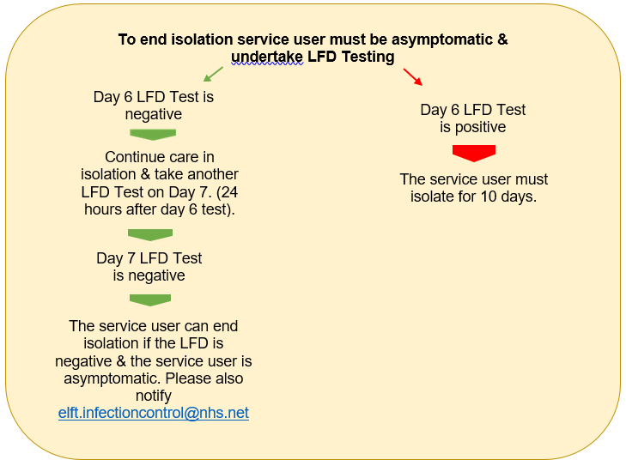

All patients on a ward with a positive case or outbreak must have physical health assessment to identify those who are clinically vulnerable to infection if not already known. Please refer to guidance for identification and management of clinically vulnerable patients.

**Appendix 3 – Management Pathway for Patient with COVID-19 Infection in Community/Domestic Settings**

**Pre Home Visit Checklist**

Phone call to the patient and ask the following:

* Has the Patient had a diagnosis of COVID19
* Do they have a new continuous cough?
* Do they have a high temperature?
* Do they have a loss of, or change in, your normal sense of taste or smell (anosmia)?
* Does anyone in the household have the above?
* Has the patient been discharged from an inpatient unit in the last 7 days?

No

Document visit as required on RIO/EMIS/S1

* Visit to be completed by 1 nurse
* PPE to be worn
* Waste disposed of as per waste management policy pre COVID19.
* DO NOT REUSE Gloves and Aprons. Change at each visit.
* Complete visit with 1 nurse, 2 if the patient is a ‘double up’ visit.
* PPE to be worn – Gloves/aprons/face mask with visor or goggles depending on risk assessment. Goggles need to be thoroughly cleaned after each use with Green Clinell wipes, and allow to dry thoroughly before use.
* Waste must be double-bagged, then transported back to base and disposed of as clinical waste or left for 72 Hours and patient disposes of in household waste stream.
* DO NOT REUSE Gloves and Aprons. Change at each visit.

Yes

Consider: Clinical assessment can the visit be safely re-scheduled? If No follow below.

Ensure that all COVID-19 related care plans are implemented onto the patients’ records on RIO/EMIS/S1

Remember to document on RIO/EMIS/S1 reminders that the patient is either ‘suspected’ or ‘confirmed positive’ so all staff are aware.  
  
Complete Datix for confirmed COVID-19 Infection.

**Appendix 4 - Management Pathway for Healthcare Staff Member with COVID-19 Infection**

Staff who have symptoms of a respiratory infection, and who have a high temperature or do not feel well enough to attend work, are required to take a lateral flow device (LFD) test as soon as they feel unwell. They are no longer required to take a PCR test.

Staff who are close contacts of a case of COVID-19 are also no longer required to take a PCR test.

There is no longer any need to test visitors to our wards. There is no longer a requirement to undertake twice weekly LFD testing.

LFD self-testing kits will continue to be supplied for free to NHS staff. LFD tests will continue to be available through the [gov.uk portal](https://technology-trust-news.org/t/1TXQ-7SZ0F-QFLSPD-4R9030-1/c.aspx) for NHS staff. For testing enquiries**,** please contact[elft.testing@nhs.net](mailto:elft.testing@nhs.net)

**Report Your Result whatever it is**  
as always, please report your results, through the [Trust portal COVID-19 Home testing outcome form](https://technology-trust-news.org/t/1TXQ-7SZ0F-QFLSPD-4R8Q5V-1/c.aspx).

**Appendix 5 - Staff Testing Flowcharts**

**Staff member has symptoms of COVID-19?**

* *Fever*
* *a new and continuous cough*
* *loss of smell*
* *loss of taste*
* *shortness of breath*
* *fatigue*
* *loss of appetite*
* *myalgia (muscle ache)*
* *sore throat*
* *headache*
* *nasal congestion (stuffy nose/ runny nose)*
* *Diarrhoea*
* *Nausea and vomiting*

Staff members who develop *symptoms,* at any point, must inform management & follow stay-at-home procedure and undertake an LFD test.

**Positive LFD result** – Staff member to continue to stay at home for required number of days

**Negative LFD result** – Staff member to return to work.

Once at work,

staff member should comply rigorously with all relevant infection control precautions and PPE should be worn appropriately throughout the day.

**Appendix 6 - Stay at Home Flowchart for Staff Tested Positive for COVID-19 Infection**

Staff who develop COVID-19 symptoms or who have tested positive on a lateral flow device (LFD) test can end their isolation on the sixth day, provided they have 2 consecutive negative LFD tests.

All staff, regardless of vaccination status who receives a positive LFD test must adhere to the stay at home advice as per Government guidance.

**Action**

**Ending Self-isolation early using LFD Tests**

**Day of Isolation**

**Self-Isolation begins from the day of the positive result, swabbing or initial symptoms**

Self-Isolate

**0**

Stay at home

**1-4**

**Stay at home**

Continue to stay at home & undertake daily LFD Tests, 24 hours apart until 2 consecutive negative results are received.

Day 6 LFD Test is negative

Continue to stay at home & take another LFD Test on Day 6.

Day 5 LFD Test is negative

Day 5 LFD Test is positive

**Stay at home &**

**undertake LFD Testing**

Stay at home

**10+**

Stay at home ends & staff should return to work. Once at work, staff should continue LFD testing until 10 days.

**Risk Assessment for early return:**

* If the first LFD test result was negative on the fifth day, and the second LFD test result is negative on the sixth day, the staff member can return to work but should continue to take LFD tests on days 7, 8, 9 and 10.
* Staff who were asymptomatic at the time of the test can return to work after their stay at home period has ended if they do not develop symptoms.
* Please note that if asymptomatic staff do develop symptoms during this period, they are no longer required to restart a new isolation period. They can return to work if well enough.
* Symptomatic staff can return to work after their stay at home period has ended provided their symptoms have improved i.e. they have been afebrile (not feverish) for 48 hours without the use of medication to control fever, and are medically fit to return.
* Staff may still return to work if they still have any of the other symptoms and are fit enough to do so, as these may persist for some time after the infection has resolved. Adhere to IPC precautions on shift including appropriate use of PPE & and hand Hygiene at all times.
* If working with clinically vulnerable service users, a local risk assessment must be carried out with line manager, and consideration should be given to redeployment until period day 10 after their symptoms started (or the day their test was taken if they did not have symptoms)

**Be alert for Symptoms of COVID-19, flu and common respiratory infections include:**

* continuous cough
* high temperature, fever or chills
* loss of, or change in, your normal sense of taste or smell
* shortness of breath
* unexplained tiredness, lack of energy
* muscle aches or pains that are not due to exercise
* not wanting to eat or not feeling hungry
* headache that is unusual or longer lasting than usual
* sore throat, stuffy or runny nose
* diarrhoea, feeling sick or being sick

**Appendix 7 - Staff Identified as Contact of a Person with COVID-19**

**Has staff member identified themselves or notified as a contact of COVID-19 infection, whilst at work?**

Yes

Inform line manager and contact Occupational Health [Ohteamprevent.elft@nhs.net](mailto:Ohteamprevent.elft@nhs.net) for advice on completing risk assessment. Or call 01327 810777.

Occupational Health to conduct risk assessment including:

* the severity of patients’ symptoms
* the length of exposure
* the proximity to patients
* the activities that took place when the staff member was in proximity (such as aerosol-generating procedures (AGPs), monitoring, personal care)
* whether the staff had their eyes, nose or mouth exposed
* whether Personal protective equipment was worn appropriately

**Is there a high risk of exposure?**

Yes

1. Refer to Occupational Health – TP Health for contact tracing and follow-up. Please also complete Datix if high risk of exposure is identified at work.
2. If the risk assessment concludes there has been significant breach or close contact without PPE, the staff is to be treated as a contact and to follow the advice for staff who are contacts.

No

Continue to work

**Appendix 8 - Staff Identified as Contact of a Person with COVID-19 Outside of Work**

Contacts outside of the household

Household contacts & staff who stayed overnight in a household with someone with Covid-19

Continue to adhering IPC precautions including strict PPE use whilst at work.

Staff who are identified as a household or overnight contact of someone who has had a positive COVID-19 test result should discuss ways to minimise risk of onwards transmission with their line manager.

This may include considering:

* redeployment to lower risk areas for patient-facing healthcare staff, especially if the member of staff works with patients whose immune system means that they are at higher risk of serious illness despite vaccination
* working from home for non-patient-facing healthcare staff limiting close contact with other people especially in crowded, enclosed or poorly ventilated spaces
* Whilst they are attending work, staff must continue to comply rigorously with all relevant infection control precautions.

If staff develop any symptoms during these 10 days, they should follow the advice for staff with symptoms of a respiratory infection, including COVID-19.

**Appendix 9 – Management Pathway for Service User/Patients Contacts of COVID-19**

**Service User / Patient identified as a contact due to exposure**

Inpatient/service-user exposure

Contact IPC department [elft.infectioncontrol@nhs.net](mailto:elft.infectioncontrol@nhs.net) for support with risk assessment

Inter-ward transfer of contacts are to be discouraged

Is patient symptomatic?

No

Yes

Monitor patient for 10 days. If they become symptomatic complete PCR. Also contact the IPCT [elft.infectioncontrol@nhs.net](mailto:elft.infectioncontrol@nhs.net)

Document on RIO clinical record results of LFT.

Symptomatic patients are to be encouraged to isolate. Take a PCR test for COVID-19.

Manage as though positive until the result of the test.

Any vulnerable patients on the ward are to be protected from ongoing exposure and managed as clinical vulnerable guidance.

Please see Appendix 10.

Contacts can be discharged home & to another health & social care facilities

Can be allowed leaves and visitors

Patients can be discharged home if well enough. They may receive visitors if necessary

**Appendix 10 - Management of Individuals Who Are at Higher-risk (Clinically Vulnerable) of Severe Illness from COVID-19**

The UKSHA guidance on measures to combat respiratory infections including COVID-19 continue to evolve as more evidence on the virus emerge and vaccine program has proven to be a success in offering people protection. However, there remains a smaller number of people whose immune system means they are at higher risk of serious illness from COVID-19, despite vaccination.

**What**-This document is intended to provide guidance and increase awareness for clinicians and anyone involved in the assessment and placement of patients to help in early identification and protection of patients with immunosuppressed and other physical health conditions that put them at higher risk of infection.

**Who**-Immunosuppression means a person has a weakened immune system due to a particular health condition or because they are on medication or treatment that is suppressing their immune system. People who are immunosuppressed, or have specific other medical conditions that weaken their immune system, may have a reduced ability to fight infections and other diseases, including COVID-19.

In addition, there may be other physical health conditions or a combination of comorbidities that may make a person more susceptible to infection.

The Current UKSHA list of people with condition that put them at higher risk of infections includes;

* Down’s syndrome
* certain types of cancer or have received treatment for certain types of cancer
* sickle cell disease
* certain conditions affecting their blood
* chronic kidney disease (CKD) stage 4 or 5
* severe liver disease
* an organ transplant
* certain autoimmune or inflammatory conditions (such as rheumatoid arthritis or inflammatory bowel disease)
* HIV or AIDS who have a weakened immune system
* inherited or acquired conditions affecting their immune system
* rare neurological conditions: multiple sclerosis, motor neurone disease, Huntington’s disease or myasthenia gravis

**Why**-Early identification of vulnerable patients on the Government list is vital in ensuring that whiles patients are under your care in ELFT they are;

* Protected from exposure to infection, especially respiratory infections including COVID-19.
* Encouraged to take a third primary dose of the COVID-19 vaccine or spring booster ( for those eligible)
* Referred for new antiviral treatments for COVID-19 if they do test positive.

**Other patients who may be clinically vulnerable to infection**

In addition to the above list, when assessing patients on admission or those already in-patients, the following patients are to be considered;

* those on clozapine medication with abnormal neutrophil counts,
* morbidly obese,
* uncontrolled diabetes,
* pregnancy,
* frail and elderly,
* chronic respiratory diseases.

These conditions should be pointers during a good physical health assessment as can increase the risk of severe illness from respiratory infection including COVID-19. ***Though these conditions do not guarantee anti-viral treatments should the patients test positive for COVID-19****,* the purpose of identifying these patients early is to ensure a protection plan is included in their care plan and they can also be encouraged to have their vaccines if they are not yet up to date.

**How to assess**- Clinicians are encouraged to continue using their clinical judgement during physical health assessment to identify patients with conditions that put them at higher risk of infection.

Most people with immunosuppression listed on the government list will be under the care of a hospital specialist and will usually have been identified and issue a letter to that effect. Ask your patients and their relatives if they have any such letter identifying them as ‘*at higher risk of serious illness if they become infected with COVID-19’.*

To identify those in the ‘other vulnerable group’, clinicians are to ask patients if they have ever been previously identified under the shielding plan as clinically vulnerable at the beginning of the COVID-19 pandemic. This information can be used in addition to findings from their current assessment to determine clinical vulnerability.

It is vital that all reasonable measures are taken in identify these patients as early as possible. This will enable the drawing of a tailored care plan and other necessary actions required to protect them from infection.

**Documentation**

It is important that the Trust have a system and processes in place to identify and capture the information on vulnerable patients for assurance purposes. Patients identified as clinically vulnerable per the above lists, must have an alert placed on their Rio to help with easy identification. A new alert category has been added to Rio for this purpose;

**How to add the alert;**

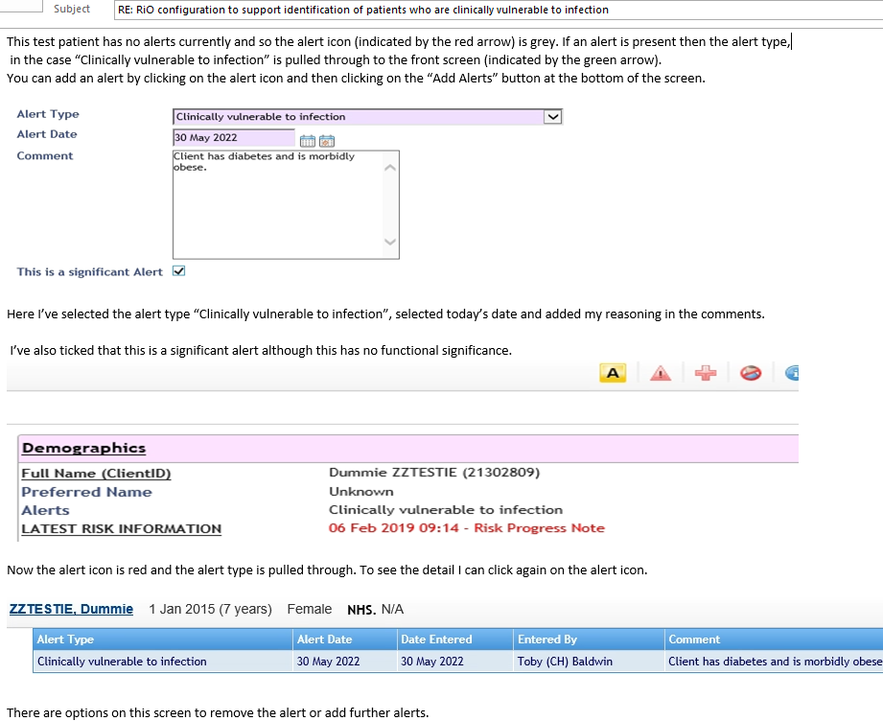

**Protective measures**

The following measures should be taken to minimise transmission risk to all clinically vulnerable patients:

* En-suite bedroom placement especially if in a ward that has an incident of infection.
* separate toilet facilities if en-suite room not possible
* Encourage 2m distancing from others as much as possible.
* Signage of protective care in isolation on patients bedroom door
* Continued use of face masks except when alone in their own room.
* Encourage vaccination if not yet fully vaccinated.
* Weekly PCR testing for COVID-19 whiles they remain in-patients. Result must be entered on Rio

Further information can be found here;

<https://www.gov.uk/government/publications/covid-19-guidance-for-people-whose-immune-system-means-they-are-at-higher-risk/covid-19-guidance-for-people-whose-immune-system-means-they-are-at-higher-risk#vaccines>

<https://www.gov.uk/guidance/covid-19-information-and-advice-for-health-and-care-professionals>

London IPC management of respiratory infections (including SARS-CoV-2) for Spring 2022- by the London IPC Reference Group Approved by London CEG 13.04.22 Version1.0

**Appendix 11 - Stepping-down of Care in Isolation Precautions for Severely Immunosuppressed Patients**

Severe immunosuppression includes people who had or may recently have had:

* a blood cancer (such as leukaemia or lymphoma)
* a weakened immune system due to a treatment (such as steroid medicine, biological therapy (sometimes called immunotherapy), chemotherapy or radiotherapy
* an organ or bone marrow transplant
* a condition that means you have a very high risk of getting infections
* a condition or treatment your specialist advises makes you eligible for a third dose of COVID-19 vaccine.

**Please note that neutropenia in these patients is an essential mark to being severely immunosuppressed.**

**Severely immunosuppressed patients** **can remain infectious for a much longer period. Resolution of symptoms cannot be used as a marker of decreased infectiousness and these patients should be isolated in a single room until they return a negative PCR test.**

**Not all clinically vulnerable patients are severely immunosuppressed. If in doubt discussed with patient’s clinician and a member of the IPC team.**

Is the patient severely immunosuppressed?

Yes

No

Patients must be assessed on a case-by-case basis to determine severe immunosuppression. Stepping down of care in isolation precautions will need to be discussed with clinical medical teams & the IPC Team/Infection Control doctor.

Please follow the flowchart for all other patients on page 1.

**Appendix 12 - Documentation of Lateral Flow Test / PCR results/ RIO Crib-Sheet.**

**Image 1**

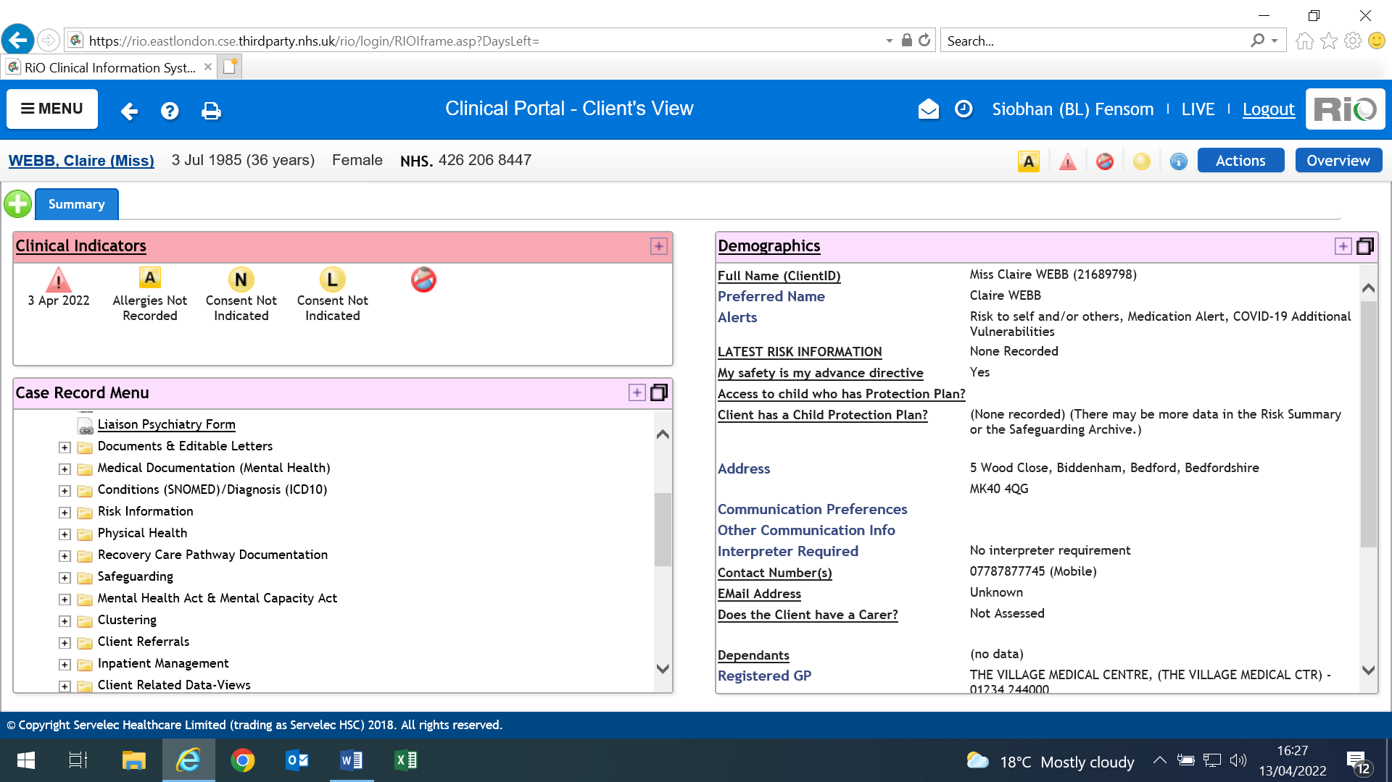

Click Physical Health Assessment Form to open Infection Screening Form

**Image 2**

New Admission: Complete Infection Screening Form

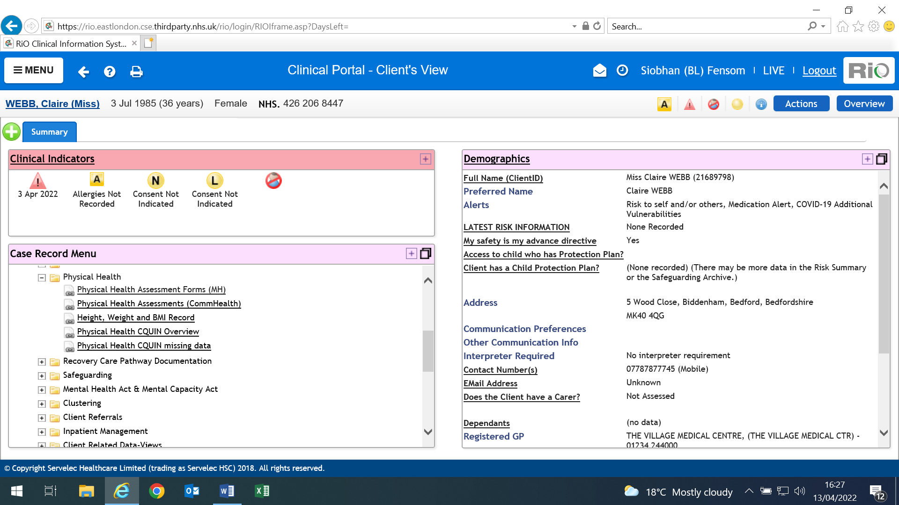

**Image 3**

Note: After ‘Infection Screen’ is completed you can access COVID 19 record here.

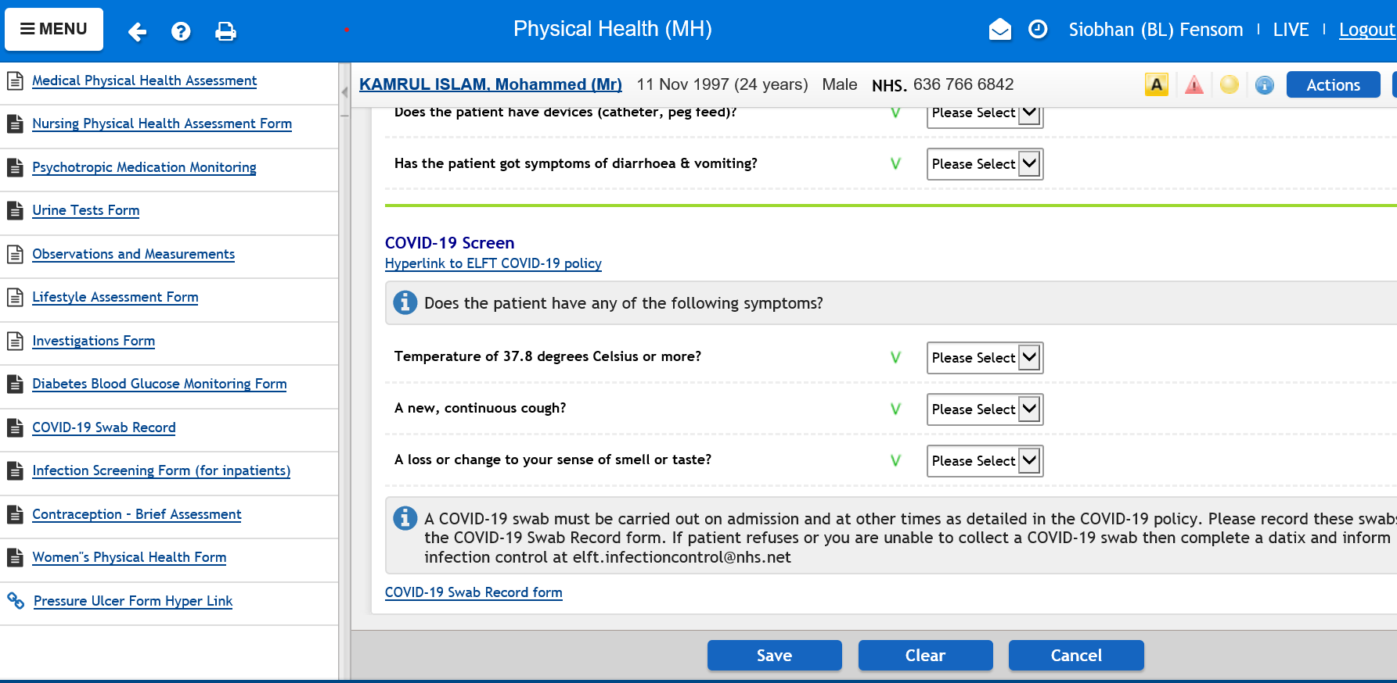

**Image 4**

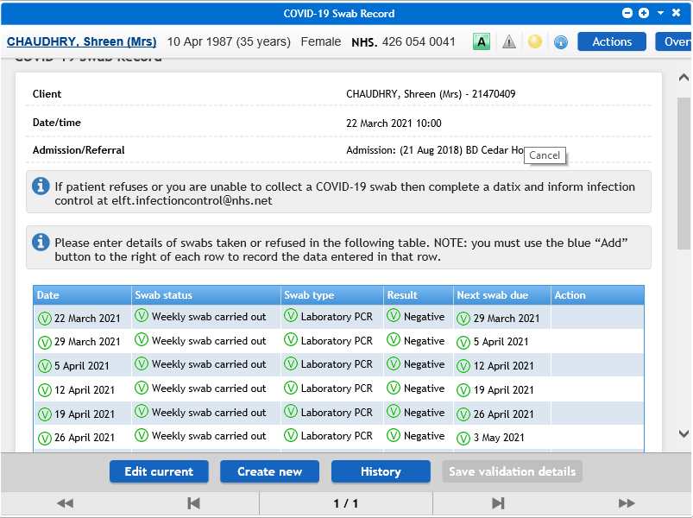

Populate date etc. Please ensure you click create new to ensure that data is added to the record. All swabs taken and swab results received need to be recorded here. This includes weekly swab for patients that are identified as clinically vulnerable, other swab i.e. taken due to symptoms, and swabs completed in other organisations if known.

**Image 5**

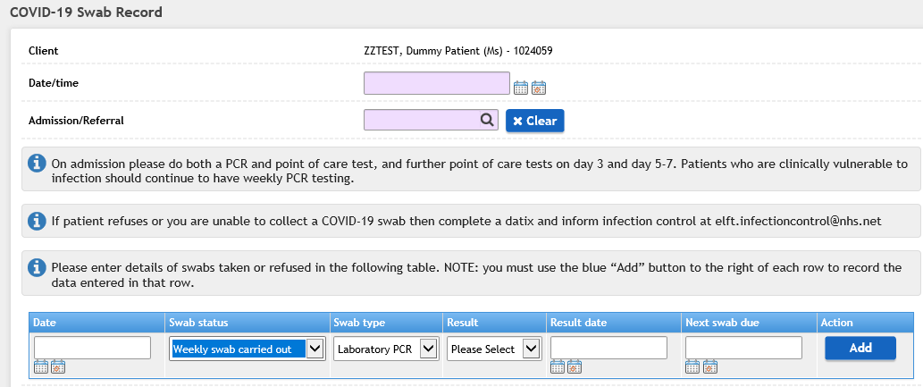

Once clicked ‘create new’ this screen can be seen. Please Note:**. Patients who are clinically vulnerable to infection should continue to have weekly PCR testing.**

**Image 6**

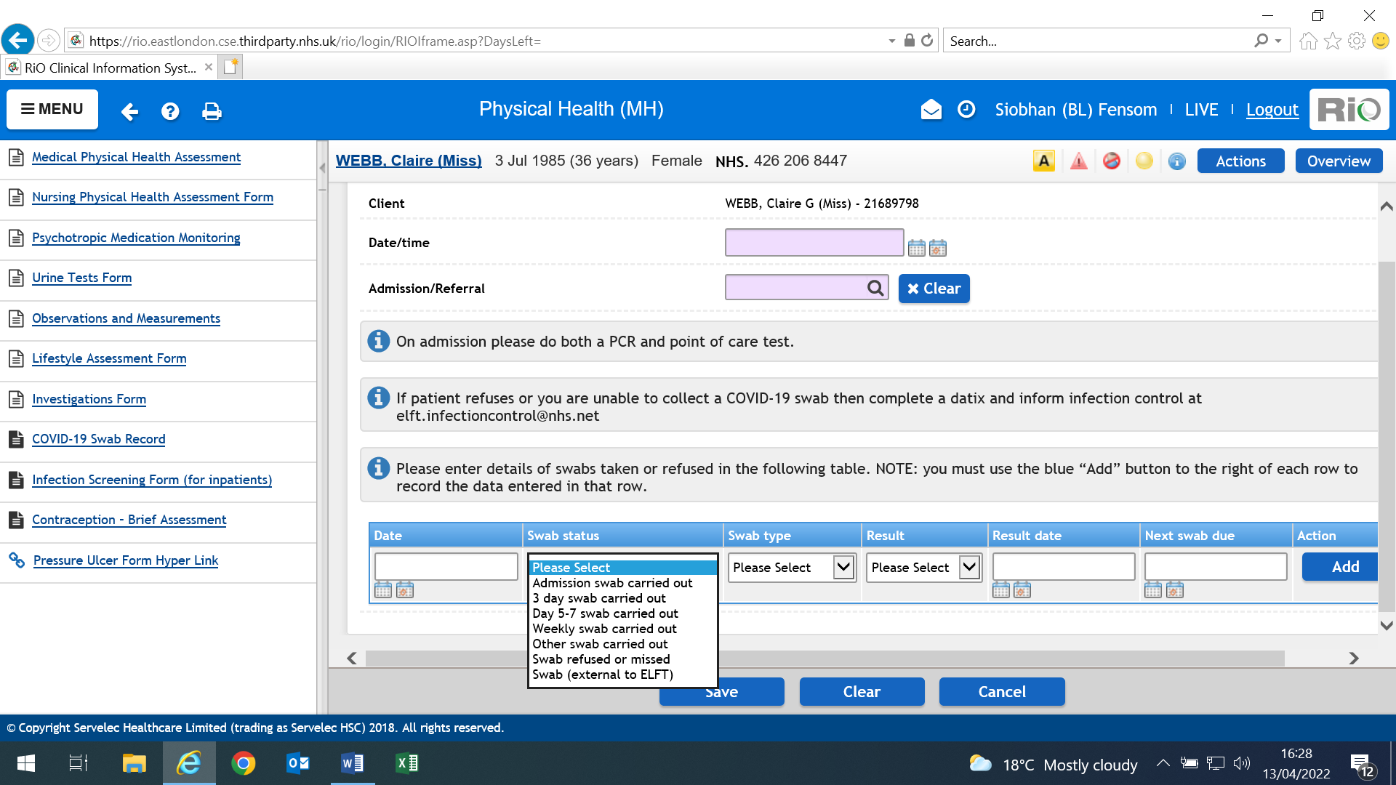

Populate Swab Status - what swab was taken, the method used to carry out the swab i.e. Lateral Flow Test/Device (LFT/LFD).

**Image 7**

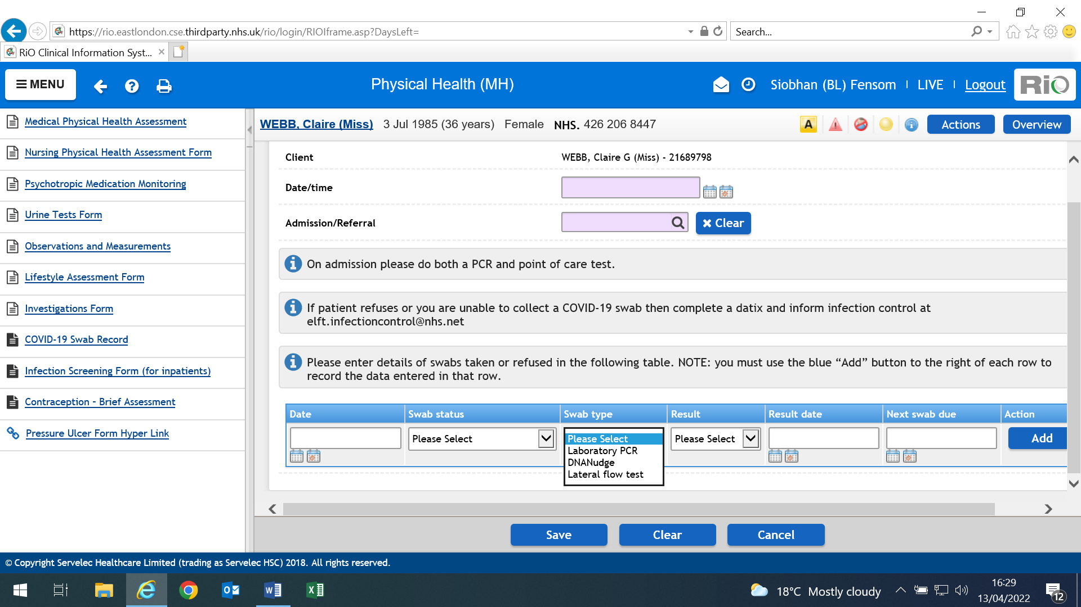

To document Swab type, result, result date.

If entering a result, please click ‘Edit Current’. (As per Image 4). See image below Image 8 for entering result once received.

**Image 8**

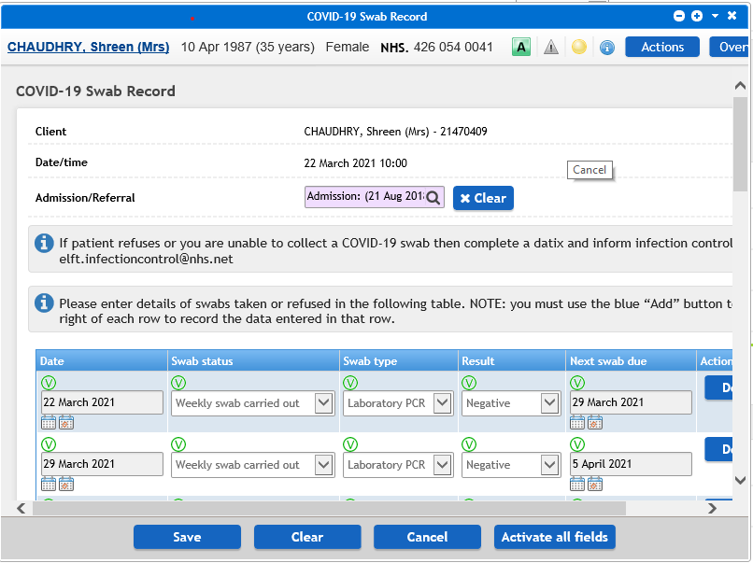

**Appendix 13 - Management of COVID-19 Outbreaks**

2 or more positive COVID-19 cases in the same time and place

Contact IPC department [elft.infectioncontrol@nhs.net](mailto:elft.infectioncontrol@nhs.net) for support with risk assessment. For Out of hours Contact Director on-call

IPCT to conduct risk assessment:

* Confirmed cases and details.
* Extent of secondary exposure.
* Location of incident
* Whereabouts of employees involved
* Manager/team contact details

For patient outbreaks

Healthcare staff outbreaks

Management attend outbreak management meeting organised by IPC team.

Management attend outbreak management meeting organised by IPC team.

The manager needs to Occupational Health immediatelyManager start completing Contact Tracing to identify any risk to colleagues and patients

If patient are at risk, complete patient Contact Tracing form and send to IPCT [**elft.infectioncontrol@nhs.net**](mailto:elft.infectioncontrol@nhs.net)

Complete staff Contact Tracing form and send to team prevent **tpukl.elftteamprevent@nhs.net** managers should inform IPCT of this action completed

Outbreak management meeting to be held on as and when required depending on scale of outbreak

Team manager takes appropriate action re resourcing in light of staff self-isolating etc.

Team prevent provides OH intervention/Signposting for staff as necessary and appropriate

Staff members notifies line manager of LFD results

**Appendix 14 - A-Z Management of an Outbreaks**

|  |  |
| --- | --- |
| **Blood pressure machine** | One machine should be allocated to affected patients and wiped with Detergent wipe in between patients |
| **Borrowing from/lending to other wards** | Should not happen if at all possible. If an essential piece of equipment needs to be borrowed from an affected ward it should be cleaned with Actichlor first |
| **Equipment** | Whenever possible any equipment should be dedicated to affected patients only and cleaned in between usage. |
| **Laundry** | Patients’ clothes for laundering should be collected by ward staff and taken to the laundry room. Symptomatic patients’ clothing should be segregated and laundered separately. The laundry staff should NOT be visiting the affected wards. |
| **Linen (clean)** | Linen should be brought to the ward entrance, transferred to a ward trolley and taken immediately to the linen cupboard. The linen contractor should not visit the affected wards. |
| **Linen (dirty)** | Dirty linen bags from affected wards should be collected by porters after the unaffected wards |
| **Meals** | Meals should be delivered to affected wards after the unaffected wards. The kitchen staff will deliver and set up the food on the ward food trolley as usual. |
| **Patients (affected)** | Must be in a side room, or if there are many patients with symptoms, they could be nursed together in a dedicated bay. An accurate stool chart must be kept for everyone affected. |
| **Patients (unaffected)** | Should be looked after normally |
| **Protective clothing** | Yellow apron for isolated rooms  All sizes of gloves to be available |
| **Rooms (care in isolation)** | Isolation sign on the door.  Door shut at all times (unless in exceptional circumstances when patient safety may be endangered) |
| **Staff** | To be assigned on each shift to look after affected patients only |
| **Therapy** | Any unessential therapy should be postponed. Therapy staff should not attend affected wards if at all possible |
| **Waste** | Waste bags from affected wards should be collected by porters after the unaffected wards |

**Appendix 15 - Contact Tracing Form for Occupational Health-Team**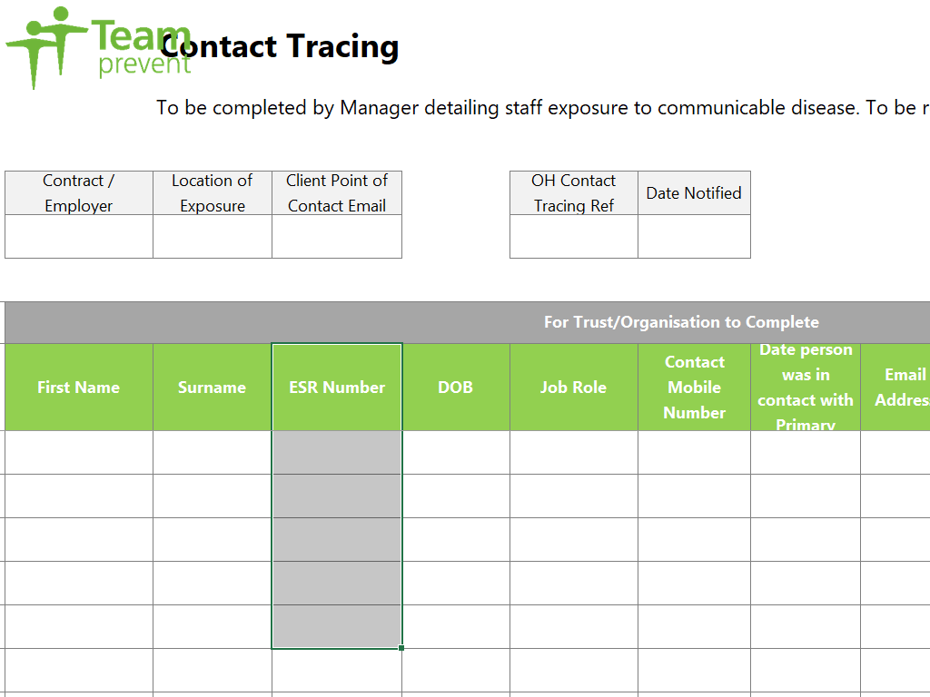

**Appendix 16 – Outbreak Checklist**

|  |  |
| --- | --- |
| 1 Alert Signal- organism Laboratory, clinical , surveillance data  IPC assessment:   * Is this an Outbreak ? * Are Patients infected? * Are patients linked? * Has patient exposure occurred? | |
| 2 | Put in place initial control measures for patient, staff and visitor safety. e.g. close the ward, isolate co-hort cases. Stop suspect procedures. |
| 3 | Confirm Standard and transmission based precautions in place |
| 4 | IPCT to agree and then set up an incident /outbreak management team |
| 5 | Use local agreed communication strategy |
| 6 | Look at Situation /control measures ,seek patient and visitor support |
| 7 | Refer to expertise to aid in early control or diagnosis e.g. labs |
| 8 | Investigations and actions by outbreak /incident Management Team |
| 9 | Define a case(confirmed/probable/possible/colonised) may take time |
| 10 | Identify and count all cases , Laboratory, look back, screening, sampling of patients , Contacts e.g. shared en-suite facilities , No PPE etc. |
| 11 | Describe the case-time place, person ,questions from admission history |
| 12 | Look for a change in the system that may have provoked the outbreak  i.e. changes in people, equipment, procedures, the environment. |
| 13 | Present the data , Epi curve , time line , transmission plot or ward map |
| 14 | Develop a Hypothesis |
| 15 | Consider the need for additional case finding, e.g. discharges/transfers |
| 16 | Take microbiological samples to test hypothesis |
| 17 | IPCT to visit to observe step by step procedures e.g. hand hygiene/PPE |
| 18 | Confirm through audit and data review that standard based precautions and transmission based precautions as required are being adhered to |
| 19 | Confirm control measures are being effectively applied in relevant areas |
| 20 | **Are IPC control measures working**? If new cases are still occurring, re-check control measures applications. e.g. high touch surfaces x3 daily. |
| 21 | Continue to assess and communicate and refer to expertise as required |
| 22 | IPCT assessment: **is it safe to return to normal services**  discussion with Lead and Directors ? |
| 23 | Take action to ensure environment , equipment safe including high touch surfaces and has infectious/terminal clean before reopening unit. |
| 24 | Undertake a debrief with all staff involved to identify learning points with regards to prevention, early detection and management of the outbreak. |
| 25 | Complete and action plan following a de-brief to identify actions with timescale. |
| 26 | Identify and share lessons with service and wider for the organisation and to prevent future incidents /outbreaks |
| 27 | Produce a final report for IPC Committee |

**Appendix 17 - Reporting to the UK Health Security Agency**

During outbreaks, the local health protection team should be informed of confirmed COVID

19 cases of outbreak. Local Clinicians/Borough Lead Nurses/IPC nurses need to call or

email their local coronavirus response cell when outbreak has been declared. A reference

number is provided– please ensure this is shared with Infection Protection & Control Team.

**Contact Details for Notification of COVID-19**

|  |  |
| --- | --- |
| Area | Contact Details |
| East London | London Coronavirus Response Cell (LCRC)  Phone: 03003030450  Email: [LCRC@phe.gov.uk](mailto:LCRC@phe.gov.uk) or [phe.lcrc@nhs.net](mailto:phe.lcrc@nhs.net) if contains PII. London also require reporting to:  NELCCG on [nelondon.ipc@nhs.net](mailto:nelondon.ipc@nhs.net) and [nelcsu.ipcteam@nhs.net](mailto:nelcsu.ipcteam@nhs.net) Do we still need to report to both? |
| Luton & Bedfordshire | East of England Coronavirus Response Cell  EOE.CRC@phe.gov.uk |

**Notifiable Disease – Reporting to UK Health Security Agency (UK HSA)**

COVID-19 is a notifiable disease and must be reported to UK HSA – local Health Protection

Team (HPT).

Registered Medical Practitioners (RMPs) have a statutory duty to notify the ‘proper officer’

at their local HPT of suspected cases of certain infectious diseases.

**Appendix 18 - Covid-19 Outbreak Meeting – Chairing Guide**

|  |  |
| --- | --- |
|  | **Agenda Item** |
| **1** | **Welcome and Introductions**  *Chair to welcome and induce everyone. Attendee to write name and title/department they are representing on MS teams platform.* |
| **2** | **Update on situation of Outbreak**  *Chair to ask ward staff the following information. IPC Nurse (IPCN) can support with this information*  **Number of patients affected**   * Date of index case? * Did they go on leave/overnight leave? * Did they have visitors? * Did index case go for group therapy, GP or hospital/healthcare provider in last 14 days? * Contact with other previous COVID-19 cases in past 14 days? * Is this a health care associated infection over 15 days of admission? * Number of clinical vulnerable patients on ward/service? * Any patients on immunosuppressant/clozapine? - Medical team to review this. Advice to link in with physical health team if support required. * Are there any risk factors groups- cares of elderly ward/immunosuppressant/BAME group? Advice additional measures to be taken * Any patients admitted to hospital from COVID-19 infection? * Any visitors reported COVID-19 in past 48hrs?   **Ward operational activity**   * Number of beds on ward? * Number of empty beds on ward? * Number of admission expected? * Number of discharges/transfer expected? |
| **3** | **Current preventive and control measures in place**  *Chair to discuss with ward staff the following information. IPCN can support with this information*  **Personal protective equipment**   * Are there enough supplies of PPE? * FFP3 Mask? * Are there sufficient supplies of FFP3 mask and staff fit test trained?   **Contact tracing**   * Have contact tracing forms been returned to[elft.infectioncontrol@nhs.net](mailto:elft.infectioncontrol@nhs.net)   **Audits/training education**   * Are there PPE and Hand hygiene audit undertaken by ward? * What is the latest environment audit result? * Have there been any PPE breaches in practice? * What is the staff IPC stat & Mandatory training compliance?   **Visitors restrictions**   * Is visitors discontinued?   **Laundry/linen**   * Are red bags unused for clinical infectious linen?   **Track and Trace**   * Is there a tack and trace system in place for staff to sign in & out?   **Waste**   * Is the correct waste bin in place (orange coloured bio bins)?   **Point of caring testing /Lateral flow testing**   * Is lateral flow testing used instead as POC testing?   **Laboratory issues**   * Are there any delays on lab results?   **Outbreak escalation**   * Has this outbreak been Datix? * Has this outbreak been reported to UKSHA? * Is there a reference number for outbreak? * Have the local service lead and DMT clinical/ director and Director of nursing been notified? |
| **4** | **Estates & Facilities**  *Chair to discuss with ward staff the following information. IPCN can support with this information*  **Cleaning issues**   * Are there enough decontamination wipes on ward/unit? * Are there enough cleaning supplies/products on ward/unit? * Is high touch surfaces implemented on door handles, IPad/laptops, light switches, mobile phones, fobs, PC’s, on ward/unit?   **Environment**   * Is there a dedicated Donning and Doffing area? * Is there enough soap, hand towels, alcohol gels supplies? * Is there access to hand wash basin? Is hot water working? * Has there been a review of COVID-19 Work place risk assessment tool? * What is the ventilation like on unit? Do windows open? Is there air conditioning? * Is outbreak sign on door of unit/ward? |
| **5** | **Staffing issues**  *Chair to discuss with ward staff the following information. IPCN can support with this information*   * Have there been any social events outside of work? Was PPE worn? * Are staffs completing lateral flow testing on twice weekly basis? * Any staff (contractors/ students/ etc.) gone off sick in past 48hrs? * Enough staff on ward to support outbreak management? * Are staff encouraged to have vaccination? * Manager to review any staff who are clinical vulnerable? |
| **6** | **Communications**   * IPCN to circulate communications to DMT directors/service leas * DMT to circulate communications via local newsletter |
| **7** | **AOB** |

**Appendix 19 - Admitting to Wards with Active COVID-19 Outbreaks**

**Guidance when admitting new patients to wards with an active COVID-19 case or outbreaks of COVID-19 (High risk areas)**

The new variants of Coronavirus are highly transmissible and prevalent in our inpatient wards. This means that the need to admit to a ward with Covid+ patients is much more likely due to the spread of infection across wards.

Before considering admission or transfer to a ward with infections please clarify (via the DSN) if there are any available beds on Wards without Covid cases in an ELFT borough (including those in NELFT and available beds in the Priory Hospitals).

***Criteria to consider when admitting patients to these areas:***

1) The clinical risk is such that delaying admission would be likely to cause avoidable harm whether the patient is in the community, ED or acute hospital bed.

2) This is a clinical decision and must be made by the admitting consultant/Doctor, balancing the risks and benefits for the patient, and if the balance of risks needs further discussion, in consultation with the service’s Clinical Director and Borough Lead Nurse or nominated deputies as required (Out of hours on-call consultant and DSN). IPC advice is available 9am to 5 pm Monday – Friday and of these times on the Director on call should be utilised as required through the on-call system. Each Borough Lead Nurse will need to keep record of each patient admitted using the SOP which is on the daily DSN report.

Please e mail [elft.infectioncontrol@nhs.net](mailto:elft.infectioncontrol@nhs.net), for all patient admitted using the SOP. This email should be sent by the Borough Lead Nurse, Duty Senior Nurse and/or Ward Manager.

Prior to admission the following requirements must be met and clearly recorded in the patient’s Rio note:

* **Open and transparent discussion about the risks with the patient and family:**
* The patient and relatives/carer must be informed of the ward status regarding the positive case or outbreak prior to admission, and must agree to the admission.
* This discussion must take place at the point of assessment/decision to admit, and must be recorded in patient’s Rio note.
* If not possible to achieve this discussion and agreement with the patient and family, then best interest principles must be applied by the clinical decision maker (out of hours this is the on-call consultant) and the outcome recorded in patient’s note.

**Risk assessment**

1. Patient must be assessed on individual case by case basis.
2. The vaccination status of the patient being admitted should also be taken into consideration. Whilst this may be considered in the risk assessment, it is important to note that under the current NHS advice, there is a chance people might still get or spread COVID-19 even if they have had different doses of the vaccine due to the different variants rising. All the IPC precautions must still be followed regardless. **Patient with no COVID-19 vaccination (or no previous infection) must not be admitted to a ward with an on-going outbreak.**
3. Risk assessment must consider any underlying health conditions and comorbidities (chronic and acute) of the patient being admitted to ensure they are not clinically extremely vulnerable (Refer to UKSHA definition) <https://www.nhs.uk/conditions/coronavirus-covid-19/people-at-higher-risk/who-is-at-high-risk-from-coronavirus-clinically-extremely-vulnerable>
4. The health status of patients on admitting ward i.e. acuity, number of confirmed cases, and their cooperation with care in isolation. (If needed)
5. Environmental limitations (availability of en-suite facilities, equipment, etc.)
6. Staffing levels and competency.
7. Risk of delaying the admission
8. If risk assessment determines that admission to the outbreak ward is not recommended and not in the patient’s best interest, but they still require a bed then use the formal escalation procedure via the on-call manager.

**Admission agreed;**

If the outcome of the risk assessment determines that admission to the outbreak/affected ward is in the patient’s best interest and outweighs the risk of exposure to infection, the following must be considered to help minimise the risk;

1. The new patients should be admitted into an en-suite bedroom (please note Hackney do not have en-suite rooms but may have beds – please discuss this with the DSN and local Senior Nurses). Admission swabs should only be taken if the patient is symptomatic. (Both LFT and PCR must be obtained).
2. Only if symptomatic, the patient has to remain care in isolation until their PCR results are available. Please discuss with IPC if needed.
3. If symptomatic, should the patient need to leave their room, encourage them to wear surgical face masks and perform hand hygiene before leaving and returning to their rooms.

Once a decision to admit has occurred then a message confirming the decision needs to go to the IPC email address: [elft.infectioncontrol@nhs.net](mailto:elft.infectioncontrol@nhs.net) with the patients name and RiO number and the admission ward. The number of these admissions can be reviewed as appropriate in the Silver Group, specific clarity or information on cases would need to be obtained from the Lead Nurses as required and appropriate.

**Appendix 20 - Root Cause Analysis Investigations of Hospital onset COVID-19 Infections Flowchart**

COVID-19 positive case is identified on a ward (check date of admission and specimen date to determine if HOCI definition is met as below

IPC nurse to send a notification email to department (ward manger, matron and borough lead nurse) and request a date for RCA meeting. Attached the RCA template to this email. RCA to be completed within 2 weeks of notification

Ward to report all HOCI cases on Datix and Datix No.to be added to the RCA form

IPC Admin will support the wards by sending a diary invite for the RCA meeting, either as part of an outbreak meeting (if outbreak) or as a separate meeting, whichever works best

Ward complete a draft RCA form with as much information from the patient’s case note and any relevant documents (aim to cover 14 days prior to the date of positive swab. Also include information of audits carried out around this time as evidence and for assurance.

Ward to send the completed RCA draft form to IPC at least 2 days prior to the meeting date

All to review and update the draft RCA form during the meeting and identify root course and contributing factors etc.

Base on the issues identified and lessons learned, formulate a SMART action plan

Agree on how and where the lessons will be shared

**Appendix 21 - Root Cause Analysis (RCA) Form for Reviewing Hospital-onset COVID-19 Cases**

|  |  |  |  |
| --- | --- | --- | --- |
| Draft completed by: |  | Date |  |

|  |  |  |  |  |  |  |
| --- | --- | --- | --- | --- | --- | --- |
| Patient Details (Use index case when reviewing a cluster or outbreak) | | | | | | |
| Full name | |  | | NHS Number | |  |
| ELFT/Rio No | |  | | Date of Birth | |  |
| Admission date to ELFT facility | |  | | Ethnicity | |  |
| Current ward | |  | | Bedroom number, En-suite? | |  |
| Date of admission to this ward | |  | | Patient’s Consultant | |  |
| Admitted from: | | | | | | |
|  | Home/Usual residence |  | Nursing/Care home |  | Other Care facilities or institutions |  |
| Test Results: | | | | | | |

|  |  |  |  |
| --- | --- | --- | --- |
| Date/s of previous negative swabs (if any) |  | Ward/Department where positive sample was taken |  |
| Ward where Infection is thought be acquired |  | Directorate where acquired |  |
| Date positive sample collected |  | Date positive result received |  |
| Admission Diagnosis |  | Compliant with care in isolation? |  |
| Is the patient on clozapine therapy? (State yes or no ) |  | If yes, was medication reviewed on detection of COVID-19? | Comment: |
| Symptomatic? |  | Symptom onset date |  |
| COVID-19 vaccination status |  | Admitted to Hospital due to symptoms? |  |
| **A brief case summery;** | | | |
|  | | | |

|  |  |  |
| --- | --- | --- |
| Timeline with Dates | Activity- (case note review 14 days prior to positive result/symptoms) | Source of information/ Comment |
|  |  | e.g. Rio note, outbreak meeting, emails, others |
|  |  |  |
|  |  |  |
|  |  |  |
|  |  |  |
|  |  |  |
|  |  |  |
|  |  |  |
|  |  |  |
|  |  |  |
|  |  |  |
|  |  |  |
|  |  |  |
|  |  |  |
|  |  |  |
|  |  |  |

|  |  |  |  |  |  |  |  |  |
| --- | --- | --- | --- | --- | --- | --- | --- | --- |
| Details of Contact **with other care providers** and wards 14 days prior to positive test | | | | | | | | |
| (Including appointments and admissions with dates) | | | | | | | | |
| 1) e.g. appointment with GP or hospital | | | | |  | | | |
| 2) | | | | |  | | | |
| List of contacts within this Hospital and current ward 14 days prior to positive test | | | | | | | | |
| e.g. previous positive patients or staff | | | |  | | |  | |
|  | | | |  | | |  | |
| Did the patient have multiple moves within and or out of the Hospital? | | | |  | | |  | |
| Date transferred | | | | Ward | | | Reason | |
|  | | | |  | | |  | |
|  | | | |  | | |  | |
|  | | | |  | | |  | |
|  | | | |  | | |  | |
|  | | | | | | | | |
| Risk factors of contacts from above e.g. Care of elderly wards, COVID-19 dedicated wards, contact with immunosuppressed patients who might be shedding the virus for longer etc. | | | | | | | | |
|  | | | | | | | | |
|  | | | | | | | | |
|  | | | | | | | | |
| Has any staff members gone off sick in the past 14 days prior to positive swab in the areas of admission? | | | | | | | | |
| Comment with dates: | | | | | | | | |
|  | | | | | | | | |
|  | | | | | | | | |
|  | | | | | | | | |
| Are staff doing their twice weekly lateral flow testing? | | | | | | | | |
| Comment: | | | | | | | | |
| Has any member of the patients’ household or visitors reported to have COVID-19? | | | | | | | | |
|  | Yes |  | No | |  | Unknown | |  |
| Comment: | | | | | | | | |
| Was Covid testing for the patients compliant with the national and Trust guidance? | | | | | | | | |
|  | Yes |  | No | |  |  | |  |
| Comment if any: | | | | | | | | |
| Did this patient have a **prolonged admission**? | | | | | | | | |
|  | Yes |  | No | |  |  | |  |
| Comment if any: | | | | | | | | |
| During this patient’s journey did the Trust have high numbers of outbreaks/nosocomial cases? | | | | | | | | |
|  | Yes |  | No | |  |  | |  |
| Comment if any: | | | | | | | | |
| Have there been any other confirmed COVID positive patients on this ward in the past 14 days? | | | | | | | | |
|  | Yes |  | No | |  | Unknown | |  |
| Comment if any: | | | | | | | | |
| Did the patient have **multiple co-morbidities**? E.g. patient on immuno-suppressants, extremely clinically vulnerable/clinically vulnerable group, from BAME background? | | | | | | | | |
|  | Yes |  | No | |  | If yes, did they have shielding plan? | |  |
| Comment if any: | | | | | | | | |
|  | Yes |  | No | |  | Unknown | |  |

|  |  |  |  |  |  |
| --- | --- | --- | --- | --- | --- |
| Has the patient been on day/overnight leave or absconded within 14 days prior? | | | | | |
|  | Yes |  | No |  | Comments: |

|  |
| --- |
| Any other factors not already listed above: |
|  |
|  |
|  |

|  |  |  |  |  |  |  |
| --- | --- | --- | --- | --- | --- | --- |
| **Environmental factors** | | | | | | |
| Was the ward nursing team aware of cleaning requirements and their responsibilities? | | | | | | |
|  | Yes |  | No |  | Unknown |  |
| Comment if any: | | | | | | |
| Was the ward domestic staff aware of cleaning requirements and their responsibilities? | | | | | | |
|  | Yes |  | No |  | Unknown |  |
| Comment if any: | | | | | | |
| Was additional **touchpoint cleaning in place** in the ward / departments during the patients care? | | | | | | |
| |  |  |  |  |  |  |  | | --- | --- | --- | --- | --- | --- | --- | |  | Yes |  | No |  |  |  | | | | | | | |
| Comment if any: | | | | | | |
| Has the wards where the patient has been admitted to have a **ventilation system review as part of work place risk assessment and deemed adequate**? (if there are air condition units please check with estate and facility that they are the types that brings in fresh air and not recirculating the air) | | | | | | |
|  | Yes |  | No |  | Unknown |  |
| Comment if any: | | | | | | |
|  | | | | | | |

|  |  |  |  |  |  |
| --- | --- | --- | --- | --- | --- |
| Give the latestCleaning audit score by contract monitors- **contractor** |  | Give the latestCleaning audit score by contract monitors-**Nursing** |  | Date of audit |  |
| Cleaning comments/List any issues from this audit: | | | | | |
|  | | | | | |
| Give the latest **infection control (IPCN)** Environmental audit score |  |  |  | Audited by and Date |  |
| Cleaning comments/List any issues from this IPCN environmental audit: | | | | | |
|  | | | | | |

|  |  |  |  |  |  |  |  |  |
| --- | --- | --- | --- | --- | --- | --- | --- | --- |
| Give the latest **ward** hand hygiene score - | |  | |  | |  | Date of audit |  |
| Hand hygiene comments/List any issues from this audit: | | | | | | | | |
|  | | | | | | | | |
| Give the latest Hand hygiene validation audit score (if any) | |  | |  | |  | Audited by and Date |  |
| Hand hygiene comments/List any issues from this audit: | | | | | | | | |
|  | | | | | | | | |
| **Staff factors;** | | | | | | | | |
| Give the latest IPC **Stat & Man** training (L1 & L2) compliant score for the ward – All staff | |  | | Any **latest COVID-19** training/Update for staff? | |  | Provided by & Date |  |
| Training related comments/List any issues identified in IPC training: | | | | | | | | |
|  | | | | | | | | |
| During the patient’s journey were there any areas where **staffing was challenged**? High sickness high agency/bank staff usage, staff working across wards during shifts? | | | | | | | | |
|  | Yes |  | No | |  | Unknown |  | |
| Comments if any: | | | | | | | | |

|  |
| --- |
| Any other ward/staffing Comments / avoidable contributory factors not mentioned above: |
|  |

|  |
| --- |
| Hand Hygiene **Facilities**- Have there been any barriers to compliance with hand hygiene two 14 days prior to incident? (e.g. lack of paper towels, soap, alcohol based hand rub, accessible hand wash basin etc. ) |
|  |

|  |  |  |  |  |  |  |
| --- | --- | --- | --- | --- | --- | --- |
| Personal Protective Equipment | | | | | | |
| Has staff been trained in the use of PPE (Donning and doffing? | | | | | | |
|  | Yes |  | No |  | Unknown |  |
| Are staff wearing the appropriate PPE when in contact with patients? | | | | | | |
|  | Yes |  | No |  | Unknown |  |
|  | | | | | | |
| Ward PPE Audit score and comments: | | | | | | |
|  | | | | | | |

|  |  |  |  |  |  |  |  |
| --- | --- | --- | --- | --- | --- | --- | --- |
| Cleaning monitoring by ward management; | | | | | | | |
| Have any recent environmental audits/ spot checks been completed by ward management? | | | | | | | |
|  | Yes |  | No |  | Unknown |  | |
|  | | | | | | | |
| Management Cleaning comments: List any issues identified on spot check; | | | | | | | |
|  | | | | | | | |
| Summary of learning from all the risks above- Root course/Risk factors | | | | | | | |
| YES NO | | | | | | | |
| Screening of Staff & any risk from staff? (positive staff and breach in PPE) | | | | | |  |  |
| Screening of patients & any risk from other/previous positive patients? | | | | | |  |  |
| Risk from contact with other healthcare facilities/service providers? | | | | | |  |  |
| Risk from family/visitors? | | | | | |  |  |
| Contact Tracing completed for all contacts and they are monitored? | | | | | |  |  |
| Any risk from non-compliant with isolation of positive patients? | | | | | |  |  |
| Any risk from Isolation/ co-horting of contacts? (e.g., non-compliant and lack of isolation facility | | | | | |  |  |
| Any risk from the environment i.e. availability of facilities and cleaning? | | | | | |  |  |
| Any risk from staff non -compliant with PPE? | | | | | |  |  |
| Any risk from non-compliant with Hand Hygiene? | | | | | |  |  |
| Any risk due to gap in staff knowledge? (Staff training & update) | | | | | |  |  |
| Any risk from staffing challenges | | | | | |  |  |
| Any risk from patient’s co-morbidity? | | | | | |  |  |
| Any other risks? | | | | | |  |  |

**Action log for completion;**

|  |  |  |  |
| --- | --- | --- | --- |
| Lessons and Actions agreed | Responsible person | Complete by Date | Date completed/ Status/comment |
|  |  |  |  |
|  |  |  |  |
|  |  |  |  |
|  |  |  |  |
|  |  |  |  |

|  |  |  |
| --- | --- | --- |
| HCAI categories; | | |
| Please tick which category this case falls into, definitions below: | | |
| Hospital-onset indeterminate healthcare-associated – first positive specimen date 3-7 days after admission to trust | |  |
| Hospital-onset probable healthcare-associated – first positive specimen date 8-14 days after admission to trust | |  |
| Hospital-onset definite healthcare-associated – first positive specimen date 15 or more days after admission to Trust | |  |
| Other – please state : | |  |
|  | | |
| **Levels of Harm-Please tick (see definition in appendix 1on page 9)** | | |
| Low harm |  | |
| Moderate harm |  | |
| Severe harm |  | |
| Serious incidence/Death |  | |
|  | | |
| **Conclusion:** | | |
|  | | |

**Sharing the lessons;**

|  |  |  |
| --- | --- | --- |
| Name of meeting/Medium where lessons will be shared | By Whom | When |
|  |  |  |
|  |  |  |
|  |  |  |
|  |  |  |

**List members of the RCA meeting: Date of meeting:**

|  |  |
| --- | --- |
| Name | Title |
|  |  |
|  |  |
|  |  |
|  |  |
|  |  |
|  |  |

**Appendix A - Definition of level of Harm for Hospital-Onset Probable and Definite Healthcare Associated COVID-19 infection**

|  |  |
| --- | --- |
| **Level of Harm** | **Definition** |
| No Harm | Asymptomatic.  Symptomatic but does not meet the definition for harm. |
| Low Harm | Requires Low level support – such as oxygen therapy. |
| Moderate Harm | **Moderate harm’ includes harm that requires a moderate increase in treatment. There is no easy rule for defining what is considered a ‘moderate’ increase in treatment but applying previous guidance in the context of COVID-19 suggest moderate could include; a move to specialty care (such as ICU), a prolonged hospital stay arising from the treatment needs of the nosocomial infection, or need for higher levels of oxygen therapy for more than a short period.\***  *NB: Transfer to another area for the purpose of infection control alone (that is, transfer to a COVID-19 ward when no other harm is identified) would be considered low harm. Note that prolonged hospital stays for infection control reasons alone (e.g. need to be clear of infection before return to a care home) would not automatically count as a moderate increase in treatment*  **Where a patient suffers permanent or long-term harm, including permanent physical impairment, chronic (>12 weeks) pain, and/or other long-term impacts such as psychological harm or impairment to normal working or personal life. Harm should also be considered severe if there was a need to undertake lifesaving intervention such as CPR.\***  *NB: This definition can be difficult to apply in the context of COVID-19 as long-term disability from COVID-19 infection may be unrelated to the initial disease severity and may not be apparent until months later. Organisations must use their judgement in assessing the severity of harm*. |
| High Harm Serious incident (COVID-19 deaths) | **All hospital onset healthcare associated COVID-19 cases (both HOPA and HODA) where COVID-19 is cited on either part 1 or part 2 of the death certificate (i.e., the death resulted from a COVID-19 clinically compatible illness with no period of complete recovery between the illness and death) and have been medically determined to have been caused or contributed to by COVID-19**. *  NB: *Placing COVID-19 in part 2 of the death certificate does not indicate the patient ‘died with’ COVID-19. It means that COVID-19 was known or suspected to have contributed to the death.*  *Where there is clear evidence that the death of a patient within 28 days of a COVID-19 positive swab being taken has been caused by something other than COVID-19, this does not meet the definition of a nosocomial COVID-19 serious incident.* |

*\*Always seek the views of the patient’s clinician/clinical team when defining these level of harm. Also note that some harm may not be obvious immediately, start with the level of harm at diagnosis. This can be changed later if patient’s condition change*

**Appendix 22 - Risk Assessment Template for COVID-19 Exposures in Healthcare**

| **Item** | **Information obtained** |
| --- | --- |
| **Check correct details of patient/s or HCW/s** |  |
| **Case Ascertainment**:   1. When was / were the case/s tested? 2. Date of symptom onset. If there are no symptoms, then the date that the test was done is taken as the date of onset. 3. Date of test results 4. Establish infectious period (2 days before symptom onset to10 days after) 5. Confirm that the HCW/s was / were at work during their infectious period. 6. What was their last day at work? |  |
| **Healthcare setting:**  What was the healthcare setting? e.g. ITU / SCBU / NNU/ ward?  *Note – there may be more than one setting if a HCW has worked on 2 units or wards during their infectious period or patient has been moved* |  |
| **Identify contacts:**   1. Identify all contacts (other healthcare workers and patients) during the infectious period. (definitions of a contact can be found [here](https://www.gov.uk/government/publications/guidance-for-contacts-of-people-with-possible-or-confirmed-coronavirus-covid-19-infection-who-do-not-live-with-the-person/guidance-for-contacts-of-people-with-possible-or-confirmed-coronavirus-covid-19-infection-who-do-not-live-with-the-person)) 2. If case is a HCW, check their contact with other HCWs through clinical work, huddles, handovers, social activity or in staff rooms, sharing food, relationships, friendships, shared accommodation, shared transport etc. 3. If case is a patient, did they sit in a waiting room? (get arrival in time and time they were called in) 4. Lists of staff and patients exposed to the case / cases would need to be compiled if a breach of PPE or a significant exposure is identified. |  |
| **Risk assess contacts:**   1. Contacts (defined [here](https://www.gov.uk/government/publications/guidance-for-contacts-of-people-with-possible-or-confirmed-coronavirus-covid-19-infection-who-do-not-live-with-the-person/guidance-for-contacts-of-people-with-possible-or-confirmed-coronavirus-covid-19-infection-who-do-not-live-with-the-person)) to be identified in relation to the case’s infectious period   The proximity of the contact regarding activities of concern for example:   * *AGP done without FFP3 mask* * *Sat in staff room without PPE for? duration* * *Type of exposure (e.g. eyes, nose or mouth exposed)* * *Duration of exposure* * *PPE breach leading to exposure -e.g. mask not worn during coffee or lunch break and sitting less than 2 m from others*  1. Confirm if IPC measures were in place (for patient). Was the patient care in isolation? If not – details of exact location and contacts on the ward / unit 2. Confirm if IPC measures were in place (for HCW) Was HCW wearing PPE? For example:  * *face mask in non-clinical areas and appropriate PPE when doing clinical care* * *did the HCW have a breach in use of PPE, or had not washed their hands before handling the patient?* |  |
| **Actions for contacts:**   1. Lists of staff and patients exposed and identified as contacts would need to be compiled if a breach of PPE or a significant exposure is identified, and they would need to be advised to self-isolate from their last date of exposure to the case, for the appropriate period as per current [guidance-for-contacts](https://www.gov.uk/government/publications/guidance-for-contacts-of-people-with-possible-or-confirmed-coronavirus-covid-19-infection-who-do-not-live-with-the-person/).   Note: Isolation following significant exposure to COVID-19 is a legal requirement applicable to all settings.   1. Refer to the flowcharts below for actions following symptomatic and asymptomatic HCWs 2. Informing other patient and staff who don’t need isolation but are aware of the outbreak and could be anxious |  |
| **Testing:**  Provider / trust may consider testing of all HCWs and patients on the unit / ward / setting as a one-off or as “cocoon screening” on days 0, 2, 4, 8, 10 following exposure from the index case. This would be a local provider / trust decision. |  |
| **Additional IPC actions:**   1. Consider additional actions that need to be taken to improve infection control measures e.g. cleaning frequency, environmental cleaning, staff IPC training, minimising staff movement and mixing as in accordance with the [Infection Prevention & Control guidance](https://assets.publishing.service.gov.uk/government/uploads/system/uploads/attachment_data/file/910885/COVID-19_Infection_prevention_and_control_guidance_FINAL_PDF_20082020.pdf#page=21) (Section on Environment) 2. Invite key partners if an IMT or OCT is convened 3. If there is a possible operational impact of this outbreak or situation, the provider should also inform their CCG / ICS and the borough Director of Public Health |  |

**Risk Assessment Summary**

* index case infectious period
* the length of exposure of contact / contacts
* the proximity of the contact
* activity of concern (e.g. AGP / sat in staff room without PPE for 1 hour)
* exposure (e.g. eyes, nose or mouth exposed or PPE breach leading to exposure)

**Risk Assessment Outcome**

* e.g. OCT / IMT convened (if applicable) or RA done
* number of Cases – patients:
* number of Cases – staff:

**Exclusion**

* number of patient contacts advised to self-isolate:
* number of staff contacts advised to self-isolate:

**Tests or Follow up**

* number of patients offered tests or follow up, and any results:
* number of staff offered tests or follow up and any results:

**Appendix 23 - Virology Diagnostic Testing**

To test for influenza or other respiratory viruses **in adults** a green viral swab must be taken from the throat (for influenza) or nose (for COVID-19). Staff must wear appropriate PPE including gloves, apron, face and eye protection when obtaining a swab.

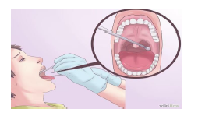**Take the swab.** Take green virology swab and gently rub it against the back of the throat on the area near the tonsils. This ensures that a proper sample in the area is captured well onto the swab

**In children** to test for respiratory viruses a nasopharyngeal swab or aspirate is taken (commonly for respiratory syncytial virus RSV). The viral medium is in a green swab.

**Nasopharyngeal Aspirate Specimen Collection:**

• Insert tubing attached to syringe (or compressed bulb for infants) through nose and direct toward nasopharynx.

• Pull back on syringe (or decompress bulb for infants) to withdraw secretions

• Expel secretions into viral transport media

• This process also used for nasopharyngeal swabs for COVID-19 detection, swabbing the throat first and proceeding to the nostrils.

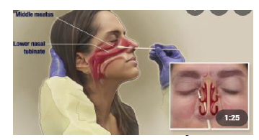 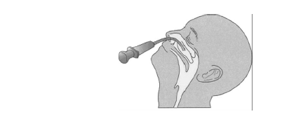

**Nose swab.**

Take a nose swab using a dry swab and insert into both nostrils. Wear PPE – Apron, gloves, face mask and eye protection. Do not exert too much force.

**Sending samples to the testing laboratory**

* label each sample with ID, date of birth and type of sample
* use the specific microbiology , one form for each sample
* do not place paperwork (request forms) in the primary container for Category B transport
* request form must include a contact phone number for sharing of results
* samples without appropriate paperwork will not be tested or testing will be delayed
* All samples for COVID-19 testing should be packaged and transported in accordance with Category B transportation regulations.

**Equipment for Specimens Collection:**

|  |  |  |
| --- | --- | --- |
| **Items for taking viral specimen** | | |
| Virology swabs | 1 |  |
| Pathology Bio Hazard plastic sample bag **(Double bag specimen)** | 2 |  |

.

**Appendix 24 - PPE Requirements When Caring for Suspected/Confirmed Respiratory Infection**

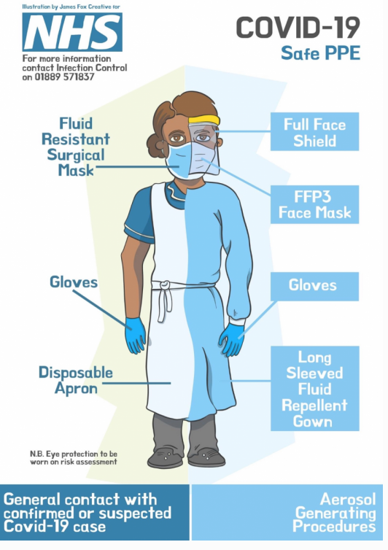

***GPPE for standard precautions***

***PPE for Suspected/Confirmed respiratory infections including COVID-19 & AGPs***

**Appendix 25 - PPE Guidance for General Areas, Including Non-Patient Facing Environments**

|  |
| --- |
| **Appendix 23 -PPE Guidance for General Areas, Including Non-Patient Facing Environments** |
| Following on from the Living with Covid-19 white paper, NHS England in conjunction with UKHSA have updated their guidance  This revised guidance contains the following important changes in relation to mask wearing and physical distancing |
| **Mask wearing** |
| **Staff mask wearing** |
| **When to wear a fluid resistant surgical mask (FRSM)**  All staff working in patient facing settings should continue to wear Fluid Resistant Surgical Face Masks [FRSMs] during any **patient contact or indirect patient interaction**, such as in a waiting area, corridor, or reception area.  **When a FRSM is not required**  Staff are not required to wear a FRSM in any area where there is **no patient contact or indirect patient interaction,** including staff office areas, kitchens, enclosed nurses’ stations, meeting rooms.  **Q: “I work in a community base do I have to wear a FRSM”?**  A: “Yes in areas where you might have indirect patient interaction such as when walking through a waiting area, corridor, or reception area, lifts (where there may be patients) then you will be required to wear a FRSM until you are in an area where there are no patients, then you can remove your FRSM”.  **Q: “I work on a ward; do I have to wear a FRSM at all times when on the ward”?**  A: “Yes, except in circumstances where there is no direct or indirect contact with patients, such as, in the nurse’s station, meeting rooms, kitchens. When leaving these areas, or if contact with a patient is likely, staff must put their FRSM back on”.  **Q: “I work at the Hackney Centre for Mental Health. Do I need to wear a mask when I enter the hospital”?**  A: “Yes, when entering any healthcare setting where there may be indirect contact with patients you are required to wear a FRSM, this includes corridors, lifts, reception areas”.  **Q: “Do I need to wear a FRSM if visiting a café/restaurant within a healthcare setting”?**  A: “Staff can remove their FRSM when they are sitting down at a table to eat and drink”.  **Q: ‘If a patient designated area looks empty, do I still need a FRSM?’**  A: ‘Yes, because it is likely you may come across a patient even if patient is not initially visible.  **Q: “Do I need to wear a FRSM when car sharing”?**  A: No are required when car sharing, with windows opened. Mask are only required if you are car sharing with a patient”.  **Q: ‘I work in the community. Do I need to wear a FRSM when visiting a patient’s home?’**  A: ‘Yes FRSMs should be worn for all patient facing contact’  **Q: “I was previously shielding; do I need to wear a FRSM?**  A: “No, a FRSM is not required you can continue to wear one based on personal preference”. |
| **Visitor and patient mask wearing** |
| Mask/face covering for patients and visitors remains the same   * Visitors are not required to wear a mask/face covering when in healthcare settings however may choose to wear FRSM based on personal preference. * Patients visiting outpatient departments/community bases should wear a FRSM or face covering if tolerated * Patients in their own homes who have a suspected or confirmed respiratory infection, such as COVID-19, should wear a FRSM or face covering if tolerated during face-to-face care * All inpatients who have a suspected or confirmed respiratory infection should wear a FRSM if tolerated, when leaving their room or during direct patient care * All inpatients who are attending outpatient appointment and during transportation should wear a FRSM if tolerated     Before giving a face mask to patient ensure ligature risk assessment is conducted.  A face mask should not be worn by patients if there is potential for their clinical care to be compromised (for example, when receiving oxygen therapy via a mask). |
| **Physical Distancing** |
| Physical distancing will remain at least 1-meter distancing and good ventilation of the environment.  **Q: “Is there still a maximum number of people that can be in a room”?**  A: “There is no longer a requirement for number of people in one room, however you should maintain 1 metre distancing capacity where possible. A risk assessment should be conducted of the environment using Work place risk assessment tool (WRAP tool).  **Q: “I work on a ward where a patient has COVID-19, do I need to keep a 2-metre distance”?**  A: “Yes, a 2-metre distance should be maintained where possible when not providing direct patient care”.  **Q: “I work in outpatients are patients required to physical distance in the waiting areas”?**  A: “There is no longer a requirement for patients to physical distance, however they should be wearing a mask/face covering in the waiting area”. |
| **Staff COVID-19 risk assessments** |
| Line managers and staff should ensure that they have completed a COVID-19 staff risk assessment that will identify any specific risks and enable these risks to be mitigated as far as possible |

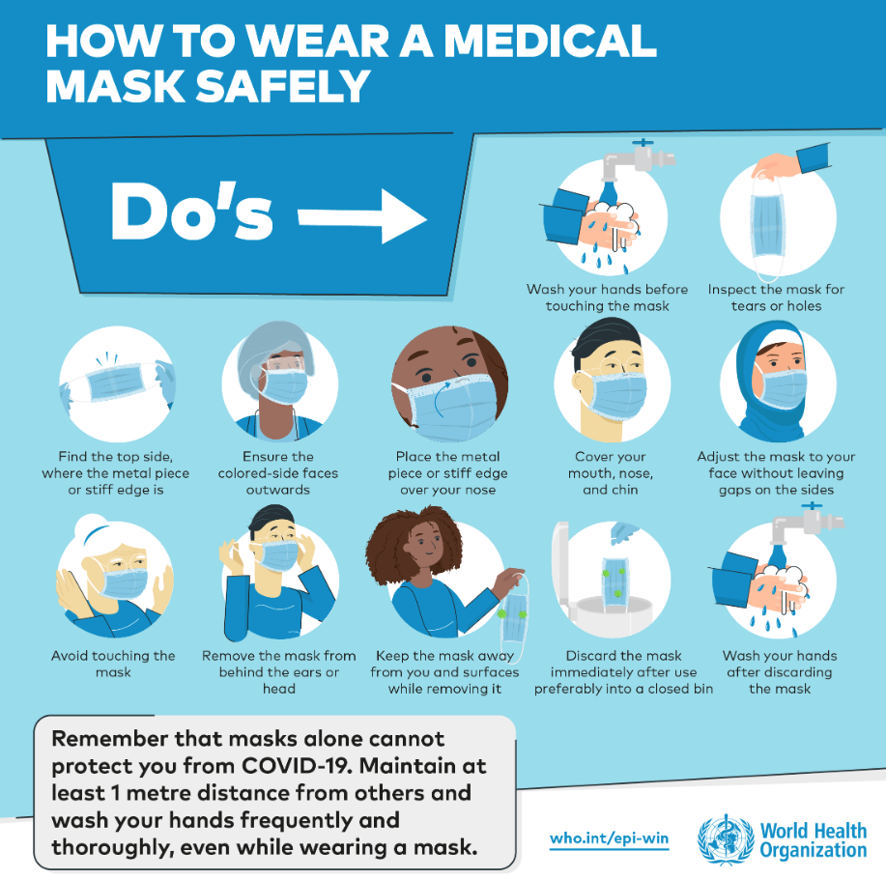

**Appendix 26 - Donning and Doffing of PPE**

* **Video of donning can be found here**: <https://www.youtube.com/watch?v=kKz_vNGsNhc>
* **Video of doffing can be found here:** <https://www.youtube.com/watch?v=oUo5O1JmLH0>
* **Video for donning/doffing coveralls can be found here:** <https://www.youtube.com/watch?v=ufmH3vIqfE0> 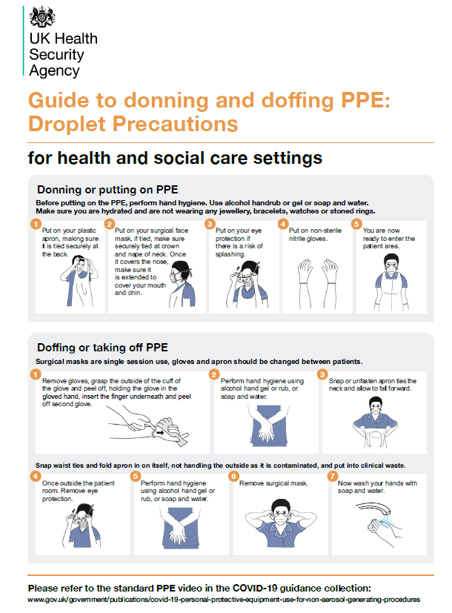

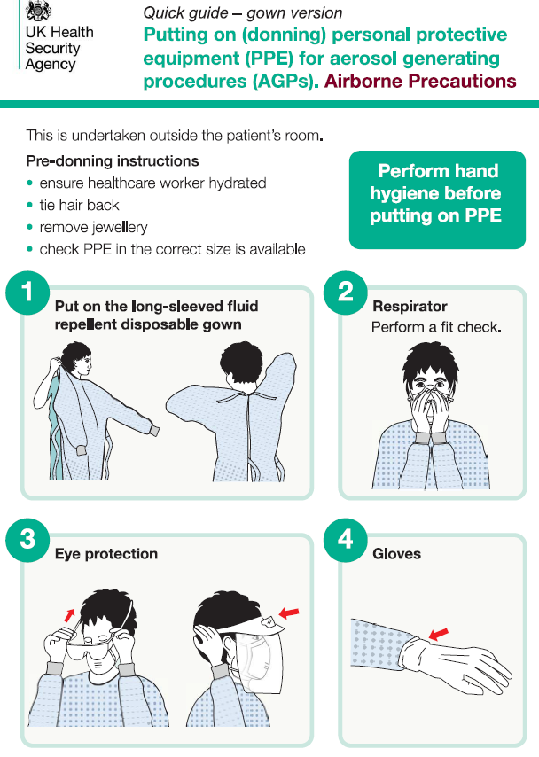

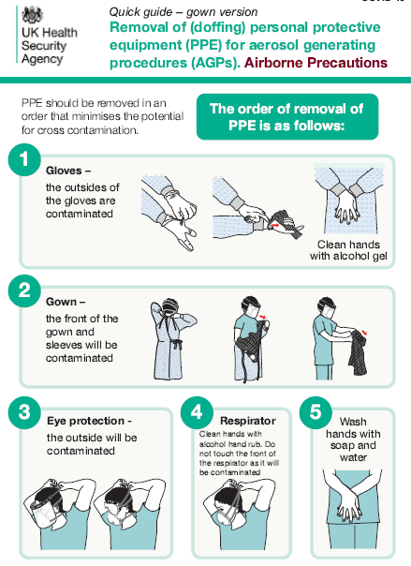

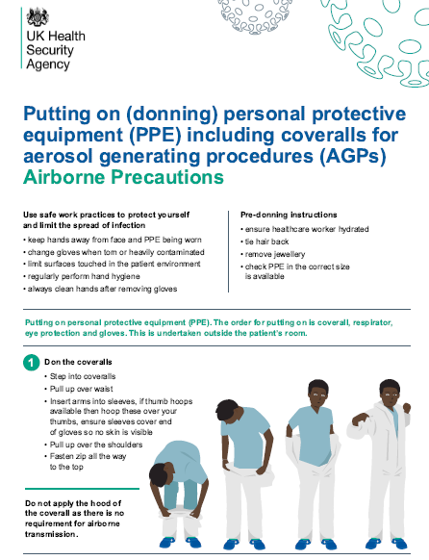

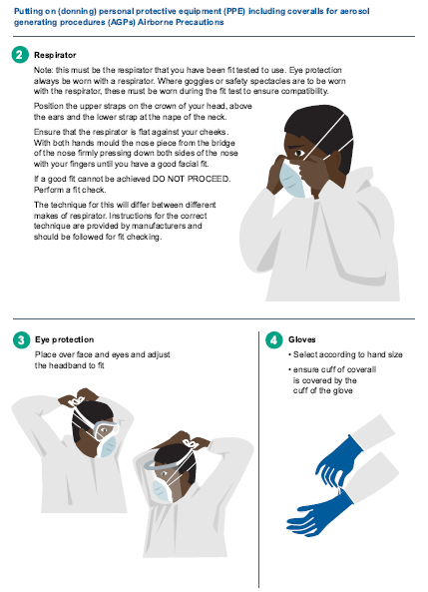

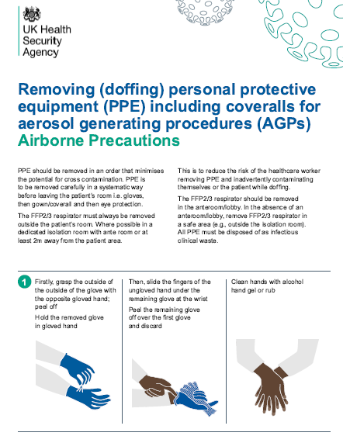

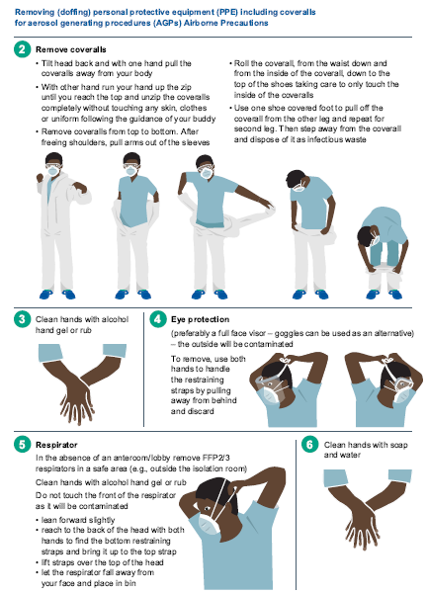

**Appendix 27 - Factsheet and Guidance on the Use of Filtering Face Piece Mask (FFP3 Mask)**

**1.** **What is filtering face piece mask (FFP3 Mask)?**

A filtering face piece is a type of respiratory protection that is worn over the nose and mouth designed to protect the wearer from inhaling hazardous substances, including airborne particles (aerosols). There are 2 types of respiratory protection that can be used, tight-fitting disposable FFP respirators and loose-fitting powered respirator hoods. There are 3 categories of FFP respirator: FFP1, FFP2 and FFP3. FFP3 mask and loose-fitting powered respirator hoods provide the highest level of protection and are recommended when caring for patients in areas where high risk.

**2. What do I need to consider before I wear FFP3 Mask?**

Before wearing an FFP3 mask there are a few things to consider. Under Health and Safety law it is a legal requirement all staff using this type of equipment are face fit tested.

**3.** **What is face fit testing?**

A face fit test should be carried out before wearing FFP 3 mask for the first time. Inadequate fit can reduce the protection provided and lead to immediate or long-term ill health or can even put the wearer's life in danger.

A fit test should be repeated whenever there is a change to the FFP3 mask type, size, model or material, or whenever there is a change to the circumstances of the wearer that could alter the fit of the FFP3 mask, for example:

* weight loss or gain
* substantial dental work
* any facial changes (scars, moles, effects of ageing etc.) around the face seal area facial piercings
* introduction or change in other head-worn personal protective equipment (PPE)

There is no stipulated frequency for retesting, and you do not need to re-test if there are no changes in these circumstances.

1. **How do I wear FFP3 mask?**

Training can be provided by the Trust fit testing team. Please contact them on [elft.fittesting@nhs.net](mailto:elft.fittesting@nhs.net)

1. **Can visitors and patients wear FFP3 mask?**

FFP3 mask are recommended only for use by healthcare personnel who need protection from both airborne and fluid hazards (e.g., splashes sprays). These respirators are not used or needed outside of healthcare settings. Patients should not be routinely given FFP3 mask

however, in cases of suspected TB infection (based on risk assessment) this may be used. However please seek advice from infection control department in the first instance on [elft.infectioncontorl@nhs.net](mailto:elft.infectioncontorl@nhs.net)

**6.** **When should I wear an FFP3 Mask?**

Please refer to flow chart on page 4 for when to wear FFP3 mask.

1. ***Should I wear and FFP3 mask with Valve or Non-valve?***

The Infection Prevention and Control department recommends wearing FFP3 mask without a value. An FFP3 mask with a valve is not fluid resistant and doesn’t not provide the wearer adequate protection to airborne particles.

1. ***Can I re-use the FFP3 mask after I have worn it?***

Ideally FFP3 mask should be discarded after each patient encounter and after aerosol generating procedures. It should also be discarded when;

* it becomes damaged or deformed;
* no longer forms an effective seal to the face; becomes wet or visibly dirty;
* breathing becomes difficult;
* or if it becomes contaminated with blood,
* Respiratory or nasal secretions, or other bodily fluids from patients.

1. **What is an Aerosol generating procedure (AGPs)?**

AGPs are procedures that create a higher risk of respiratory infection transmission and are defined as any procedure that can result in the release of airborne particles <5um in size from the respiratory tract of an individual. These can remain suspended in the air, may travel over a distance and may cause infection if they are inhaled when treating someone who is suffering from an infectious disease, transmitted wholly or partly by the airborne or droplet route.

FFP3 respirator masks will be required when undertaking an AGP on a patient COVID-19 pathway or when an unacceptable risk of transmission remains following rigorous application of the hierarchy of control.

The list of medical procedures that are considered to be aerosol generating and associated with an increased risk of respiratory transmission is:

* Cardiopulmonary resuscitation (*Local policy for ELFT);
* awake bronchoscopy (including awake tracheal intubation)
* awake ear, nose, and throat (ENT) airway procedures that involve respiratory suctioning
* awake upper gastro-intestinal endoscopy
* dental procedures (using high speed or high frequency devices, for example ultrasonic scalers/high speed drills)
* induction of sputum
* respiratory tract suctioning
* surgery or post-mortem procedures (like high speed cutting / drilling) likely to produce aerosol from the respiratory tract (upper or lower) or sinuses.
* tracheostomy procedures (insertion or removal). *Awake including ‘conscious’ sedation (excluding anaesthetised patients with secured airway.

1. **Additional Infection control measures:**

When using FFP3 mask the following infection prevention and control measures should also be utilised:

* Wearing PPE including gowns/aprons/ gloves, face visor/eye protection- *please conduct risk assessment of clinical activity and PPE required.*
* Hand hygiene using soap & water or alcohol
* Twice weekly lateral flow test
* COVID-19 staff risk assessment
* COVID-19 vaccination
* COVID-19 work place risk assessment
* Opening of windows for ventilation. Mechanical ventilation which does not recirculate the air.

1. **References**

<https://www.england.nhs.uk/wp-content/uploads/2022/04/C1636-national-ipc-manual-for-england-v2.pdf>

[*https://www.hse.gov.uk/pubns/indg479.pdf*](https://www.hse.gov.uk/pubns/indg479.pdf)

[*https://www.hse.gov.uk/coronavirus/ppe-face-masks/face-mask-ppe-rpe.htm*](https://www.hse.gov.uk/coronavirus/ppe-face-masks/face-mask-ppe-rpe.htm)

[*https://www.hse.gov.uk/coronavirus/ppe-face-masks/face-mask-ppe-rpe.htm*](https://www.hse.gov.uk/coronavirus/ppe-face-masks/face-mask-ppe-rpe.htm)

**Appendix 28 - Risk Assessment Guide for Wearing FFP3 mask**

**Are you:**

* Working on ward with suspected or confirmed COVID-19 or respiratory illness (Influenza, TB etc)?
* Are you looking are COVID-19 positive case in the community?
* Undertaking aerosol generating procedure (See AGP list - page 2)?
* Undertaking physical resistant?
* Working in poorly ventilated environments?

No

Yes

**Consider wearing Fluid resistant surgical mask Including the following IPC measures:**

* PPE – Gown, gloves, face visors/eye protection-conduct risk assessment of clinical activity
* Hand hygiene-soap and water or alcohol gel
* COVID-19 staff risk assessment tool
* 2 meters social distancing
* COVID-19 Workplace risk assessment
* Opening of windows for ventilation
* COVID-19 Vaccination

**Have you been fit tested?**

Yes

**Consider wearing FFP3 Mask Including the following IPC measures:**

* PPE – Gown, gloves, face visors/eye protection-conduct risk assessment of clinical activity
* Hand hygiene-soap and water or alcohol gel
* COVID-19 staff risk assessment tool
* 2 meters social distancing
* COVID-19 Workplace risk assessment
* Opening of windows for ventilation
* COVID-19 Vaccination

No

**Appendix 29 - Environmental Cleaning**

For COVID-19 wards or where there is an outbreak of COVID-19 the following cleaning of the environment will take place. For areas that are not identified as dedicated wards caring for COVID- 19 infections domestic cleaning will be provided as normal.

**Cleaning products/solutions**

Decontamination of equipment and the care environment must be performed using a combined detergent/disinfectant solution at a dilution of 1,000 parts per million (ppm) of chlorine.

Only cleaning (detergent) and disinfectant products supplied, are to be used. Products must be prepared and used according to the manufacturers’ instructions and recommended product ‘contact times’ must be followed. If alternative cleaning agents/disinfectants are to be used, they should only on the advice of the IPC Team and conform to EN standard 14476 for virucidal activity. The person responsible for undertaking the cleaning with detergent and disinfectant should be trained in the process.

**Cleaning the room/ward/environment:**

* + 1. Before cleaning the environment, domestic staff to liaise with Ward nursing staff and exchange information on cleaning and any potential risk;
    2. Domestic staffs to collect PPE form ward nursing staff;
    3. Before entering the room, perform hand hygiene;
    4. Don PPE as donning guidance (gloves, apron, Fluid resistant surgical mask, visor/googles- if risk of splashing);
    5. Collect all cleaning equipment (should be single use where possible) and healthcare waste bags before entering the room;
    6. The following staff will undertake cleaning duties shown in table 1 with a chlorine-based disinfectant at a minimum strength of 1,000ppm;
    7. Equipment to be discard if not sent off to laundry;
    8. Patient care equipment should be cleaned with disinfectant wipes;
    9. Dedicated disposable equipment (such as mop heads, cloths) must be used for environmental cleaning and disposed as clinical waste;
    10. Communal cleaning trollies should not enter the room;
    11. Doff PPE as doffing guidance;
    12. Wash hands including up to elbows with soap and water;
    13. Cream hands.

Patient isolation rooms must be cleaned:

* Twice a day;
* During discharge;
* Transfer;
* After an AGP (this includes removal and laundering of all curtains).

Domestic/cleaning staff performing environmental decontamination should:

* Ideally be allocated to specific area(s) and not be moved between COVID-19 positive wards and non-COVID-19 care areas
* Be trained in which personal protective equipment (PPE) to use and the correct methods of wearing, removing and disposing of PPE.

The care environment should be kept clean and clutter free. In COVID-19 positive wards all non- essential items including toys, books, and games should be removed from reception, waiting areas, day rooms and lounges. When made available, these items should not be shared. All toys must be cleanable and should be cleaned regularly by nursing staff in line with the Trust Infection Prevention & Control Policy Manual.

**Table 1: Cleaning duties of all staff disciplines**

|  |  |  |  |
| --- | --- | --- | --- |
| **Clinical staff** | **Frequency** | **Domestic staff** | **Frequency** |
| All hard surfaces in COVID-19 positive rooms | Twice | Corridors | Twice |
| Beds | Daily | Bathrooms | Twice |
| High touch surfaces- keyboard, phones, light switches, Fobs ,Keys | Daily- A minimum of 3 times a day with disinfectant wipe | High touch surfaces  Door Handles, rails | Daily- A minimum of 3 times. |
| Bed linen. Do not shake linen and avoid all necessary agitation | Daily | Toilets | Twice |
| Toilets – where soiling | Ad-hoc | Floors | Twice |
| Mattress | Daily | Staff toilets/ changing rooms | Daily |
| Cupboard  Tables Chairs | Twice | Showers | Twice |
| All re-usable medical equipment (BP cuffs, dynamaps, blood glucose machines, oxygen cylinders | Before /after patients use/In between patients with disinfectant wipe | Communal areas- dining room/ lounge | Twice |
| Toys, books, and games/ I-pads | Before /after patients use/In between patients with disinfectant wipe | Bedrooms | Twice |
|  |  | Collection of clinical waste  – as per local arrangements | Daily |

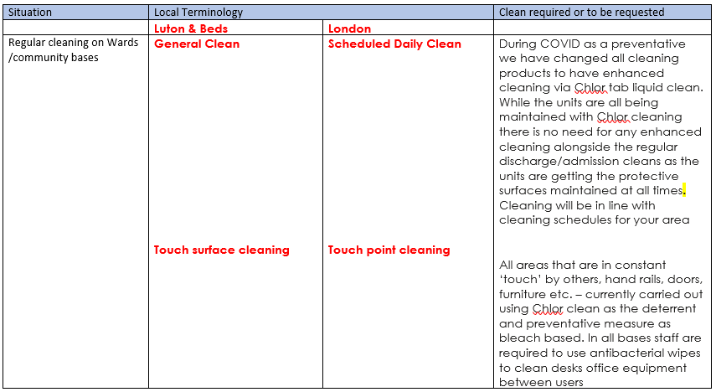

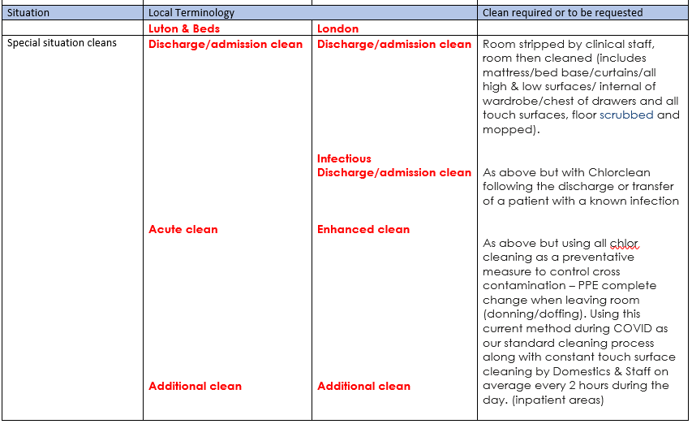

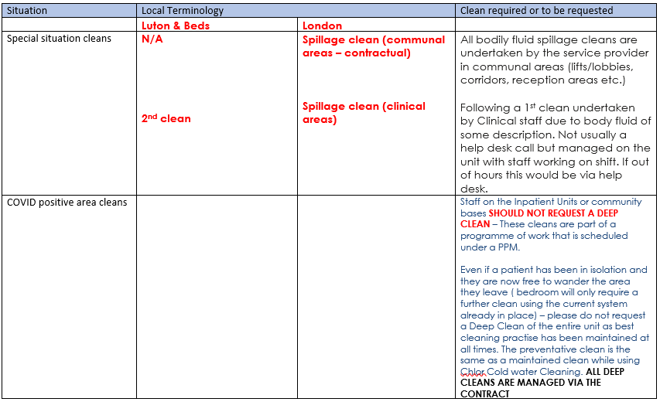

**Appendix 30 - Patient Information Leaflet on COVID-19**

1. **You have been identified as being a contact of a patient who has tested positive for COVID 19. What is COVID 19?**

Coronavirus (COVID-19) is the illness caused by a new strain of coronavirus first identified in Wuhan City, China, it can cause a cough and or a fever/high temperature.

Coronavirus can cause more severe symptoms in people with weakened immune systems, older people and those with long term conditions like diabetes, cancer and chronic lung disease**.**

1. **What are the symptoms of COVID 19?**
   * + fever,
     + a new and continuous cough,
     + anosmia (loss of smell)
     + ageusia (loss of taste).
     + shortness of breath,
     + fatigue,
     + loss of appetite,
     + myalgia (muscle ache),
     + sore throat,
     + headache,
     + nasal congestion (stuffy nose),
     + runny nose,
     + diarrhoea,
     + Nausea and vomiting.
     + Older people may present with less common symptoms.
2. **How does it spread?**

Covid-19 is spread by droplets in coughs and sneezes. It can be also spread via airborne route in areas with poor ventilation.

1. **How can I prevent other people from getting COVID-19?**

You can reduce spreading the infection by:

* Avoiding direct hand contact with your eyes, nose and mouth;
* Maintaining good hand washing;
* Avoiding direct contact with other patients or sharing personal items such as mobile phones;
* Covering your nose and mouth when coughing or sneezing with disposable tissues and disposing of them in the nearest waste bin after use.
* Getting COVID-19 vaccine

1. **Wash your hands regularly**

Wash your hands with soap and water/ disinfectant wipe before eating and drinking, and after coughing, sneezing and going to the toilet.

1. **How is it treated?**

Monoclonal antibodies can be used to treat mild to moderate COVID-19 infection in people who are more likely to get very sick.

1. **What happens if you are a contact of a patient diagnosed with COVID 19 while in hospital?**

You will be monitored for any symptoms of COVID 19 for 7 days. The nursing and medical team will liaise with the Infection Prevention & Control department on how best to support in provided care that maintains safety and prevents further harm.

1. **What happens if I am discharged before the 7 days are over?**

You need to continue to monitor for symptoms (see symptoms section above) until the 7 days are up. You should be told when that will be by the ward staff on your discharge.

.

1. **What about visitors? Are friends and family at risk?**

It is recommended that any family members who may be at risk due to underlying health conditions minimise visits, particularly when there is active COVID-19 cases on the ward you are being cared for.

**55. Document Control**

# **55.1 Procedure Checklist**

To be completed and attached to any document which guides practice when submitted to the appropriate committee for consideration and approval.

|  |  |  |  |
| --- | --- | --- | --- |
|  | **Title of document being reviewed:** | **YES / NO / UNSURE** | **Comments** |
| **1** | **Title** |  |  |
|  | Is the title clear and unambiguous? | Yes |  |
| **2** | **Purpose** |  |  |
|  | Are reasons for development of the document stated? | Yes |  |
| **3** | **Development Process** |  |  |
|  | Are people involved in the development identified? | Yes |  |
|  | Do you feel a reasonable attempt has been made to ensure relevant expertise has been used? | Yes |  |
|  | Is there evidence of consultation with stakeholders and users? | Yes |  |
| **4** | **Style/Format** |  |  |
|  | Is the document in the correct structure/format? | Yes |  |
|  | Is the document clear and concise? | Yes |  |
|  | Are key terms defined? | Yes |  |
| **5** | **Content** |  |  |
|  | Is the objective of the document clear? | Yes |  |
|  | Is the target population clear and unambiguous? | Yes |  |
|  | Are the intended outcomes described? | Yes |  |
|  | Are the statements clear and unambiguous? | Yes |  |
| **6** | **Evidence Base** |  |  |
|  | Is the type of evidence to support the document identified explicitly? | Yes |  |
|  | Are key reference cited? | Yes |  |
|  | Are the reference cited in full? | Yes |  |
|  | Are supporting documents referenced? | Yes |  |
| **7** | **Approval** |  |  |
|  | Does the document identify which committee/group will approve it | Yes | Infection Prevention & Control Committee and Quality Committee |
|  | If appropriate have the Joint Human Resources/Staff side committee (or equivalent) reviewed the document? | N/A |  |
| **8** | **Implementation Plan** |  |  |
|  | Is there an implementation Plan? | Yes |  |
|  | Does the plan clearly state how the procedure will be disseminated? | Yes |  |
|  | Does the plan include the necessary training/support to ensure compliance? | Yes |  |
| **9** | **Document Control** |  |  |
|  | Does the document identify where it will be held? | Yes |  |
|  | Have archiving arrangements for superseded documents been addressed? | Yes |  |
| **10** | **Impact Assessment** |  |  |
|  | Is the impact assessment completed? | Yes |  |
| **11** | **Review Date** |  |  |
|  | Is the review date identified? | Yes |  |
|  | Is the frequency of review identified? If so is it acceptable? | Yes |  |
| **12** | **Overall Responsibility for the Document** |  |  |
|  | Is it clear who will be responsible for co-ordinating the dissemination, implementation and review of the document? | Yes | Deputy Director of Infection Prevention & Control.  Infection Prevention & Control Team. |

|  |  |  |  |
| --- | --- | --- | --- |
| **Individual Approval** | | | |
| If you are happy to approve this document, please sign and date it and forward to the chair of the committee/group where it will receive final approval. | | | |
| Name | Deputy Director of Infection Prevention & Control. | Date | 6th October 2022 |
| Signature |  | | |

|  |  |  |  |
| --- | --- | --- | --- |
| Committee Approval | | | |
| If the committee is happy to approve this document, please sign and date it and forward copies to the person with responsibility for dissemination and implementing the document and the person who is responsible for maintaining the organisation’s database of approved documents. | | | |
| Name |  | Date |  |
| Signature |  | | |

# **55.2 Equality Analysis**

A template for undertaking equality analysis of new and existing policies, function, service redesign, internal reorganisations or restructuring processes.

**Contents**

|  |  |
| --- | --- |
|  | Page |
| Part 1: Equality Analysis Details | 198 |
| Part 2: Proposal Details | 199 |
| Part 3: Equality Analysis of Staff | 200 |
| Part 4: Equality Analysis of Service Users/Patients | 201 |
| Part 5: Findings from the Equality Analysis | 202 |
| Part 6: Equality Analysis Action Plan | 203 |
| What Happens Next? | 203 |
| References | 204 |

# **Part 1: Equality Analysis Details**

|  |  |
| --- | --- |
| **Title of ‘Proposal’** | Policy review |
| **Name of Directorate** | Corporate services |
| **Name of Manager Undertaking the Equality Analysis** | Rana Begum – Trust-wide Lead Infection Prevention and Control Nurse |
| **Consultation Date/s with Staff** | N/A |
| **Consultation Date/s with Service Users** | N/A |
| **Date Equality Analysis Completed** | 6th October 2022 |
| **Review Date**  **(Review at least once every 3 years)** | 6th October 2022 |

# **Part 2: Proposal Details**

|  |
| --- |
| **1) What are the aims of the proposal? Indicate if this is a new proposal or the review of an existing one?**  (The term ‘proposal’ covers activities such as policy development, policy review, service redesign and internal reorganisation or restructuring processes)  This policy incorporates the COVID-19 infection control policy as well as the management of respiratory infections into one policy as per national guidance recommendation |

|  |
| --- |
| **2) Provide a summary of the current activity to which the proposal relates e/g/ policy or service structure and provision and the reasons for the changes being proposed?** (State if the proposal involves relocating a service to another site; extended service hours; puts staff at risk or involves significant change)  This policy incorporates the COVID-19 infection control policy as well as the management of respiratory infections into one policy as per national guidance recommendation |

# **Part 3: Equality Analysis of Staff**

|  |  |  |
| --- | --- | --- |
| **Protected Groups**  Identify the impact or potential impact on each of the following protected groups, with due regard to the three aims of the PSED (Public sector equality duty) | **Impact Positive or Negative?**  **Or No Impact?** | **Please describe the process of your analysis with reference to the following:**   * Results of consultation * Data or research on the protected groups that you have considered * Implications for the protected groups |
| **Age:** | No impact |  |
| **Disability:** (Consider a range of impairments, including – sensory, mental, physical and learning disability) | No impact |  |
| **Sex:** | No impact |  |
| **Religion or Belief:** (including no belief) | No impact |  |
| **Sexual Orientation:** | No impact |  |
| **Race:** (Including ethnicity and nationality) | No impact |  |
| **Gender Reassignment:** | No impact |  |
| **Pregnancy and Maternity:** | No impact |  |
| **Marriage and Civil Partnership:** | No impact |  |

# **Part 4: Equality Analysis of Service Users / Patients**

|  |  |  |
| --- | --- | --- |
| **Protected Groups**  Identify the impact or potential impact on each of the following protected groups, with due regard to the three aims of the PSED (Public sector equality duty) | **Impact Positive or Negative?**  **Or No Impact?** | **Please describe the process of your analysis with reference to the following:**   * Results of consultation * Data or research on the protected groups that you have considered * Implications for the protected groups |
| **Age:** | No impact |  |
| **Disability:** (Consider a range of impairments, including – sensory, mental, physical and learning disability) | No impact |  |
| **Sex:** | No impact |  |
| **Religion or Belief:** (including no belief) | No impact |  |
| **Sexual Orientation:** | No impact |  |
| **Race:** (Including ethnicity and nationality) | No impact |  |
| **Gender Reassignment:** | No impact |  |
| **Pregnancy and Maternity:** | No impact |  |
| **Marriage and Civil Partnership:** | No impact |  |

# **Part 5: Findings from the Equality Analysis**

|  |
| --- |
| **Use this space provided below to elaborate on your decision based on the findings of the equality analysis** |
| **1. Accept the Proposal** – No evidence of discrimination and appropriate opportunities have been taken to advance equality and foster good relations.  Accept the proposal as there is no equality impact |
| **2. Adjust the Proposal** – Take steps to remove barriers to advance equality. It may involve introducing actions to mitigate the potential effect or to look at how to deliver the proposal in a different way. It is lawful under Equality Law to treat people differently in some circumstances, for instance developing single sex provision where required.  N/A |
| **3. Continue the Proposal** – Despite adverse effect or taking opportunities to advance equality provided the proposals do not unlawfully discriminate and can be objectively justified. **(To identify whether a proposal may unlawfully discriminate due regard should be given to discrimination on the basis of the protected characteristics)**  N/A |
| **4. Stop the Proposal** – The policy shows unlawful discrimination and adverse effects that cannot be mitigated  N/A |

# **Part 6: Equality Analysis Action Plan**

|  |  |
| --- | --- |
| **Adverse Impact - Staff** |  |
|  | No adverse impact on staff |
|  |  |
|  |  |

|  |  |
| --- | --- |
| **Adverse Impact – Service Users** |  |
|  | No adverse impact on service users |
|  |  |
|  |  |

**What Happens Next?**

Once a plan has been put in place to mitigate against adverse impacts, the Equality Analysis should then be signed off by the Director/Head of the Service. Following this, the proposal can then be implemented. It is important to remember that Equality Analysis is not a once off process. It is important therefore, to be alert to emergent equality impacts throughout implementation.

**This Analysis has been checked and approved by:**

**Name: Rana Begum**

**Title: Trust-wide Lead Infection Prevention & Control Nurse**

**Date:** 6th October 2022

**Once completed, the document should be sent to the Trust’s Risk & Datix Manager to support the policy development and review process:** [**j.sims3@nhs.net**](mailto:j.sims3@nhs.net)

**55.3 References**

<http://www.eastlondon.nhs.uk/about_us/equality_and_diversity.asp>Equality Information including examples of Equality Analysis, East London Foundation Trust

[www.equalityhumanrights.com](http://www.equalityhumanrights.com) Equality and Human Rights Commission

www.stonewall.og.uk Lesbian, Gay & Bisexual Information and Research, Stonewall

[www.ndti.org.uk;](http://www.ndti.org.uk/) Achieving Age Equality in Local Mental Health Services, National Mental Health Development Unit