Specialist Children and Young People’s Service
Occupational Therapy Services for Children

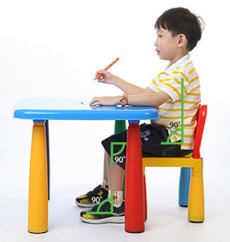
90°90°90° Handwriting Posture
90°90°90° means that, when sitting, your child should have a 90 degree angle at their hips, knees and ankles
Top tips:
- Your child’s feet should be flat on the floor. If their feet are dangling in the air, place a box/ large book/ foot stool underneath their feet
- The table top should fit just above your child’s elbows. If the table top is too high, they may struggle to reach up; if the table is too low they may slump down in their chair
- Your child’s knees should be just over the edge of the chair. If the chair is too big, place a cushion behind your child’s back
Why use 90°90°90° for table top activities?
- It supports our breathing.
- It provides safety and support when sitting which helps children to focus on their hands.

Many people find that the 90°90°90° position makes a big difference.
Even if you see no change immediately,
continue with this positioning as it is essential for supporting writing.

It is essential that this is implemented at home so that your child is stable while eating

