First-line Nutrition Support
Preventing Malnutrition
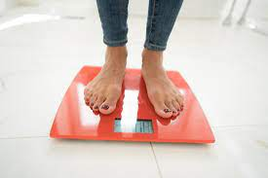 | Malnutrition can be caused by being underweight, losing weight unintentionally, or having a barrier to eating and drinking.
 | It can have serious negative impacts, causing infection, admission to hospital, and even death in extreme cases.
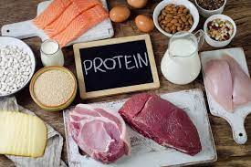 | A diet high in energy and protein can reduce the risk of malnutrition by promoting weight stability, or weight gain. This is contrary to healthy eating advice.

Food Fortification
If someone has a small appetite, adding calories to meals will help make every mouthful more nutritious, such as oil, double cream, syrup or honey, sugar, butter and sauce.

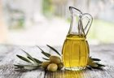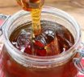

These can be added to cereal, toast, soups, stews, and desserts at the point of service.
Adding protein into meals, snacks and drinks prevents muscle wastage, such as milk powder in soup or cereal, melting cheese on mashed potato, using full-fat milk and yoghurt to make sauce, eggs, beans and nuts.
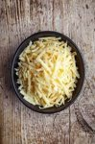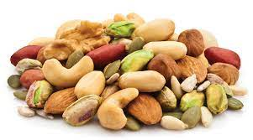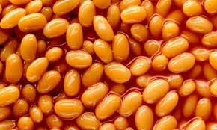
Dairy-free products can be used as long as the protein and calcium content matches dairy.

Fortified milk is made from full fat milk and skimmed milk powder

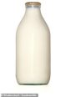+ = FORTIFIED MILK used in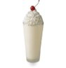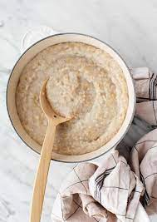

This can be taken as a milkshake or hot drink, added to porridge, sauces, or cooking mains.

Nutritious Drinks
Along with fortified milk, offering juices and sugary drinks, or making fruit smoothies with additional protein powders, nut butters, cream or yoghurt can be helpful nourishing drink.

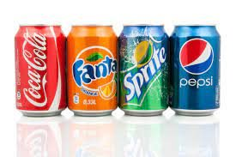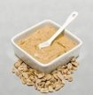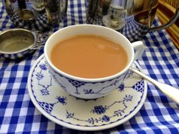

Nutritious Snacks
Offering high-protein snacks in between meals is a good way to add additional calories when someone has a low appetite. Sandwich-fillers are often a good starting point:

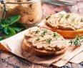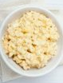

Tuna mayonnaise, hummus, meat/fish pate, cream cheese/slice, meat/chicken slices, and yoghurt with >20g protein per pot are all protein-rich snacks.
Offering high-energy snacks are often sweet and high in fat, and can be given as puddings:

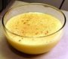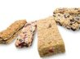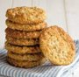

Meal Environment
 | Protected Mealtimes allow service users the guaranteed time to eat meals without interruption, even if at a belated time after appointments.
 | Creating a familiar space with preferred sound (music or silence), photos of relatives and friends, appropriate aroma (appetising food smells and away from toilets) can help boost someone’s appetite.
ELFT Nutrition Screening Tool.docx | Offer regular prompting and encouragement with eating and drinking in between meals and at mealtimes. Monitor on food and fluid charts.

