Service User: Daily Fluid Chart Date:
TIME | FLUID INTAKE (ml)  Oral/Enteral/Subcutaneous/IV | FLUID OUTPUT (ml): Urine/Vomit/Faeces/Saliva | BALANCE (ml) -ve/+ve
00.00-01.00
01.00-02.00
02.00-03.00
03.00-04.00
04.00-05.00
05.00-06.00
06.00-07.00
07.00-08.00
08.00-09.00
09.00-10.00
10.00-11.00
11.00-12.00
12.00-13.00
13.00-14.00
14.00-15.00
15.00-16.00
16.00-17.00
17.00-18.00
18.00-19.00
19.00-20.00
20.00-21.00
21.00-22.00
22.00-23.00
23.00-00.00
TOTAL

Estimating Fluid Intake
Use below table to estimate oral intake, and use syringe readings for enteral:
1 cup | 250ml | 1 teaspoon 5ml
1 soup bowl | 350ml | 1 tablespoon 15ml
1 mug | 335ml | 1 can fizzy drink 330ml

Signs of Dehydration
Does the service user have hard stools?  (type 1-2) Yes or No  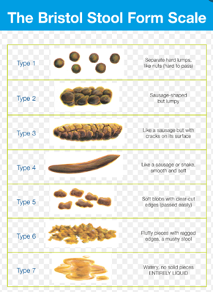 | Does the service user have dark urine?  (type 4 or more) Yes or No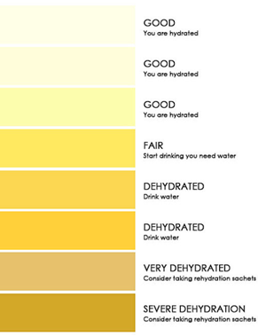
Does the service user have fluid losses? (sweating, diarrhoea, vomit) Yes or No | Does the service user have fluid losses?  (frequent urine output) Yes or No

If YES to any of the above, if no fluid restriction, add at least 200-500mls of water to the service user’s regimen, consider rehydration solution, and monitor signs regularly.

Comments:

*for further queries, please contact the dietitians

